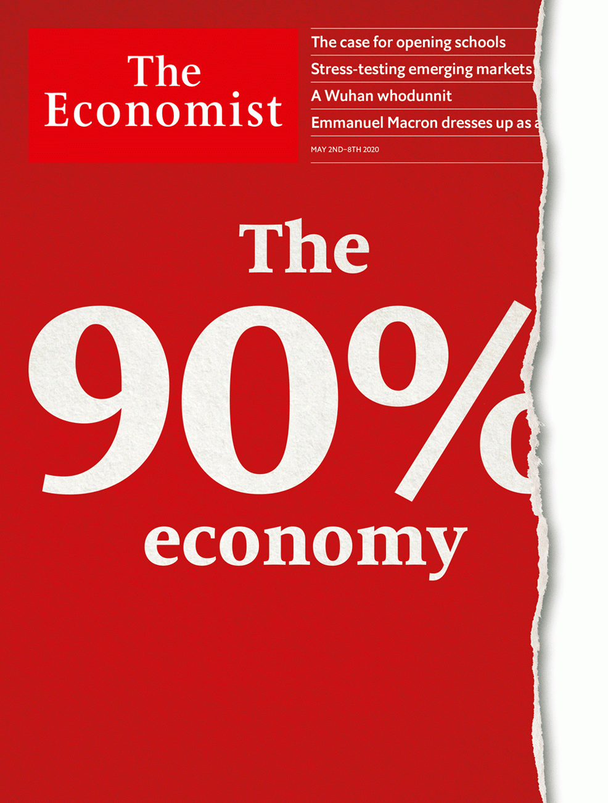

# Table of Contents

The world this week

Politics this week

Business this week

KAL’s cartoon

Leaders

Life after lockdowns: The 90% economy

Covid-19 and the classroom: Open schools first

State and local governments: Unsteady states

Big tech and the crisis: West-coast shuffle

Disease and laboratories: The origins of the virus

Letters

Letters to the editor: On testing, stimulus, the three-day week, ancient Athens, coughing

Briefing

The post-covid economy: Not quite all there

Debt in developing countries: Next in line

United States

Presidential politics: Election monitoring

Military service and citizenship: Battling to be American

Residential property: The house loses

Food supplies: Slaughterhouse dive

Distributed manufacturing: A multitude of drops

Lexington: Conservatism in the crisis

The Americas

Brazil: A dangerous divorce

Venezuelans in Colombia: The welcome mat frays

Bello: The lockdown conundrum

Asia

North Korea: Oh leader, where art thou?

Employment in Japan: Shake-work scheme

Garment factories in Bangladesh: Suffering from a stitch

Banyan: Pious and infectious

Sexism in Malaysia: When make-up is essential

Curbing covid-19 in Asia: The legitimate use of farce

China

Graduate unemployment: Spring freeze

Endangered species: Tilting the scales

Chaguan: Virus exceptionalism

Middle East and Africa

Zambia: In the pits

Sudan: Technical solutions

Africa: Leaders and misleaders

Yemen’s war within a war: The south rises

The war in Libya: A warlord in trouble

Saudi Arabia: No more flogging

Europe

Lockdowns and trust: Infectious doubt

Germany: The explainer-in-chief

Italy: In need of assistance

Covid tech: Protocol politics

Politics in Ukraine: Is the man from Georgia back?

Norway’s sovereign-wealth fund: How not to hand over to your successor

Charlemagne: Emmanuel and the three costumes

Britain

Universities: Time to think small

Horticulture: A nation of gardeners

Local government: Sinking

Scottish independence: Scarier alone?

Tracking and tracing: And then there were 18,000

Death toll: Rivalling the Blitz

British Airways: Grounded

Northern Ireland and Brexit: Just how is this going to work?

Bagehot: Blair’s back

International

Closing schools: No more pencils, no more books

The experience of Ebola: Lessons learned

Covid-19 infections: Think of the children

Business

Chinese entrepreneurs: Flowerbeds of enterprise

Bartleby: The road to hell

Virtual AGMs: Low resolution

German blue chips: Despondent DAX

Schumpeter: The riddle of Samsung

Finance and economics

Bailing out small businesses: Averting nightmare on Main Street

Bailing out large firms: Big bucks

Melissa Dell: To good effect

Local finances in America: Less than zero

Buttonwood: Pulp fiction

Free exchange: Mountain to climb

Schools brief

Computing climate change: Model behaviour

Science and technology

The origin of covid-19: Only connect

Covid-19 and the immune system: Uncertainty’s principals

Covid-19 and smoking: An unexpected ally

Books and arts

Me time: All the lonely people

Romek Marber: Order and peril

Johnson: The purpose of classics

Home Entertainment: Ghosts of baseball’s past

Home Entertainment: Rereading “The Leopard”

Economic and financial indicators

Economic data, commodities and markets

Graphic detail

Covid-19 and life expectancy: Before their time

Obituary

Joe Brown: Through crack and crag



### Friday, May 1, 2020

|  |  |
| --- | --- |
| The world this week | 3 |
| Leaders | 5 |
| Letters | 1 |
| Briefing | 2 |
| United States | 6 |
| The Americas | 3 |
| Asia | 6 |
| China | 3 |
| Middle East and Africa | 6 |
| Europe | 7 |
| Britain | 9 |
| International | 3 |
| Business | 5 |
| Finance and economics | 6 |
| Schools brief | 1 |
| Science and technology | 3 |
| Books and arts | 5 |
| Economic and financial indicators | 1 |
| Graphic detail | 1 |
| Obituary | 1 |

|  |  |  |
| --- | --- | --- |
|  | Sections | Leaders |

The world this week

Politics this week

.

Business this week

.

KAL’s cartoon

.

|  |  |  |
| --- | --- | --- |
|  | Sections | Leaders |

|  |  |  |  |
| --- | --- | --- | --- |
|  | Articles | Sections | Next |

# Politics this week

May 2nd 2020 |

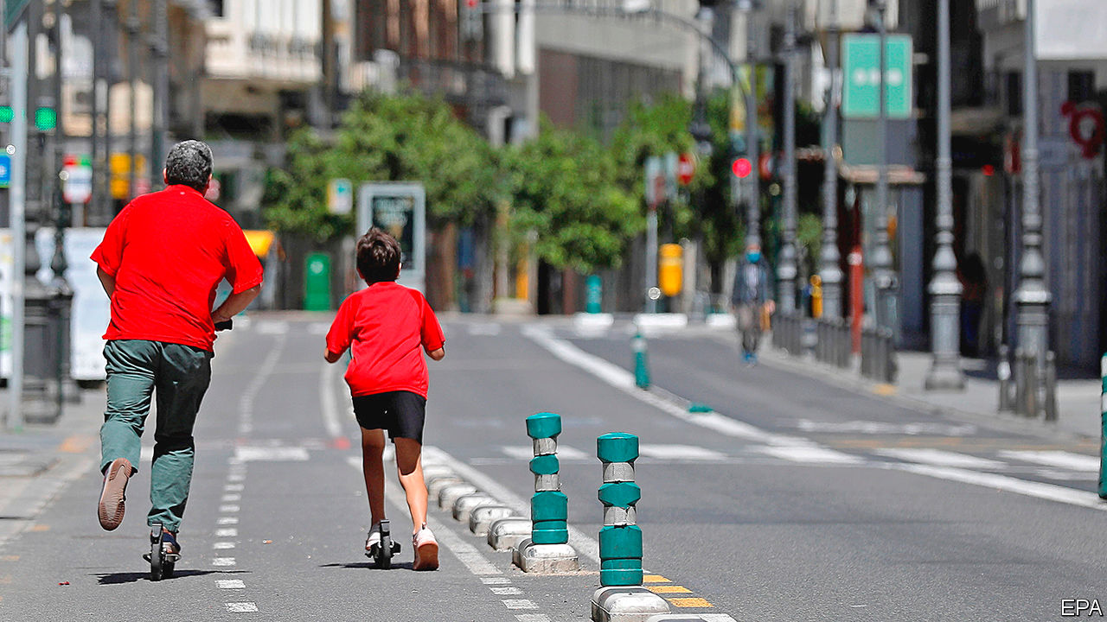

Spain announced a complicated four-phase, eight-week return to a “new normality”, which will vary in speed between provinces. If all goes well, Spaniards will be able to return to beaches and bars by the end of June, and in some places before then. France also outlined its own “deconfinement” strategy. Most businesses will be allowed to reopen from May 11th, except for cafés, restaurants and large public spaces such as museums; public transport will largely resume too. The French prime minister said this was necessary to avoid economic collapse. France also suffered some alarming instances of rioting. See article.

The chief executive of Heathrow called for the mandatory testing of passengers for covid-19 at airports in Britain,because travellers are currently allowed to enter the country “without visible measures in place”. Britain is one of only a few countries not to have introduced tighter border screening. Following scientific advice, the government has concluded that temperature checks are ineffective.

Argentina extended its ban on all domestic and international flights until September.

In El Salvador the president, Nayib Bukele, encouraged police to use “lethal force” against criminals following dozens of murders over a few days. The country’s homicide rate, one of the world’s highest, has fallen since Mr Bukele became president in June. He accused gangs of taking advantage of the pandemic, which has distracted security forces from fighting crime.

Brazil’s justice minister, Sérgio Moro, quit after the country’s populist president, Jair Bolsonaro, sacked the head of the federal police. Mr Moro accused the president of trying to interfere in investigations of members of his own family. The attorney-general opened an inquiry into Mr Moro’s charge that the president tried to obstruct justice. See article.

Dozens of people were killed when a fuel lorry rigged with explosives was detonated in the Syrian city of Afrin, which is controlled by Turkish forces and their local allies. Turkey’s defence minister blamed a Kurdish militia, the YPG, which was pushed out of the city two years ago.

Southern separatists in Yemen broke a peace deal with the internationally recognised government and claimed control of the port city of Aden. The separatists are backed by the United Arab Emirates; the government, by Saudi Arabia. All four are ostensibly on the same side in the war against the Houthi rebels, who control the north. See article.

Khalifa Haftar, the warlord battling the government in Libya, declared military rule in the east. General Haftar hopes to become Libya’s strongman, but he is on the back foot after recent losses in the west. See article.

Saudi Arabia said it would no longer execute people who committed crimes when they were children. It also banned flogging as a punishment. But the beheadings continue: 184 people were put to death last year, a record for the kingdom. See article.

The IMF agreed to provide $3.4bn in emergency funding to Nigeria,its biggest disbursement related to covid-19 so far. Nigeria faces a shortage of foreign currency after a collapse in the oil price.

The scheduled launch of the African Continental Free Trade Area on July 1st was postponed indefinitely because of the outbreak of covid-19. The agreement is intended to create the world’s largest free- trade zone, with 55 members.

At least 43 people were killed in fighting in the east of the Democratic Republic of Congo. These include 12 rangers killed by rebels in the Virunga National Park.

America’s top brass were reportedly at odds about whether to re-instate Brett Crozier as captain of the uss Theodore Roosevelt, an aircraft-carrier. Captain Crozier was fired for going outside official channels to ask for help amid an outbreak of covid-19 on his ship. The navy wants to give him his command back, but the Joint Chiefs of Staff is pushing for a full inquiry.

Gavin Newsom, the governor of California, warned that coronavirus “doesn’t take the weekends off” after two southern counties in the state re-opened beaches.

China’s parliament, the National People’s Congress, said it would convene its annual session on May 22nd. The meeting, which normally lasts for about ten days, had been scheduled for early March but was delayed because of the pandemic. The event will involve thousands of people from around the country.

Kim Jong Un, North Korea’s dictator, remained invisible. He has not been seen in public since April 11th, prompting speculation that he is sick. America and South Korea said they saw no sign of anything unusual. Mr Kim is the third-generation hereditary ruler of a supposedly communist state. He has no publicly designated successor. See article.

The government of India said it would allow migrant workers stranded far from their home villages to return to them if they wanted. Many of the workers had lost their jobs as a result of a national coronavirus lockdown, but the associated curbs on travel had left them with nowhere to go.

## Coronavirus briefs

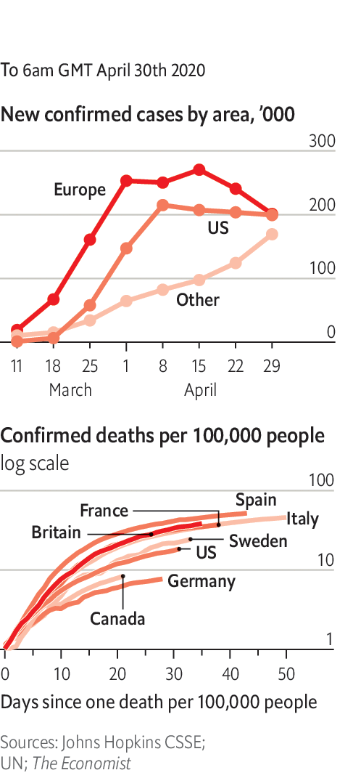

The WHO asked states not to issue immunity passports. It said there was insufficient evidence that exposure to the virus confers immunity. See article.

Singapore reported another surge in cases; it is now one of the worst-hit countries in Asia, after Iran, China, Pakistan and India. South Korea reported no new domestic infections.

In Wuhan officials said no more patients with the disease were being treated in the city’s hospitals. A team that had been deployed to the city to oversee its fight against the outbreak returned to Beijing.

Australia called for an international inquiry into the origins of the disease. China warned it not to.

Boris Johnson returned to work, three weeks after being admitted to intensive care and a period of convalescence. The British prime minister’s fiancée gave birth to a son.

This article was downloaded by calibre from <https://www.economist.com/the-world-this-week/2020/05/02/politics-this-week>

|  |  |  |  |
| --- | --- | --- | --- |
|  | Articles | Sections | Next |

|  |  |  |  |
| --- | --- | --- | --- |
| Previous | Articles | Sections | Next |

# Business this week

May 2nd 2020 |

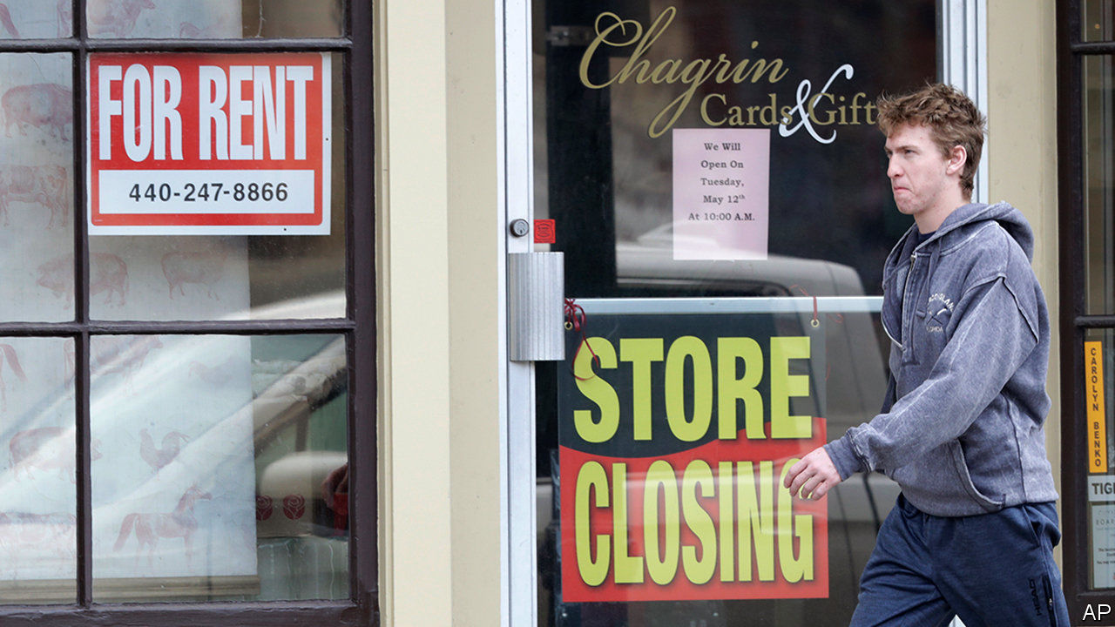

The American economy shrank by 4.8% at an annualised rate in the first quarter, the worst decline since the fourth quarter of 2008. It will get worse: pandemic restrictions began in the tail end of the quarter. The news did little to stop the recent bullishness in stockmarkets: the S&P 500 is up by more than 30% since mid-March.

Markets have been buoyed by a sharp rise in the share prices of tech firms. In its quarterly earnings Facebook reported a healthy rise in the number of active users. Microsoft said that the pandemic was having a “minimal impact” on sales and recorded a profit of $10.8bn. Alphabet’s revenues beat market expectations.

The Bank of Japan expanded its bond-buying programme to acquire an unlimited amount of government paper and increase its purchase of corporate debt. The announcement on government bonds was mostly symbolic; in recent years the central bank has bought far less sovereign debt than it had said it would, concentrating instead on pegging long-term yields around zero. Still, it is a signal to markets that the Bank of Japan intends to ramp up stimulus.

In France GDP contracted by 5.8% in the first quarter compared with the previous three months, the steepest decline in the economy by that measure since records began in 1949.

The Federal Reserve took no action at its latest meeting, though it earlier expanded eligibility for its emergency lending programmes to America’s states, counties and cities.

Russia’s central bank cut its benchmark interest rate by half a percentage point, to 5.5%, and hinted at further reductions. The economy has been hit by the collapse of the oil price and a general slump in demand for other commodities. Vladimir Putin extended the country’s lockdown until at least May 11th, warning that a “difficult path lies ahead”.

With oil markets in turmoil, oil companies began reporting their earnings for the first quarter. BP’s underlying replacement-cost profit, its preferred measure of earnings, plunged. It also reported a hefty net loss, but remains committed to paying a dividend to shareholders. After reporting a sharp drop in its headline profit, Royal Dutch Shell reduced its dividend for the first time since the 1940s.

Argentina ended trade negotiations with the other members of Mercosur, a bloc of four South American countries. The government said it wanted to focus on home, but would still work with Mercosur to secure a trade deal with the EU.

InterContinental Hotel Group, which owns the Crowne Plaza and Holiday Inn chains, said it had re-opened nearly all its hotels in China, as bookings continue to improve.

Boeing cancelled its proposed $4.2bn joint venture with Embraer, a Brazilian aerospace firm. The American company said Embraer “did not satisfy the necessary conditions” during talks. Embraer claimed Boeing had “manufactured false claims” and “engaged in a systematic pattern of delay”. Meanwhile, Boeing announced more cuts to jobs and production. The chief executive of Airbus warned staff that his company was “bleeding cash at an unprecedented speed” and to expect job losses.

## Flying low

Air France-KLM looked set to receive a bail-out that could be worth up to €11bn ($12bn) to help it through the crisis. The rescue plan comes with conditions, including commitments to lower emissions. The French finance minister proclaimed that “Air France must become the most environmentally friendly airline on the planet.”

The pain intensified for other airlines. British Airways suggested it would make 12,000 staff redundant, as only a “handful” of its planes were flying; Norwegian Air warned that its fleet is likely to remain grounded for a year; and SAS, a Scandinavian airline, said it was reducing its workforce by half. Southwest Airlines reported its first quarterly loss since 2011.

SoftBank revised its estimate of its earnings in this financial year to account for more losses at WeWork, an ailing startup. The Japanese conglomerate now expects a net loss of ¥900bn ($8.5bn).

## The president has a beef

Donald Trump used wartime powers to order meat-processing factories to stay open. This came after Tyson Foods, America’s largest meat processor, warned that the closure of slaughterhouses would cause shortages. Sales of plant-based alternatives to meat have soared in America, reportedly by 265% over two months. See article.

Tesla made another small quarterly profit, its third in a row. But the news was overshadowed by a rant from Elon Musk, the electric-carmaker’s boss, against lockdowns. He described the restrictions as “fascist”, and urged the government to “Give people back their goddamn freedom.”

This article was downloaded by calibre from <https://www.economist.com/the-world-this-week/2020/05/02/business-this-week>

|  |  |  |  |
| --- | --- | --- | --- |
| Previous | Articles | Sections | Next |

|  |  |  |  |
| --- | --- | --- | --- |
| Previous | Articles | Sections | Next |

# KAL’s cartoon

May 2nd 2020 |

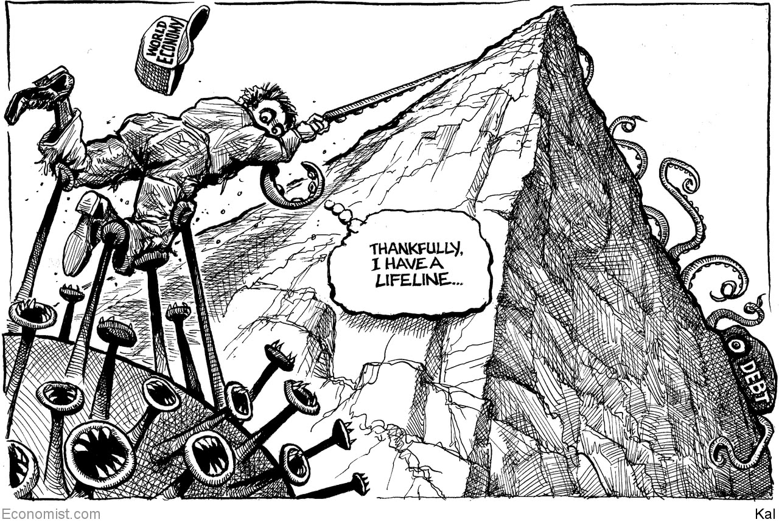

This article was downloaded by calibre from <https://www.economist.com/the-world-this-week/2020/05/02/kals-cartoon>

|  |  |  |  |
| --- | --- | --- | --- |
| Previous | Articles | Sections | Next |

|  |  |  |
| --- | --- | --- |
| The world this week | Sections | Letters |

Leaders

Life after lockdowns: The 90% economy

.

Covid-19 and the classroom: Open schools first

.

State and local governments: Unsteady states

.

Big tech and the crisis: West-coast shuffle

.

Disease and laboratories: The origins of the virus

.

|  |  |  |
| --- | --- | --- |
| The world this week | Sections | Letters |

|  |  |  |  |
| --- | --- | --- | --- |
|  | Articles | Sections | Next |

#### The 90% economy

# Life after lockdowns

It will be hard in ways that are difficult to imagine today

Apr 30th 2020 |

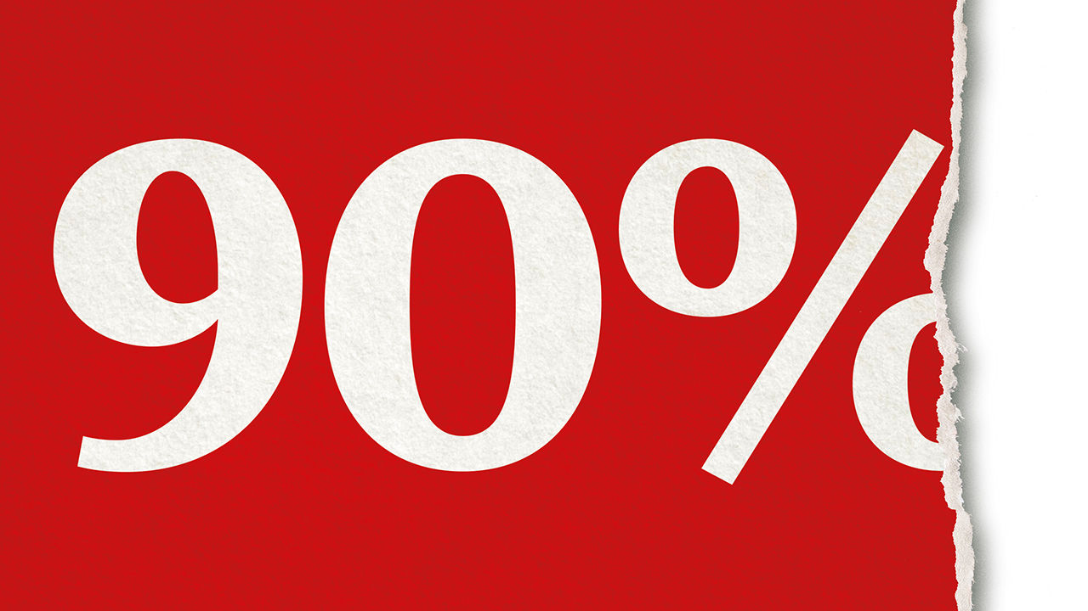

Editor’s note: The Economist is making some of its most important coverage of the covid-19 pandemic freely available to readers of The Economist Today, our daily newsletter. To receive it, register [here](https://www.economist.com/newslettersignup). For our coronavirus tracker and more coverage, see our [hub](https://www.economist.com/coronavirus)

IN MANY THINGS 90% is just fine; in an economy it is miserable, and China shows why. The country started to end its lockdown in February. Factories are busy and the streets are no longer empty. The result is the 90% economy. It is better than a severe lockdown, but it is far from normal. The missing bits include large chunks of everyday life. Rides on the metro and on domestic flights are down by a third. Discretionary consumer spending, on such things as restaurants, has fallen by 40% and hotel stays are a third of normal. People are weighed down by financial hardship and the fear of a second wave of covid-19. Bankruptcies are rising and unemployment, one broker has said, is three times the official level, at around 20%.

If the post-lockdown rich world suffers its own brand of the 90% economy, life will be hard—at least until a vaccine or a treatment is found (see Briefing). A plunge in GDP in America of anything like 10% would be the largest since the second world war. The more suffering covid-19 causes, the more profound and enduring its economic, social and political effects are likely to be.

How lockdowns ease will itself affect the scale of economic damage. For instance, the cost-benefit calculus points towards opening schools first (see article). But, however sensibly restrictions are eased, powerful forces will hold economies back.

For a start, leaving lockdown is a process, not an event. Even when the worst is over, cases ebb slowly. A month after Italy’s deaths peaked at about 900 a day, the toll is still over 300. With the virus still present, some social distancing is bound to stay.

A second reason is uncertainty. After lockdowns cease, much about the disease will remain unknown, including the chances of a second peak, whether immunity endures and the prospects for a vaccine or a cure. This inhibits those who fear the disease. Even as some states ease social distancing, a third of Americans say they would be uncomfortable visiting a mall. When Germany allowed small shops to open last week customers stayed away. Danes under lockdown cut household spending on services, such as travel and entertainment, by 80%. Danish economists reckon that people in next-door Sweden, which didn’t lock down, cut spending by about as much.

Many businesses will emerge from lockdown short of money, with strained balance-sheets and facing weak demand. In a survey for Goldman Sachs, almost two-thirds of American small-business owners said that their cash would run out in under three months. In Britain the share of commercial tenants who have fallen behind on their rent has risen by 30 percentage points. This week the boss of Boeing warned that air travel would not match the level of 2019 for two or three years. Investment, which accounts for roughly a quarter of GDP, will fall, not just to conserve cash, but also because risk cannot be priced (one reason to think a recent stockmarket rally has weak foundations).

Struggling firms will deepen people’s financial worries. Over a third of respondents in America told Pew Research that, if they lost their main source of income, their savings, new borrowings or the sale of assets would sustain them for no more than three months. Because the hardest-hit industries in the 90% economy employ a lot of low-wage people, joblessness will be high and casual work hard to come by. Even now in Europe’s five largest economies, over 30m workers, a fifth of the labour force, are in special schemes where the state pays their wages. These can be generous, but nobody knows how long they will last.

The economy will also suffer from scarring. Firms that adapt to covid-19 by cutting costs and finding new ways of working may increase productivity. But if people mix less after lockdowns lift or if they are idle for months on end, they will become detached from professional networks and may lose skills. America’s unemployed could face a lost decade (see Free exchange). Government schemes will save businesses in the short term, which is welcome. But those designed to preserve jobs risk eventually creating zombie firms that neither thrive nor go bankrupt, slowing the recycling of labour and capital.

The longer the world has to endure a 90% economy, the less likely it is to snap back after the pandemic. After the Spanish flu a century ago and SARS almost two decades ago, the overwhelming desire was for life to return to normal. But neither had such a large economic effect as covid-19, and citizens’ expectations of government were more modest in 1918 than they are today.

A deep, long recession will stoke anger, because the pandemic has held up an unflattering mirror to rich societies. Ill-run care homes for the elderly, high rates of death among minorities, the extra demands holding back working women and, especially in America, health care that is hard to reach for many, will all lead to calls for reform. So might the realisation that an unfair burden has fallen on ordinary people. Americans earning less than $20,000 a year are twice as likely to have lost their job to covid-19 as someone earning over $80,000. Much will depend on how fast they are rehired.

The popular demand for change could radicalise politics faster than it did after the financial crisis in 2007-09. The task for those who believe in open markets and limited government is to ensure that this energy is channelled towards the right sort of change. If the pandemic lowers the barrier to reform it will offer a rare chance to recast the social contract to favour those who have been shut out, and to peg back those who today enjoy entrenched privileges through the tax system, education and regulation. Perhaps the pandemic will enhance a sense of national and global solidarity. Perhaps the success of countries like Germany and Taiwan that have dealt with the disease thanks to strong institutions will contrast with places where populist showmen have spent their time theatrically deriding expertise.

Yet that may prove to be wishful thinking. In the next 18 months everyone with an agenda will argue that the pandemic proves their point. After 2007-09 politicians failed to deal with the grievances of ordinary people and the demand for change led to a surge in populism. The 90% economy threatens even greater suffering. The anger it creates may end up feeding protectionism, xenophobia and government interference on a scale not seen in decades. If, like this newspaper, that is an outcome you would reject, it is time to start arguing for something better. ■

Dig deeper:  
For our latest coverage of the covid-19 pandemic, register for The Economist Today, our daily [newsletter](https://www.economist.com/newslettersignup), or visit our [coronavirus tracker and story hub](https://www.economist.com/coronavirus)

This article was downloaded by calibre from <https://www.economist.com/leaders/2020/04/30/life-after-lockdowns>

|  |  |  |  |
| --- | --- | --- | --- |
|  | Articles | Sections | Next |

|  |  |  |  |
| --- | --- | --- | --- |
| Previous | Articles | Sections | Next |

#### The kids are not all right

# When easing lockdowns, governments should open schools first

The costs of keeping them closed are too high

Apr 30th 2020 |

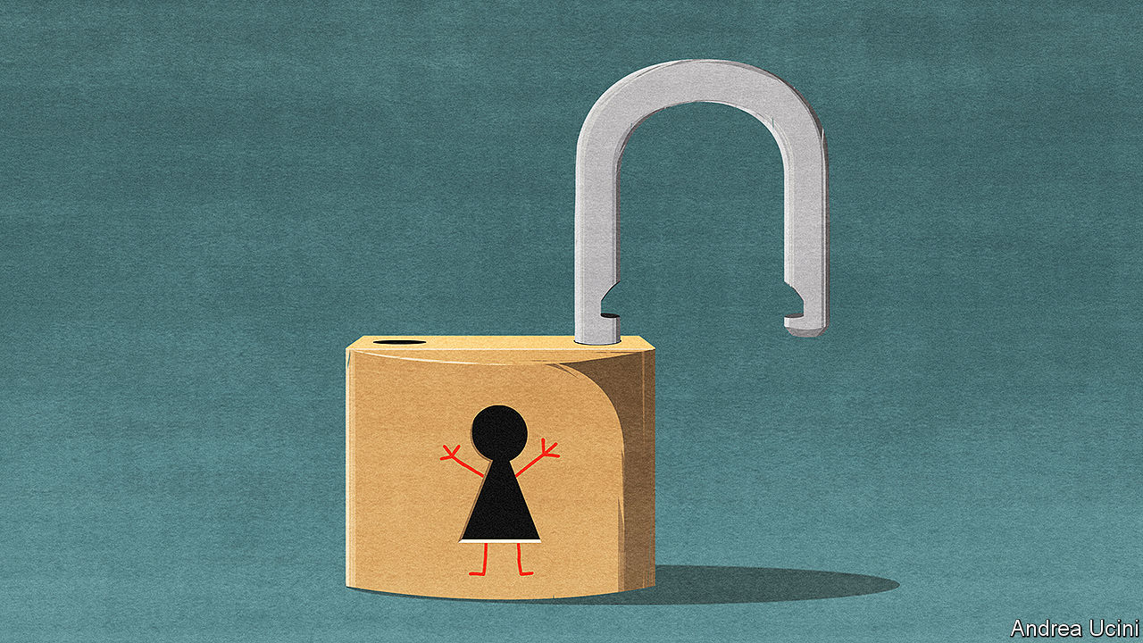

Editor’s note: The Economist is making some of its most important coverage of the covid-19 pandemic freely available to readers of The Economist Today, our daily newsletter. To receive it, register [here](https://www.economist.com/newslettersignup). For our coronavirus tracker and more coverage, see our [hub](https://www.economist.com/coronavirus)

COVID-19 HAS shut the world’s schools. Three in four children live in countries where all classrooms are closed. The disruption is unprecedented. Unless it ends soon, its effect on young minds could be devastating.

During some epidemics keeping children at home is wise; they are efficient spreaders of diseases such as seasonal flu. However, they appear to be less prone to catching and passing on covid-19. Closing schools may bring some benefit in slowing the spread of the disease, but less than other measures. Against this are stacked the heavy costs to children’s development, to their parents and to the economy (see article).

A few countries, such as Denmark, are gradually reopening schools. Others, including Italy, say they will not do so until the autumn. In America, despite recent calls from President Donald Trump for schools to open, most states plan to keep their classrooms closed for the rest of the academic year—and possibly longer. That is a mistake. As countries ease social distancing, schools should be among the first places to unlock.

Consider the costs of barring children from the classroom. No amount of helicopter parenting or videoconferencing can replace real-life teachers, or the social skills acquired in the playground. Even in the countries best prepared for e-learning, such as South Korea, virtual school is less good than the real thing.

Poorer children suffer most. Zoom lessons are little use if your home lacks good Wi-Fi, or if you have to fight with three siblings over a single phone. And whereas richer families often include well-educated parents who prod their offspring to do their homework and help when they get stuck, poorer families may not.

In normal times school helps level the playing field. Without it, the achievement gap between affluent and working-class children will grow. By one estimate, American eight-year-olds whose learning stopped altogether with the lockdown could lose nearly a year’s maths by autumn, as they fail to learn new material and forget much of what they already knew.

School matters for parents, too, especially those with young children. Those who work at home are less productive if distracted by loud wails and the eerie silence that portends jam being spread on the sofa. Those who work outside the home cannot do so unless someone minds their offspring. And since most child care is carried out by mothers, they will lose ground in the workplace while schools remain shut.

In poor countries the costs are even greater. Schools there often provide free lunches, staving off malnutrition, and serve as hubs for vaccinating children against other diseases. Pupils who stay at home now may never return. If the lockdown pushes their families into penury, they may have to go out to work. Better to re-open schools, so that parents can earn and children can study.

The obvious rejoinder is that shutting schools brings benefits. Covid-19 can be deadly. Parents do not want their children to catch it or to give it to grandma.

In fact, though children are highly susceptible to flu, covid-19 is different. Two studies from China that trace the contacts of infected people find that children are at worst no more likely to catch the disease than adults—and possibly less so. If they do get it, they are 2,000 times less likely than someone over 60 to die.

Nor is there evidence that children who do end up catching the disease are silent spreaders who pass it on to their families. Researchers in Iceland and the Netherlands have not found a single case in which a child brought the virus into their family. The European Centre for Disease Prevention and Control, the European Union’s public-health agency, said last week that child-to-adult transmission “appears to be uncommon”.

Some of these conclusions are based on small samples. Perhaps children have not been seen to transmit the disease because schools were shut early rather than because they pose no special threat. Perhaps they will start to spread it in the playground.

Schools should thus re-open in stages. The youngest children should return first, to crèches and primary schools. They have the thirstiest brains and seem to be the least at risk. They also demand the most of their parents, since few have grasped the principles of self-directed learning. Little children are unlikely to keep their distance from anyone. Classes should be split in half so that they can attend on alternate days.

Those facing exams should come next. Several countries have cancelled important tests; others have postponed them. Older students may be more at risk than the youngest ones but they are also more able to follow new protocols. Social distancing is possible in high schools, particularly if class sizes are reduced.

School openings will need to be monitored. Scientists should adjust the rules if necessary. Children who must stay at home should be contacted directly by the school. Teachers will need support. Those most vulnerable to infection, such as diabetics, should be able to teach remotely. The rest will need guidance on hygiene and social distancing. They should be tested regularly for covid-19.

Governments are understandably wary of being called bossy: no politician wants to give orders that may be widely disobeyed. France is considering reopening schools but making attendance voluntary. The trouble with this approach is that it may entrench educational inequality. A recent poll there suggests that 48% of well-off families would send their children back; only 17% of poor ones would. Under Britain’s lockdown, more than 500,000 vulnerable children have been allowed to go to school, including those with special needs; just 5% have turned up.

The best approach would be to apply attendance rules sensitively. Insist that education is compulsory, but don’t fine frightened parents willy-nilly—especially if they have extra reasons to fear infection. As classes return, parents will see that it is safe, and come round to the idea of sending their own children. Governments should help children make up for lost lessons with free summer schools, shorter holidays and longer school days.

Reopening schools may feel like a rash experiment with young lives. In fact it is an exercise in risk-balancing. Schools are the most powerful engines of social mobility in any society. Let the children in, and let them learn. ■

Dig deeper:  
For our latest coverage of the covid-19 pandemic, register for The Economist Today, our daily [newsletter](https://www.economist.com/newslettersignup), or visit our [coronavirus tracker and story hub](https://www.economist.com/coronavirus)

This article was downloaded by calibre from <https://www.economist.com/leaders/2020/04/30/when-easing-lockdowns-governments-should-open-schools-first>

|  |  |  |  |
| --- | --- | --- | --- |
| Previous | Articles | Sections | Next |

|  |  |  |  |
| --- | --- | --- | --- |
| Previous | Articles | Sections | Next |

#### State finances

# Congress, not the Fed, should bail out America’s state and local governments

The federal government can provide disaster relief without underwriting profligacy

May 2nd 2020 |

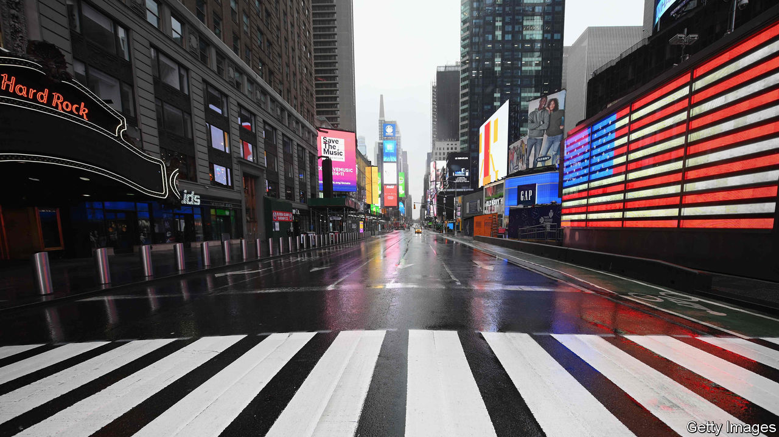

FOR MOST governments the pandemic is expensive. For America’s states, counties and cities, which provide the bulk of the country’s basic government services, it is a budgetary cataclysm. Lockdowns are depriving them of tax revenues just as they must spend more on public health, threatening budget shortfalls of more than one-quarter of annual revenues (see [article](https://www.economist.com/node/21785011)). Investors have been dumping their bonds, making it harder to borrow. And many states are in any case required by their constitution or by law to balance their budgets, or forbidden from borrowing at all. As a result many have been drawing up plans to slash spending and lay off workers just when their services are in high demand and the economy is shrinking.

The states do have some cash stashed away for a rainy day. They have built up funds worth 8% of their annual routine spending, on average. Yet that will not be nearly enough for today’s deluge, and in any case it is unevenly distributed. In 11 states, including hard-hit New York, rainy-day funds are less than 5% of spending. Infusions from the federal government are therefore the only way to avoid ill-timed austerity. The states could need as much as $650bn (3% of GDP) to cope with the economic crash—and more to help them fight the pandemic.

Help has so far been lacking. Congress has provided about $280bn and on April 22nd Mitch McConnell, the Republican leader of the Senate, suggested that states be allowed to go bankrupt (a route available to cities but not states). He has since walked back his statement, but President Donald Trump and many Republicans, complaining of poor government in Democrat-run states, say they do not want to reward recklessness.

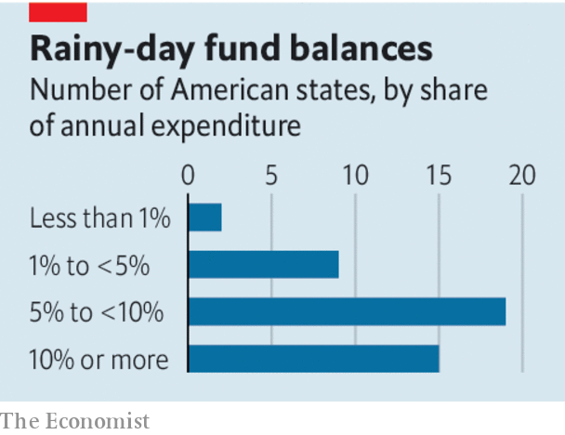

Their concerns are not empty. Many states have vast unfunded pension liabilities. In Connecticut, Illinois and California pension costs threaten to eat up over 10% of annual revenues. The problem is not limited to Democratic-leaning areas. In Mr McConnell’s state, Kentucky, one pension plan is only a sixth funded. It would be costly to create the impression that Congress will, in a downturn, bail out states and cities who live precariously. When local-government finances were shot in the 1830s, the federal government stayed on the sidelines for this reason. It was reluctant to intervene when New York City almost went bankrupt in the 1970s. But the pandemic is not the result of any state’s profligacy. Americans often share disaster risks nationally. Congress steps in when hurricanes or tornadoes strike. Making up tax shortfalls during lockdowns would benefit all states, not only those with extravagant pensions or bad management.

While Congress fails to act decisively, fighting the crisis has been left to the Federal Reserve. It is offering up to $500bn in loans to states, counties and cities. On April 27th it expanded eligibility to a total of 256 entities with sufficiently large populations and—at least until recently—high credit ratings.

The Fed’s loans, however, are both inadequate and undesirable. They are inadequate because bans on borrowing will restrict their uptake. They are undesirable because central banks are meant to be guardians of the financial system, not vehicles for disaster relief. The appeal of using the Fed is that it can act fast and keep costs off the government’s balance-sheet. Its $500bn of loans is underwritten by just $35bn provided by Congress to protect it against defaults. But the Fed cannot be indemnified against political risks. Its claims on state and local taxpayers will compete with those of pensioners and public-sector workers—an awkward position for an institution tasked with remaining above the fray. And the Fed has been insufficiently clear that its actions are in response to an extraordinary health emergency, rather than the new normal for fighting economic crises. That raises the risk of moral hazard.

Better for Congress to stump up. A bipartisan proposal to give a $500bn grant to states and local governments lies before lawmakers. Mr McConnell and his colleagues should pass it.■

This article was downloaded by calibre from <https://www.economist.com/leaders/2020/05/02/congress-not-the-fed-should-bail-out-americas-state-and-local-governments>

|  |  |  |  |
| --- | --- | --- | --- |
| Previous | Articles | Sections | Next |

|  |  |  |  |
| --- | --- | --- | --- |
| Previous | Articles | Sections | Next |

#### West-coast shuffle

# Big tech is thriving in the midst of the recession

Its centre of gravity is shifting, too

May 2nd 2020 |

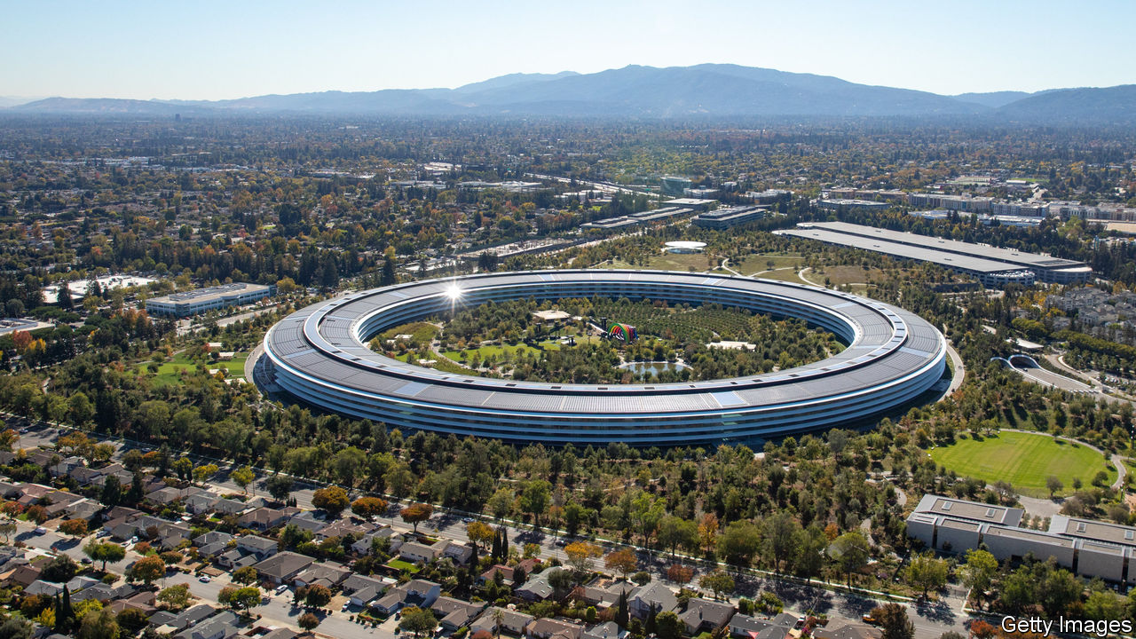

Editor’s note: The Economist is making some of its most important coverage of the covid-19 pandemic freely available to readers of The Economist Today, our daily newsletter. To receive it, register [here](https://www.economist.com/newslettersignup). For our coronavirus tracker and more coverage, see our [hub](https://www.economist.com/coronavirus)

THE TECHNOLOGY industry has never been more economically important. The biggest five Silicon Valley firms now make up about 20% of the value of the S&P 500 stockmarket index of big American companies. Yet until recently no one had much idea of how these vast, essential businesses would fare in an economic downturn. When the last slump started in 2007, Facebook was only four years old, Amazon was a twentieth of its size today, and Apple made more cash from Mac computers than from iPhones.

So how is big tech doing? An obvious—and frequently made—point is that the industry is thriving amid a savage recession as people spend more time on screens and work remotely. Look closer, however, and the picture is more complex. The industry is tilting away from business models that ruled in the past decade, towards a new era of subscriptions, e-commerce and business infrastructure. A simple way of putting it is that tech’s spiritual centre of gravity is moving from San Francisco to Seattle.

The level of pain being endured by more traditional big firms is hard to overstate. On April 29th Ford said that it would lose $5bn this quarter while Boeing is going through $4.7bn of cash every three months. Compared with that, the tech firms are on a roll. Alphabet, Google’s parent, saw sales rise by 13% in the first quarter compared with the year before, and profits reached $7bn. Facebook’s 3bn users are spending more time on its services. Microsoft, now the most valuable tech firm, booked profits of $10.8bn for the quarter.

Yet behind those figures are hints of vulnerability. Advertising revenue, the main source of income for Alphabet and Facebook, is under pressure. Google saw spending on search adverts drop by about 15% in March compared with the year before. Small-business clients, in particular, are forking out less as the recession bites. Another area of weakness may be smartphone sales, which are typically sold through retail stores and rely on fiddly supply chains. As The Economist went to press, Apple had yet to report, but both Samsung and Qualcomm, which make money from handsets, have warned that sales of devices may fall (see Schumpeter). Among firms that rely on human contact, meanwhile, there is a brutal shake-out. Lyft, a ride-sharing firm which went public a year ago, plans to fire 17% of its workforce.

Just as some of the ingredients that defined the previous era grow stale, new sources of growth are becoming clearer. Instead of bombarding consumers with advertising, subscriptions are booming. Netflix, a streaming giant, added 16m new subscribers in the quarter to March. Spotify, a music service, posted similar gains (it also reported a surge in listeners searching for “chill”). Microsoft is providing the crucial infrastructure for remote working, alongside new stars such as Zoom. And Amazon has shown that many countries cannot live without its cloud-computing arm, AWS, and its booming e-commerce operation.

## Heading north

The big firms that are less well positioned are adapting fast to this emerging new era. Facebook is rushing to beef up its video-call offering. Google is boosting its cloud-computing operation and, to stimulate demand, Apple is discounting phones and promoting its services arm. But for now the winners are Microsoft and Amazon, both based farther north on the Pacific Shelf, in Seattle. The crisis has illuminated big tech’s resilience—but also that the balance of power is shifting.■

Dig deeper:  
For our latest coverage of the covid-19 pandemic, register for The Economist Today, our daily [newsletter](https://www.economist.com/newslettersignup), or visit our [coronavirus tracker and story hub](https://www.economist.com/coronavirus)

This article was downloaded by calibre from <https://www.economist.com/leaders/2020/05/02/big-tech-is-thriving-in-the-midst-of-the-recession>

|  |  |  |  |
| --- | --- | --- | --- |
| Previous | Articles | Sections | Next |

|  |  |  |  |
| --- | --- | --- | --- |
| Previous | Articles | Sections | Next |

#### The origins of the pandemic

# Where did the novel coronavirus come from?

China’s opacity has allowed dangerous conspiracy theories to flourish

May 2nd 2020 |

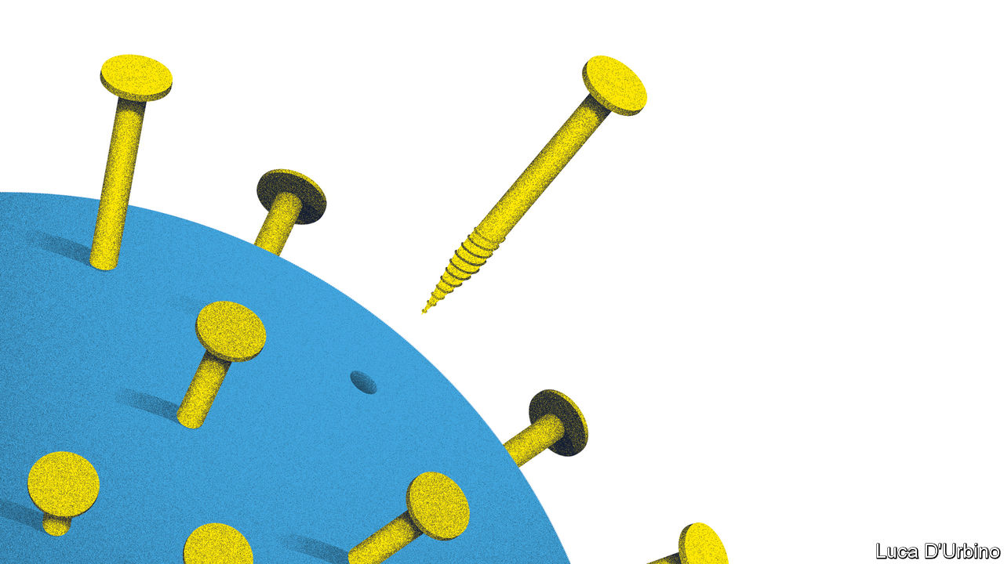

Editor’s note: The Economist is making some of its most important coverage of the covid-19 pandemic freely available to readers of The Economist Today, our daily newsletter. To receive it, register [here](https://www.economist.com/newslettersignup). For our coronavirus tracker and more coverage, see our [hub](https://www.economist.com/coronavirus)

WHERE DID it come from? After five months and over 225,000 deaths, the question is the subject of a vicious spat between America and China. By far the most likely explanation is that the virus jumped from bats to humans, perhaps via another animal such as a pangolin, at a wet market in Wuhan (see article). But conspiracy theorists mutter that the bug could have escaped from one of the city’s laboratories, at least two of which research into infectious diseases. Some American politicians, including President Donald Trump, want an investigation; China retorts that the claims are “malicious”. In March one of its spokesmen claimed the virus might have come from America. The row risks corroding public confidence in the crucial work disease laboratories do around the world. It is also a reminder of why China’s official culture of opacity and propaganda is such a profound weakness.

The virus shows no sign of deliberate human construction and there is no reason to doubt that it evolved entirely in the wild (see article). But accidents do happen. Bugs studied during legitimate experiments in laboratories have escaped in the past. SARS, a virus that killed 774 people in 2002-03, slipped out of a lab in Beijing twice in 2004. Foot-and-mouth disease, which required the culling of 6m animals in Britain in 2001, caused £8bn ($11.5bn) of damage. A sample later escaped from a research institute in 2007, but was contained. America suffered 34 laboratory-acquired infections in 2000-09, resulting in four deaths. American labs have accidentally shipped live anthrax, bird flu and Ebola to lower-security facilities in recent years. One health-security index suggests that three-quarters of countries score poorly on biosecurity.

Ending the dispute over covid’s origins is especially important because super-secure bio-labs are becoming more common. There are now around 70 “biosafety level-four” sites—designed to deal with fatal diseases lacking a cure or vaccine—in 30 countries. America has over a dozen. China has two, one at the Wuhan Institute of Virology, and plans to build up to five more by 2025. If handling pathogens is nerve-jangling stuff, tinkering with them is risky, too. One branch of research in particular is specifically aimed at making diseases even more dangerous—better at hopping between humans, for instance, or more resistant to antibiotics. Scientists at the Wuhan lab were engaging in such experiments, known as gain-of-function, in collaboration with American and Italian scientists.

It sounds creepy, but such work brings potential rewards, as scientists might understand better how a new disease might behave, aiding the development of drugs that could save many lives. As a result, it is crucial that governments around the world weigh the trade-offs involved in research, monitor breaches and encourage full transparency.

Sadly, policy has been going in the opposite direction. Since 2017 America has had a dedicated panel to scrutinise its own laboratories, but its membership and workings remain regrettably opaque. On April 27th America cut funding for a group conducting broader research into how bat coronaviruses jump to humans, seemingly because of its collaboration with scientists in Wuhan. China, meanwhile, has ramped up its campaign of propaganda and intimidation. It threatened a consumer boycott of Australian exports after Australia’s government proposed an independent global review into the origins of the crisis. And it bullied the European Union over an official report into Chinese disinformation about the virus, with officials saying its publication would “be very bad for co-operation” and make China “very angry”.

The world would be served by a clear account of how the virus made its way from bats to humans. Without one, conspiracy theories will flourish, jeopardising sensible scientific discovery. What is needed is rationality, co-operation and full transparency from all countries. Right now the world is getting the opposite.■

Dig deeper:  
For our latest coverage of the covid-19 pandemic, register for The Economist Today, our daily [newsletter](https://www.economist.com/newslettersignup), or visit our [coronavirus tracker and story hub](https://www.economist.com/coronavirus)

This article was downloaded by calibre from <https://www.economist.com/leaders/2020/05/02/where-did-the-novel-coronavirus-come-from>

|  |  |  |  |
| --- | --- | --- | --- |
| Previous | Articles | Sections | Next |

|  |  |  |
| --- | --- | --- |
| Leaders | Sections | Briefing |

Letters

Letters to the editor: On testing, stimulus, the three-day week, ancient Athens, coughing

.

|  |  |  |
| --- | --- | --- |
| Leaders | Sections | Briefing |

|  |  |  |  |
| --- | --- | --- | --- |
|  | Articles | Sections | Next |

#### On testing, stimulus, the three-day week, ancient Athens, coughing

# Letters to the editor

A selection of correspondence

May 2nd 2020 |

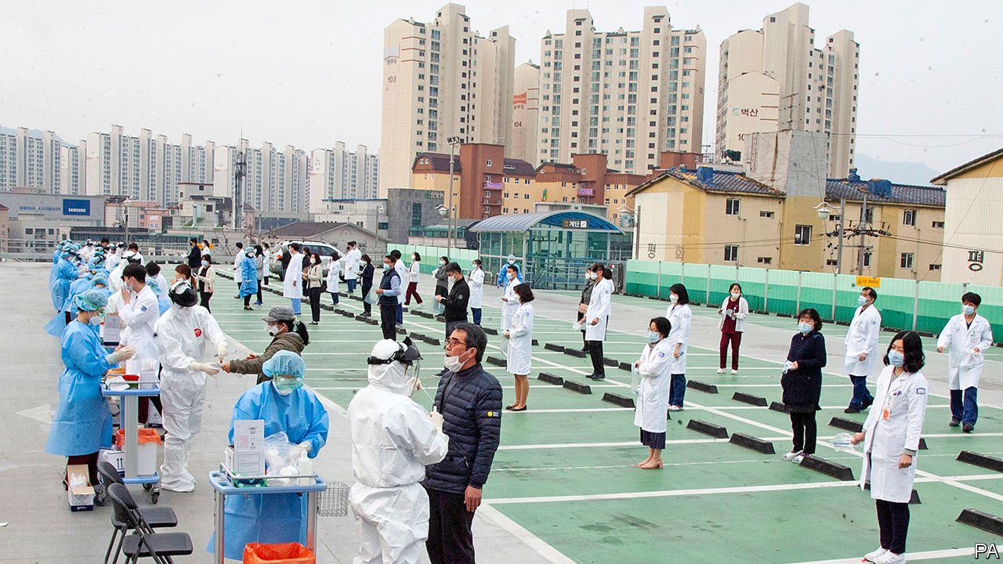

## Testing times

I was pleased that you placed the importance of testing at the heart of the response to the covid-19 pandemic (“[Tests of reason](https://www.economist.com/science-and-technology/2020/04/23/how-to-build-and-deploy-testing-systems-at-unprecedented-scale)”, April 25th). However, you did not mention the critical need to slow transmission of the disease in low-income countries with already fragile health systems. We need to do this if we are to achieve an effective exit, mitigate the economic disaster and ensure worldwide health security.

Effective testing strategies are the linchpin for saving lives and getting people back to work. This is especially true in countries where the economic impact threatens to increase extreme poverty for the first time since 1990. High and competing prices, broken supply chains and complex ordering systems have made it impossible for these countries to procure the tests they need in the global marketplace. FIND has been working closely with global bodies, particularly the World Health Organisation, in pushing for universal access to essential tests, accelerating the establishment of a Global Diagnostics Alliance to strengthen procurement systems, increase the availability of tests, reduce prices and build country capacity. As Bill Gates said in the same issue, wealthy nations must include poorer ones in their pandemic preparations (By invitation, “[Learning to fight the next pandemic](https://www.economist.com/by-invitation/2020/04/23/bill-gates-on-how-to-fight-future-pandemics)”, April 25th).

It is vital that public- and private-sector donors show up at the Coronavirus Global Response Summit on May 4th and pledge the funds needed for diagnostics and testing so that poor countries can increase their technical capacity and access simple, low-cost tests. This investment will not only address today’s crisis, but ensure long-term preparedness for future crises.

In a pandemic, no one is safe until everyone is safe.

MARK KESSEL  
Chairman  
Foundation for Innovative New Diagnostics (FIND)  
Geneva

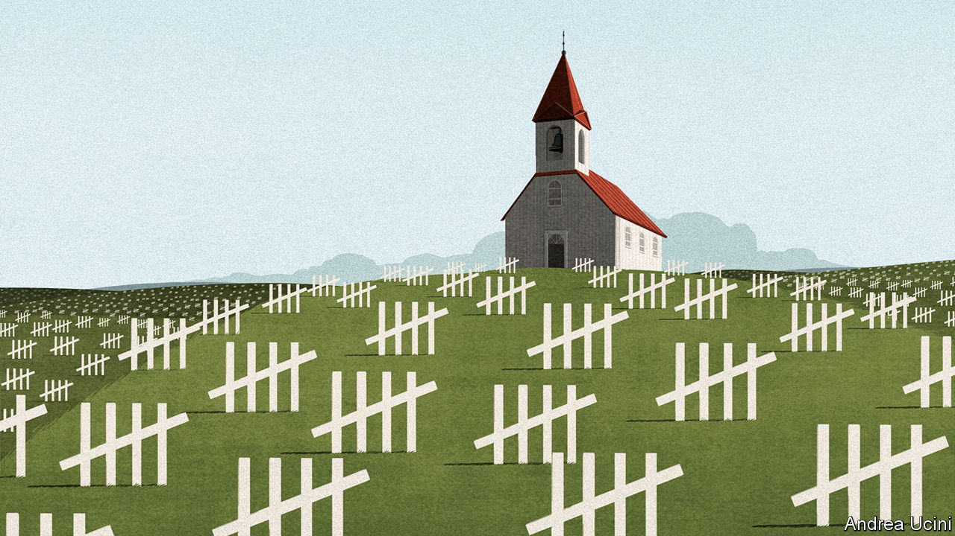

## Thinking about the future

Governments must consider how they will manage their finances after the pandemic (“[A grim calculus](https://www.economist.com/leaders/2020/04/02/covid-19-presents-stark-choices-between-life-death-and-the-economy)”, April 4th). Specifically, how do they return to a position that is sustainable for future generations? There are two tools available that governments often overlook. The first is to ensure public finances are managed with the quality of information that is routinely available in the corporate sector. Governments’ financial positions are far too complex to be managed using information that focuses almost exclusively on cashflows and debt. The second is to use both sides of the balance-sheet. Do not focus only on debt, but manage other liabilities, pensions for instance, and more importantly, manage assets. Recent work by the IMF makes it clear how important asset-management can be, contributing revenues potentially equivalent to 3% of GDP.

IAN BALL  
Professor of public financial management  
Victoria University of Wellington

Regarding stimulus, governments are, in fact, unable to create something from nothing. More than a decade of this predominant philosophy has left us unable to respond to a real crisis without doing untold damage to the next generation by piling on many more trillions in debt. The greatest free lunch of all is slashing interest rates, which takes resources from savers and gives them to borrowers in a bit of financial voodoo. Only by being candid about government’s role as redistributor rather than producer can we have an honest discussion about whether its new-found responsibility to fix every problem is a good thing.

GRANT LEWIS  
Reston, Virgina

There is a trade off of money versus lives. But what is the point of being alive if you can’t study, spend time with friends, or just enjoy the sound of water sloshing as you swim? Not everything has to go back to normal immediately, but we are all going to die, so the real question is whether we’re going to live?

TONY BRUGUIER  
Milpitas, California

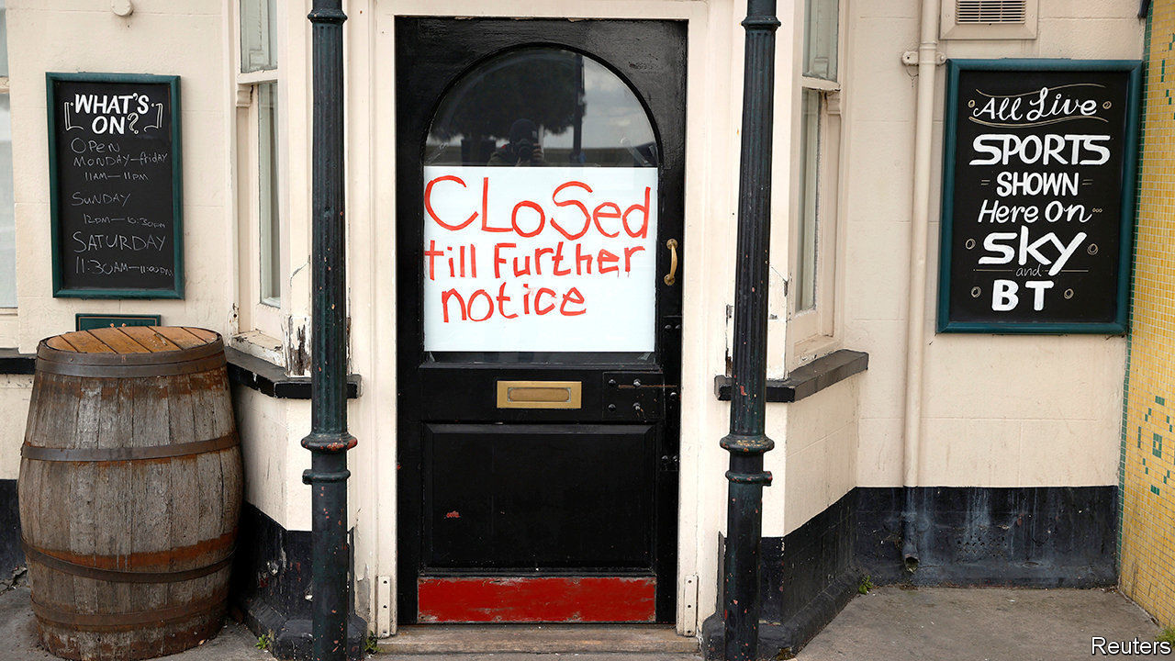

## When the pubs were closed

There may be some readers, like me, old enough to remember Britain’s three-day week, another event when “record-breaking bad economic news” came flooding in ([“Over the cliff edge](https://www.economist.com/britain/2020/04/11/covid-19-causes-britains-fastest-economic-contraction-on-record)”, April 11th). In early 1974, against the background of an oil crisis and strikes, the government introduced a limited working week to conserve energy. On the first day 885,000 people registered as unemployed. ITV and the BBC took turns on alternate days to broadcast. Most pubs were shut and queues formed outside shops. Half of the country’s streetlights were turned off and heating in commercial and public buildings reduced. Power cuts were common.

Despite the most drastic restructuring of the economy since the second world war, British industry showed remarkable resilience. In the first quarter of that year consumer spending only fell slightly, in part because of a significant increase in alcohol consumption. Nearly every economist of the day predicted a 40% drop in production to match the 40% reduction in working hours, but in the event the loss of production was less than 20% and probably closer to 10%. British industry managed this with the co-operation of British workers, who managed to cram a lot more than three days’ production into three working days through a huge increase in productivity. The long-term impact on the economy was negligible. This may have been by way of a national coming together, or it may have been by way of self-preservation, employees protecting the precious three days’ work they still had.

Today’s economic background is a lot more positive than it was in 1974. The government’s furlough and loan schemes should hopefully help businesses get through.

FRANCIS MAGUIRE  
New Malden, Surrey

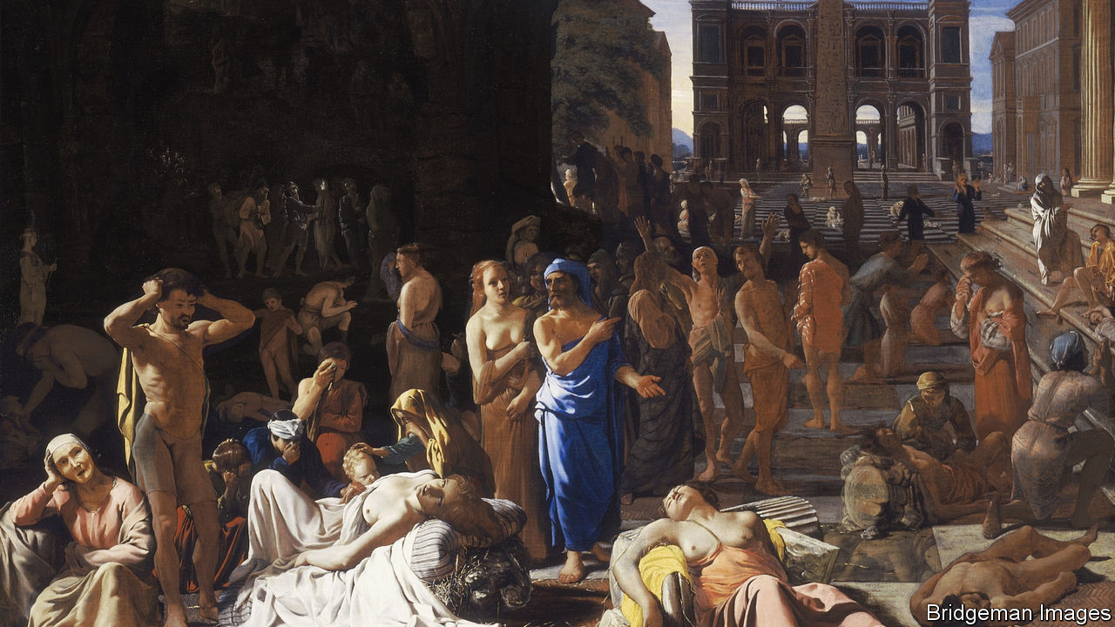

## Learning from the classics

Although the jury may be out on how the Plague of Athens affected ancient democracy, or indeed, how today’s pandemic will affect our own, there are uncanny parallels between Athenian politics and ours (“[How to survive a plague](https://www.economist.com/books-and-arts/2020/03/26/when-athenians-feared-a-disease-would-wreck-their-democracy)”, March 28th). Thucydides remarked that the political leaders of Athens:

stopping at nothing in their struggles for ascendancy, engaged in direct excesses. In their acts of vengeance they went to even greater lengths, not limiting them to what justice or the good of the state demanded, but making the party caprice of the moment their only standard.

He added, in what would not feel out of place today, “In this contest the blunter of the wits were most successful.”

Your article provided cold comfort that, following the plague, Athens “rumbled on, more or less democratically, for another eight decades”. Such a decline, if repeated today, could take place entirely within my children’s lifetime.

JEREMY KUHRE  
Irvine, California

## Covid humour

Reading about the abundance of Dutch swear words that relate to disease ([Letters](https://www.economist.com/letters/2020/04/18/letters-to-the-editor), April 18th) reminded me of a saying that my mum, who grew up in London, was fond of: “It’s not the cough that carries you off, it’s the coffin they carries you off in.” Dry (cough) humour indeed.

SCOTT SWINK  
Los Gatos, California

This article was downloaded by calibre from <https://www.economist.com/letters/2020/05/02/letters-to-the-editor>

|  |  |  |  |
| --- | --- | --- | --- |
|  | Articles | Sections | Next |

|  |  |  |
| --- | --- | --- |
| Letters | Sections | United States |

Briefing

The post-covid economy: Not quite all there

.

Debt in developing countries: Next in line

.

|  |  |  |
| --- | --- | --- |
| Letters | Sections | United States |

|  |  |  |  |
| --- | --- | --- | --- |
|  | Articles | Sections | Next |

#### Not quite all there

# The 90% economy that lockdowns will leave behind

It will not just be smaller, it will feel strange

Apr 30th 2020 |

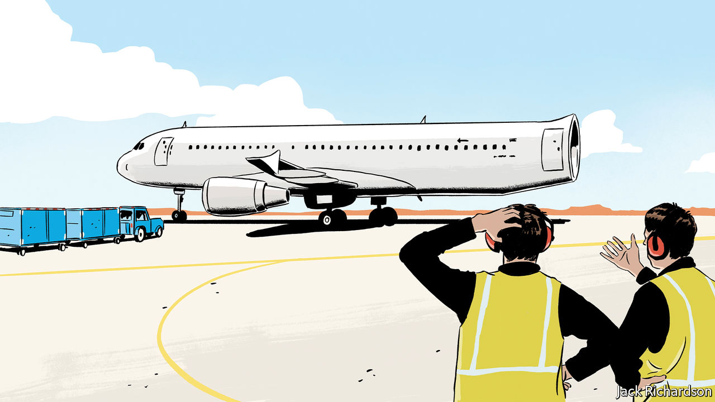

Editor’s note: The Economist is making some of its most important coverage of the covid-19 pandemic freely available to readers of The Economist Today, our daily newsletter. To receive it, register [here](https://www.economist.com/newslettersignup). For our coronavirus tracker and more coverage, see our [hub](https://www.economist.com/coronavirus)

IN THE 1970s Masahiro Mori, a professor at the Tokyo Institute of Technology, observed that there was something disturbing about robots which looked almost, but not quite, like people. Representations in this “uncanny valley” are close enough to lifelike for their shortfalls and divergences from the familiar to be particularly disconcerting. Today’s Chinese economy is exploring a similarly unnerving new terrain. And the rest of the world is following in its uncertain steps.

Whatever the drawbacks of these new lowlands, they are assuredly preferable to the abyss of lockdown. Measures taken to reverse the trajectory of the pandemic around the world have brought with them remarkable economic losses.

Not all sectors of the economy have done terribly. New subscriptions to Netflix increased at twice their usual rate in the first quarter of 2020, with most of that growth coming in March. In America, the sudden stop of revenue from Uber’s ride-sharing service in March and April has been partially cushioned by the 25% increase of sales from its food-delivery unit, according to 7Park Data, a data provider.

Yet the general pattern is grim. Data from Womply, a firm which processes transactions on behalf of 450,000 small businesses across America, show that businesses in all sectors have lost substantial revenue. Restaurants, bars and recreational businesses have been badly hit: revenues have declined some two-thirds since March 15th. Travel and tourism may suffer the worst losses. In the EU, where tourism accounts for some 4% of GDP, the number of people travelling by plane fell from 5m to 50,000; on April 19th less than 5% of hotel rooms in Italy and Spain were occupied.

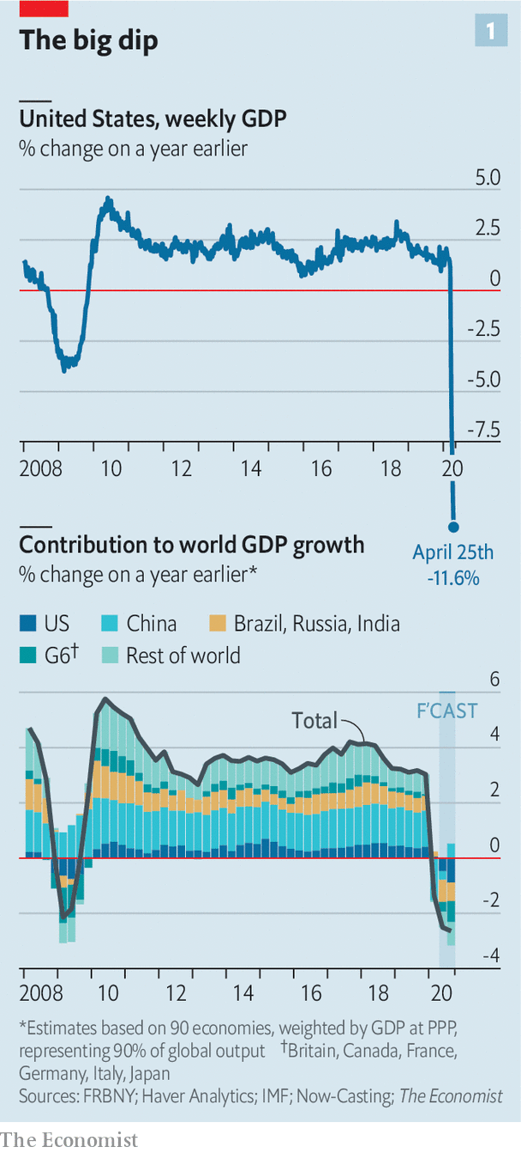

According to calculations made on behalf of The Economist by Now-Casting Economics, a research firm that provides high-frequency economic forecasts to institutional investors, the world economy shrank by 1.3% year-on-year in the first quarter of 2020, driven by a 6.8% year-on-year decline in China’s GDP. The Federal Reserve Bank of New York draws on measures such as jobless claims to produce a weekly index of American economic output. It suggests that the country’s GDP is currently running about 12% lower than it was a year ago (see chart 1).

These figures fit with attempts by Goldman Sachs, a bank, to estimate the relationship between the severity of lockdowns and their effect on output. It finds, roughly, that an Italian-style lockdown is associated with a GDP decline of 25%. Measures to control the virus while either keeping the economy running reasonably smoothly, as in South Korea, or reopening it, as in China, are associated with a GDP reduction in the region of 10%. That chimes with data which suggest that if Americans chose to avoid person-to-person proximity of the length of an arm or less, occupations worth approximately 10% of national output would become unviable.

The “90% economy” thus created will be, by definition, smaller than that which came before. But its strangeness will be more than a matter of size. There will undoubtedly be relief, fellow feeling, and newly felt or expressed esteem for those who have worked to keep people safe. But there will also be residual fear, pervasive uncertainty, a lack of innovative fervour and deepened inequalities. The fraction of life that is missing will colour people’s experience and behaviour in ways that will not be offset by the happy fact that most of what matters is still available and ticking over. In a world where the office is open but the pub is not, qualitative differences in the way life feels will be at least as significant as the drop in output.

The plight of the pub demonstrates that the 90% economy will not be something that can be fixed by fiat. Allowing pubs—and other places of social pleasure—to open counts for little if people do not want to visit them. Many people will have to leave the home in order to work, but they may well feel less comfortable doing so to have a good time. A poll by YouGov on behalf of The Economist finds that over a third of Americans think it will be “several months” before it will be safe to reopen businesses as normal—which suggests that if businesses do reopen some, at least, may stay away.

## Ain’t nothing but tired

Some indication that the spending effects of a lockdown will persist even after it is over comes from Sweden. Research by Niels Johannesen of Copenhagen University and colleagues finds that aggregate-spending patterns in Sweden and Denmark over the past months look similarly reduced, even though Denmark has had a pretty strict lockdown while official Swedish provisions have been exceptionally relaxed. This suggests that personal choice, rather than government policy, is the biggest factor behind the drop. And personal choices may be harder to reverse.

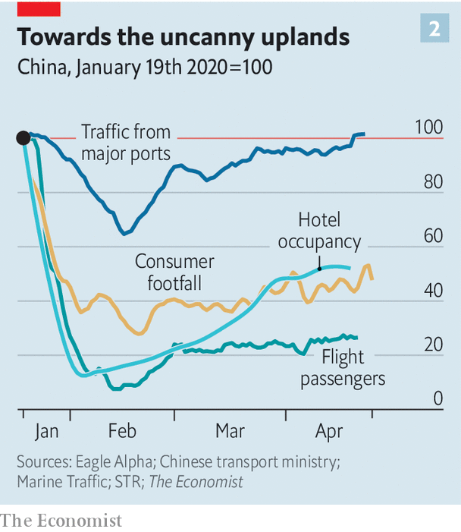

Discretionary spending by Chinese consumers—the sort that goes on things economists do not see as essentials—is 40% off its level a year ago. Haidilao, a hotpot chain, is seeing a bit more than three parties per table per day—an improvement, but still lower than the 4.8 registered last year, according to a report by Goldman Sachs published in mid-April. Breweries are selling 40% less beer. STR, a data-analytics firm, finds that just one-third of hotel beds in China were occupied during the week ending April 19th. Flights remain far from full (see chart 2).

This less social world is not necessarily bad news for every company. UBS, a bank, reports that a growing number of people in China say that the virus has increased their desire to buy a car—presumably in order to avoid the risk of infection on public transport. The number of passengers on Chinese underground trains is still about a third below last year’s level; surface traffic congestion is as bad now as it was then.

Wanting a car, though, will not mean being able to afford one. Drops in discretionary spending are not entirely driven by a residual desire for isolation. They also reflect the fact that some people have a lot less money in the post-lockdown world. Not all those who have lost jobs will quickly find new ones, not least because there is little demand for labour-intensive services such as leisure and hospitality. Even those in jobs will not feel secure, the Chinese experience suggests. Since late March the share of people worried about salary cuts has risen slightly, to 44%, making it their biggest concern for 2020, according to Morgan Stanley, a bank. Many are now recouping the loss of income that they suffered during the most acute phase of the crisis, or paying down debt. All this points to high saving rates in the future, reinforcing low consumption.

A 90% economy is, on one level, an astonishing achievement. Had the pandemic struck even two decades ago, only a tiny minority of people would have been able to work or satisfy their needs. Watching a performance of Beethoven on a computer, or eating a meal from a favourite restaurant at home, is not the same as the real thing—but it is not bad. The lifting of the most stringent lockdowns will also provide respite, both emotionally and physically, since the mere experience of being told what you can and cannot do is unpleasant. Yet in three main ways a 90% economy is a big step down from what came before the pandemic. It will be more fragile; it will be less innovative; and it will be more unfair.

Take fragility first. The return to a semblance of normality could be fleeting. Areas which had apparently controlled the spread of the virus, including Singapore and northern Japan, have imposed or reimposed tough restrictions in response to a rise in the growth rate of new infections. If countries which retain relatively tough social-distancing rules do better at staving off a viral comeback, other countries may feel a need to follow them (see Chaguan). With rules in flux, it will feel hard to plan weeks ahead, let alone months.

## Can’t start a fire

The behaviour of the economy will be far less predictable. No one really knows for how long firms facing zero revenues, or households who are working reduced hours or not at all, will be able to survive financially. Businesses can keep going temporarily, either by burning cash or by tapping grants and credit lines set up by government—but these are unlimited neither in size nor duration. What is more, a merely illiquid firm can quickly become a truly insolvent one as its earnings stagnate while its debt commitments expand. A rise in corporate and personal bankruptcies, long after the apparently acute phase of the pandemic, seems likely, though governments are trying to forestall them. In the past fortnight bankruptcies in China started to rise relative to last year. On April 28th HSBC, one of the world’s largest banks, reported worse-than-expected results, in part because of higher credit losses.

Furthermore, the pandemic has upended norms and conventions about how economic agents behave. In Britain the share of commercial tenants who paid their rent on time fell from 90% to 60% in the first quarter of this year. A growing number of American renters are no longer paying their landlords. Other creditors are being put off, too. In America, close to 40% of business-to-business payments from firms in the spectator-sports and film industries were late in March, double the rate a year ago. Enforcing contracts has become more difficult with many courts closed and social interactions at a standstill. This is perhaps the most insidious means by which weak sectors of the economy will infect otherwise moderately healthy ones.

In an environment of uncertain property rights and unknowable income streams, potential investment projects are not just risky—they are impossible to price. A recent paper by Scott Baker of Northwestern University and colleagues suggests that economic uncertainty is at an all-time high. That may go some way to explaining the results of a weekly survey from Moody’s Analytics, a research firm, which finds that businesses’ investment intentions are substantially lower even than during the financial crisis of 2007-09. An index which measures American nonresidential construction activity 9-12 months ahead has also hit new lows.

The collapse in investment points to the second trait of the 90% economy: that it will be less innovative. The development of liberal capitalism over the past three centuries went hand in hand with a growth in the number of people exchanging ideas in public or quasi-public spaces. Access to the coffeehouse, the salon or the street protest was always a partial process, favouring some people over others. But a vibrant public sphere fosters creativity.

Innovation is not impossible in a world with less social contact. There is more than one company founded in a garage now worth $1trn. During lockdowns, companies have had to innovate quickly—just look at how many firms have turned their hand to making ventilators, if with mixed success. A handful of firms claim that working from home is so productive that their offices will stay closed for good.

Yet these productivity bonuses look likely to be heavily outweighed by drawbacks. Studies suggest the benefits of working from home only materialise if employees can frequently check in at an office in order to solve problems. Planning new projects is especially difficult. Anyone who has tried to bounce ideas around on Zoom or Skype knows that spontaneity is hard. People are often using bad equipment with poor connections. Nick Bloom of Stanford University, one of the few economists to have studied working from home closely, reckons that there will be a sharp decline in patent applications in 2021.

Cities have proven particularly fertile ground for innovations which drive long-run growth. If Geoffrey West, a physicist who studies complex systems, is right to suggest that doubling a city’s population leads to all concerned becoming on aggregate 15% richer, then the emptying-out of urban areas is bad news. MoveBuddha, a relocation website, says that searches for places in New York City’s suburbs are up almost 250% compared with this time last year. A paper from New York University suggests that richer, and thus presumably more educated, New Yorkers—people from whom a disproportionate share of ideas may flow—are particularly likely to have left during the epidemic.

## Something happening somewhere

Wherever or however people end up working, the experience of living in a pandemic is not conducive to creative thought. How many people entered lockdown with a determination to immerse themselves in Proust or George Eliot, only to find themselves slumped in front of “Tiger King”? When mental capacity is taken up by worries about whether or not to touch that door handle or whether or not to believe the results of the latest study on the virus, focusing is difficult. Women are more likely to take care of home-schooling and entertainment of bored children (see article), meaning their careers suffer more than men’s. Already, research by Tatyana Deryugina, Olga Shurchkov and Jenna Stearns, three economists, finds that the productivity of female economists, as measured by production of research papers, has fallen relative to male ones since the pandemic began.

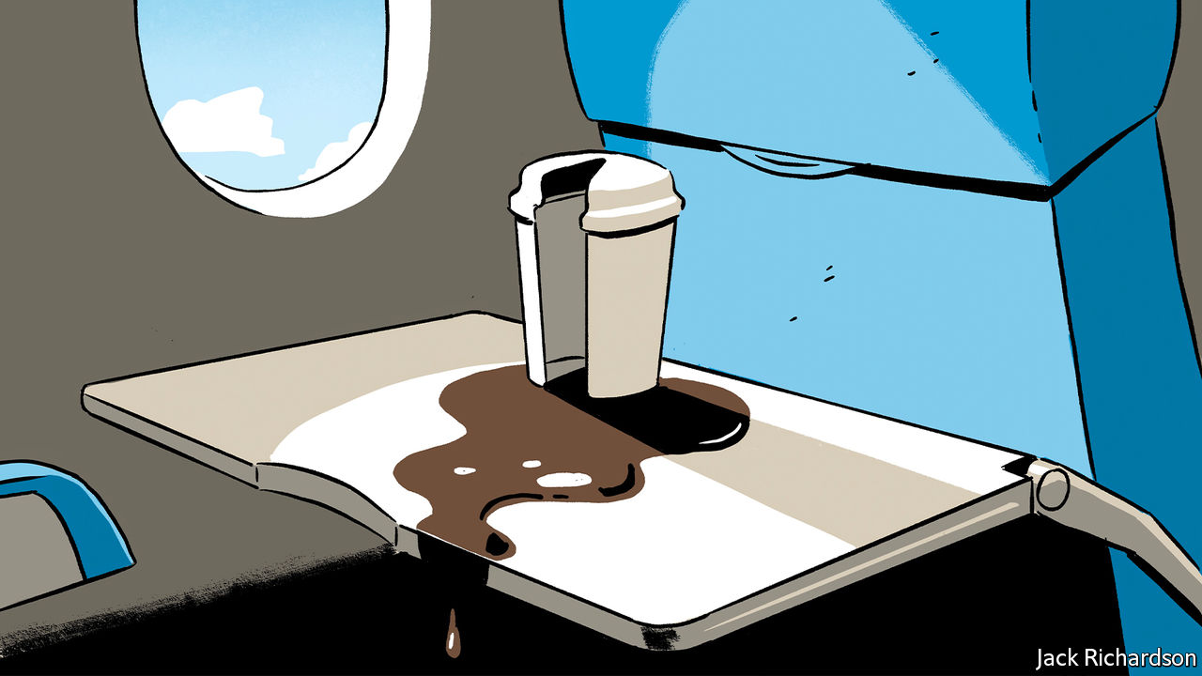

The growing gender divide in productivity points to the final big problem with the 90% economy: that it is unfair. Liberally regulated economies operating at full capacity tend to have unemployment rates of 4-5%, in part because there will always be people temporarily unemployed as they move from one job to another. The new normal will have higher joblessness. This is not just because GDP will be lower; the decline in output will be particularly concentrated in labour-intensive industries such as leisure and hospitality, reducing employment disproportionately. America’s current unemployment rate, real-time data suggest, is between 15-20%.

The lost jobs tended to pay badly, and were more likely to be performed by the young, women and immigrants. Research by Abi Adams-Prassl of Oxford University and colleagues finds that an American who normally earns less than $20,000 a year is twice as likely to have lost their job due to the pandemic as one earning $80,000-plus. Many of those unlucky people do not have the skills, nor the technology, that would enable them to work from home or to retrain for other jobs.

The longer the 90% economy endures, the more such inequalities will deepen. People who already enjoy strong professional networks—largely, those of middle age and higher—may actually quite enjoy the experience of working from home. Notwithstanding the problems of bad internet and irritating children, it may be quite pleasant to chair fewer meetings or performance reviews. Junior folk, even if they make it into an office, will miss out on the expertise and guidance of their seniors. Others with poor professional networks, such as the young or recently arrived immigrants, may find it difficult or impossible to strengthen them, hindering upward mobility, points out Tyler Cowen of George Mason University.

The world economy that went into retreat in March as covid-19 threatened lives was one that looked sound and strong. And the biomedical community is currently working overtime to produce a vaccine that will allow the world to be restored to its full capacity. But estimates suggest that this will take at least another 12 months—and, as with the prospects of the global economy, that figure is highly uncertain. If the adage that it takes two months to form a habit holds, the economy that re-emerges will be fundamentally different. ■

Dig deeper:  
For our latest coverage of the covid-19 pandemic, register for The Economist Today, our daily [newsletter](https://www.economist.com/newslettersignup), or visit our [coronavirus tracker and story hub](https://www.economist.com/coronavirus)

This article was downloaded by calibre from <https://www.economist.com/briefing/2020/04/30/the-90-economy-that-lockdowns-will-leave-behind>

|  |  |  |  |
| --- | --- | --- | --- |
|  | Articles | Sections | Next |

|  |  |  |  |
| --- | --- | --- | --- |
| Previous | Articles | Sections | Next |

#### Next in line

# Which emerging markets are in most financial peril?

Our ranking of 66 countries shows which are in distress, and which are relatively safe

May 2nd 2020 | HONG KONG

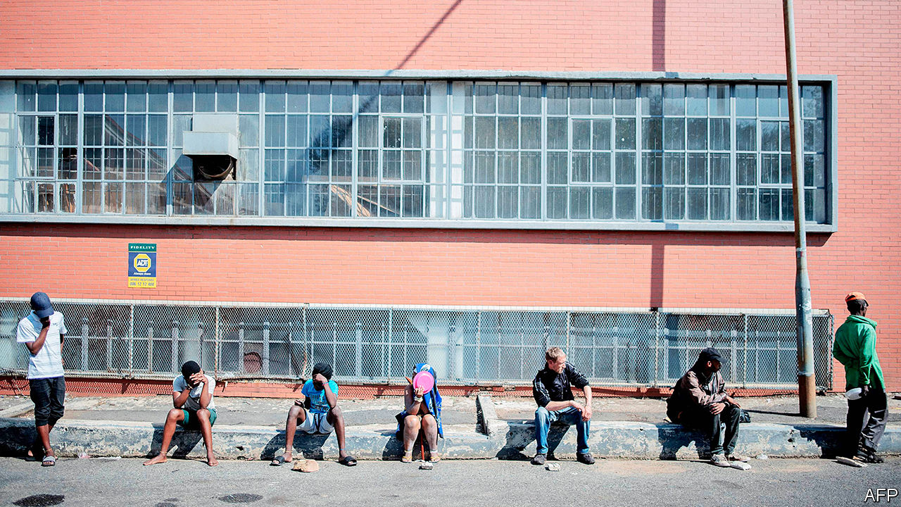

Editor’s note: The Economist is making some of its most important coverage of the covid-19 pandemic freely available to readers of The Economist Today, our daily newsletter. To receive it, register [here](https://www.economist.com/newslettersignup). For our coronavirus tracker and more coverage, see our [hub](https://www.economist.com/coronavirus)

WHAT TO WEAR? The question puzzles many people shaken out of their routines by the pandemic. It also troubles investors. The world is full of “dirty shirts”, as Bill Gross, a legendary bond trader, once put it, when contemplating the bonds on offer from heavily indebted governments. But you have to wear something. Thus many investors buy Treasuries, despite America’s less-than-sparkling public finances, because it is the “least dirty shirt”.

The grubbiest garments are found elsewhere—among the world’s emerging markets. They collectively owe $17trn of government debt, 24% of the global total. Eighteen of them have had their credit ratings cut in 2020 so far by Fitch, more than in the whole of any previous year. Argentina has missed a $500m payment on its foreign bonds. If it cannot persuade creditors to swap their securities for less generous ones by May 22nd, it will be in default for the ninth time in its history. The laundry pile also includes Ecuador, which has postponed $800m of bond payments for four months to help it cope with the pandemic; Lebanon, which defaulted on a $1.2bn bond in March; and Venezuela, which owes barrelfuls of cash (and crude oil) to its bondholders, bankers and geopolitical benefactors in China and Russia. These defaulters may soon be joined by Zambia, which is seeking to hire advisers for a “liability-management exercise”, an agreement to pay creditors somewhat less, somewhat later than it promised (see article).

As the pandemic wreaks havoc on economies and public finances, the natural question is: who’s next? More than 100 countries, including South Africa, have asked the IMF for help. It has already approved 40 of the quick, small loans it provides after natural disasters. Some countries are repeat customers. Egypt is also seeking a new bail-out only nine months after it drew down the final instalment of a loan agreed on in 2016.

When the virus first jolted financial markets, the threat of a full-blown emerging-market crisis loomed. Since January foreign investors have withdrawn about $100bn from emerging-market bonds and shares, according to the Institute of International Finance (IIF), a banking association. That is over three times what they yanked out over an equivalent period of the global financial crisis (although these numbers do not cover all capital flows, and emerging economies have grown significantly since 2008).

The sense of panic has since begun to abate. The Federal Reserve’s swap lines to 14 central banks—including those of Brazil, Mexico and South Korea—have helped ease a global dollar shortage. Capital outflows have subsided and emerging-market bond yields have fallen. This tentative reprieve invites a more discriminating assessment of emerging-market finances. The Economist has ranked 66 countries using four indicators of financial strength (see chart). Some, such as Russia, Peru and the Philippines, look relatively robust. About 30 are in distress, or flirting with it. The alphabet of alarm runs from Angola to Zambia. But these 30 account for a relatively small share of the group’s debt and GDP.

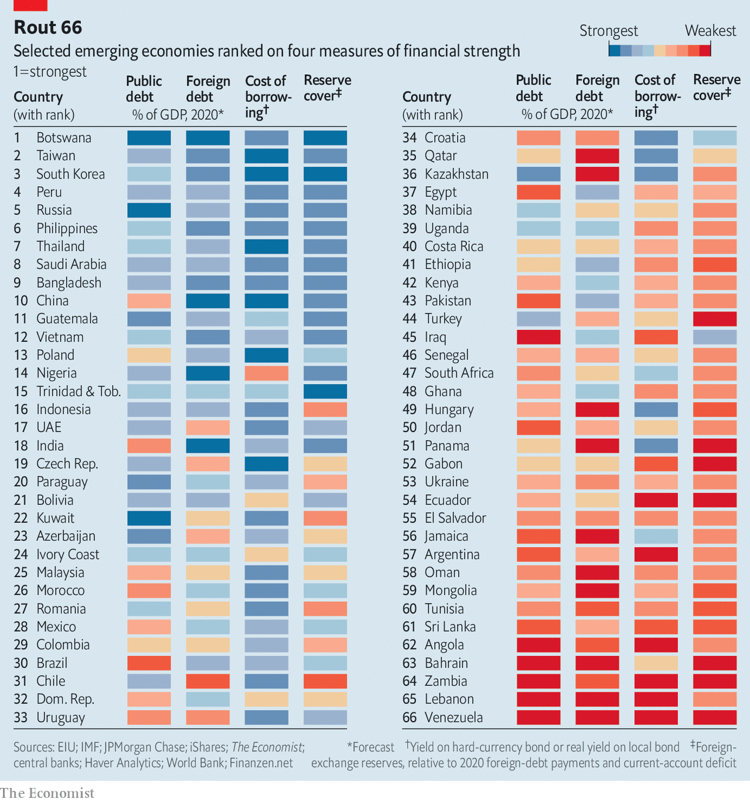

Covid-19 hurts emerging economies in at least three ways: by locking down their populations, damaging their export earnings and deterring foreign capital. Even if the pandemic fades in the second half of the year, GDP in developing countries, measured at purchasing-power parity, will be 6.6% smaller in 2020 than the IMF had forecast in October.

The damage to exports will be acute. Thanks to low oil prices, Gulf oil exporters will suffer a current-account deficit of over 3% of GDP this year, the IMF reckons, compared with a 5.6% surplus last year. When exports fall short of imports, countries typically bridge the gap by borrowing from abroad. But the reversal of capital inflows has been matched by higher borrowing costs. In March the risk premium that emerging markets must pay buyers of their dollar bonds rose to distressed levels (over ten percentage points) for nearly 20 governments—a record number, says the IMF.

To weather the crisis, emerging economies may need at least $2.5trn, the fund reckons, from foreign sources or their own reserves. One way to ensure countries have more hard currency is to stop taking it from them. The G20 group of governments has said it will refrain from collecting payments this year on its loans to the poorest 77 countries (though the borrowers will have to make up the difference later). The G7 group of countries has urged private lenders to show forbearance too. A group of over 70 private creditors supports the idea, while noting its “complexity” and the “constraints” lenders face.

A sweeping debt standstill may also be less necessary than it seemed even two weeks ago, as investors have calmed somewhat. That may reflect over-optimism about the course of the pandemic. But even false optimism can be of true help to emerging markets, by allowing them to refinance debt on affordable terms.

The relative calm also allows for a more discerning look at emerging-market strains. Some have wide fiscal or external deficits; others have high debts. In some the weak link is the government; elsewhere it is the private sector. Debt may be largely domestic, or it may be owed to foreigners—and sometimes in foreign currency, too.

Our ranking examines 66 economies across four potential sources of peril. These include public debt, foreign debt (both public and private) and borrowing costs (proxied where possible by the yield on a government’s dollar bonds). We also calculate their likely foreign payments this year (their current-account deficit plus their foreign-debt payments) and compare this with their stock of foreign-exchange reserves. A country’s rank on each of these indicators is then averaged to determine its overall standing.

The strongest countries, such as South Korea and Taiwan, are overqualified for the role of emerging markets. Many bigger economies, including Russia and China, also appear robust. Most of the countries that score badly across our indicators tend to be small. The bottom 30 account for only 11% of the group’s GDP, and less than a quarter of both its foreign and its public debt.

The ranking also reveals the vast differences in the source and scale of potential weaknesses. Countries like Angola, Bahrain and Iraq have public debt that some reckon will exceed 100% of GDP this year. But about half of the economies we examine have debts below 60% of GDP, the threshold that euro-zone members are supposed to meet (and which few do).

The Asian financial crisis of 1997 showed that strong public finances are not enough to protect an emerging economy if private firms borrow heavily abroad. Mongolia’s public debt looks manageable (less than 70% of GDP) but its foreign debt (public and private) is almost twice GDP. Conversely, the well-known fiscal frailties of Brazil and India are mostly confined within their own borders.

Bond yields, meanwhile, show how costly foreign borrowing will be. Sixteen of the economies in our group must offer yields of over 10% on their existing dollar bonds to find takers. But over 20 have hard-currency bonds yielding less than 4%, the kind of cheap finance that used to be the preserve of rich countries. Some, like Botswana, have no dollar bonds at all, preferring to borrow in their own currency.

Over the course of 2020, the 66 economies in our exercise will have to find over $4trn to service their foreign debt and cover any current-account deficits. Excluding China, the figure is $2.9trn. But this leaves out the buffers that emerging economies have accumulated. The governments in our exercise hold over $8trn in foreign-exchange reserves (or almost $5trn, excluding China). Half have enough reserves to cover all of their foreign-debt payments due this year and any current-account deficits. The rest (including 27 of the bottom 30) have a combined reserve shortfall of about $500bn. By far the largest gap in dollar terms is in Turkey, which has swiftly depleted its reserves by intervening to prop up the lira.

The calculations for the reserve shortfall ignore the risk of capital flight, when a country’s own citizens decide to take their money out of the country. But they also assume that countries will attract no foreign direct investment and fail to roll over any of their foreign debt coming due this year. In March such a scenario seemed all too plausible. Now it looks too gloomy.

Indeed, in recent weeks 11 emerging economies have been able to sell over $44bn-worth of bonds between them, says Gregory Smith of M&G Investments, an asset manager. Even Panama, with large external debts and a big reserve shortfall, issued bonds at a yield of less than 4% at the end of March. The sale was three times oversubscribed. In a world of dirty shirts, some investors fancy a Panama hat. ■

Dig deeper:  
For our latest coverage of the covid-19 pandemic, register for The Economist Today, our daily [newsletter](https://www.economist.com/newslettersignup), or visit our [coronavirus tracker and story hub](https://www.economist.com/coronavirus)

This article was downloaded by calibre from <https://www.economist.com/briefing/2020/05/02/which-emerging-markets-are-in-most-financial-peril>

|  |  |  |  |
| --- | --- | --- | --- |
| Previous | Articles | Sections | Next |

|  |  |  |
| --- | --- | --- |
| Briefing | Sections | The Americas |

United States

Presidential politics: Election monitoring

.

Military service and citizenship: Battling to be American

.

Residential property: The house loses

.

Food supplies: Slaughterhouse dive

.

Distributed manufacturing: A multitude of drops

.

Lexington: Conservatism in the crisis

.

|  |  |  |
| --- | --- | --- |
| Briefing | Sections | The Americas |

|  |  |  |  |
| --- | --- | --- | --- |
|  | Articles | Sections | Next |

#### Election monitoring

# We spent the lockdown sorting American voters into 380,000 distinct groups

What did this exercise suggest about how November’s presidential election will go?

May 2nd 2020 | WASHINGTON, DC



Editor’s note: The Economist is making some of its most important coverage of the covid-19 pandemic freely available to readers of The Economist Today, our daily newsletter. To receive it, register [here](https://www.economist.com/newslettersignup). For our coronavirus tracker and more coverage, see our [hub](https://www.economist.com/coronavirus)

YOU WOULD think that everything about this year’s presidential election has changed over the past month. With coronavirus sweeping the country, President Donald Trump suggesting that Americans might want to disinfect their veins and Joe Biden going underground, such an assumption would appear reasonable.

State-level political polls, which are known to oscillate wildly from day to day, show the former vice-president gaining a lot of ground in recent weeks. Yet there is actually little evidence that the picture has changed at all since February. Mr Trump’s approval ratings are exactly where they were when the outbreak of covid-19 began. Properly weighted public opinion polls that account for interviewees’ political affiliations reveal that Mr Biden holds just the same lead over the president as he did back in March.

Mr Biden looks a bit stronger than that slight edge would imply. The former vice-president is polling better than Hillary Clinton did where it matters most: among white voters in the Midwest, who have outsize importance in the electoral college. Though he is losing ground with non-whites and younger voters, their distribution across the country gives them less influence in presidential elections than they ought to have. The sudden economic slump has also affected Mr Trump’s re-election odds, though less than you might think. As a result, Mr Biden starts the campaign ahead of Mr Trump.

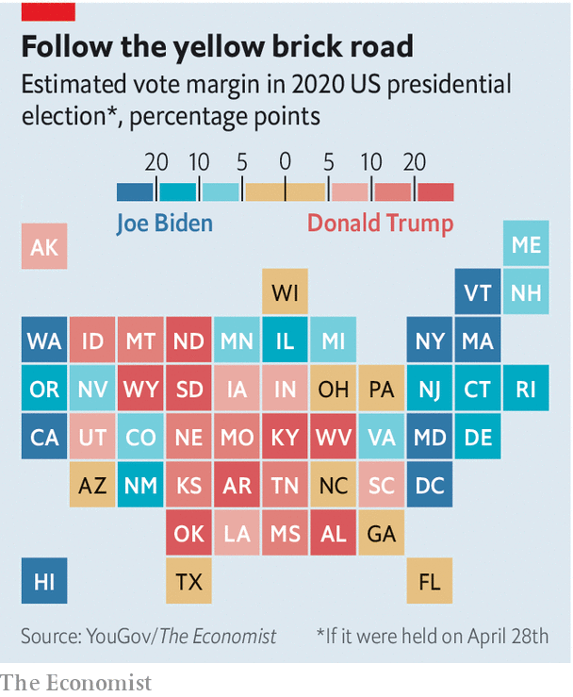

To gauge the candidates’ strengths with a variety of demographic groups, The Economist used a statistical technique called “multilevel regression and poststratification” (MRP) that takes raw survey data collected by YouGov, a pollster, and produces finely-detailed predictions for many different types of voters. We know how white women with a college degree lean Democratic, for example, and how white Christian men from Michigan tend to vote for Republicans. And since we also know how many people of each type live in each state, we can estimate how the race would play out if the election were held today.

This method is not unlike the one used by Simulmatics Corporation, which in 1960 fed a primitive computer decades’ worth of polls from George Gallup and Elmer Roper to advise Kennedy on a winning strategy. The scientists behind Simulmatics made predictions for 480 types of voters. Based on data about nearly 9,000 voters collected by YouGov in March and April, we have made predictions for over 380,000 types, one for each combination of nine different demographic and geographical factors.

Our MRP model tells us both whether people are likely to vote, and who they will support if they do. Our method adjusts for many of the factors that increase the variance of live-caller polls, chiefly by ensuring a balanced sample of Democrats, Republicans and independents in each state. Perhaps most important, MRP allows us to fill in the blanks where public polling is scarce, which was a big problem when handicapping the 2016 election.

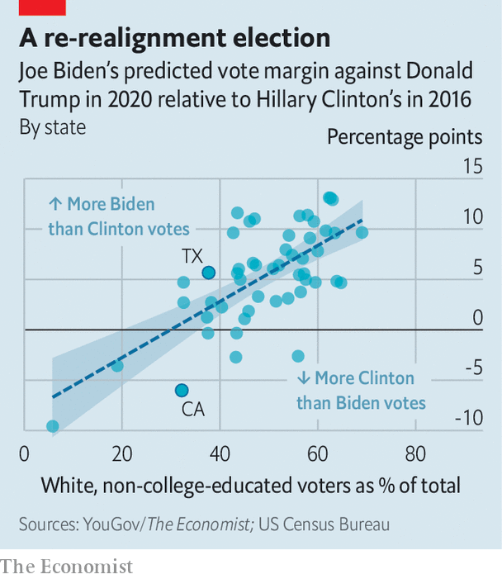

Currently our model estimates that 41% of whites who cast ballots would vote for Mr Biden if the election were held today, whereas 51% say they will cast their lot for Mr Trump—a ten-percentage-point margin. In 2016 Mrs Clinton lost this group by 15 points. Mr Biden has improved his standing both among whites who have college degrees and the ever-watched group of those who do not. He polls four and six percentage points better than Mrs Clinton did among each group, respectively. Mr Biden is currently polling 11 points better than Mrs Clinton in states where working-class white voters make up the largest share of the electorate, and he is performing roughly six points worse in those states where they are the lowest share (see chart).

That improvement has a disproportionate effect on Mr Biden’s chances of victory. Whereas Mrs Clinton lost the election by small margins in Wisconsin, Michigan and Pennsylvania, we find Mr Biden with a slight lead in all three. He is also likely to beat Mrs Clinton’s margin in Arizona, which is likelier than any of the midwestern battlegrounds to tip the election.

That is despite Mr Biden faring relatively poorly with non-white voters and with younger ones. YouGov’s data suggest that African-Americans favour Mr Biden over Mr Trump by a 72-percentage-point margin. That sounds impressive—yet Mrs Clinton won the same group by 80 points. Hispanics, too, have shifted away from the Democrats. Whereas Mrs Clinton won them by 38 points, they now say they will vote for Mr Biden by 28. In other words, Mr Trump is polling a bit better with blacks and Hispanics than he did last time round.

Young voters, a large majority of whom are Democrats, are also less likely to support the vice-president than they were to back Mrs Clinton. But the majority of eligible voters younger than 30 do not typically vote: only 43% of them showed up to the polls in 2016, based on numbers from the Census Bureau. And even though YouGov’s data suggest nearly 70% of all eligible adults will vote in November, the model expects only 53% of voters under the age of 30 to do so. Young people are also concentrated in the safest Democratic states, so are unlikely to have a large sway over the election. Thus Mr Biden can prosper despite a relatively weak performance among the Democratic Party’s core constituencies, because the electoral college makes them less important than they would be if the presidency were decided by a popular vote.

Guessing now how things will be in November is hard, for obvious reasons. In the past, one of the best predictors of a president’s chances has been the state of the economy. Today, after a 4.8% decline in GDP (at an annual rate) in the first quarter, any model that puts weight on that correlation predicts a blowout Biden win. Yet thanks to political polarisation, most voters no longer blame (or reward) the president for economic conditions.

The biggest constant since 2016 is that Mr Trump has retained his relative advantage in the electoral college. Because rural states both lean Republican and are rewarded with a disproportionately large number of votes, the deck is stacked in his favour. According to our MRP estimates, the president could lose the popular vote by two-to-three percentage points and still win the majority of electoral-college votes. His path to victory again runs through the Midwest, though he has added Minnesota and New Hampshire to his list of heavily working-class states that could flip from Democratic in 2016 to Republican in 2020.

That scenario looks unlikely at the moment, however. After all the fancy maths, six months before the election, Mr Biden is six points ahead of Mr Trump. If the vote were held today he would probably win.■

Dig deeper:

* Sign up and listen to Checks and Balance, our [newsletter](https://www.economist.com/checksandbalance/) and [podcast](https://www.economist.com/podcasts/2020/04/24/checks-and-balance-our-weekly-podcast-on-american-politics) on American politics
* [Explore our guide](https://www.economist.com/united-states/2020/04/22/the-economists-guide-to-the-us-2020-elections) to the US 2020 elections
* For more coverage of covid-19 see our [coronavirus hub](https://www.economist.com/news/2020/03/11/the-economists-coverage-of-the-coronavirus)

This article was downloaded by calibre from <https://www.economist.com/united-states/2020/05/02/we-spent-the-lockdown-sorting-american-voters-into-380000-distinct-groups>

|  |  |  |  |
| --- | --- | --- | --- |
|  | Articles | Sections | Next |

|  |  |  |  |
| --- | --- | --- | --- |
| Previous | Articles | Sections | Next |

#### Battling to be American

# The path to citizenship for those who put on American uniform has narrowed

Military service was a time-honoured way to earn citizenship. No longer

May 2nd 2020 | NEW YORK

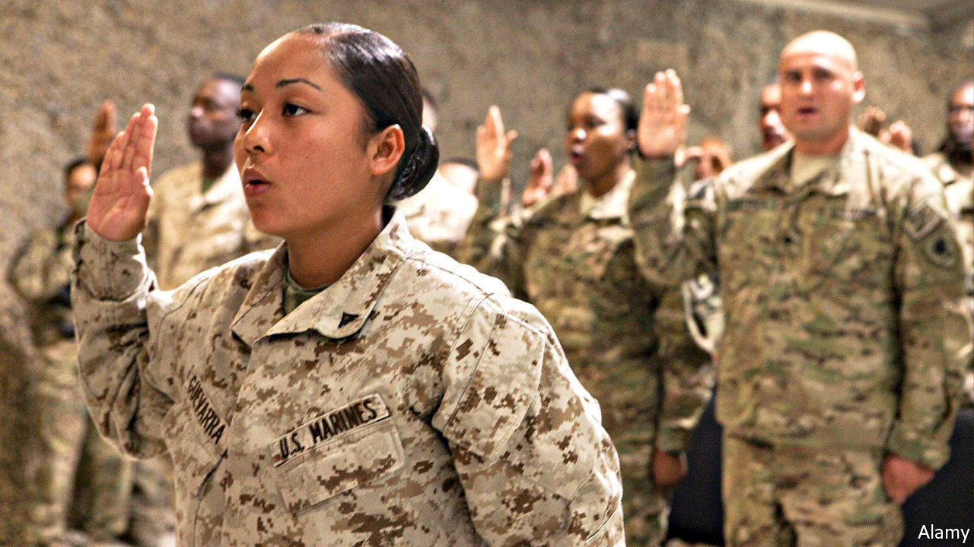

WHEN Baron Friedrich von Steuben, a Prussian officer helping the Continental Army, asked for a translator at Valley Forge to address some troops during America’s revolutionary war, the story goes that he was told there was no need. This particular group were immigrants and spoke German. Colonial militias offered state citizenship to soldiers. The Continental Congress granted citizenship even to enemy soldiers who switched sides. The baron was later given American citizenship for helping to see off the Brits.

Since 1952, immigrants have been able to apply for citizenship after one year of honourable service during peacetime. In wartime they have been able to become Americans almost as soon as they join up. Since the September 11th attacks in 2001, more than 100,000 service members have become citizens. But this avenue to citizenship is no longer assured.

In order for the naturalisation process to begin, the Department of Defence has to sign an honourable-service certification form. Without it, the Citizenship and Immigration Services (USCIS) will not consider the applicant. In October 2017 the department adopted stricter vetting; as a result, claims a new lawsuit, it is very difficult for service members to be naturalised speedily. This policy change is “a departure from pretty close to 200 years of US history”, says Muzaffar Chishti of the Migration Policy Institute, a think-tank.

Ange Samma, along with five other active-duty service members, and the American Civil Liberties Union (ACLU), an advocacy group, filed a class-action lawsuit against the Department of Defence on April 24th. Private Samma enlisted in 2018 and is serving in South Korea. Originally from Burkina Faso, he came to America as a teenager. According to the suit, it took multiple requests for him to receive the honourable-service certification form. When he finally did, USCIS rejected it as his officers had not filled it out properly. Without citizenship, he cannot get security clearance for some army work. He is not alone. Scarlet Kim, an ACLU lawyer, says that thousands of service members are having similar difficulties.

In 2018 there was a 70% drop in naturalisation applicants from the armed forces after the extra vetting was put in place. The lawsuit says the servicemen would have been naturalised faster if they had taken the lengthy civilian route. Their applications are being rejected at a higher rate than civilian ones. Margaret Stock, a retired lieutenant-colonel and now an immigration lawyer, says some serving soldiers are placed in deportation proceedings by the same government that they volunteered to fight for, before the application process has been completed.

Some countries are loosening citizen-enlistment rules because of military-recruitment problems, but only a few make service a path to citizenship as America does. This distinction helps with recruiting. Without immigrants the army would have failed to meet its goals nearly every year between 2002 and 2013. A Department of Defence report in 2016 found that non-citizens perform better, have lower attrition rates and are more likely to have medical and IT expertise than their citizen counterparts. Not only do they make useful recruits to the armed forces; they would make good citizens, too.■

This article was downloaded by calibre from <https://www.economist.com/united-states/2020/05/02/the-path-to-citizenship-for-those-who-put-on-american-uniform-has-narrowed>

|  |  |  |  |
| --- | --- | --- | --- |
| Previous | Articles | Sections | Next |

|  |  |  |  |
| --- | --- | --- | --- |
| Previous | Articles | Sections | Next |

#### The house loses

# America is getting worse at building new homes

Even before covid-19 struck, housing supply was not responding to demand as it ought to

May 2nd 2020 | LAS VEGAS



OVER A DECADE on from its almighty bust, Nevada’s housing market was on a roll. Since 2015 house prices have risen by 10% a year, not far off the dizzying price growth of the years leading up to the financial crisis. In 2019 just 2% of houses in Nevada lay empty, close to a record low—and quite a change from the early 2010s, when abandoned properties with “No Trespassing” signs blighted the suburbs of Las Vegas. Yet even before the pandemic, something was amiss with Nevada’s housing market. Though it looks as if there was money to be made, housebuilding has been remarkably weak (see chart).

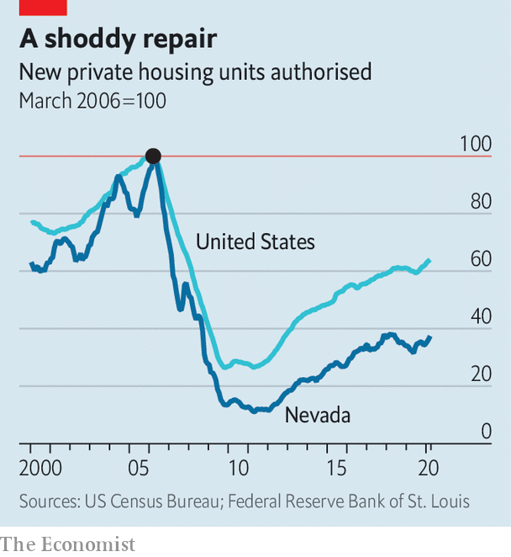

Nevada is an extreme example of a national trend. Housing costs are high and have been rising, especially in prosperous cities. Vacancy rates are at rock-bottom. Yet builders are oddly cautious. A recent Bank of England working paper from Knut Are Aastveit, Bruno Albuquerque and André Anundsen finds that housing-supply elasticities—ie, the extent to which building responds to demand—have dropped since the pre-crisis boom, not just in Las Vegas but across the country. Before covid-19 hit, housebuilding was 20% lower than it was before the financial crisis in other G7 countries. In America it was 40% lower. This is a sorry state of affairs for the one in two American renters who devote more than 30% of their pre-tax income to housing, and for those who cannot afford to buy their first home. Unless there is more building, housing will remain dear. Depending on the region, up to three reasons explain what has gone wrong.

The first relates to the rising cost of construction, which makes fewer projects viable. In the past decade it has become harder to find workers, in part because of fewer arrivals from Latin America. Labour costs have risen: in March construction-workers’ pay in Nevada was 6% higher than it was a year ago. Meanwhile, since Donald Trump came to office and slapped tariffs on various imports, the cost of building materials has risen faster than overall prices.

A second factor—tighter regulations—may play an even bigger role. Developers now have to jump through more regulatory hoops than before, which stop them building the dwellings that the modern economy demands. According to a recent paper by Joseph Gyourko of the University of Pennsylvania and colleagues, project-review times have increased in many areas since the mid-2000s. The share of areas imposing minimum-lot-size restrictions (which make it more difficult to build dense housing) has risen from 84% to 94%.

In some places NIMBYism is now virulent. Berkeleyside, a news website, reported in February that a resident in California opposed a new development on the ground that the incomers’ pets were “all going to come to my house and poop on my lawn”. Mr Aastveit’s co-written paper, in slightly more formal language, finds that “housing-supply elasticities have declined more in areas where land-use regulation has tightened the most.”

No one knows for sure why Americans have become less receptive to new housing development. Some say it is merely the continuation of a long historical trend (the regulation of land has been getting tighter since at least the 1960s). Another is that, following the bust a decade ago, homeowners are especially keen to preserve their property values, and are thus trying harder than they were to block development.

Ed Glaeser of Harvard University floats another intriguing theory—that places with lots of progressive folk are more likely to oppose development. Certainly, in liberal utopias such as Burlington and San Francisco, where residents flaunt their environmentalist and anti-gentrification credentials, getting any housing development off the ground is a nightmare. Political scientists have noted that in recent years America’s cities have shifted leftwards. More acute NIMBYish tendencies may be the consequence.

Yet housebuilders are not merely the victims of overbearing bureaucrats or sharp-elbowed activists. The third reason for America’s housing scarcity is linked to a problem that now afflicts many markets, from airlines to beer to hospitals. Housebuilding is less competitive than it once was. In many areas a small number of big firms have come to dominate the market, in part because of a series of big mergers and in part because only big firms can navigate increasingly complicated regulations. Since the recession the market share of Las Vegas’s top three housebuilders has increased from one-third to over 40%, according to Home Builders Research, a local firm. Other markets across America have seen similar trends.

Economic theory suggests that firms with market power may reduce their output if it helps them maximise their profits. A new paper from Jacob Cosman and Luis Quintero, both of Johns Hopkins University, finds evidence of this. The rise in market concentration in housebuilding since the recession has lowered annual housing construction by about 150,000—or roughly one-third of the current shortfall.

The disruptions associated with the coronavirus pandemic will slow down construction for some time. But even when the economy recovers, housebuilding may not. Though there are stirrings of a “YIMBY” movement—“Yes In My Back Yard”—where activists push for regulatory changes to make it easier to build, the forces pressing down on housing construction are strong. Immigration policies continue to deprive construction of much-needed labour. Few politicians are interested in solving America’s competition problem—and the big housebuilders enjoy being the only ones who understand increasingly gnarly regulations. It could be some time before housebuilding is once again on a roll.■

This article was downloaded by calibre from <https://www.economist.com/united-states/2020/05/02/america-is-getting-worse-at-building-new-homes>

|  |  |  |  |
| --- | --- | --- | --- |
| Previous | Articles | Sections | Next |

|  |  |  |  |
| --- | --- | --- | --- |
| Previous | Articles | Sections | Next |

#### Slaughterhouse dive

# In America, the virus threatens a meat industry that is too concentrated

Healthy animals are being killed and buried for want of slaughterhouse workers

May 2nd 2020 | CHICAGO

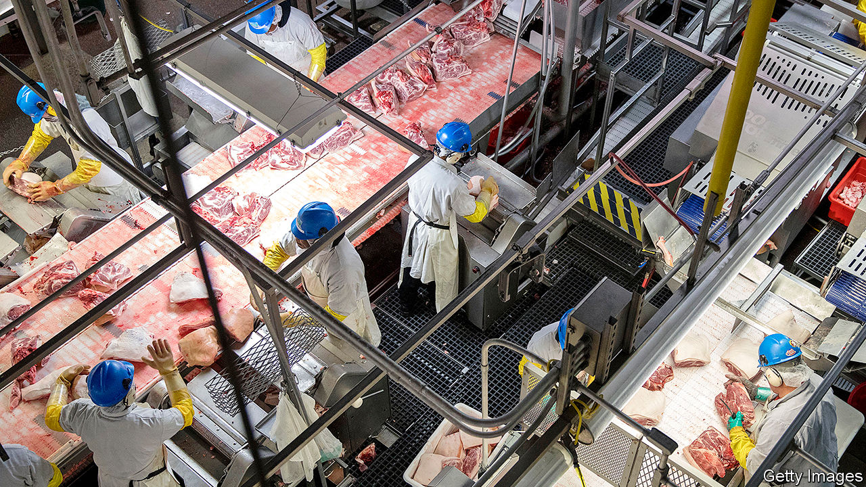

Editor’s note: The Economist is making some of its most important coverage of the covid-19 pandemic freely available to readers of The Economist Today, our daily newsletter. To receive it, register [here](https://www.economist.com/newslettersignup). For our coronavirus tracker and more coverage, see our [hub](https://www.economist.com/coronavirus)

WHAT IS THE biggest concern about America’s food-supply chain? The White House worries that shoppers, even before summer, may find supermarket shelves empty of steaks, burgers, sausages or chicken. Donald Trump invoked emergency powers under the Defence Production Act, declaring that closure of meatpacking plants threatens “critical infrastructure”, on April 28th. Supposedly that will oblige them to stay open, after more than 20 had closed because of coronavirus outbreaks affecting thousands of workers. At least 20 workers have died.

Mr Trump’s order, and a vow that all will have protein, came after big meat producers warned that supply bottlenecks would cause shortages. In mid-April the boss of Smithfield Foods, a huge pork firm, spoke of looming “severe, perhaps disastrous” effects on the food chain. It had just shut a big slaughterhouse in South Dakota. On April 26th the head of Tyson Foods, which dominates America’s chicken production, chirped up to greater effect. In full-page ads in national papers, John Tyson said a “vulnerable” food-supply chain is “breaking” and asked government to help. Tyson has closed plants in Iowa and beyond.

The White House took the alarm seriously. An official there suggested that some 80% of America’s meat-processing capacity might shut, at least for a while. Already a quarter of the pig-slaughtering capacity has closed. In recent weeks farmers and meatpackers in several states had begun culling millions of chickens and killing pigs to be rendered for fat and tallow, or just buried. Every year American farmers produce over 50m tons of beef, pork, turkey and chicken, and over 33m cattle, 120m pigs and 9bn chickens are slaughtered.

Just how the president’s order will keep slaughterhouses open is not clear, but one aim is to give legal cover for firms that do operate. As more workers fall sick, and some die, the presidential order could help limit their liability.

Unions say worker safety is bound to suffer—most workers in such plants are immigrants or refugees with few other job options. Those who spend shifts butchering meat while standing cheek-by-jowl at conveyor belts transmit the virus all too easily. Distancing is near-impossible unless plants operate more slowly, spacing out workers. Many have lacked protective equipment, such as masks, and some had to pay for their own. Testing, left to the companies, has also fallen badly short.

Even in the best conditions, safety is hard. Crammed in locker and lunch rooms, walking along narrow corridors (some shifts can involve as many as 2,000 people) and breathing air recirculated by refrigeration systems puts those inside at risk of catching the virus.

Temple Grandin, who has designed and audited slaughterhouses in Colorado, says much depends on isolating the unwell and most vulnerable. She suggests staggering shifts and setting up separate places to eat, as well as slowing lines. This could all mean that plants’ efficiency falls, perhaps by 50%, Ms Grandin says, so “the cost of meat is gonna go up as the supply chain tightens,” even if places stay open.

The pandemic is having another effect, “exposing weaknesses that people have talked about for ever,” argues Chris Leonard, author of a book that traces the rise of Tyson Foods to dominate the chicken industry. He says this is the moment to raise the alarm that the meat industry as a whole is unhealthily consolidated, in the hands of a few large firms as plump and mis-shapen as the big-breasted chickens or elongated hogs they cultivate.

Just four big companies now integrate almost every stage of raising animals, slaughtering them and packing the meat, and thus dominate the industry. That builds in weakness, he says. Such firms win economies of scale by building huge plants, but “big is fragile”, says Ms Grandin. When she began working in the meatpacking industry in the 1970s, there were many medium-size plants in each state. If one or two closed, others picked up their work. Now a single beef plant may slaughter 5,000 cattle daily, ten times more than when she started. Just one hog plant can account for 5% of America’s total pork processing. If a few such mega-sites close, as is happening now, it causes a wider shock.

That is all too clear when looking from the ground up. Art Cullen, a newspaper editor in Storm Lake, in northern Iowa, says his home town has become a “protein centre”. A pork plant has operated in town since 1928; it is now owned by Tyson Foods. A poultry farm nearby, also run by Tyson, can slaughter 30,000 birds a day. “There are virtually no independent producers left,” he says of pig farmers, noting how Smithfield breeds—through contracted farmers—some 40% of all the pigs in Iowa.

He blames weak regulators and politicians, who let a few firms dominate. “It unquestionably would have been more secure if there were lots of independent hog farmers and meatpackers,” he says. Instead he watches a “brutal” system, where bottlenecks in one or two big companies’ supply chains are putting workers at risk, threatening shortages and forcing the culling of millions of healthy animals. ■

Dig deeper:  
For our latest coverage of the covid-19 pandemic, register for The Economist Today, our daily [newsletter](https://www.economist.com/newslettersignup), or visit our [coronavirus tracker and story hub](https://www.economist.com/coronavirus)

This article was downloaded by calibre from <https://www.economist.com/united-states/2020/05/02/in-america-the-virus-threatens-a-meat-industry-that-is-too-concentrated>

|  |  |  |  |
| --- | --- | --- | --- |
| Previous | Articles | Sections | Next |

|  |  |  |  |
| --- | --- | --- | --- |
| Previous | Articles | Sections | Next |

#### A multitude of drops

# America’s makers and tinkerers turn their hands to PPE

Makers and takers

Apr 30th 2020 | DOBBS FERRY

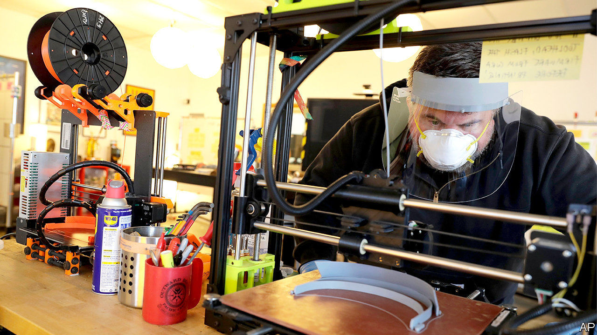

Editor’s note: The Economist is making some of its most important coverage of the covid-19 pandemic freely available to readers of The Economist Today, our daily newsletter. To receive it, register [here](https://www.economist.com/newslettersignup). For our coronavirus tracker and more coverage, see our [hub](https://www.economist.com/coronavirus)

BEFORE THE pandemic, John-Paul Kaminski was a retired cross-country coach and middle-school technology teacher in Dobbs Ferry, a village about 15 miles (24km) up the Hudson river from Manhattan, who liked to tinker with his 3D printer at home. He used it to make key chains, jewellery boxes, maze games and the occasional carved pumpkin. These days, he and other tech teachers he knows from university use their printers—60 in all—to make head- and chinstraps that hold plastic face-shields in place. A college student nearby uses a laser cutter to stamp out the shields himself. Using materials bought out-of-pocket and through donations, they have given away more than 3,000 face shields to hospitals and nursing homes in four counties.

Across America, makers of all ages and skill levels have thrown themselves into helping to alleviate the shortage of personal protective equipment (PPE). Some, like Mr Kaminski, are making masks, shields and gowns. Others are collaborating on designs, and making those designs public. Still others are trying to figure out how to get PPE to those who need it most as quickly as possible. These charitable tinkerers provide ground for both a deeply American kind of hope—strangers doing as much as they can, wherever they can, for the good of their neighbours—and despair, at the colossal federal failure that inspired them.

One reason so many people have turned to face shields, explains Paul Mirel, a Baltimore-based maker, is that shields need not be sterile, and “they’re easiest to manufacture”. Rubber gloves require a complex extrusion process. Surgical masks and N95 masks (which filter 95% of small airborne particles) require polypropylene fibre and strenuous testing. Ventilators are complex machines that require a respiratory therapist to manage. Shields are just a stamped piece of plastic held in place with two other bits of plastic. They can be washed and disinfected. Wearing them extends the lives of the masks beneath, which in turn eases supply-chain pressure.

Some makers have been drawn to more complex challenges. Matt Parlmer, a Chicago-based computer scientist, says that in mid-March his father, an anaesthesiologist, was given a surgical mask and an N95 mask, and “told to wear them until they fell apart”. That made him angry but also curious. He cut an N95 mask apart, and realised that while “there’s some degree of technical complexity, it’s not building a car or a fighter jet”. He and a group of engineers have been making prototypes, testing them and trying to increase small-scale manufacturing capacity.

Getting more of them into the supply chain will not just help front-line workers. It could also help ordinary people feel more secure about being in crowds and taking public transport, which are essential if cities are to return to something approaching normal levels of productivity before a vaccine becomes widely available. And just as Mr Kaminski says his project was born of “wanting to help [but] not knowing how”, Mr Parlmer notes that his “solid amount” of donations and volunteers has been “organic, which shows how dire the need is and how willing people are to help”.

This surge in makers’ activity is also putting some people back to work—albeit on a small scale. Will Holman, who has converted the 34,000-square-foot makers’ space he runs in Baltimore into a face-shield production plant, has rehired five of the 21 people he had to lay off to do clerical and packaging work. He sits at the hub of a network of makers running 500 printers in homes, schools and libraries that in the first three weeks of production have made 7,650 masks, which they sell at cost to cover production materials and labour.

Mr Holman knows that “there’s no way that this is more cost- or labour-efficient than making it in a giant factory, but when all the giant factories are in China and China needs all the face shields domestically, it just exposes the yawning gap in America’s industrial space.” This sort of production, making use of crowdsourced design and small distribution networks, realises the promise of 3D printers: they will never compete in cost and efficiency with huge assembly lines, but they give American manufacturing a nimble, local backstop.

Once materials are made, where do they go? Mr Holman has an online form for local service organisations such as homeless shelters, which need PPE but, unlike hospitals and doctors’ offices, are unaccustomed to ordering it. Mr Kaminski and his network send it to anyone who asks.

A team of doctors have founded a network called getusppe.org to think bigger. They are using data on hospitals’ needs to build a centralised PPE distribution platform. Some have also been urging clothing manufacturers to start making cool-looking masks. Initially the firms were reluctant, says one, because “they didn’t want to look like they were making money” from a pandemic. But the more masks they make that people want to buy, the fewer people will buy surgical and N95 masks intended for front-line workers.

Ultimately, just as Mr Holman says his work is a “bridge project” to fill a need until big manufacturers can catch up, the doctors behind getusppe.org are trying to nudge the federal government into action. A few thousand makers, however dedicated and well-intentioned, cannot be a supply chain for a country of almost 330m. Tracking the needs of thousands of American hospitals—to say nothing of doctors’ offices and other medical facilities—cannot be left to doctors in their spare time. Mr Mirel calls his work “a tiny drop in a giant ocean of need”. But, as David Mitchell wrote in “Cloud Atlas”, “What is any ocean, but a multitude of drops?”■

Dig deeper:  
For our latest coverage of the covid-19 pandemic, register for The Economist Today, our daily [newsletter](https://www.economist.com/newslettersignup), or visit our [coronavirus tracker and story hub](https://www.economist.com/coronavirus)

This article was downloaded by calibre from <https://www.economist.com/united-states/2020/04/30/americas-makers-and-tinkerers-turn-their-hands-to-ppe>

|  |  |  |  |
| --- | --- | --- | --- |
| Previous | Articles | Sections | Next |

|  |  |  |  |
| --- | --- | --- | --- |
| Previous | Articles | Sections | Next |

#### Lexington

# Conservatism in the crisis

The pandemic has emboldened conservative proponents of a more expansive view of government

May 2nd 2020 |

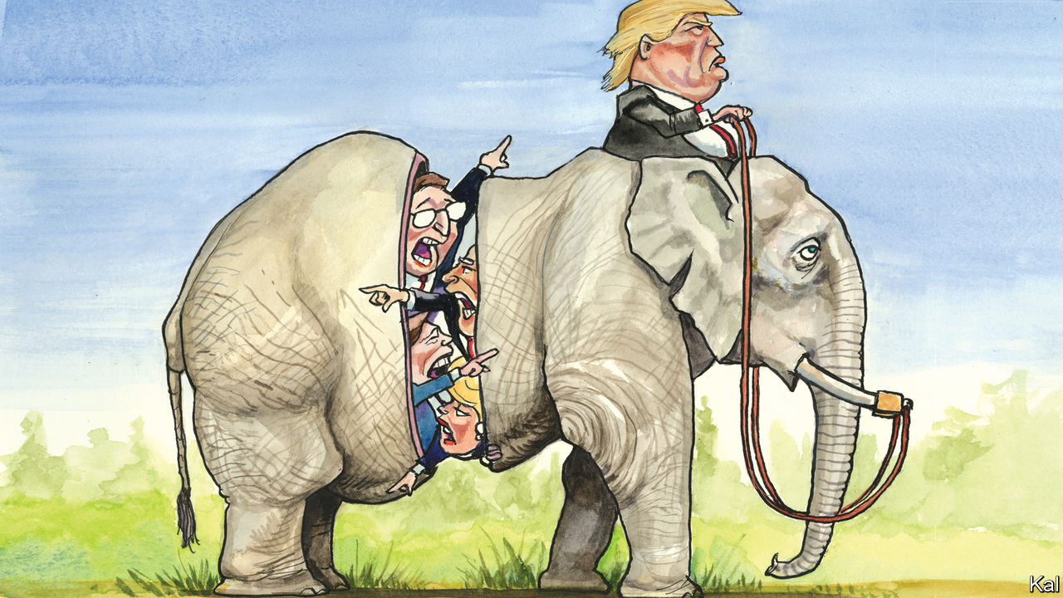

FOLLOWING THE strangely tidy conclusion to their presidential primary, the Democrats are marching in lockstep. This week Senator Kirsten Gillibrand, queen of the #MeToo movement, dismissed an allegation of sexual assault against Joe Biden on the basis that the former vice-president had denied it. Al Franken and Brett Kavanaugh would have been glad of the same treatment.

Meanwhile the Republicans appear to be trying to fill the role of feuding opposition their rivals have vacated. The only stiff resistance to the $3trn stimulus authorised by Congress came from their ultra-libertarian wing. One of its members, Congressman Thomas Massie, accuses his colleagues of “abandoning” conservative principles by tiding over America’s shuttered economy. It seems he was not mollified by Mitch McConnell’s more tactical small-governmentism, displayed in the Senate leader’s opposition to bailing out stricken Democratic states. Larry Hogan, the pragmatic Republican governor of Maryland, called letting states go bankrupt “complete nonsense”. Meanwhile a former compadre of Mr Massie in the House Freedom Caucus, Justin Amash, declared a plan to run for president for the Libertarians.

Another querulous Republican faction looks closer to the grain of the crisis. Led by some of the most interesting conservative thinkers, including Yuval Levin and Oren Cass, plus a handful of senators, it rejects Mr Massie’s market fundamentalism and takes a more flexible and positive view of government than most Republicans have since the 1970s. Its members, who include Trump-style populists and the remnants of a reform conservative movement that began in the doldrums of George W. Bush’s presidency, want to turn the party’s attention from economic freedom to socioeconomic outcomes, from corporations to workers. A pro-poor redesign of one stimulus bill by Senators Tom Cotton, Mitt Romney and Marco Rubio, all affiliated with this faction, was an indication of its growing alignment. Its members believe the crisis has validated their position and pushed it to the centre of politics.

Mr Rubio said as much in a searing critique of his party’s economic libertarianism in the New York Times last week. He connected the damage it has done to some working-class communities, the loss of industrial capacity exposed by the crisis and the absence of adequate stockpiles of the medical supplies America no longer makes. All, he argued, are products of a misguided homage to economic efficiency, rooted in a “hyperindividualistic ethos”, that the coronavirus has shown to be self-defeating as well as immoral. To address these inadequacies, he would boost domestic production through a range of industrial and labour policies.

Mr Cass, who on May 5th will launch an impressive organisation of this dissident faction, called American Compass, would go further. A former policy director for Mr Romney, he describes the crisis similarly as an indictment of an “economic piety” that ignores many values that markets do not capture, including the well-being of American workers and development of future industries. “Supply chains are much more than whoever is promising to make something more cheaply tomorrow,” he says. In an influential book on labour-market reform, he has proposed a range of novel fixes, including wage subsidies and labour unions, and some familiar ones, including more aggressive deregulation than even Mr McConnell might consider feasible.

Politics does seem to be moving towards the dissidents. With the government standing between millions of Americans and ruin, hardly anyone, maybe not even Mr Massie, will propose starving the beast for a bit. The crisis is also likely to slow and, in specific industries such as health care, reverse globalisation. Yet the Republican quarrelling and rise of the dissidents are mainly a response to the equally disorientating reality of Donald Trump.

The president’s lack of attachment to any Republican faction has encouraged all to claim to be the animating spirit of his revolution. The Freedom Caucus claim him for their pugnacious anti-establishmentarianism. The small-government establishment notes that his only big legislative achievement was the tax reform it designed. The dissidents claim more convincingly to be offering solutions to the working-class grievances Mr Trump highlighted on the trail, even though he has since jettisoned them.

This may explain why their programme seems more political than the cerebral Mr Cass would care to admit. There is a rational and, given his focus on strengthening institutions, conservative case for his proposed labour-market reforms. The same cannot be said for the immigration curbs and laissez-faire attitude towards climate change he also advocates. Both look like pandering.

That is forgivable to a degree. Even critics of Mr Rubio and Mr Cass should recognise that their proposals are the most direct answer to the president’s ethno-nationalism available. Going back to the hoary question of whether his working-class fans were incited more by economic or by racial anxiety, Mr Trump’s behaviour suggests he thinks it was the latter; Mr Rubio et al refuse to accept that.

## Neoreformacon-ism

The irony of this is that they have fashioned a virtuous Trumpian agenda that has little or no chance of being promulgated under Mr Trump. No more are the libertarians or small-government pharisees or pragmatists like Mr Hogan hopeful of influencing his scattergun administration. All are wrestling to claim the post-Trump future of their party—which leads to two further conclusions.

First, that future will be determined not by ineluctable socioeconomic forces but by whoever wins the party’s next presidential nomination. The Democrats’ embrace of fiscal rectitude in the 1990s now looks inevitable. But had Bill Clinton not scrambled to a second-place finish in New Hampshire, it would not have happened. Second, the fact that Republicans are feuding only six months from a general election suggests that many of them believe their post-Trump future may not be far off.■

This article was downloaded by calibre from <https://www.economist.com/united-states/2020/05/02/conservatism-in-the-crisis>

|  |  |  |  |
| --- | --- | --- | --- |
| Previous | Articles | Sections | Next |

|  |  |  |
| --- | --- | --- |
| United States | Sections | Asia |

The Americas

Brazil: A dangerous divorce

.

Venezuelans in Colombia: The welcome mat frays

.

Bello: The lockdown conundrum

.

|  |  |  |
| --- | --- | --- |
| United States | Sections | Asia |

|  |  |  |  |
| --- | --- | --- | --- |
|  | Articles | Sections | Next |

#### Bust-up in Brasília

# Jair Bolsonaro’s dangerous divorce

Brazil’s justice minister storms out, calling the president a scofflaw

Apr 30th 2020 | SÃO PAULO

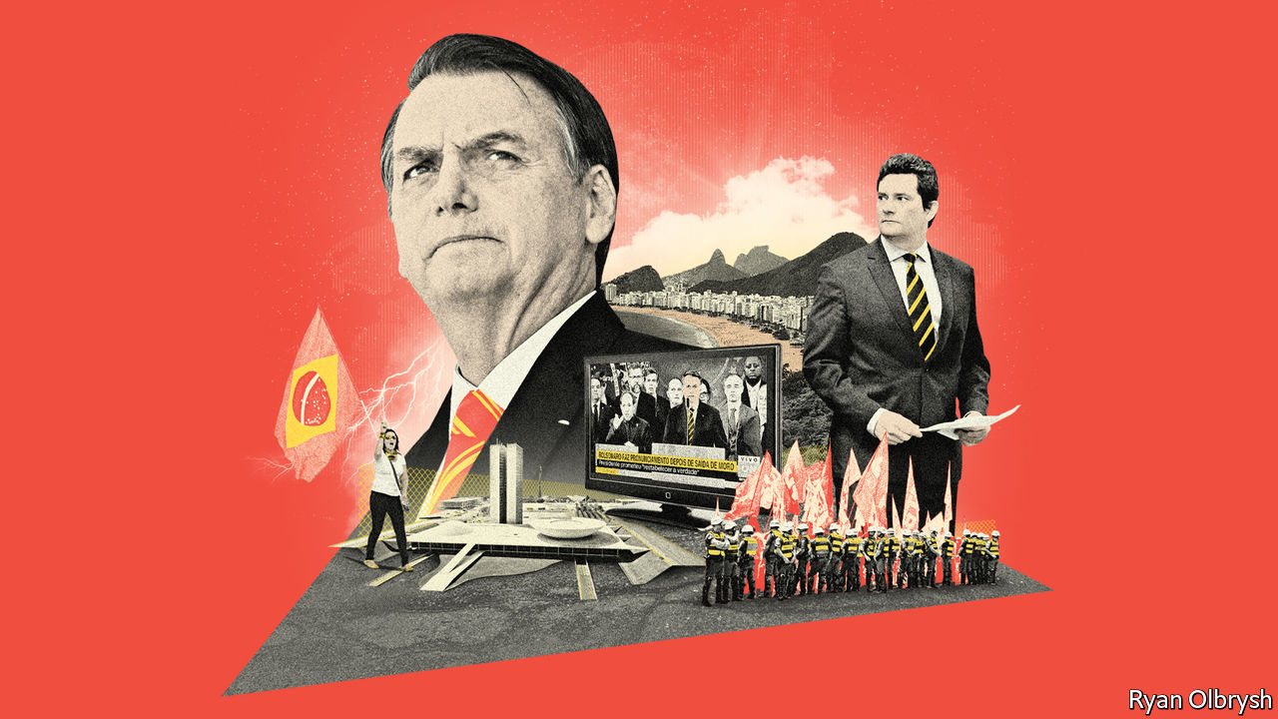

ON APRIL 19TH Brazil’s president, Jair Bolsonaro, climbed onto a lorry outside army headquarters in Brasília to fire up protesters who were calling for a shutdown of Congress and the Supreme Court. Soon after, according to Folha de S. Paulo, a newspaper, he learned that federal police were investigating allegations that one of his sons, Carlos, runs an online fake-news network that may have inspired the protest. On April 24th Mr Bolsonaro sacked the head of the federal police. Hours later the justice minister, Sérgio Moro, resigned. He accused the president on television of “political interference” in the police to shield his family.

Mr Moro’s resignation is the biggest political blow to Mr Bolsonaro since he became president at the beginning of 2019. An army captain turned congressman, Mr Bolsonaro rose from obscurity by exploiting anger at corruption. His appointment as justice minister of Mr Moro, a judge who jailed scores of politicians and businessmen as leader of the Lava Jato (Car Wash) anti-corruption investigations, signalled his determination to fight graft. Now Mr Moro, a hero to many Brazilians, has accused his former boss of obstructing justice. If an investigation backs that claim, Mr Bolsonaro could be impeached.

That crisis comes on top of twin calamities: the covid-19 pandemic and the economic slump it has caused. On April 16th Mr Bolsonaro sacked the health minister, Luiz Mandetta, who had refused to back his demands that shops and schools reopen. Some supporters are disillusioned. “I voted for Bolsonaro in hopes of a better Brazil,” says Ary, a taxi driver in the north-eastern city of Maceió. “But it was all in vain.”

The allegations against Carlos Bolsonaro are not the first to be levelled against the president’s family. Before he took office prosecutors opened an investigation into possible embezzlement by his eldest son, Flávio, now a senator from Rio de Janeiro. Documents published by the Intercept, a news site, suggest he used public money to finance illegal construction projects run by right-wing “militias”. Now Mr Moro has accused the president himself.

Mr Bolsonaro’s survival in office depends on three factors. The first is the probe triggered by Mr Moro. Its outcome may depend on whether the president’s alleged misconduct achieves its aim. Things are not going as he might wish. The person he appointed to be the new police chief is a family friend. But on April 29th a Supreme Court judge put the appointment on hold. Mr Bolsonaro says he will appeal that decision. The judge had earlier ruled that a new chief could not change the officers leading investigations into the actions of Mr Bolsonaro’s sons, who deny wrongdoing.

The second arena of judgment is Congress, which can evict a president from office by a two-thirds majority of both houses. To avoid this, Mr Bolsonaro is cosying up to the centrão, a block of ideologically vacant parties. He has abandoned his earlier pledge not to give legislators benefits, such as government jobs for their allies, in exchange for political support. Impeachment “is not in Congress’s interest”, says Ricardo Barros, a federal deputy from the Progressives party, part of the centrão.

That could change, he admits, if the president loses the support of voters, the third and most important influence on Mr Bolsonaro’s future. Before Dilma Rousseff was impeached in 2016 her approval rating dropped to 8% and she faced huge protests. Mr Bolsonaro remains strongly supported by a third of voters. According to Datafolha, a pollster, 46% of Brazilians want him to resign, a rise of nine percentage points within a month. But half think he should stay.

“People are starting to say: ‘I was wrong,’” says Renan Santos, the leader of the right-wing Free Brazil Movement, which organised protests against Ms Rousseff and initially supported Mr Bolsonaro but now calls for his impeachment. For the first time since 2017, Mr Bolsonaro has lost Facebook fans.

Whatever the popular verdict, Mr Bolsonaro’s presidency lost much of its purpose when Mr Moro resigned. Its other main justification, the reform programme led by the liberal economy minister, Paulo Guedes, is endangered by the recession. He wants to slash spending, simplify taxes and privatise state enterprises. Now the government must splash out. It has promised tens of millions of Brazilians a monthly payment of 600 reais ($110). That will cost 118bn reais this year, about 1.6% of GDP. On April 22nd the government announced a “recovery plan” to employ 1m people through sketchily defined infrastructure projects. Mr Guedes was not consulted. Rumours flew that he would follow Mr Moro out of the door.

The financial markets’ confidence in Brazil depends on Mr Guedes staying put. Knowing this, Mr Bolsonaro paraded him before journalists on April 27th and backed down from the public-works plan, for now. Even so, “reforms aren’t going to happen,” says Eduardo Cury, a federal deputy from the centre-right Party of Brazilian Social Democracy. “Guedes will have to hang his head or go home.”

His marginalisation leaves the government in the hands of ideologues and generals. The ideologues reinforce Mr Bolsonaro’s strongest preferences, for example to loosen gun controls. The soldiers, who occupy seven of 22 cabinet posts (including all four with offices in the presidential palace), sometimes restrain him. They tempered his hostility towards China, Brazil’s biggest trading partner. “They believe they’re capable of doing something important for the government at a time when it’s very chaotic,” says a retired general. But they are in tune with Mr Bolsonaro on developing the Amazon and favour bulking up the state’s economic role.

Some officers may have second thoughts about backing his imploding presidency, says a scholar who studies Brazil’s army. But their sense of duty will keep them loyal. Impeachment would not diminish their role. Hamilton Mourão, the vice-president, was a serving general until 2018. If the military-minded president is removed, he will leave a martial legacy.■

This article was downloaded by calibre from <https://www.economist.com/the-americas/2020/04/30/jair-bolsonaros-dangerous-divorce>

|  |  |  |  |
| --- | --- | --- | --- |
|  | Articles | Sections | Next |

|  |  |  |  |
| --- | --- | --- | --- |
| Previous | Articles | Sections | Next |

#### The welcome mat frays

# Colombia cools on Venezuelan refugees

Covid-19 is straining the country’s generosity

May 2nd 2020 | BOGOTÁ

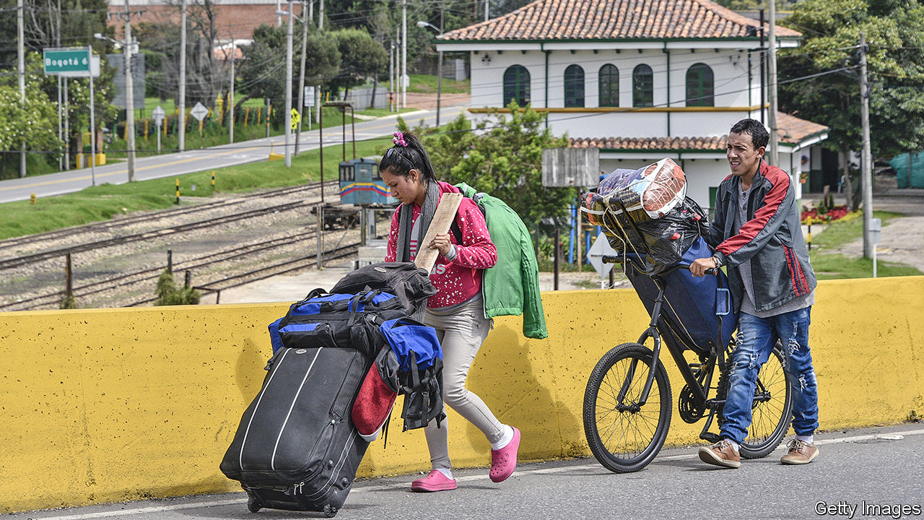

A YEAR AGO Janelis Beris left Valencia, her hometown in northern Venezuela, because the monthly pittance she earned as a cleaner was enough to buy only a packet of rice and two of flour. She arrived in Bogotá, Colombia’s capital, where she made more money picking through rubbish left on the street for recyclable plastic, glass or anything else of value she could find. With that she could pay rent and feed her four children. She promised herself she would not return until Nicolás Maduro, Venezuela’s dictator, had left power.

On April 12th Ms Beris broke that promise. A strict lockdown in Colombia, imposed to stop the spread of covid-19, has left her worse off than when she lived in Venezuela. Demand for waste disappeared. Her landlord evicted her in late March. After that, she and her children slept under a bridge. When that became unendurable she put her children and belongings in a cart and pushed them to a bus station 20km (12 miles) away. Her plan: to head back to Valencia, where she still owns a house.

Until recently, Colombia has been the main destination for the 4m-odd Venezuelans who have fled Mr Maduro’s poverty-stricken dictatorship. Nearly half have settled there. Colombia’s government, now led by President Iván Duque, has allowed them to attend school and receive emergency medical treatment and given many permission to take formal jobs. But the pandemic has pummelled the refugees. On March 14th Mr Duque closed Colombia’s borders to foreigners, including the 55,000 a day, most of them shoppers, who came from Venezuela. The lockdown has been hardest for informal workers like Ms Beris and most other Venezuelan migrants. At least 12,000 returned to Venezuela between April 4th and 26th.

This will not end Venezuela’s exodus. Despite the border closure, the numbers fleeing into Colombia probably still exceed the numbers going back. The flight may return to its former level when covid-19 ravages Venezuela. But the next wave of migrants will find Colombia less welcoming.

Even before the pandemic anti-immigrant feelings were on the rise, polls show. The virus has increased xenophobia, says Ronal Rodríguez, a researcher at the Venezuelan Observatory, part of Rosario University in Bogotá. Hundreds of bogotanos have protested against plans to house migrants in sports facilities. Along the border, false reports of Venezuelans trying to break into gated neighbourhoods, spread through Facebook, prompted police to deport some.

Mr Duque’s government continues to support Venezuelans who are already in Colombia. It is handing out 200,000 food packages and channelling international aid to migrants in the form of cash payments. Those who test positive for covid-19 will be enrolled in health-insurance schemes if they have formal-work permits.

The government remains relatively generous, in part because Mr Duque’s conservative Democratic Centre party is a fierce foe of Mr Maduro’s left-wing regime. For some on Colombia’s political left, however, Mr Maduro is a lesser evil than Mr Duque’s right-wing mentor, Álvaro Uribe, a former president. They do not share the right’s sympathy for Mr Maduro’s victims.

Colombian mayors, many of whom belong to left-wing parties, have taken the lead in exploiting anti-immigrant feeling. They “see the virus as an opportunity to get rid of [the Venezuelans]”, says an official in Mr Duque’s government. In Pamplona, where Venezuelans stop as they walk to Bogotá, on March 17th the left-wing mayor barred migrants from entering the town and shut down shelters. The mayor of Yopal, in Colombia’s oil-producing east, has called migrants a “burden”, responsible for the city’s “security and health problems”. He says he will not give them a penny to help them through the health crisis.

Even Bogotá, which had been hospitable to its 350,000 Venezuelans, has turned frosty. Claudia López, its mayor since January, is openly gay and a member of the Green Alliance. But her attitudes towards migrants are less liberal than you might expect. She says the city’s taxpayers have done enough for them. A cash-transfer scheme for informal workers, which she unveiled on March 26th, relies on databases that include few Venezuelans.

In televised speeches, Mr Maduro promises a friendly homecoming. In fact, he has set up checkpoints that intercept returning Venezuelans and administer covid-19 tests, donated by China. Those who have been through the process say infection rates are high. Infected or not, they are forcibly quarantined in abandoned schools and sports facilities for up to 15 days, according to Colombian officials.

Conditions are terrible. Returning migrants sleep on asphalt in scorching heat. They eat rice, plantain or rotting tuna once a day, said two inmates in one such centre. The ELN, a Colombian guerrilla group backed by Mr Maduro, stops people from leaving, they say.

That will not stop the disease from spreading within Venezuela, where many people cannot afford soap. Faced with a health-care system that had collapsed before the pandemic, many Venezuelans will seek treatment in Colombia, according to Felipe Muñoz, an adviser to Mr Duque. Its health system is also under strain, but at least it functions. The porous border cannot serve as an “epidemiological fence” for Colombia, says Mr Rodríguez. Forced to choose, many Venezuelans will brave growing hostility next door in preference to tyranny and implosion at home.■

This article was downloaded by calibre from <https://www.economist.com/the-americas/2020/05/02/colombia-cools-on-venezuelan-refugees>

|  |  |  |  |
| --- | --- | --- | --- |
| Previous | Articles | Sections | Next |

|  |  |  |  |
| --- | --- | --- | --- |
| Previous | Articles | Sections | Next |

#### Bello

# Choosing between livelihoods and lives in Latin America

The pressure to move to more flexible lockdowns

May 2nd 2020 |

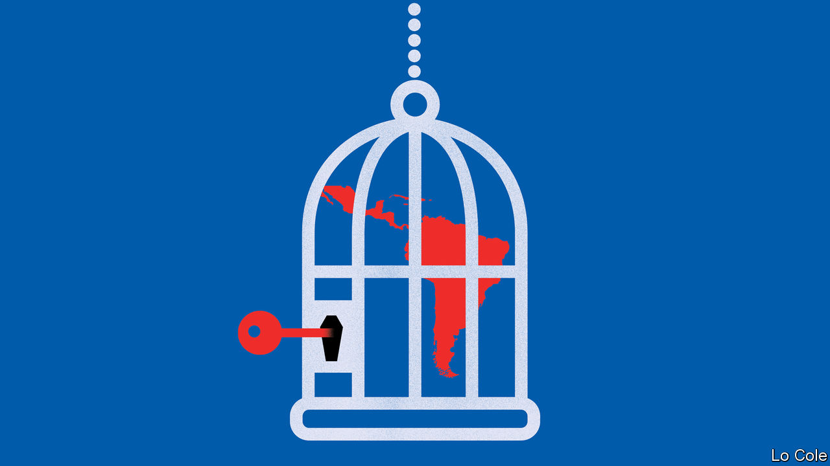

Editor’s note: The Economist is making some of its most important coverage of the covid-19 pandemic freely available to readers of The Economist Today, our daily newsletter. To receive it, register [here](https://www.economist.com/newslettersignup). For our coronavirus tracker and more coverage, see our [hub](https://www.economist.com/coronavirus)

SCORES OF street vendors set up an open-air food market this week in Huáscar, a shantytown in north-eastern Lima, defying Peru’s strict lockdown against covid-19. Hundreds of seasonal workers have broken quarantine, too, to travel back from the coast after the summer harvests to their homes in Andean villages. In locked-down Colombia, in Bogotá suburbs like Ciudad Bolívar and Soacha, life goes on more or less normally. Vendors offer coffee and corn bread on the street. That picture is repeated in many poorer parts of Latin America.

The virus struck the region a few weeks after it laid waste to Europe and the United States. Forewarned, many governments reacted early. By the end of March, 11 had imposed strict lockdowns while others had closed schools and imposed rules of social distancing. These measures have generally been popular, and they have almost certainly blunted the impact of covid-19 so far, saving thousands of lives.

In most cases, the minority who are not respecting lockdowns are acting out of necessity. Data from Google, which tracks mobile phones, show more movement in poorer states and provinces in many countries. Several national governments, including those in Colombia and Peru, have been swift to get emergency payments to some of their poorer citizens. But that is a big challenge: one out of two Latin Americans works informally, often relying on daily cash takings. A new popular slogan holds that it is better to die of coronavirus than of hunger.

That poses an acute problem for governments. In Latin America generalised lockdowns can be maintained for no more than two months, reckons the Inter-American Development Bank. In a new paper, the bank worries that confinement will be loosened before health facilities have expanded enough to cope, and before governments can ensure that opening up does not lead to the uncontrolled spread of the virus. Many countries have done little testing. Even Chile and Peru, which have done the most, have done only half as much as the United States, relative to their populations.

Many officials expect the epidemic to peak in May. But they are navigating through a fog of unknowing. Though they vary greatly across countries, the statistical curves of infection and deaths in Latin America are slightly below those in Europe and the United States. It is not clear why. Some think the data are unreliable. Mexico doesn’t pretend to count more than a sample of cases, for example. There may be other explanations. Latin America has been good at vaccinating against diseases like measles and tuberculosis. Some researchers think this may provide some immunity against covid-19. And there are proportionally fewer vulnerable old people than in Italy or Spain.

While the policymakers agonise over the trade-off between protecting lives and livelihoods, this is likely to be resolved on the ground and in favour of livelihoods. “To stay closed is impossible. People are desperate,” says Alejandro Gaviria, a Colombian former health minister. He argues for a strategy of “active vigilance” in which officials monitor the occupation of intensive-care beds city by city, give priority to increasing testing rather than to more ventilators and rely more on primary health-care networks, which are easier to expand than hospitals. Some Latin American countries have experience in tracing infected people, from recent viral epidemics such as Zika and chikungunya. “We don’t have to start from scratch,” notes Mr Gaviria.

Chile and Colombia, which have relatively low infection rates, are working towards more flexible strategies. Chile relies on a nightly curfew and shutting commerce to enforce social distancing. Only in 15 hotspots of infection has it imposed a strict lockdown. Having started with one laboratory to process tests, it expanded that to more than 50, partly by bringing the private health system under temporary state control. Officials will also need to consider who can safely go back to work, and organise more buses to transport them.

Ecuador, which has had a bad outbreak, and Argentina are starting to loosen up. A more flexible approach is harder where hospitals are overwhelmed. That applies in Peru, in parts of Mexico (which has not locked down) and in some Brazilian cities. Such places may have no choice but to confine people for a bit longer. Elsewhere, trying to slow the epidemic as much as possible while loosening the stranglehold on the economy is the hard, but ineluctable, task.

Dig deeper:  
For our latest coverage of the covid-19 pandemic, register for The Economist Today, our daily [newsletter](https://www.economist.com/newslettersignup), or visit our [coronavirus tracker and story hub](https://www.economist.com/coronavirus)

This article was downloaded by calibre from <https://www.economist.com/the-americas/2020/05/02/choosing-between-livelihoods-and-lives-in-latin-america>

|  |  |  |  |
| --- | --- | --- | --- |
| Previous | Articles | Sections | Next |

|  |  |  |
| --- | --- | --- |
| The Americas | Sections | China |

Asia

North Korea: Oh leader, where art thou?

.

Employment in Japan: Shake-work scheme

.

Garment factories in Bangladesh: Suffering from a stitch

.

Banyan: Pious and infectious

.

Sexism in Malaysia: When make-up is essential

.

Curbing covid-19 in Asia: The legitimate use of farce

.

|  |  |  |
| --- | --- | --- |
| The Americas | Sections | China |

|  |  |  |  |
| --- | --- | --- | --- |
|  | Articles | Sections | Next |

#### Oh leader, where art thou?

# North Korea’s dictator has disappeared

It has been three weeks since Kim Jong Un made any public appearances

May 2nd 2020 | SEOUL

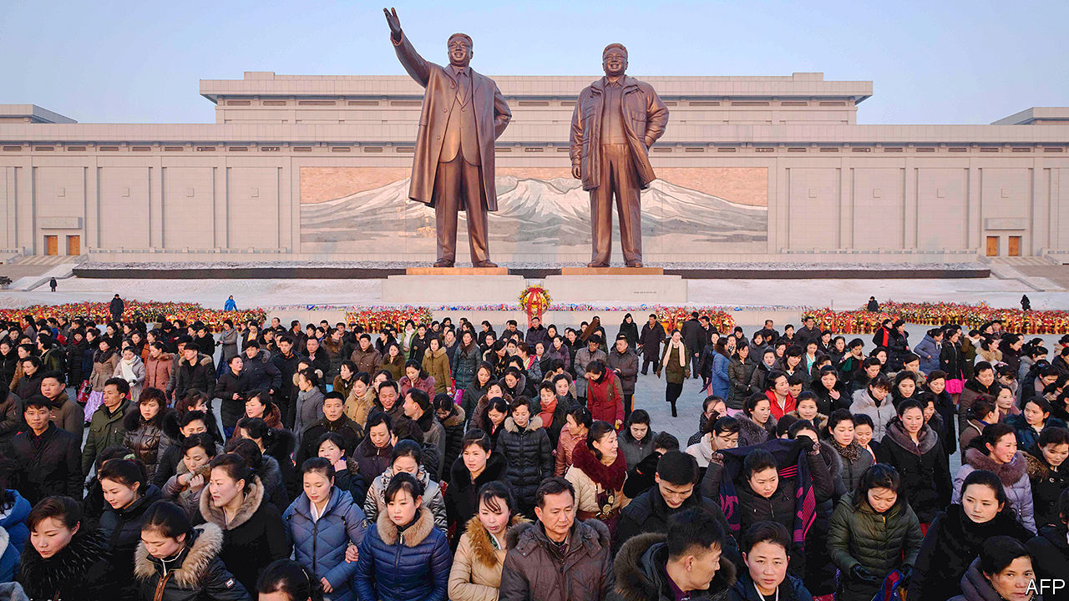

HE IS DEAD, or brain-dead, or in a coma following botched heart surgery. He has been deposed in a coup. Maybe he has simply had a chin-lift or a tummy-tuck. Or he might just be hiding from the coronavirus at his seaside villa. Since Kim Jong Un, North Korea’s dictator, failed to make an appearance on April 15th at festivities marking North Korea’s most important public holiday (which commemorates the birthday of his grandfather, Kim Il Sung, the country’s founding despot) theories about his absence have been taking flight with the frequency and ferocity of the missiles his government so often tests.

The frenzy reflects the dearth of information on North Korea’s inner workings. It also highlights the potentially alarming implications if Mr Kim, who although only 36 is obese and fond of cigarettes and alcohol, should indeed turn out to be dead or incapacitated. Given his total authority and lack of any presumed, let alone designated, successor, a bloody political crisis might well follow.

Mr Kim’s health is a closely guarded secret to which only his inner circle has access. Anyone leaking information about it to the outside world would be risking death. His absence at and since the celebrations on April 15th is certainly unusual: he had previously attended them every year since coming to power in 2011. But observers caution against over-interpretation. “Judging from state media reporting, it looks like business as usual,” says Rachel Lee, a former analyst for the American government. “Without more information there is nothing to indicate that anything abnormal is going on.”

South Korea, too, is downplaying the disappearance. The minister in charge of relations with the North says Mr Kim is in all likelihood taking precautions against the coronavirus (of which North Korea still claims to have no cases). However, points out Andrei Lankov of Kookmin University in Seoul, given that the South Korean government is still eager for detente with the North, it may be reluctant to advertise unusual goings-on. The normal difficulty of discerning what is happening, Mr Lankov adds, is compounded by the closure of the North’s border with China to ward off covid-19, which has further reduced the flow of information. Cheong Seong-chang of the Sejong Institute, a think-tank, says: “The fact that he isn’t showing his face in public suggests there is something wrong with his health, though it’s probably not as serious as some people claim.”

Mr Kim has previously disappeared from view for long stretches. In 2014 he vanished for six weeks, inducing hyperventilated rumours, before resurfacing without official explanation. He was, however, walking with a cane when he popped up again, suggesting he had undergone surgery on his ankle.

As in 2014, Mr Kim’s prolonged absence has fuelled speculation over what might happen if he became too sick to govern. Attention has focused on Kim Yo Jong, his younger sister. She has risen to prominence in recent years, having been dispatched as an envoy to the Winter Olympics in South Korea in 2018 and put in charge of the North’s propaganda machinery. Given that all North Korea’s leaders have been members of the Kim dynasty, many observers consider her the most likely candidate to take over. But she is also a young woman, which might not endear her to her brother’s elderly, patriarchal lieutenants. That raises the possibility of a drawn-out power struggle in the case of his sudden demise. “She’d probably have to shoot a lot of people to assert her authority,” says Peter Ward of the University of Vienna.

While that would be in keeping with family tradition, it might still portend a period of instability in the North which the world is currently uniquely ill-equipped to deal with. In theory America and South Korea have contingency plans for responding to a crisis in the North, including the recovery of its nuclear weapons. But those appear to have been little discussed in recent years either between the allies or with China, which would have to be considered in any military operation. Relations between America and South Korea are tetchy amid stalled talks over South Korea’s contribution towards the cost of keeping American troops on the peninsula. America and China, for their part, are at loggerheads over everything from the pandemic to trade. If something is indeed ailing Mr Kim, the malady could quickly spread beyond the North’s borders. ■

This article was downloaded by calibre from <https://www.economist.com/asia/2020/05/02/north-koreas-dictator-has-disappeared>

|  |  |  |  |
| --- | --- | --- | --- |
|  | Articles | Sections | Next |

|  |  |  |  |
| --- | --- | --- | --- |
| Previous | Articles | Sections | Next |

#### Shake-work scheme

# Japan’s new industry: turning down jobs

Graduates with multiple offers hire specialists to reject would-be employers

May 2nd 2020 | TOKYO



SELF-HELP books overflow with advice on how to say “no”, one of the trickiest words in any language. Doing so is a problem for Japanese university graduates in particular since, unlike their peers in many other countries, they are deluged with job offers: an average of three each last year. “They have no idea of how to deal with it,” says Shimizu Takahisa, a lawyer. His firm, Kawagoe Mizuho, is part of the mini-industry that has sprung up to take the job off their hands, so to speak.

Those who do not use a law firm offering “job-rejection services” can always turn to career consultants, who provide templates of polite no-thank-yous. There are even a few specialist job-rejection firms, such as Reccel, which for just ¥19,800 yen ($185) will convey the bad news to up to five would-be employers. Recoiling recruits need not speak a single word either to the firms they plan to jilt or to Reccel itself—the entire process can be arranged through Line, a messaging app.

An ageing population and restrictive immigration policies have left Japan with more jobs than jobseekers. Employers compete fiercely to hire talented youngsters and are reluctant to dismiss those they do manage to hire. If they need to cut costs, they are more likely to “adjust wages rather than headcounts”, says Yamaguchi Takeshi of Morgan Stanley. Firms worry that having fired staff (which the law makes difficult anyway) might put off recruits, notes Hugh Patrick of Columbia University.

Covid-19 may change things somewhat. The ratio of jobs to applicants hit a three-year low of 1.39 in March, well before the full effects of the virus were felt. Surveys suggest that firms plan to trim hiring further. Most of the pain will be felt by part-time and casual workers, who make up 38% of the workforce, are easier to sack and tend to skew younger and more female. (In late April the government announced the extension of unemployment benefits to such workers as part of its coronavirus response.) Analysts at Goldman Sachs think Japan’s unemployment rate will rise more in the coming months than it did during the global financial crisis—to 4.2%.

This article was downloaded by calibre from <https://www.economist.com/asia/2020/05/02/japans-new-industry-turning-down-jobs>

|  |  |  |  |
| --- | --- | --- | --- |
| Previous | Articles | Sections | Next |

|  |  |  |  |
| --- | --- | --- | --- |
| Previous | Articles | Sections | Next |

#### Suffering from a stitch

# Bangladesh cannot afford to close its garment factories

But keeping them open seems like a terrible idea, too

May 2nd 2020 |

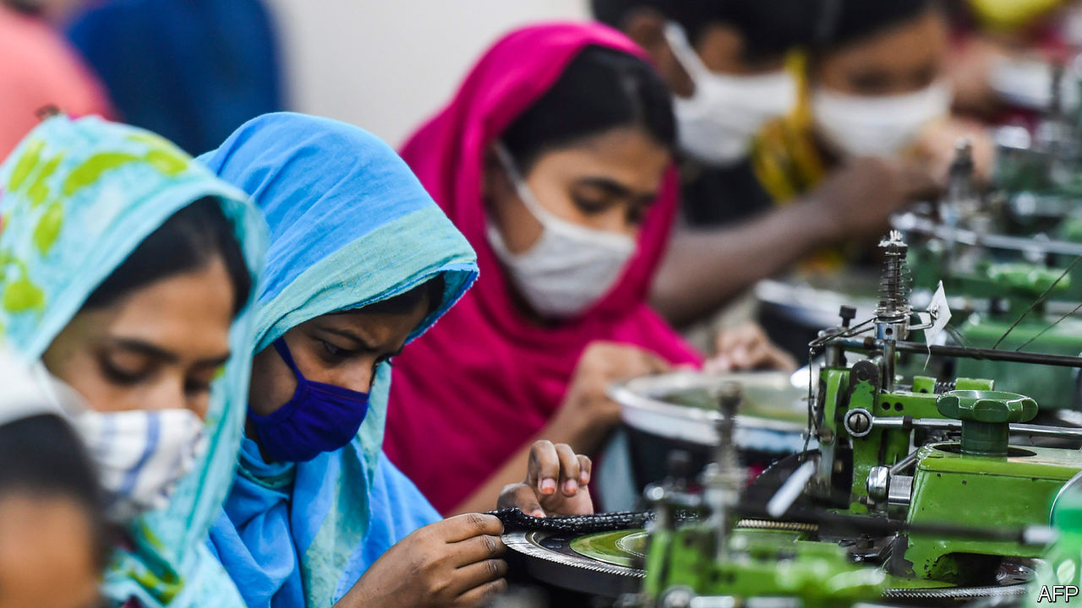

Editor’s note: The Economist is making some of its most important coverage of the covid-19 pandemic freely available to readers of The Economist Today, our daily newsletter. To receive it, register [here](https://www.economist.com/newslettersignup). For our coronavirus tracker and more coverage, see our [hub](https://www.economist.com/coronavirus)

THE BANGLADESHI version of lockdown, observes Rumi, a garment-worker, is quite ruthless: “Police and soldiers beat up people, rickshaw pullers and street vendors, anyone who comes out onto the street.” But when it comes to garment factories (and mosques—see [Banyan](https://www.economist.com/node/21784972)) the authorities equivocate.

The factories’ 4.1m workers, who both live and labour in cramped conditions, are particularly vulnerable to covid-19. Yet the garment industry, which brought in $34bn in export revenue last year, accounts for 13% of GDP and has driven the country’s impressive growth over the past few decades.

The government first tried to fight the coronavirus through a prolonged public holiday. When it became clear that would not be enough, it ordered businesses to close on March 31st. Conspicuously omitted from the lockdown, however, were the garment factories, which are concentrated in and around Dhaka, the capital. Four days later a directive ordered them to close, too, but not before the workers, many of whom had gone to their home villages for the holiday, had returned at the urging of factory-owners. Hundreds of thousands travelled back and forth, says Kalpona Akter, a labour activist, many on foot.

The workers were then left languishing in slums by the garment factories—now the centres of Bangladesh’s coronavirus outbreak. Out of work and hungry, thousands have ignored the legions of baton-wielding police and soldiers to protest about unpaid wages. The government has promised $590m in cheap loans to allow factories to pay wages, but owners are still waiting for the central bank to dole out the funds. The government says 150,000 workers have not been paid for March. It is more like 200,000, says Ms Akter.

Faced with what Rubana Huq, president of the Bangladesh Garment Manufacturers and Exporters Association (BGMEA), calls a “brutal dilemma” of “lives versus livelihoods”, authorities have instructed factories to get back to work. Around 2,000 reopened this week, with hundreds more set to open in stages in the next few days.

Even though demand for clothes has plummeted in much of the world because of the coronavirus, many factory owners feel they cannot afford to remain closed. The fact that some $3.5bn of orders have been cancelled makes them even more eager to fulfil the few jobs that remain. Some online retailers are still buying, and demand may revive as lockdowns ease in parts of Europe and America.

Rival garment factories in Cambodia, China, Sri Lanka and Vietnam have already reopened, says Syed Naved Hussain of Beximco Textiles, which employs 40,000 people and sells to big Western retailers such as Walmart and Zara. If Bangladeshi suppliers remain on lockdown, he fears, customers may start to shop elsewhere.

BGMEA has issued guidelines to protect workers. As well as advising preventive measures such as wearing masks, washing hands and keeping employees well spaced, Ms Huq is trying to broker deals with hospitals to make sure that the garment-workers who catch covid-19 get treatment.

But good health care is in short supply. Bangladesh has 170m people but fewer than 2,000 ventilators and around 1,000 intensive-care beds. It has reported 7,100 coronavirus cases so far, but the number is rising fast despite limited testing. The disease seems to be spreading most rapidly in the very districts where garment factories are clustered. In one such area, Narayanganj, 150 out of 160 tests conducted one day this week proved positive.

Some factories, having already suffered a financial blow from cancelled orders, are trying to cut costs by flouting the rules designed to curb the disease. The one in which Rumi works in Gazipur, another covid-19 hotspot, has stayed open throughout lockdown, despite the government’s changing directives. Eight of her colleagues have died. She says that BGMEA told her bosses to hand out gloves, but they seem to have kept them for themselves. “Why aren’t we given gloves too?” Rumi asks. “Our lives are worth less, it seems.” ■

Dig deeper:  
For our latest coverage of the covid-19 pandemic, register for The Economist Today, our daily [newsletter](https://www.economist.com/newslettersignup), or visit our [coronavirus tracker and story hub](https://www.economist.com/coronavirus)

This article was downloaded by calibre from <https://www.economist.com/asia/2020/05/02/bangladesh-cannot-afford-to-close-its-garment-factories>

|  |  |  |  |
| --- | --- | --- | --- |
| Previous | Articles | Sections | Next |

|  |  |  |  |
| --- | --- | --- | --- |
| Previous | Articles | Sections | Next |

#### Banyan

# Many of Asia’s Muslims are celebrating Ramadan in the normal way

Few Asian governments are brave enough to put public health before piety

May 2nd 2020 |



Editor’s note: The Economist is making some of its most important coverage of the covid-19 pandemic freely available to readers of The Economist Today, our daily newsletter. To receive it, register [here](https://www.economist.com/newslettersignup). For our coronavirus tracker and more coverage, see our [hub](https://www.economist.com/coronavirus)

IN NORMAL TIMES, Chawkbazar in the heart of old Dhaka, the capital of Bangladesh, is heaving during Ramadan, the Muslim month of prayer, daytime fasting and night-time feasting which began a week ago. Thousands of street hawkers sell biryani, kebabs and jilapis—sticky spirals of deep-fried batter, drenched in syrup, that most Bangladeshis consider essential for iftar, the evening meal breaking the day’s fast. But this year Chawkbazar is nearly deserted. The few vendors who attempt to set up are chased off by baton-wielding soldiers. And at home nearby, Nuzhat, who prides herself on her cooking, is making jilapis for the very first time, because the family’s favourite sweet shop is closed. Asked how they taste, her husband, Tarif, will not pass judgment. If he did, he adds in a grave aside, “My wife would kill me.”

Bangladesh, like other Asian countries with large Muslim populations, has announced restrictions on the celebration of Ramadan to contain the covid-19 epidemic. The government, which in early April urged people to stay away from mosques and pray at home, has become more specific for Ramadan, restricting attendance at prayers to 12. In Malaysia the government recently extended its lockdown to mid-May. On the eve of Ramadan, the prime minister, Muhyiddin Yassin, claimed the jihad against the pandemic was achieving results but that the country must keep up its guard. Mosques are live-streaming worship. Zakat, the alms all Muslims are supposed to donate, is collected at drive-throughs and online. Singapore has closed mosques until further notice.

Yet crisply issued and enforced rules are the exception. Jakarta, the capital of Indonesia, the world’s biggest Muslim-majority nation, has been under a partial lockdown since April 10th. But only on April 21st did the government of President Joko Widodo, or Jokowi, announce a national ban on mudik, the return home of vast numbers of migrants for the holiday that marks the end of Ramadan. The ban did not come into force for three days, by which point many were already on the move. One survey found nearly a quarter of migrants intended to return home, surely bringing the virus with them. Meanwhile, though some clerics have issued fatwas against praying in big groups, many small-town mosques operate as usual. In Banda Aceh, on Sumatra, thousands crowd daily into the Baiturrahman Grand Mosque, lots of them without face masks.

In Pakistan restrictions on the faithful promulgated by the prime minister, Imran Khan, have been late and half-hearted. Prominent clerics have pressed the government to declare that lockdowns do not apply to mosques, bringing out doctors in protest. A list of distancing measures was agreed, but four-fifths of mosques appear not to be enforcing them. In Bangladesh, Dhaka’s rigour is not mirrored elsewhere. In a recent video, the mayor of Gazipur, whose garment factories are coronavirus hotspots, declared its mosques open for business. In the countryside, as well as in camps housing Rohingya refugees from Myanmar, many believe the virus to be a punishment from God—for which more attendance at mosques, not less, is the fitting response. Across Asia, poorly paid imams have a powerful financial incentive to welcome the devout, who are at their most generous during Ramadan.

Religious gatherings earlier this year have already shown how worshippers can be vectors for the novel coronavirus. Huge jamborees organised by Tablighi Jamaat, a missionary movement with tens of millions of followers, are responsible for big clusters in India, Malaysia and Pakistan.

Across much of the Arab world, secular authorities have hobbled religious ones. But most of Asia’s billion-odd Muslims live in countries where religious leaders have more clout, and politicians are reluctant to stand up to them.

Jokowi has long pandered to conservatives who accuse him of insufficient piety or even of being a closet Christian. Mr Khan knows the snap of a cleric’s finger can bring tens of thousands of protesters out on the streets. And however eagerly Sheikh Hasina Wajed, Bangladesh’s prime minister, locks up critics, she makes an exception for religious leaders. She trembles before Hefazat-e-Islam (“Protectors of Islam”), a puritanical group founded in the country’s madrassas whose boss, Shah Ahmad Shafi, recently reversed course and called for mosques to remain open during Ramadan. The pandemic terrifies governments across Asia. But for some, the self-declared emissaries of God are even more frightening.

Dig deeper:  
For our latest coverage of the covid-19 pandemic, register for The Economist Today, our daily [newsletter](https://www.economist.com/newslettersignup), or visit our [coronavirus tracker and story hub](https://www.economist.com/coronavirus)

This article was downloaded by calibre from <https://www.economist.com/asia/2020/05/02/many-of-asias-muslims-are-celebrating-ramadan-in-the-normal-way>

|  |  |  |  |
| --- | --- | --- | --- |
| Previous | Articles | Sections | Next |

|  |  |  |  |
| --- | --- | --- | --- |
| Previous | Articles | Sections | Next |

#### When make-up is essential

# The reflexive sexism of Malaysia’s bureaucrats

The sectarian political system helps to reinforce chauvinist policies

May 2nd 2020 |

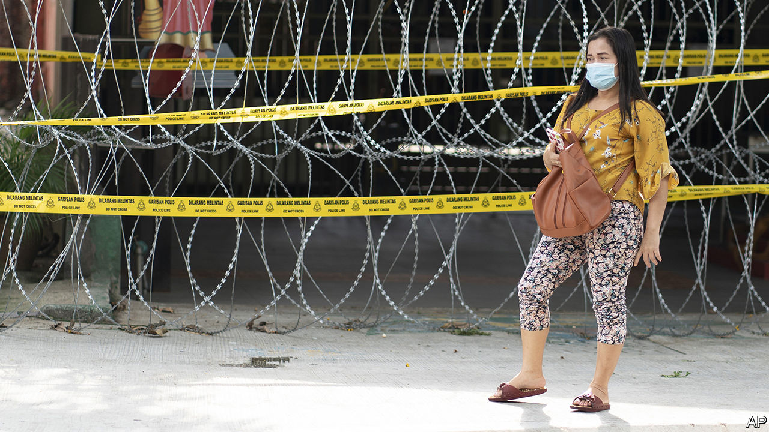

“MAYBE SOME men think it’s cute, lah, but…” Rather than finish her sentence, Chelsia Ng, a Malaysian musician, simply giggles. Other Malaysian women, however, were not as amused by the government’s recent advice to wives spending more time than usual with their husbands during the country’s coronavirus lockdown. The dutiful spouses should dress nicely, put on make-up, “avoid nagging” and—the trigger for Ms Ng’s mirth—talk in the same tones as Doraemon, a robotic cat from a Japanese animated cartoon. Women’s groups slammed the government’s perpetuation of “harmful gender stereotypes”. The Ministry of Women, the Family and Community Development quickly withdrew the posters in question. It also reversed its decision to shut its domestic-abuse hotline during the lockdown.

To many Malaysians, the surprising thing about this episode was not the reflexive sexism of the bureaucracy, but the fact that the bureaucrats changed course in response to the indignation. The latest Global Gender Gap Index from the World Economic Forum, which measures progress towards parity between men and women, ranks Malaysia as 104th out of 153 countries. It lags almost all of its neighbours in South-East Asia, including Indonesia, the Philippines, Thailand and Vietnam. Less than a quarter of Malaysia’s lawmakers are female and only 26% of companies have any women among their senior managers. Only 55% of women work outside the home; 80% of men do. Many chauvinist laws endure. A Malaysian father can pass his nationality to a child born abroad but a Malaysian mother must apply to do so. There is no law against marital rape.

Malaysia’s constitution puts family law in the hands of its 13 states. For Muslims, marriage, divorce and child custody are administered by religious authorities. Men can take up to four wives but women must stick to one husband. Boys cannot marry until they turn 18, but girls can do so at 16. Islamic judges can also approve marriages at a younger age. They received almost 6,000 such requests between 2013 and mid-2018. And it is possible to dodge even that requirement: in 2018 an Islamic court merely fined a 41-year-old man for marrying an 11-year-old girl abroad.

Although the plight of child brides stirs widespread outrage, challenging the Islamic authorities is difficult given the ethnic and sectarian dynamics of Malaysian politics. Most Malaysians are ethnic Malays. Politicians tend to favour this majority, who enjoy privileges meant to make them richer. But since the law defines Malays as Muslims, criticism of Islamic edicts is easily painted by their defenders as an attack on all Malays.

The United Malays National Organisation (UMNO), which held power for 61 years, tended to tread a middle path, stoking Malay nationalism but resisting the most doctrinaire interpretations of Islam. But as UMNO grew corrupt and lost popularity, it began to pander more to religious sentiment. Although it lost power at elections in 2018, it recently managed to manoeuvre its way back into government by aligning with PAS, a conservative Islamic party. Malaysia’s one big secular party was pushed out of the ruling coalition in this realignment, as was an outfit that draws most of its support from the 24% of Malaysians who are of Chinese extraction.

The change in government has probably put paid to a bill to combat sexual harassment and may well scupper another, to promote equality for women. The new deputy minister in the women’s ministry is from PAS. She suggested in a video in March that wives “accept, remain patient and forgive” abusive husbands, even as calls to the previously suspended domestic-violence hotline shot up. “The best-case scenario is that they don’t roll back our rights,” says Honey Tan, a human-rights lawyer. ■

This article was downloaded by calibre from <https://www.economist.com/asia/2020/05/02/the-reflexive-sexism-of-malaysias-bureaucrats>

|  |  |  |  |
| --- | --- | --- | --- |
| Previous | Articles | Sections | Next |

|  |  |  |  |
| --- | --- | --- | --- |
| Previous | Articles | Sections | Next |

#### The legitimate use of farce

# Some Asian governments are fighting covid-19 with fun

Others prefer fear

May 2nd 2020 | SINGAPORE

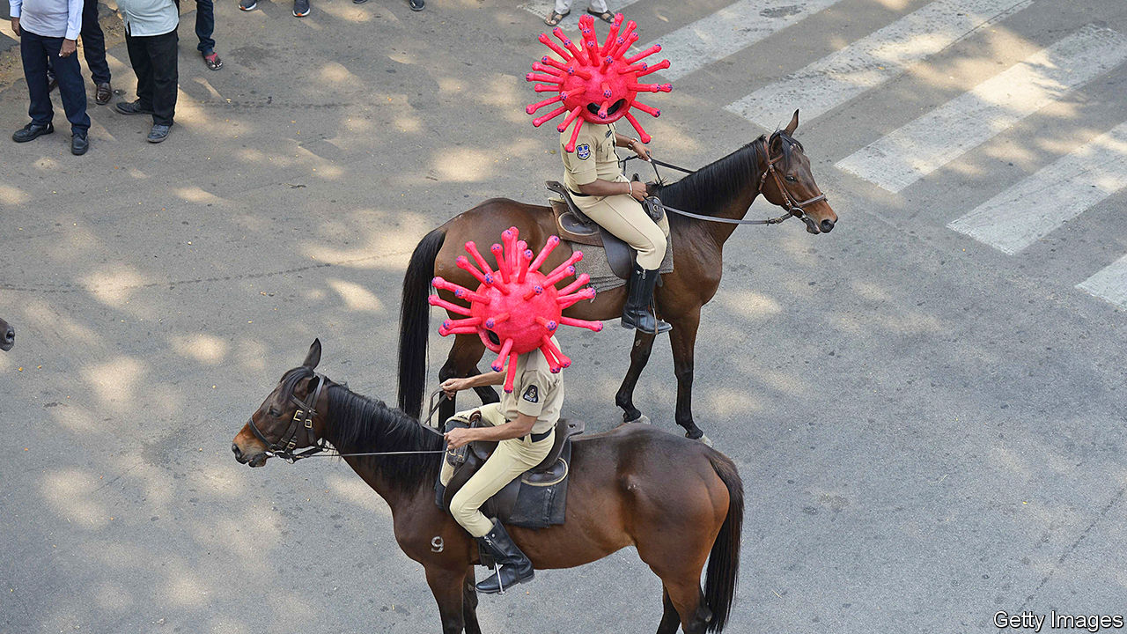

Editor’s note: The Economist is making some of its most important coverage of the covid-19 pandemic freely available to readers of The Economist Today, our daily newsletter. To receive it, register [here](https://www.economist.com/newslettersignup). For our coronavirus tracker and more coverage, see our [hub](https://www.economist.com/coronavirus)

NOT ALL Malaysians are afraid of catching covid-19, judging by the sometimes half-hearted adherence to the national lockdown. But Muhammad Urabil Alias of Kemaman, a town in the state of Terengganu, thinks everyone is scared of a pontianak (the bloodthirsty ghost of a woman who has died in childbirth). Every night he dresses as one and haunts the streets, to deter his neighbours from breaking the curfew. Villagers in Indonesia have hit on a similar tactic, patrolling the streets while dressed as pocong (another type of ghost, trapped in its burial shroud). Rodrigo Duterte, the president of the Philippines, has come up with another variation on the idea of enforcing lockdowns through fear: he has told the police to shoot anyone caught breaking quarantine.

Most Asian governments are more humane. Vietnam’s pioneered the idea of helping people absorb the flood of public-health advisories by making them fun. During the epidemic’s first flush, in February, it commissioned a catchy pop song about hand-washing and social distancing. It later asked a choreographer to come up with a dance to accompany the by-then viral tune. People around the world continue to upload footage of themselves performing the routine on TikTok, a video-sharing platform.

Gurmit Singh, a Singaporean comedian, has released an anti-covid rap. He also sang “Sar-Vivor”, which the government commissioned in 2003, during an outbreak of SARS, to urge Singaporeans to “be safe, not sar-ry”. Now he tells them “wash yo hands” before, among other things, picking their noses.

Cheery traffic police in Hyderabad, the sixth-biggest city in India, have donned coronavirus-shaped helmets to remind people of the perils of leaving home (the main danger in much of India being savage beatings from the police). On government orders, many Indian mobile networks are playing a 30-second public-service announcement before connecting calls. It begins with a cough.

A resort to patriotism is yet another tactic. Streets in Vietnam have been plastered with posters proclaiming, “To stay at home is to love your country”. Le Duc Hiep, their designer, says he mimicked old-fashioned propaganda posters to “invoke patriotic emotions”. Vietnam’s claim to have brought its outbreak under control without a single death is presumably another spur to national pride.

Dig deeper:  
For our latest coverage of the covid-19 pandemic, register for The Economist Today, our daily [newsletter](https://www.economist.com/newslettersignup), or visit our [coronavirus tracker and story hub](https://www.economist.com/coronavirus)

This article was downloaded by calibre from <https://www.economist.com/asia/2020/05/02/some-asian-governments-are-fighting-covid-19-with-fun>

|  |  |  |  |
| --- | --- | --- | --- |
| Previous | Articles | Sections | Next |

|  |  |  |
| --- | --- | --- |
| Asia | Sections | Middle East and ... |

China

Graduate unemployment: Spring freeze

.

Endangered species: Tilting the scales

.

Chaguan: Virus exceptionalism

.

|  |  |  |
| --- | --- | --- |
| Asia | Sections | Middle East and ... |

|  |  |  |  |
| --- | --- | --- | --- |
|  | Articles | Sections | Next |

#### Spring freeze

# In China, millions of students brace for joblessness

The government is anxious, too

May 2nd 2020 | SHANGHAI

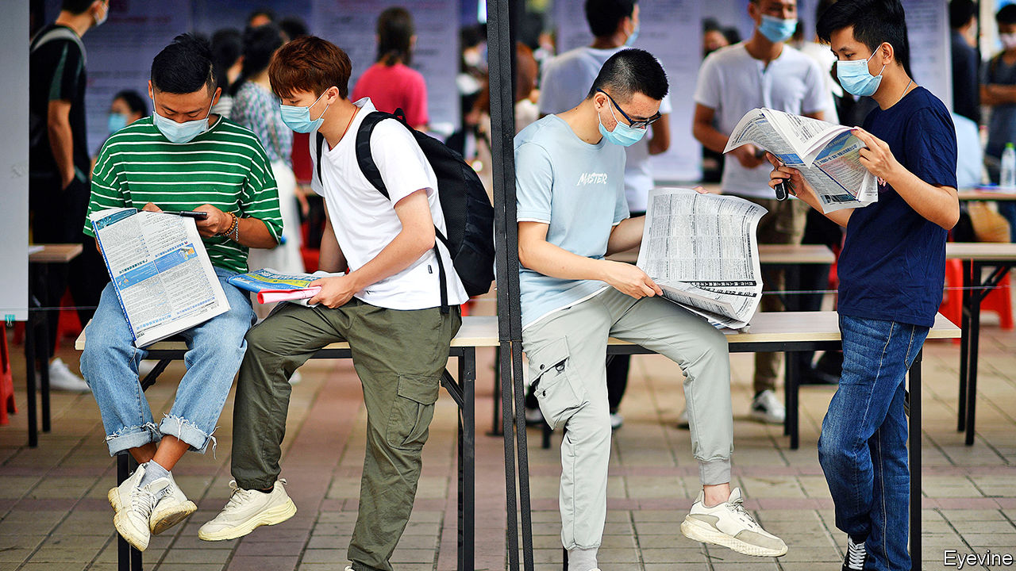

Editor’s note: The Economist is making some of its most important coverage of the covid-19 pandemic freely available to readers of The Economist Today, our daily newsletter. To receive it, register [here](https://www.economist.com/newslettersignup). For our coronavirus tracker and more coverage, see our [hub](https://www.economist.com/coronavirus)

“GRADUATION EQUALS unemployment” has long been a common saying in China (the nouns share a character). It is often used in jest by university students as final exams loom. But for the 9m or so due to graduate in June—a record high—the words convey a dark reality. As China limps back to work after covid-19, their job prospects are truly bleak. They will enter the workforce as prospective employers mull lay-offs or hiring freezes. For a middle class used to relentlessly strong economic growth, the shock will be great.

As it surveys an economy ravaged by the disease, the leadership’s biggest worry is unemployment. In February the urban jobless rate jumped to 6.2%, the highest ever. In March it fell slightly to 5.9% as businesses reopened. But official figures mask the scale of the problem. Urban unemployment could reach 10% this year, reckons the Economist Intelligence Unit, a sister company of The Economist. And that does not include the tens of millions of migrants who sat out the epidemic in their ancestral villages. Many of them now have no jobs to return to in the cities.

China’s leaders describe the problem of graduate unemployment as a matter of “paramount importance”. In recent days university officials around the country have been holding meetings to discuss how to ensure that as many as possible find jobs. They have often used similar language, stressing the “urgency” of this “political task” relating to “social stability”. Jobless migrants make officials anxious, too. But the party frets more about threats involving better-educated people with urban roots and strong social networks.

Last year just over half of entrants to China’s urban workforce were university graduates. Usually about 60% of them would be hired by small- and medium-sized enterprises. But such firms have been among those hardest-hit by the coronavirus. On April 14th Li Keqiang, the prime minister, told his cabinet that the situation for this year’s graduates was “grim”.

Companies normally begin scouring campuses for recruits soon after the spring-festival holiday (another big hiring round takes place in the autumn). This time, however, with universities shut and big gatherings banned, the entire process was “wiped out”, says a business veteran.

Some employers have gone digital, using video interviews and online tests. But many, reeling from the impact of work stoppages and still-tepid consumer demand, have cut hiring. A survey of 1m companies by Peking University’s Guanghua School of Management and Zhaopin, a job-search site, found there were 30% fewer openings in the first quarter compared with last year. Those for fresh graduates in finance fell by more than 50% this spring, according to Boss Zhipin, another recruitment website—even as the number of final-year students searching for a job rose by half. With less competition, firms that are still hiring can pick the best and brightest. But they are also likely to plump for old hands rather than trainees.

Competition for graduate jobs had already grown fierce in recent years, particularly for the most prestigious positions. Now it is cut-throat. Miriam Zhang, a graduate from Weifang, a city in the northern province of Shandong, has sent out 100 applications in the past two months and got responses only to six. One job, she heard, had attracted 3,000 hopefuls.

At least the epidemic has helpfully “weeded out” weak or dodgy companies, Ms Zhang notes. She is now keener than ever to get hired by a big firm, and is mainly searching for openings at state-owned companies. In a survey by China Youth Daily, an official newspaper, more than 60% of respondents said covid-19 had steered them towards “more stable” work. To many that means finding an employer with links to the government.

Officials are trying to satisfy such demand. They have promised more openings in the civil service (not least in rural areas) as well as in the army. They have directed state-owned businesses to boost their recruitment of new graduates. Sinopec, an oil giant, is hiring another 3,500 on top of the 6,600-odd it has already taken on—the most people it has ever signed up in a year. Other state-owned firms are also taking on record numbers. They are giving preference to graduates from Hubei province, where the outbreak began. (This is in response to an appeal from the central government that firms should stop discriminating against Hubei residents, who are often treated with suspicion because of their province’s reputation as a covid-19 disaster zone.) The government has also told universities to offer an additional 200,000 places for graduate studies.

Until recently, job-hunting involving intercity travel was hampered by quarantine-related restrictions. Even though such measures have been eased in most places, hassles remain (see Chaguan). Wang Zheqi, who is meant to graduate this year in Shanghai, had hoped to use her dorm room as a base for job-hunting. Instead she is stuck in her hometown because her university is still closed and she cannot afford off-campus accommodation in Shanghai.

Students did not have to search for jobs until the 1990s. Instead they had to take positions assigned to them by the government. As a result of covid-19, officials are getting more involved in finding work for students than they have been since those days. Xinchao Media, an advertising company, says that the government of Chengdu, the south-western city where the firm is headquartered, has offered to recommend graduates for its job openings. The city of Beijing, among others, has launched a recruitment website for people preparing to graduate.

Many governments are also rewarding firms that hire graduates. In Shanghai, the district of Pudong is offering them subsidies and reduced social-security payments worth up to 2,000 yuan ($282) for each local graduate they take on. Others are giving refunds on social-security contributions to companies that do not lay off workers.

The government is right to worry about social stability. Well-educated young people have been in the vanguard of many of China’s biggest protest movements of the past century. Students whose futures are clouded by the unaffordability of housing and competition for jobs with immigrants from the Chinese mainland were at the forefront of last year’s unrest in Hong Kong. As the covid crisis subsides in China, social tensions are becoming more evident. Hundreds of shop owners recently took to the streets of the southern city of Guangzhou and dozens gathered outside a mall in Wuhan, the capital of Hubei, to demand rent deductions after weeks of unemployment. (Videos of the protests were swiftly removed from the internet.)

Graduating at a time of such economic hardship could be more than just a temporary setback. Studies show that it can have “a huge impact” on lifetime earnings, says Li Jin of the University of Hong Kong. That is because many will go into a different line of work from the one they had hoped to pursue, and for lower pay. In normal times, according to Zhaopin, a third of Chinese graduates aim to earn between 6,000 and 8,000 yuan a month in their first jobs, but fewer than one in five end up doing so. Their disappointment will be far greater this year—and may last well beyond it. ■

Dig deeper:  
For our latest coverage of the covid-19 pandemic, register for The Economist Today, our daily [newsletter](https://www.economist.com/newslettersignup), or visit our [coronavirus tracker and story hub](https://www.economist.com/coronavirus)

This article was downloaded by calibre from <https://www.economist.com/china/2020/05/02/in-china-millions-of-students-brace-for-joblessness>

|  |  |  |  |
| --- | --- | --- | --- |
|  | Articles | Sections | Next |

|  |  |  |  |
| --- | --- | --- | --- |
| Previous | Articles | Sections | Next |

#### Tilting the scales

# Covid-19 has put pangolins in the spotlight

The scaly anteaters may benefit from the attention

May 2nd 2020 |

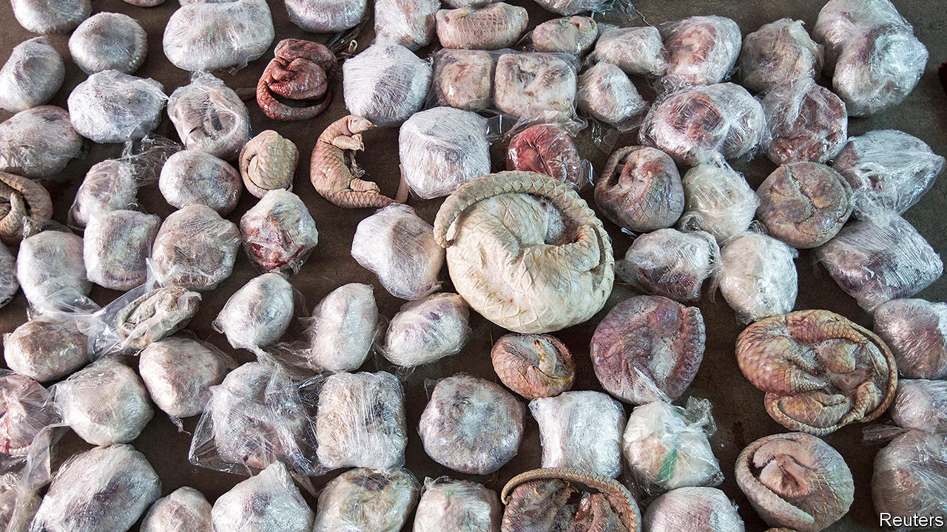

Editor’s note: The Economist is making some of its most important coverage of the covid-19 pandemic freely available to readers of The Economist Today, our daily newsletter. To receive it, register [here](https://www.economist.com/newslettersignup). For our coronavirus tracker and more coverage, see our [hub](https://www.economist.com/coronavirus)

PITY THE pangolin. With its hard covering and ability to roll into a small ball when threatened, the scaly anteater, as it is also known, has an advantage over most predators. But it cannot repel humans. Pangolins, which are endangered, are the most trafficked wild mammals in the world. Most end up in China.

Practitioners of traditional Chinese medicine claim the scales have properties that can help with breastfeeding and poor circulation. Some Chinese consider the flesh a delicacy. Live specimens occasionally appear in China’s wildlife markets. Scientists speculate that a pangolin could have spread the covid-19 virus to humans. This idea has thrust the animals into the global limelight. The attention is badly needed.

Pangolins are found in the wild in several Asian countries, including China. But China’s demand, particularly for scales, has taken a heavy toll on those populations. So the smuggled animals are now mainly from Africa. The UN estimates that the equivalent of 142,000 whole pangolins was seized by various countries in 2018, more than ten times more than in 2014 (when police in the southern Chinese city of Guangzhou found the haul pictured here).

Eating pangolins is illegal in China, but putting their scales into medical concoctions is not. More than 700 hospitals in China are allowed to prescribe pangolin scales, which they can buy from the government. This use provides cover for illegal trading. So too does the government’s approval of pangolin farms. These are an unlikely source for many scales—pangolins are very hard to breed in captivity—but they can help with pangolin-laundering.

Campaigners see encouraging signs. On World Pangolin Day in February, the Communist Party’s main mouthpiece, the People’s Daily, used social media to appeal for pangolin love and to remind people that the scales are no more useful as medicine than human fingernails. That month the government temporarily banned wildlife trading and closed wildlife farms. China’s parliament says it will hold its covid-delayed annual session next month. It may decide to make these measures permanent. But conservationists worry that exceptions for medicine will still be made. In October 2018 China lifted a 25-year ban on the medicinal use of tiger bone and rhino horn. What hope, then, for pangolins?

Dig deeper:  
For our latest coverage of the covid-19 pandemic, register for The Economist Today, our daily [newsletter](https://www.economist.com/newslettersignup), or visit our [coronavirus tracker and story hub](https://www.economist.com/coronavirus)

This article was downloaded by calibre from <https://www.economist.com/china/2020/05/02/covid-19-has-put-pangolins-in-the-spotlight>

|  |  |  |  |
| --- | --- | --- | --- |
| Previous | Articles | Sections | Next |

|  |  |  |  |
| --- | --- | --- | --- |
| Previous | Articles | Sections | Next |

#### Chaguan

# China plans to crush new covid outbreaks with tough measures

They may work, but the cost will be high

Apr 30th 2020 |

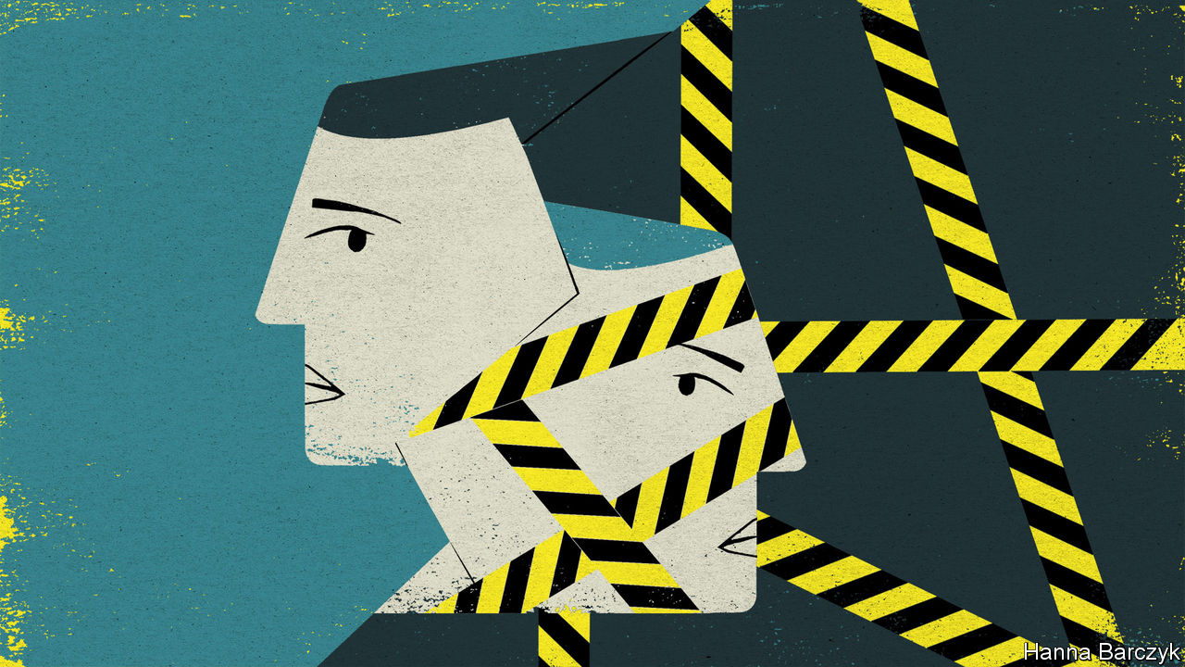

Editor’s note: The Economist is making some of its most important coverage of the covid-19 pandemic freely available to readers of The Economist Today, our daily newsletter. To receive it, register [here](https://www.economist.com/newslettersignup). For our coronavirus tracker and more coverage, see our [hub](https://www.economist.com/coronavirus)

CHINA’S MOST frightening outbreak of covid-19 lurks in Harbin, a north-eastern city known for Russian architecture and a winter festival featuring large castles hewn from river ice. Traced to a Chinese student who flew from America in March, the outbreak has pushed the city of 10m back into semi-lockdown, weeks after a first wave of the virus was defeated in Wuhan, far to the south.

The Chinese authorities are deeply alarmed by imported cases. The country’s borders are closed to almost all foreigners and only about 20 international flights land in all of China each day. Domestically, however, travel bans are being lifted, and businesses and schools urged to resume work. Not in Harbin. Travellers reaching the city from abroad must spend 14 days in government-arranged quarantine, then another 14 in isolation at home. School reopenings have been postponed. A single case in a housing compound condemns every resident there to a fortnight’s quarantine. When those unfortunate neighbours emerge from isolation they may not leave Harbin. That ban is enforced via smartphone apps that must be shown by all domestic travellers.

The world is familiar by now with China’s approach to virus control, combining brute force (breaking transmission chains by preventing Chinese people from meeting others, if needs be for weeks) with high-tech surveillance and contact tracing. The Harbin lockdown is revealing because it was triggered by such a small cluster. At the time of writing, the city has just 63 confirmed cases of covid-19, plus another 17 asymptomatic cases.

Compare Harbin with another chilly, northern city with 63 confirmed cases: Fairbanks, Alaska. Though Alaska has a far higher rate of infections per person than China—Fairbanks is home to just 31,500 people—the state began reopening on April 23rd. Alaska’s Republican governor, Mike Dunleavy, told citizens to incorporate the virus into daily life, saying: “There will be deaths, as there have been with car accidents and cancers and strokes.” In rich countries, politicians and scientists are weighing the economic and social costs of lockdowns. It is increasingly common to hear calls to shelter the old and infirm while letting healthy folk take their chances. The aim is to restart the economy while keeping the current pace of covid infections—the effective reproduction number, or Rt—below a replacement rate of one-for-one, so that cases decline over time and never overwhelm health systems.

China is taking a different path. Alone among large countries with many land neighbours, it wants an Rt as close to zero as possible, and will endure pain to achieve that. To date, the world shows little interest in debating the wisdom or folly of that strategy. One cause may be suspicion of China’s numbers. Western politicians call it naive to believe that China has suffered only 84,000 cases to date, and 4,600 deaths. This when Belgium, a country only a bit more populous than Harbin, has reported 7,200 covid deaths.

True, some official claims are risible, such as a boast in March that the 2m-strong People’s Liberation Army had no virus cases. Nor have any senior officials admitted to being infected, which seems odd. Other numbers are surely undercounts. A new paper in the Journal of Medical Virology, by Yong Feng and others, examines serological tests conducted on 1,402 people at a single hospital in Wuhan in April, after the epidemic’s peak. Most were locals needing test certificates to return to work. Overall, one-tenth tested positive for covid antibodies. Wuhan’s population is 11m. Even allowing for false positives and a sample skewed by the inclusion of almost 400 hospital patients, very large numbers were clearly infected at some point, many without knowing it. Yet a more basic claim—that China is currently free of large, uncontrolled outbreaks—is credible. In Wuhan’s worst weeks, smartphone videos of overwhelmed hospitals were seen by millions of social-media users, before censors deleted them. If a city were in such agonies now, it would leak. China has achieved something worth debating.

The Communist Party is a black box. But some incentives that guide its leaders are knowable. For one thing, maintaining order and keeping people safe is the foundation of the social contract between rulers and the masses. That compact wins public support for a fair amount of sacrifice. Should economic woes endure, the party will stoke nationalism, with even more propaganda reports about incompetence and chaos in the democratic West.

For another thing, covid-19’s first wave almost broke China’s underfunded health system. A paper examining China’s virus response, co-authored by Ruoran Li of Harvard University, finds that any city suffering a Wuhan-like outbreak will need 2.6 intensive-care beds per 10,000 adults. Nationally, China has only about 0.3 such beds per 10,000 people (America has ten times as many).

## Forget flattening the curve, China wants no curve

Another sobering conclusion is drawn by Qifang Bi and others from the Johns Hopkins Bloomberg School of Public Health, writing in Lancet Infectious Diseases. They examine how the large, affluent southern city of Shenzhen traced and isolated contacts of early virus cases. The clever sleuthing worked. But questions about asymptomatic cases missed by surveillance “temper any hopes of stopping the covid-19 pandemic” by tracing and isolation alone, they conclude. Put another way, China may feel obliged to keep imposing lockdowns and border controls for a long time, despite the costs. Whether Chinese rulers come to regret that trade-off may depend on whether an effective vaccine is found soon, says Benjamin Cowling, head of epidemiology at Hong Kong University. “If they can protect people’s health and get a vaccine by the end of the year, then China will look extremely smart,” he argues.

Should others open up, China will look more and more unusual: a giant economy repeatedly slamming on the brakes to smother even small clusters. If effective vaccines or treatments fail to emerge, that cannot be sustainable for ever. Born out of caution, China’s virus exceptionalism is a gigantic gamble. ■

Dig deeper:  
For our latest coverage of the covid-19 pandemic, register for The Economist Today, our daily [newsletter](https://www.economist.com/newslettersignup), or visit our [coronavirus tracker and story hub](https://www.economist.com/coronavirus)

This article was downloaded by calibre from <https://www.economist.com/china/2020/04/30/china-plans-to-crush-new-covid-outbreaks-with-tough-measures>

|  |  |  |  |
| --- | --- | --- | --- |
| Previous | Articles | Sections | Next |

|  |  |  |
| --- | --- | --- |
| China | Sections | Europe |

Middle East and Africa

Zambia: In the pits

.

Sudan: Technical solutions

.

Africa: Leaders and misleaders

.

Yemen’s war within a war: The south rises

.

The war in Libya: A warlord in trouble

.

Saudi Arabia: No more flogging

.

|  |  |  |
| --- | --- | --- |
| China | Sections | Europe |

|  |  |  |  |
| --- | --- | --- | --- |
|  | Articles | Sections | Next |

#### Lungu’s largesse

# Zambia was already a case study in how not to run an economy

Then came covid-19

May 2nd 2020 | JOHANNESBURG

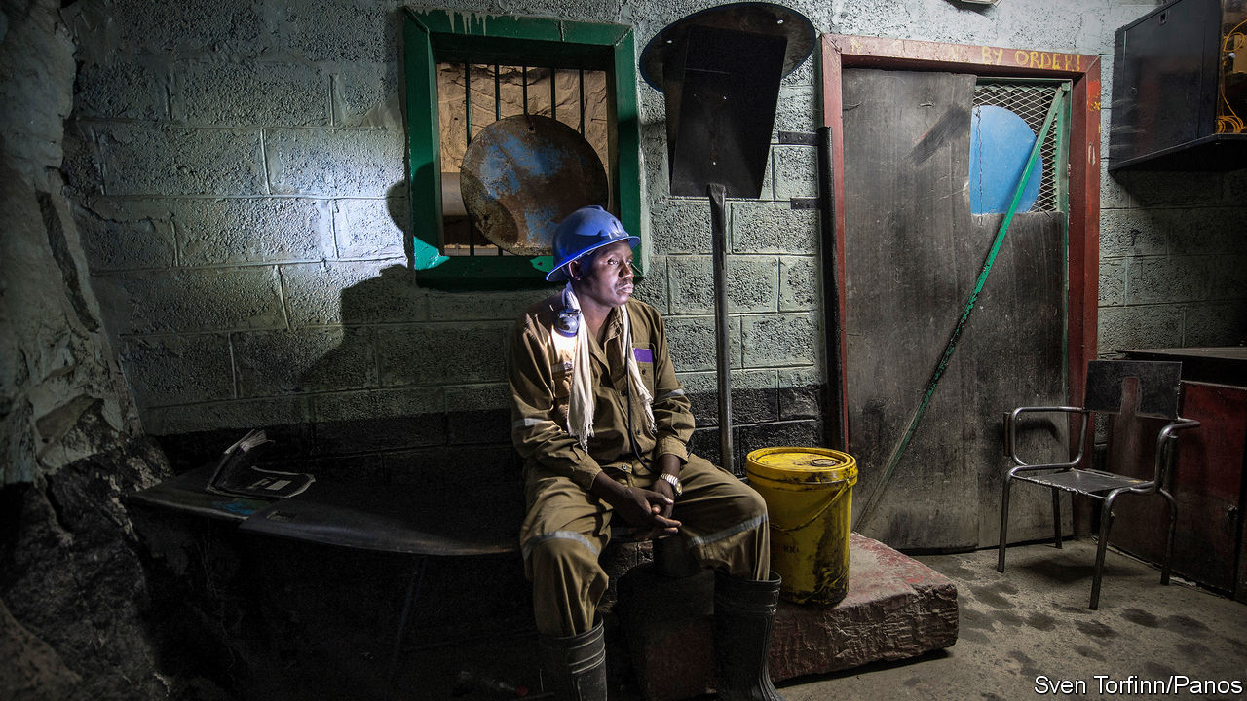

“I FEEL YOUR PAIN,” said Edgar Lungu in a televised address on April 24th. The president of Zambia claimed that covid-19 had “thrown into disarray” the country’s finances. He mused about whether the government could afford to pay for pensions, civil-service salaries and medicine. “Where will the money come from?”

It is a good question. Zambia is arguably the developing country facing the biggest debt crisis in the era of covid-19 (see article). Nearly half of its tax revenues go towards debt service; add the public wage bill and there is little left. In 2019 its budget deficit was 10.9% of GDP. Investors are now pricing its sovereign bonds for default. Though the pandemic has worsened these problems, it did not cause them. Rather, it is Mr Lungu’s profligate politics that have weakened Zambia.

Before his party, the Patriotic Front (PF), took power in 2011, Zambia’s economy was doing rather well. Over the previous two decades the Movement for Multi-party Democracy (MMD) had unpicked the one-party socialism of Kenneth Kaunda, Zambia’s founding president. Copper mines, which generate 75% of the country’s exports, were privatised before the commodity boom of the 2000s. After Zambia was forgiven some loans, its debt as a share of GDP fell from 104% in 2005 to 25% a year later. Economic growth averaged 7.4% a year from 2001 to 2010.

The PF has borrowed heavily, splurging on infrastructure and civil-service pay. In 2015, when Mr Lungu became president, these trends accelerated. Debt in foreign currencies or owed to foreigners tripled between 2014 and 2018 relative to GDP. Compared with the mid-2000s, today’s creditors are more diverse and interest rates are higher. Of the roughly $12bn (51% of GDP) of external debt on Zambia’s books at the end of 2018, about 30% was owed to China, 25% to bondholders and 19% to foreign banks. The World Bank, the IMF and Western governments hold a relatively small share.

Financial management has been calamitous. Often individual departments take out loans and the finance ministry only finds out later, notes Trevor Simumba, a consultant who has written extensively on Zambian debt. This has encouraged, for example, the purchase of a presidential Gulfstream jet and other planes.

Then there are loans that have been authorised but do not yet show up in official figures. These added up to about $10bn in April 2019, according to analysis by the IMF and the World Bank. Most are owed to China for infrastructure. Since these loans may include the underlying asset as collateral, they have led to speculation that any restructuring of Zambian debt to China could involve the handing over of roads, airports or perhaps even mines. (Zambia denies this.)

A short-sighted search for revenue is one reason why Zambia has taken a hostile approach to its mining sector. Taxes on mining are among the highest in the world, says EY, a consultancy. Miners say they are owed more than $1bn in VAT refunds. In May 2019 the government went to court to, in effect, grab Konkola Copper Mines, which is mostly owned by Vedanta, an Indian company. The case rumbles on.

Zambia has picked a strange time for a spasm of resource nationalism. Mining firms, and thus taxes and royalties, have been hit by the collapse in global demand. The price of copper has fallen by 16% this year. Zambia produced more than 800,000 tonnes in 2019; one miner says he would be “astonished” if the country produced more than 700,000 in 2020.

The effects of covid-19 were cited by Glencore when it said on April 7th that it would stop operations at its Mopani mine. Eight days later the firm’s local boss, Nathan Bullock, was stopped from leaving the country and temporarily detained (he has now left). The government is in talks with Glencore over reopening the mine.

On April 20th Bwalya Ngandu, the finance minister, said that Zambia had asked multilateral lenders, including the IMF, for help. Yet the Fund will lend only to countries it believes are getting their borrowing under control. To that end, the finance minister has suspended some projects, advertised for debt advisers to try to renegotiate its commercial loans, and is in talks with Chinese lenders.

Is it enough? Mr Ngandu is a trusted technocrat. But that still leaves Mr Lungu. Under his presidency Zambia has become more corrupt by some international yardsticks. Dodgy procurement deals, from 42 fire engines bought for $1m each to inflated contracts to build roads, have been alleged. The Financial Intelligence Centre, a watchdog, reckoned the value of money-laundering and shady transactions had leapt to $520m in 2018 from $382m in 2017.

Mr Lungu is also becoming more authoritarian. In 2017 Hakainde Hichilema, an opposition politician, was detained for four months on charges of endangering the president after not making way for his motorcade. In March Prime TV, an independent channel, had its licence suspended. Most worrying is a bill before parliament that would give sweeping powers to the presidency. Muna Ndulo, a Zambian law professor at Cornell University, calls it a recipe for a “constitutional dictatorship”.

The president is eyeing re-election in August 2021. He may struggle in a fair fight against Mr Hichilema; previous votes have been marred by allegations of rigging. His stance on mines is partly to shore up support in the copper belt, a former PF stronghold where it lost a by-election in 2019.

His reluctance to put a stop to borrowing for pet projects reflects his concern that he may not win his party’s nomination in July. Mr Lungu was a compromise candidate after the death of Michael Sata in office in 2014. But members of the large Bemba ethnic group, who were pre-eminent under Sata, have become frustrated with the president. Mr Lungu, who is from the smaller Nsenga group, is accused of favouring other ethnicities. Some Bemba want Mr Ngandu to take over.

Mr Lungu has been somewhat unlucky. Disease and drought have both hurt the economy. Being a landlocked country at a time of closed borders is difficult. But it is not the virus that has got Zambia into this mess. It is the president. ■

This article was downloaded by calibre from <https://www.economist.com/middle-east-and-africa/2020/05/02/zambia-was-already-a-case-study-in-how-not-to-run-an-economy>

|  |  |  |  |
| --- | --- | --- | --- |
|  | Articles | Sections | Next |

|  |  |  |  |
| --- | --- | --- | --- |
| Previous | Articles | Sections | Next |

#### Technical foul

# How Sudan’s warlords buy their gun trucks

Despite the carmakers’ objections, it is not hard

May 2nd 2020 |

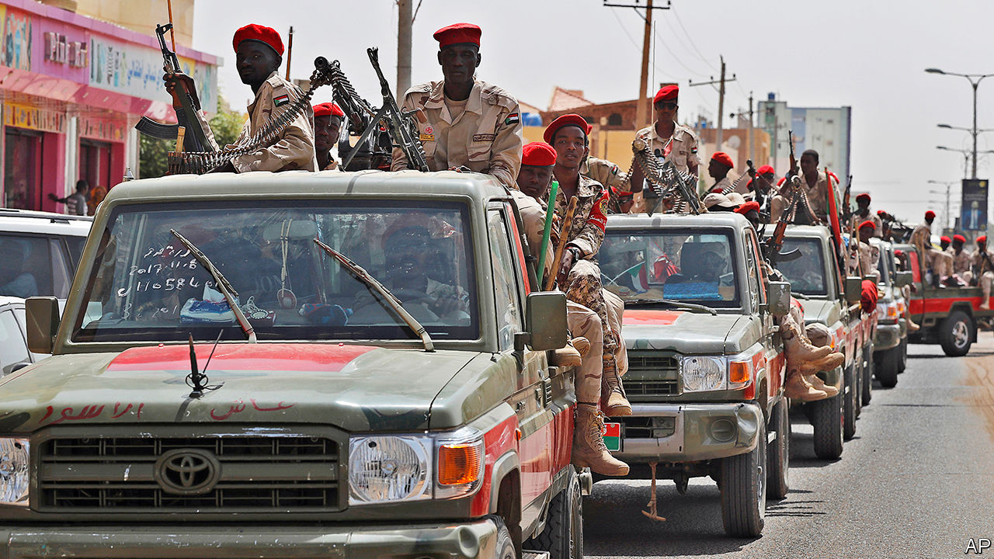

THE TOYOTA HILUX is a sturdy vehicle. That makes it especially popular in Africa. It outsells all other pickup trucks, or “bakkies”, in South Africa. In Mali and Niger smugglers transporting people and goods across the Sahara will accept no alternative, since they can cram 30 people onto one and can still climb a sand dune. It is also a familiar sight in African war zones, as the vehicle of choice for anyone who wants to create a “technical”—a pickup truck with a machine gun mounted on the back.

This is not the kind of publicity that Toyota craves. The firm says it has “a strict policy” not to sell vehicles to those “who may use or modify them for paramilitary or terrorist activities”. But this is hard to enforce. Buyers do not say: “I’m going to mount a gun on it.”

On April 5th Global Witness, a watchdog, published a study showing how at least one paramilitary group, Sudan’s Rapid Support Forces (RSF), a semi-official band of thugs with roots in the Darfur conflict, bought more than 1,000 Toyota Hiluxes and Land Cruisers to convert into technicals. Many such were seen at roadblocks last year after a bloody massacre of civilian protesters. The purchases hint at the worrying way in which power in Sudan is still a function of access to money and weapons, a year after the revolution that overturned the 30-year dictatorship of Omar al-Bashir.

Global Witness acquired a spreadsheet that seems to have been made by the RSF to track its purchases. By checking pictures of RSF technicals on social media, ship manifests and satellite imagery, Global Witness claims it was able to corroborate the information in it. The organisation claims that the RSF bought Toyota pickup trucks in the Gulf through two RSF front companies that are also linked to gold trading. This is a business in which the RSF’s commander, Mohamed Hamdan Dagalo (known as “Hemedti”), has a big interest. Despite the militia’s official status the money used to pay for the vehicles seems not to have come from the Sudanese state.

Mr Bashir’s government was built almost entirely on violence and patronage. Many hope that his fall will lead to a civilian-led government and democracy. But the transition remains fragile. Real power, which grows out of the barrels of guns mounted on technicals, is still in the hands of the army and RSF.

This article was downloaded by calibre from <https://www.economist.com/middle-east-and-africa/2020/05/02/how-sudans-warlords-buy-their-gun-trucks>

|  |  |  |  |
| --- | --- | --- | --- |
| Previous | Articles | Sections | Next |

|  |  |  |  |
| --- | --- | --- | --- |
| Previous | Articles | Sections | Next |

#### Leaders and misleaders

# Some African politicians risk spreading covid through quackery

Most follow the science, but some have turned to herbs or prayer

May 2nd 2020 | JOHANNESBURG

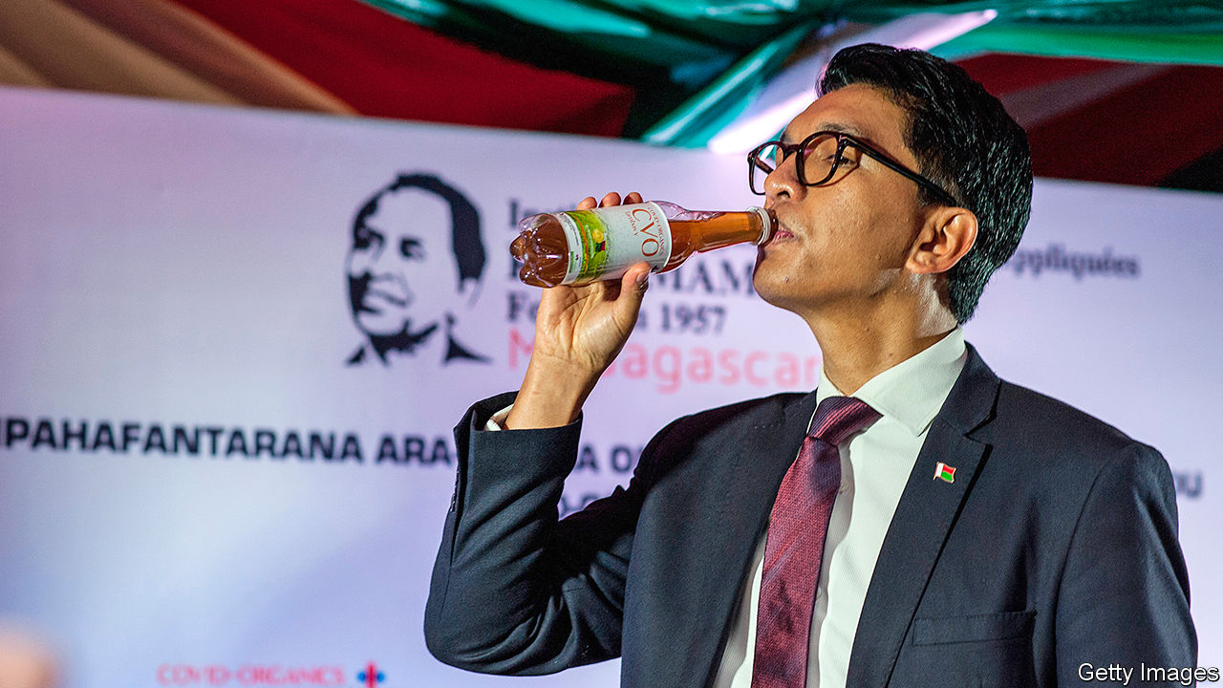

Editor’s note: The Economist is making some of its most important coverage of the covid-19 pandemic freely available to readers of The Economist Today, our daily newsletter. To receive it, register [here](https://www.economist.com/newslettersignup). For our coronavirus tracker and more coverage, see our [hub](https://www.economist.com/coronavirus)

MANY AFRICAN politicians are fighting covid-19 with tools prescribed by science. South Africa’s president, Cyril Ramaphosa, surrounds himself with top-notch boffins. Salim Abdool Karim, the government’s chief adviser on the pandemic, is often likened to Anthony Fauci, America’s voice of reason on the subject.

George Weah, Liberia’s president, is trying hard to disseminate public-health tips in ways that are both easy to understand and memorable. The former football star has released a ballad about covid-19, featuring medically accurate lyrics such as: “People catch the virus when they touch their infected hands to their mouth, nose or eyes.” In the accompanying video, Mr Weah dresses in sepulchral white and sways to a funky beat. In a country where many people are illiterate, setting medical advice to music makes a lot of sense.

Some other Big Men’s approaches do not. Andry Rajoelina (pictured), Madagascar’s president, says the island of 26m people has a herbal remedy that will “change the course of history”. Covid-organics, as the herbal potion is known, is meant to cure covid-19. But scientists doubt it. “It’s likely that it could actually harm the health of the population,” says Marcel Razanamparany, the spoilsport president of the country’s Academy of Medicine.

In Guinea, President Alpha Condé recommends drinking hot water and inhaling menthol. Nairobi’s governor, Mike Sonko, has distributed miniature bottles of Hennessy, or as he calls it, “throat sanitiser”. (Hennessy has felt obliged to deny that its brandy has antiviral qualities.)

Some leaders trust in God to stop the virus. John Magufuli of Tanzania insists that “we are not closing places of worship. That’s where there is true healing.” Burundi needs no lockdown “because it is a country that has put God first,” says a spokesman for the president, Pierre Nkurunziza.

On the plus side, no African president has recommended injections of disinfectant or suggested that scientists investigate whether doses of ultraviolet light inside the body can kill the virus. But bad advice from clueless Big Men may still cost lives. It will also undermine commerce. On April 29th it was reported that the implementation of the African Continental Free Trade Agreement was being postponed from the scheduled date of July 1st. If some countries fail to control the virus there could be further delays. That would then make it harder for African countries to sell goods to one another—including not only herbal remedies but also useful products. ■

Dig deeper:  
For our latest coverage of the covid-19 pandemic, register for The Economist Today, our daily [newsletter](https://www.economist.com/newslettersignup), or visit our [coronavirus tracker and story hub](https://www.economist.com/coronavirus)

This article was downloaded by calibre from <https://www.economist.com/middle-east-and-africa/2020/05/02/some-african-politicians-risk-spreading-covid-through-quackery>

|  |  |  |  |
| --- | --- | --- | --- |
| Previous | Articles | Sections | Next |

|  |  |  |  |
| --- | --- | --- | --- |
| Previous | Articles | Sections | Next |

#### The war within a war

# Separatists and Yemen’s government are at it again

Ostensible allies continue to tussle over Aden

May 2nd 2020 | BEIRUT

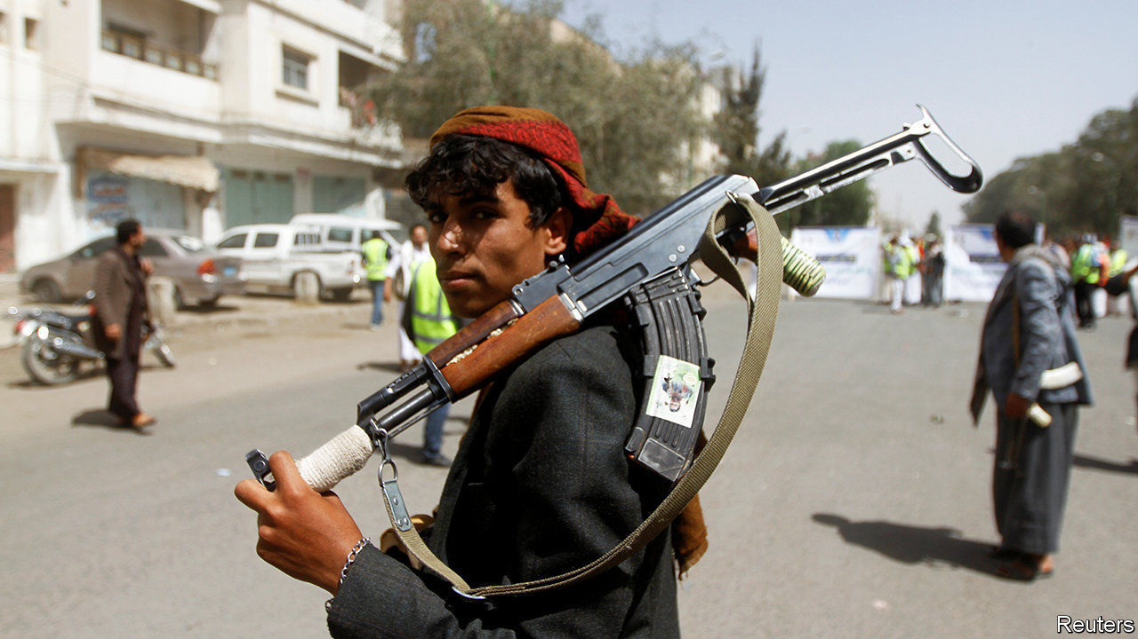

WHEN IT INTERVENED in Yemen’s civil war, Saudi Arabia hoped to make quick work of the Houthis, an Iranian-backed group that had swept down from the northern highlands to seize the capital, Sana’a. Five years later the Houthis are still in control—and Saudi Arabia cannot even corral its own allies. One is the government, which the Saudis are trying to restore. Another is the Southern Transitional Council (STC), a separatist group, which declared “self-administration” in southern Yemen on April 25th.

Exactly what the council meant is unclear. Fighters seized government offices, including the central bank, and drove through the streets waving the flag of South Yemen, a sovereign state until 1990. But the governors of several nearby provinces, including Hadramawt, the south’s largest, rejected the idea of renewed autonomy. The STC’S declaration will probably spark more infighting among erstwhile partners.

The south has long had a restive streak. Britain set up a base in Aden, a refuelling stop on the passage to India, and ruled it until 1967, when a local rebellion forced it out. After winning independence South Yemen became the Arab world’s only formally communist state. But unification with the north in 1990 created new grievances. Many southerners came to resent the government in Sana’a for its corruption and perceived bias. Money and power flowed north while Aden, the former capital of the south, was neglected. Its disrepair was clear in mid-April, when heavy rains caused floods that killed at least 14 people.

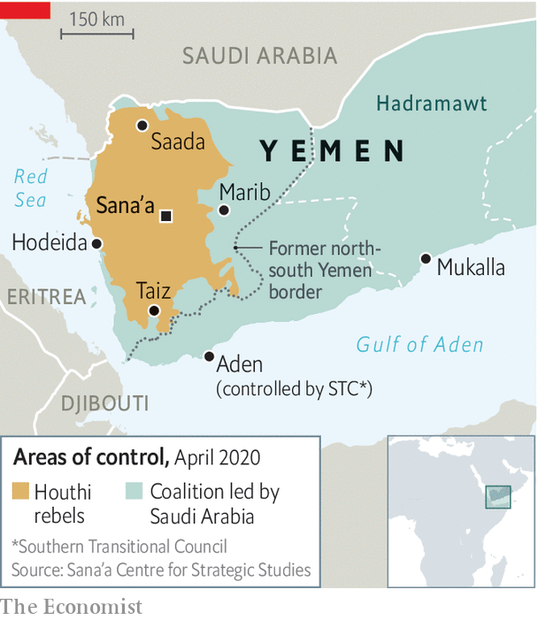

Still, the STC aligned itself with the Saudi-led coalition. The Houthis enjoy little support in the south, where they are seen as interlopers from a different religious and tribal background. The United Arab Emirates (UAE), which led the fighting in the south, put separatist fighters on its payroll. But last summer, tired of the long campaign, the UAE withdrew most of its troops.

The STC took advantage of the vacuum to seize Aden, then controlled by the government. A peace deal in November, brokered by the Saudis, tried to end the rift. It nominally put the southern forces under the command of Abd Rabbo Mansour Hadi, the exiled president. Like most peace agreements in Yemen, though, the deal was longer on symbolism than substance. The council says that its fighters have not been paid in months and that supplies of weapons and food are scarce on the front lines. Public anger over the floods may have informed its decision to break away, which could be a ploy to squeeze the kingdom.

Officially Saudi Arabia still wants a united Yemen led by Mr Hadi. Quietly, though, some Saudis wonder if southern secession would be acceptable, given local hostility towards the Houthis. One problem is that the STC does not enjoy universal support outside Aden: local tribes might chafe at its rule, as might the Giants’ Brigade, a powerful Salafist-led militia.

Even if the STC could consolidate power, secession would further immiserate the north. The southern provinces hold Yemen’s modest oil reserves, its Arabian Sea coastline and much of its arable land. The north would keep its long, porous border with Saudi Arabia—and gain another reason for hostility towards the kingdom. ■

This article was downloaded by calibre from <https://www.economist.com/middle-east-and-africa/2020/05/02/separatists-and-yemens-government-are-at-it-again>

|  |  |  |  |
| --- | --- | --- | --- |
| Previous | Articles | Sections | Next |

|  |  |  |  |
| --- | --- | --- | --- |
| Previous | Articles | Sections | Next |

#### A warlord in trouble

# Khalifa Haftar is losing ground and lashing out in Libya

The government in Tripoli has made big gains against the rebellious general

May 2nd 2020 |

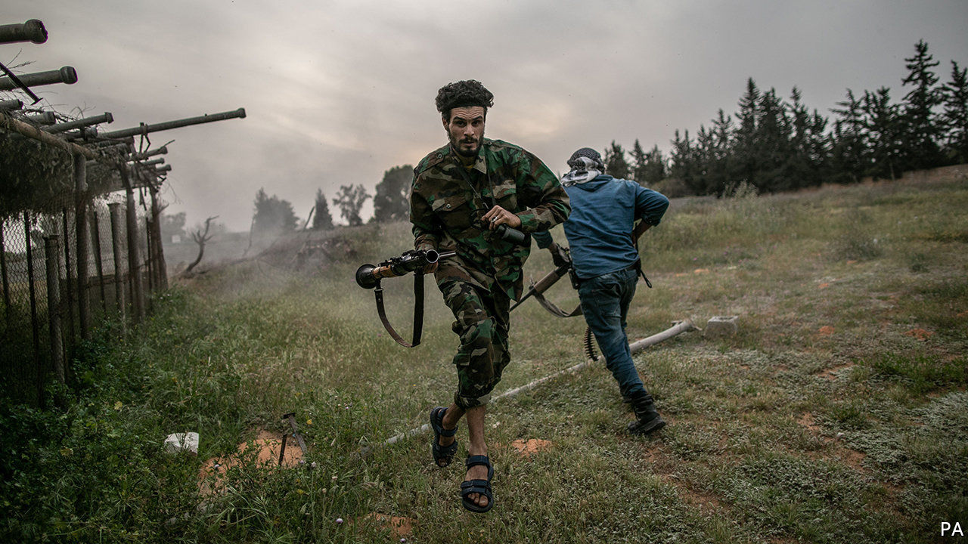

KHALIFA HAFTAR’S self-styled Libyan National Army (LNA) says it will cease fire for what remains of the holy month of Ramadan. But friends of General Haftar say he is doubling down on the civil war he started six years ago. His year-long siege of Tripoli, seat of the UN-backed Government of National Accord (GNA), has intensified of late. Groups loyal to him have messed with the city’s power and water supplies. The LNA’s shells have hit hospitals. “It’s hard to believe it’s not deliberate,” says a diplomat. In the east General Haftar is trying to consolidate his power. On April 27th he claimed a “popular mandate” for his LNA and placed the region under military rule.

These moves cannot hide the fact that, for the first time in a while, General Haftar is on the back foot. Militias aligned with the GNA and backed by Turkey have regained a string of cities connecting Tripoli to the Tunisian border. They have hemmed the LNA inside al-Watiya air base, its headquarters for western operations, and are besieging Tarhuna, one of its strongholds (see map). The loss of these positions could doom General Haftar’s campaign in the west and lead to Libya’s partition.

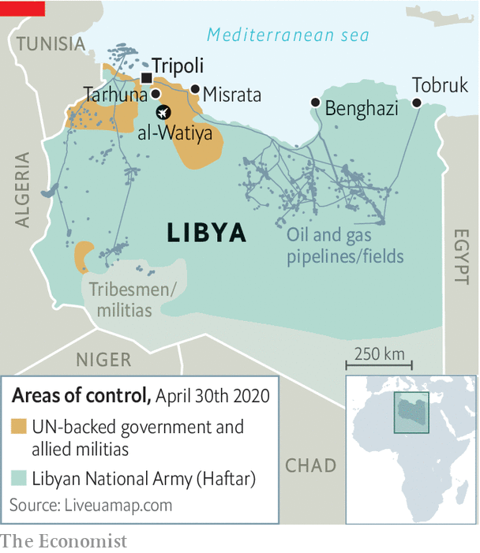

Until recently General Haftar had the edge, thanks to covert backing from Egypt, France, Russia and the United Arab Emirates (UAE). But Recep Tayyip Erdogan, the president of Turkey, is challenging their influence in the eastern Mediterranean. In November he signed a pact with the GNA’s prime minister, Fayez al-Serraj, committing to defend Tripoli in exchange for gas-exploration rights in Libya’s waters. Since then Turkish arms and intelligence, as well as 4,000 fighters from Turkish-controlled parts of Syria, have shifted the balance on the ground in Libya. From the sky Turkish drones have been striking General Haftar’s long supply lines.

In January forces loyal to General Haftar seized Libya’s eastern oil terminals, blocking exports, which account for almost all state revenues. But this has put a strain on him, too. The central bank, which collects the revenues, pays consumer subsidies and the salaries of government workers across Libya. Officials in the east say their coffers may be empty by June. “The general is holding a gun to his own head,” says Tim Eaton of Chatham House, a think-tank based in London.

In the east General Haftar stokes fear of a Turkish-backed Islamist threat. But Tripoli is 1,000km away. Many of the east’s 2m or so people, though hungry for more autonomy, grumble about the high cost of the war. The LNA consumes a third of the east’s budget. Some 7,000 of its men have been killed in the past year. “Every family has lost someone,” says Muhammad Eljarh, an analyst in the city of Tobruk. Most are too scared of the general’s goons to criticise. But on April 23rd Aguila Saleh, a powerful politician in the east, unveiled a peace plan endorsed by the UN. Four days later General Haftar made his announcement.

The general’s backers sound tired of him, too. “We do not approve the statement that Field-Marshal Haftar will now single-handedly decide how the Libyan people should live,” said Sergei Lavrov, Russia’s foreign minister. Russia and others are preoccupied with covid-19 and may be questioning whether access to Libya’s oil is worth all the trouble given lower prices. Still, Russia has sent mercenaries to fight the GNA, and the UAE’s support for General Haftar is increasing.

The warlord is unlikely to receive a knockout blow. The militias that support the GNA are too quarrelsome and undisciplined to mount a sustained campaign. Misrata, home to some of the most powerful armed groups, supports the GNA but is a separate centre of power.

Meanwhile, the head of the UN mission in Libya, Ghassan Salame, bowed out in March. “I can no longer continue with this level of stress,” he said. His successor, as yet unnamed, will be the fourth person to hold the job since 2014. Trying to put Libya back together is an exhausting task. ■

This article was downloaded by calibre from <https://www.economist.com/middle-east-and-africa/2020/05/02/khalifa-haftar-is-losing-ground-and-lashing-out-in-libya>

|  |  |  |  |
| --- | --- | --- | --- |
| Previous | Articles | Sections | Next |

|  |  |  |  |
| --- | --- | --- | --- |
| Previous | Articles | Sections | Next |

#### Reform, Saudi style

# Saudi Arabia stops flogging

And vows no longer to execute people for crimes committed as children

May 2nd 2020 |

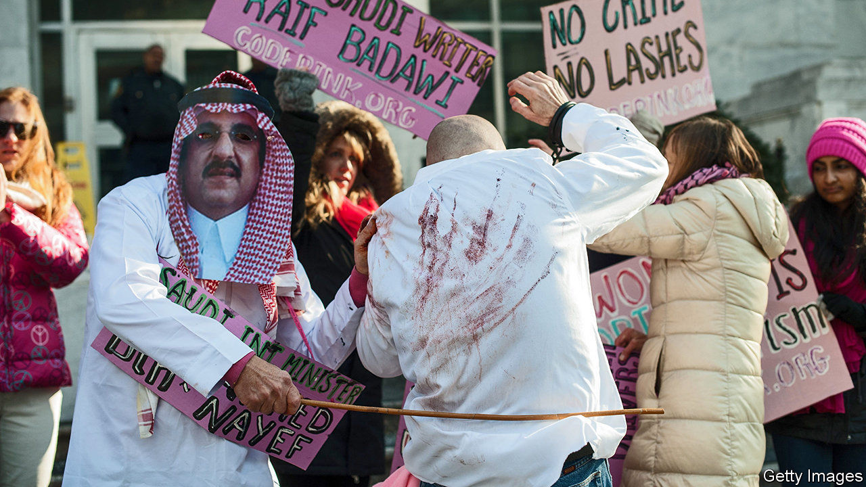

“THE FORNICATRESS and the fornicator—flog each of them with a hundred stripes; and do not let pity for them hold you back from carrying out God’s law.” So says the Koran, which dates back to the seventh century. Prince Muhammad bin Salman, the de facto ruler of Saudi Arabia, is trying to drag the kingdom into the 21st. So on April 25th the government banned flogging as a punishment, to the relief of blasphemers, adulterers and liberals. A day later it said it would stop executing people for crimes committed when they were children.

This is merely Prince Muhammad’s latest push to modernise. Since his elderly father, Salman, became king in 2015, the crown prince has curbed the morality police, allowed women to drive and lifted a ban on cinemas. The public is pleased; clerics, not so much.

The new decrees challenge the clerics in an area where they may be reluctant to take orders: the implementation of sharia (Islamic law). Since the kingdom was founded in 1932 they have administered justice based on their knowledge of scripture. Prince Muhammad, though, is mulling a plan to codify penal law. Eventually he may even allow the appointment of judges who consider a woman’s testimony equal to that of a man, instead of worth half as much, as is currently the case. Some clerics are quietly calling the prince an enemy of Islam.

Liberals may cheer, but Prince Muhammad is concentrating ever more power in his own hands—and compassion is not his strong suit. He has thrown thousands of people into jail, including an uncle and a cousin (a potential rival for the throne), as well as campaigners for democracy and women’s rights. Minors may be spared, but the rate of executions has doubled on the prince’s watch. The kingdom set a record last year with 184. (The number of extrajudicial killings is unknown.)

Capital punishment is falling out of favour in much of the world, but not in the Middle East. Last year Iran, Iraq and Saudi Arabia carried out over 80% of all executions outside China, says Amnesty International, a watchdog. Executions in Iraq increased by 92%. In Saudi Arabia, convicts will no longer be sentenced to flogging, but some are still beheaded with a sword.

This article was downloaded by calibre from <https://www.economist.com/middle-east-and-africa/2020/05/02/saudi-arabia-stops-flogging>

|  |  |  |  |
| --- | --- | --- | --- |
| Previous | Articles | Sections | Next |

|  |  |  |
| --- | --- | --- |
| Middle East and ... | Sections | Britain |

Europe

Lockdowns and trust: Infectious doubt

.

Germany: The explainer-in-chief

.

Italy: In need of assistance

.

Covid tech: Protocol politics

.

Politics in Ukraine: Is the man from Georgia back?

.

Norway’s sovereign-wealth fund: How not to hand over to your successor

.

Charlemagne: Emmanuel and the three costumes

.

|  |  |  |
| --- | --- | --- |
| Middle East and ... | Sections | Britain |

|  |  |  |  |
| --- | --- | --- | --- |
|  | Articles | Sections | Next |

#### Infectious suspicion

# Do low-trust societies do better in a pandemic?

When you don’t trust your neighbours to wash their hands, you stand farther away

May 2nd 2020 | AMSTERDAM AND BUCHAREST

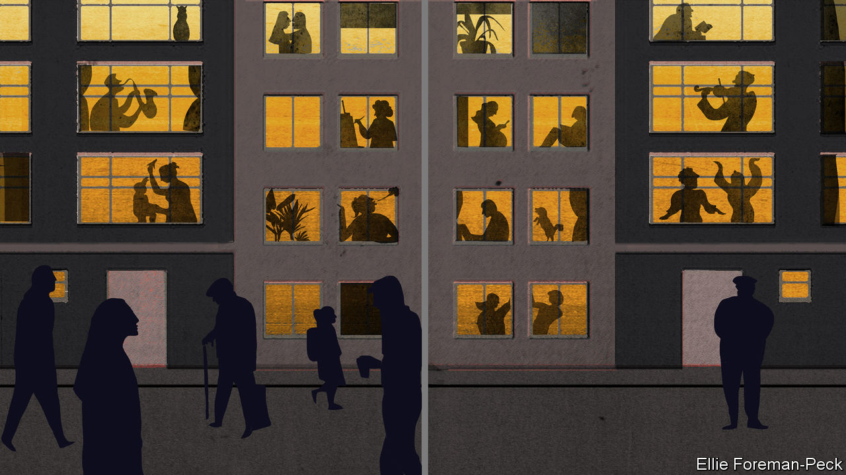

Editor’s note: The Economist is making some of its most important coverage of the covid-19 pandemic freely available to readers of The Economist Today, our daily newsletter. To receive it, register [here](https://www.economist.com/newslettersignup). For our coronavirus tracker and more coverage, see our [hub](https://www.economist.com/coronavirus)

SURVEYS CONSISTENTLY find that residents of north-western Europe trust their governments and fellow citizens quite a lot, while those in southern and eastern Europe do not. When the World Values Survey (WVS) asks Swedes whether most people can be trusted, more than 60% answer yes. In Italy only about 30% do so, and in Romania a mere 7%. Another study, the European Social Survey (ESS), asks respondents to rate their trust in politicians on a ten-point scale. In 2018 the Dutch averaged 5.4, the Poles 3.1 and the French and Germans in between. One in eight Bulgarians gave their politicians a zero.

Such results reflect deep sociocultural differences. Higher trust correlates with greater wealth, less crime and other metrics of well-being. It also seems to influence responses to covid-19. Trusting countries have generally implemented less stringent lockdowns. Rather than harshly enforcing social-distancing rules, their governments rely on citizens to observe guidelines voluntarily. Which method is better? The answer is complicated.

Take Romania, where a brutal communist dictatorship followed by decades of corruption has left citizens suspicious of institutions and each other. Unable to rely on public goodwill, the government responded to covid-19 with a harsh lockdown, declaring a state of emergency even before the country’s first official death. Written declarations of purpose are required to leave home. From March 24th to April 19th police issued 200,000 fines (worth $85m) to scofflaws.

Most Romanians are practicing social distancing, says Barbu Mateescu, a Romanian sociologist. The fines are not the only reason. Few trust the country’s decrepit health system to treat them if they get the virus. Some recall food shortages in the 1980s, and were quick to shift into crisis mode. Mr Mateescu calls them “uniquely equipped in Europe” to deal with hardship.

Like Romania, many low-trust eastern European countries locked down hard and fast. Serbia, Greece and other Balkan states imposed curfews. Croatia requires a government-issued pass to travel between towns. Poland, among the first countries to shut its borders, bars children under 13 from leaving home without an adult. Shoppers must wear disposable gloves, and face-masks are required in public.

Such quick, tough responses have helped spare eastern Europe the worst of the pandemic. Confirmed death rates in Poland and Romania are less than a tenth those in hard-hit countries such as France, Italy and Spain. Lower testing rates account for only a fraction of the difference.

In western Europe, unsurprisingly, lockdowns are toughest where the pandemic is deadliest. In France, Italy and Spain, public gatherings and social visits are barred, non-essential enterprises are shut and parks and beaches are closed. In France outdoor exercise is allowed within 1km of home; in Italy the limit is 200 metres, and Spain has banned it until May 2nd. French police had issued over 400,000 fines for violating confinement rules by April 3rd. In Spain the total has reached nearly 800,000, with almost 7,000 arrests.

Less obviously, these harsh lockdowns reflect widespread distrust. Even fewer French and Spanish than Italians think most people can be trusted: about 20%, similar to Poland. Some 25-30% trust the government, half as many as in Sweden. Some approve of tough rules because they mistrust fellow citizens. As a news kiosk owner in Madrid put it: “It’s a necessary evil. People here are all kisses and hugs, they eat paella from the same spoon.”

If low-trust countries in the east are doing better than those in the west, it is partly luck. Eastern Europe was generally faster to adopt tough measures, says Thomas Hale, a political scientist at Oxford who helped assemble an index of the stringency of covid-19 responses. But that could be partly because the virus got there later, and Italy served as a warning.

Meanwhile, citizens of Europe’s high-trust countries have had it relatively easy. Germany has had little confrontational policing. The Netherlands implemented what it terms an “intelligent lockdown”, closing schools and restaurants but allowing socialising with up to three visitors. There are no limits on circulating outdoors other than staying 1.5 metres apart. Mark Rutte, the prime minister, says people are “treated as adults, not as children”.

As for Sweden, it has no lockdown at all. Schools and restaurants are open, though citizens are advised to avoid non-essential travel. “We use the phrase ‘freedom under responsibility’,” says Lars Tragardh, a Swedish historian. On Mr Hale’s index Sweden and Germany were the only EU countries that never reached maximum stringency.

The Swedes and Dutch are following government recommendations: mobility is down by about 40%, according to Google data. But in France and Italy it is down about 80%. Worryingly, Dutch and Swedish covid-19 mortality rates outstrip those in neighbouring countries. The Dutch death rate per head is almost four times that in Germany. Sweden’s is double that in Denmark, which has a tight lockdown.

This suggests that during epidemics trust is a double-edged sword. High-trust countries will probably do better economically, as they usually do. But in public-health terms, high trust may have lulled Dutch and Swedes into a false sense of security. For now, most are satisfied with their governments’ responses. But so are most Romanians. Perhaps that will help to close Europe’s trust gap. ■

Dig deeper:  
For our latest coverage of the covid-19 pandemic, register for The Economist Today, our daily [newsletter](https://www.economist.com/newslettersignup), or visit our [coronavirus tracker and story hub](https://www.economist.com/coronavirus)

This article was downloaded by calibre from <https://www.economist.com/europe/2020/05/02/do-low-trust-societies-do-better-in-a-pandemic>

|  |  |  |  |
| --- | --- | --- | --- |
|  | Articles | Sections | Next |

|  |  |  |  |
| --- | --- | --- | --- |
| Previous | Articles | Sections | Next |

#### Fighting microbe with mike

# Christian Drosten, Germany’s covid-19 explainer-in-chief

A virologist’s podcast helps Germans make sense of the pandemic

May 2nd 2020 |

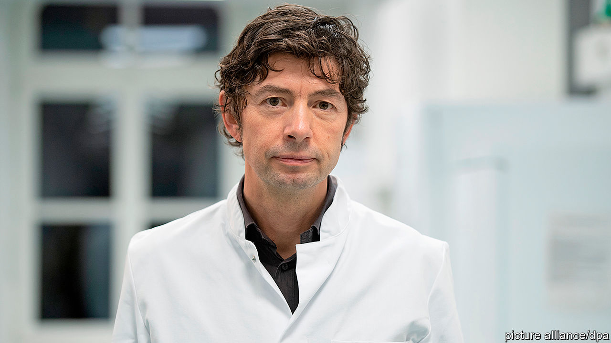

Editor’s note: The Economist is making some of its most important coverage of the covid-19 pandemic freely available to readers of The Economist Today, our daily newsletter. To receive it, register [here](https://www.economist.com/newslettersignup). For our coronavirus tracker and more coverage, see our [hub](https://www.economist.com/coronavirus)

CHRISTIAN DROSTEN of Berlin’s Charité—Germany’s most renowned hospital—knows a thing or two about going viral. Despite his busy schedule advising Chancellor Angela Merkel and her government, Charité’s head of virology has regularly spoken with two journalists from NDR, a public broadcaster, since February 26th. Their 30-minute-plus podcast went out every weekday for the first six weeks of the crisis, and still goes out twice a week.

When the podcast launched, Germany had just 21 recorded cases of covid-19 and the producers planned just ten to 15 episodes. There have now been 161,539 cases, and 36 episodes to date, which together have received 34m plays. It is the most popular podcast in Apple’s iTunes store across Germany and Austria, and number two in Switzerland.

Dr Drosten’s credentials are second to none. He was part of the team that discovered SARS in 2002 and on January 13th his team released a new diagnostic test for covid-19, since adopted by medical practitioners from Lithuania to Iran. His inimitably Germanic explanations can span five minutes or more, something which the producers say he insisted on prior to launch.

His appeal to Germans is similar to that of Mrs Merkel. Both are measured speakers with scientific backgrounds (she has a PhD in physics). But despite that their fans are often younger than one would expect. Memes of Dr Drosten and GIFs of Mrs Merkel, who occasionally appear at press conferences together, have lit up social-media channels frequented by the young.

Dr Drosten is also good at anecdotes, talking about his father, who wondered how social distancing would affect his shooting-club celebrations, or the struggles of balancing child care and work. And he admits to having enjoyed a drink at the pub before they closed down—but always from the bottle, as it is more hygienic. Of course.

Dig deeper:  
For our latest coverage of the covid-19 pandemic, register for The Economist Today, our daily [newsletter](https://www.economist.com/newslettersignup), or visit our [coronavirus tracker and story hub](https://www.economist.com/coronavirus)

This article was downloaded by calibre from <https://www.economist.com/europe/2020/05/02/christian-drosten-germanys-covid-19-explainer-in-chief>

|  |  |  |  |
| --- | --- | --- | --- |
| Previous | Articles | Sections | Next |

|  |  |  |  |
| --- | --- | --- | --- |
| Previous | Articles | Sections | Next |

#### In need of assistance

# An interview with Luigi Di Maio

Italy’s foreign minister is pressing the EU to be generous

May 2nd 2020 | ROME

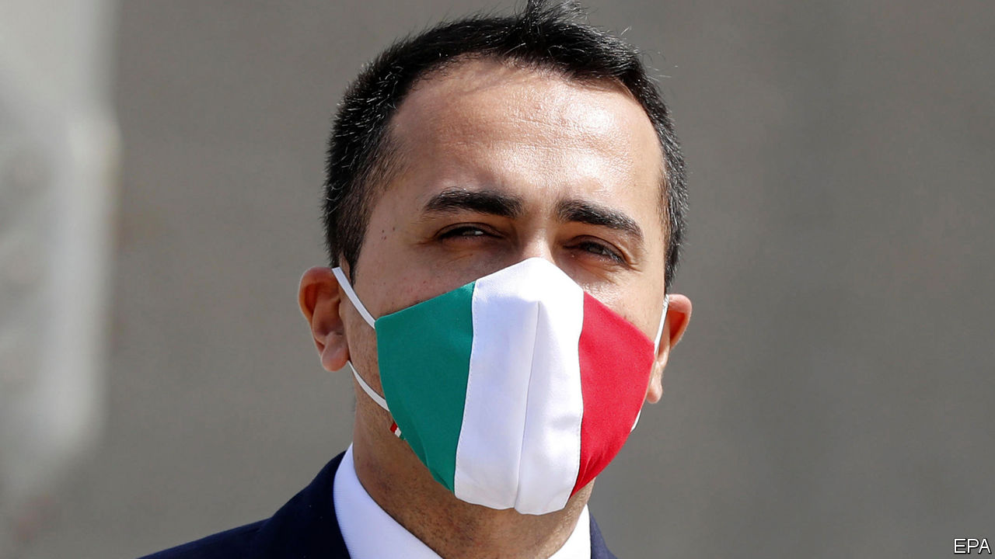

YOU MIGHT expect Italy’s foreign minister, Luigi Di Maio, to be wary of sporting allusions. One of the many jobs—none of them permanent—that he took on before his spectacular political rise was as a crowd steward for Napoli football club. It has earned the 33-year-old wunderkind more than a few snide comments. But when it comes to judging Italy’s position after last week’s European summit, he cannot resist a metaphor from football.

“We’ve had a good first half,” he says. “But now the issue is to win the game.” On April 23rd the leaders of the 27 EU member states agreed to establish a big covid-19 recovery fund linked to the EU budget—a decision that ran counter to Germany’s previously resolute opposition to ambitious spending plans. Italy’s prime minister, Giuseppe Conte, expressed delight at the outcome, which one of his aides called a “great victory”. But to say there is still much to play for is quite the understatement.

The leaders left undecided such trifling details as the fund’s size, when it would begin to function and whether cash would be lent or given outright to member states. To the delight of debt-laden countries such as Italy, which already owes almost 135% of its GDP, the European Commission president, Ursula von der Leyen, suggested both grants and loans. She has mooted a fund leveraged to €1trn ($1.1trn) or more. The obvious advantage of a grant is that it would not add to a recipient’s debt stock, and so might avoid spooking the markets and driving up its borrowing costs. Italy’s are already under upward pressure, following this week’s surprise downgrade of its debt by Fitch, a ratings agency.

The commission is due to present a plan for the new fund in the coming weeks. Mr Di Maio says Italy will press for it to be worth €1.5trn. The EU’s next seven-year budget, on which members ominously failed to agree even before the virus began to spread, is not due to come into effect until the start of next year. But, he says, “the recovery fund needs to be launched well before the approval of the new budget.”

Lobbying Brussels and its European partners is not the only challenge Italy’s government faces. At home it needs to draw the sting of a toxic debate over whether Italy should avail itself of one of three pots of cash in a previously agreed €540bn package that the European leaders rubber-stamped last week. This includes up to €100bn in loans to help governments stem unemployment, and up to €200bn of credit from the European Investment Bank to bolster companies. It also offers access to loans from the EU’s bail-out fund, the European Stability Mechanism (ESM). Italy could borrow as much as €37bn, and Mr Di Maio’s coalition partners in the centre-left Democratic Party are keen that it should.

But opposition politicians, and particularly Matteo Salvini of the hard-right Northern League, have succeeded in convincing many Italians that the ESM is a device for providing loans at extortionate rates and subject to humiliating conditions. The problem for Mr Conte is that a sizeable number of lawmakers from the Five Star Movement (M5S), the largest party in the ruling coalition, agree. It has prompted speculation that the Five Stars could split if the government borrows from the ESM, thereby robbing the coalition of its majority. Mr Di Maio, as the M5S’s former leader, has a key role to play in allaying his party colleagues’ fears. After a bitter stand-off between Italy and the Netherlands, an agreement seems to have been reached that only minimal conditions will apply to loans so long as they are for health spending. “At this point, we’re not talking about the ESM as it was,” says Mr Di Maio, though he cautions that the small print of any agreement will require close scrutiny.

Italy’s need for help has also put Mr Di Maio at the centre of another controversy, with even wider implications. The countries his ministry has tapped for medical aid include China and Russia, which sent a contingent of military doctors and decontamination experts. Mr Di Maio, whose party has a record of pro-Russian stances, brushes aside the suggestion that he may be using the pandemic to realign Italy.

“We are proudly, firmly in the Atlantic pact and the European Union,” he says. But, in what might just be a warning to Italy’s traditional allies, he goes on to remark that Italy depends heavily on exports and that “the strengthening of our relations will be linked to our desire to strengthen our economic ties.”

The M5S also has a record of intermittent Euroscepticism. But, says Mr Di Maio, its criticism has been directed more at the euro than at the EU itself. As for himself, “I was never one of those who wanted to leave Europe or weaken it.”

His hope is that, as has often happened in the past, Europe will take advantage of the current crisis to become more united. Among changes he favours, apart from the definitive scrapping of fiscal austerity and an equally definitive embracing of debt mutualisation, are greater fiscal harmonisation and a more central role for the European Parliament. With a hint of asperity he says: “We are, of necessity, heading for a Europe that learns from its mistakes.” ■

This article was downloaded by calibre from <https://www.economist.com/europe/2020/05/02/an-interview-with-luigi-di-maio>

|  |  |  |  |
| --- | --- | --- | --- |
| Previous | Articles | Sections | Next |

|  |  |  |  |
| --- | --- | --- | --- |
| Previous | Articles | Sections | Next |

#### Privacy be damned

# Some countries want central databases for contact-tracing apps

Apple and Google say no

May 2nd 2020 |

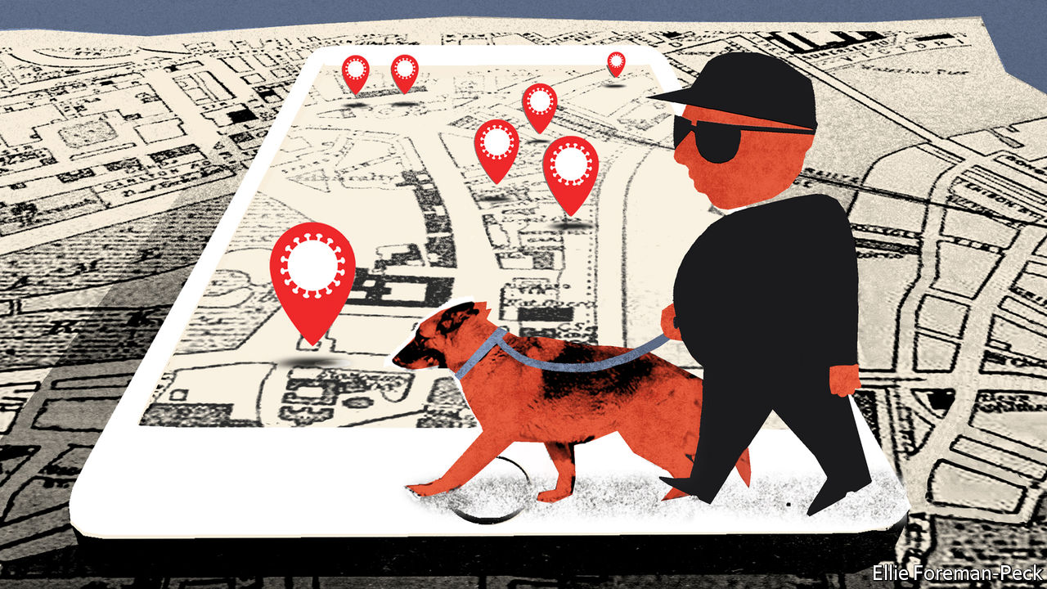

Editor’s note: The Economist is making some of its most important coverage of the covid-19 pandemic freely available to readers of The Economist Today, our daily newsletter. To receive it, register [here](https://www.economist.com/newslettersignup). For our coronavirus tracker and more coverage, see our [hub](https://www.economist.com/coronavirus)

BY EARLY APRIL, as covid-19 spread around the world and lockdown gripped Europe, many of its governments had started building contact-tracing apps. They hoped to use smartphones to track people’s contact with each other, and to pinpoint who might have been infected. Apple and Google tried to help. They started working together to rewrite the Bluetooth protocols in their phones so that apps could gather contact data in the background, from both iPhones and Android devices, without interfering with the normal operation of the phone or running down its battery.

Building apps with that degree of interoperability and energy efficiency is vital if they are to help with the pandemic. Doing so is between hard and impossible without the new protocol. But it came with a catch. The plan from Apple and Google stated that contact data would be collected and stored privately on users’ own phones, decentralised in a way that makes it impossible to siphon it all into central government servers. Many European countries had already started building contact-tracing apps that collect data in a centralised manner. The Apple-Google update would do nothing for them. They were upset.

France’s digital minister, Cédric O, called for Apple to change its protocol to make it easier to build a “a sovereign European health solution”. The German government said it was pursuing a centralised approach, via an outfit in Berlin. Hans-Christian Boos, a member of Angela Merkel’s digital advisory council, said on April 17th that some “government leaders” would “explode in [Apple’s & Google’s] faces” if they did not get their way.

They did not get their way. On April 26th the German chancellery minister, Helge Braun, and health minister, Jens Spahn, announced that Germany’s contact-tracing app would use the Apple-Google decentralised system after all. Any explosion did little to sway the American companies.

In acquiescing, the Germans join the Swiss, Estonians and Austrians. All these countries have agreed to make their contact-tracing efforts decentralised. Others have yet to announce a decision. There are still holdouts, including Britain and France, which have not explained in any detail how they will get round the interoperability and battery-life issues, or why the centralised approach is needed when the decentralised one will do.

There is, of course, no general requirement for private firms to tune their products to the preferences of governments. A road-builder would not be expected to craft highways out of Gruyère simply because a democratically elected government asked it to. The Apple-Google decentralised protocol is the right choice when it comes to privacy. Once enabled, the centralised collection of contact data would have been open to abuse from less scrupulous governments. Yet the pandemic has highlighted the core role that digital systems play in human life. That important decisions about them seem to be made beyond the reach of democratic governance is worrying for some. For now, nations have more pressing matters to attend to. But having the terms of apps designed to help the public dictated to them by Silicon Valley is likely to irk many European governments. ■

Dig deeper:  
For our latest coverage of the covid-19 pandemic, register for The Economist Today, our daily [newsletter](https://www.economist.com/newslettersignup), or visit our [coronavirus tracker and story hub](https://www.economist.com/coronavirus)

This article was downloaded by calibre from <https://www.economist.com/europe/2020/05/02/some-countries-want-central-databases-for-contact-tracing-apps>

|  |  |  |  |
| --- | --- | --- | --- |
| Previous | Articles | Sections | Next |

|  |  |  |  |
| --- | --- | --- | --- |
| Previous | Articles | Sections | Next |

#### A conviction politician

# A former president of Georgia tries to shake up Ukraine

Mikheil Saakashvili is bidding to become Ukraine’s chief negotiator with the IMF

May 2nd 2020 |

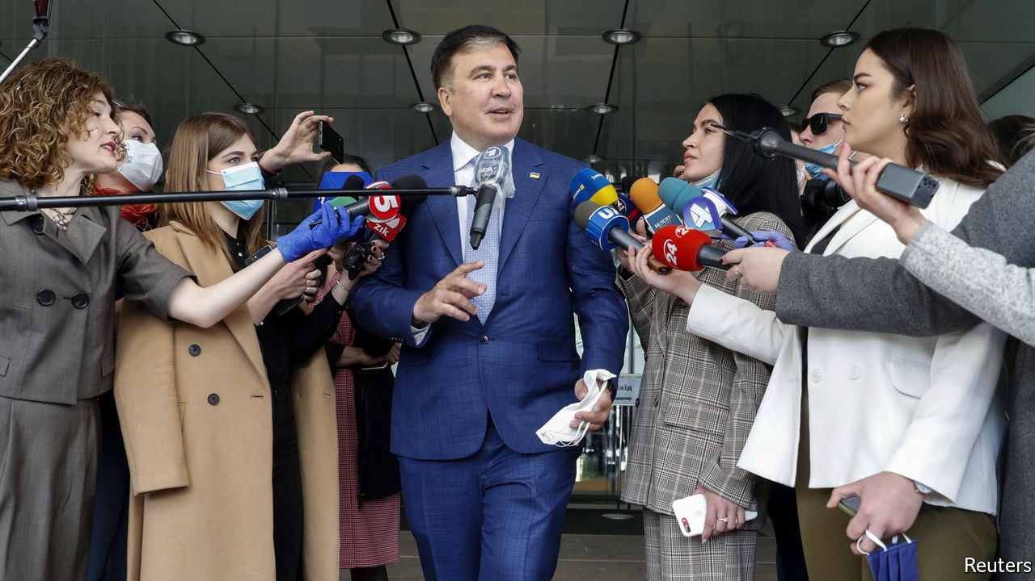

THE LAST time Mikheil Saakashvili grabbed the headlines in Ukraine was when he was filmed climbing onto the roof of an apartment block in Kyiv, the capital, as he was being chased by security men. That was in December 2017, when the former president of Georgia, who had bizarrely become a prominent politician in Ukraine, was being hounded by Ukraine’s then president, Petro Poroshenko, a one-time friend who had invited him to Ukraine and then turned against him.

Now the tables have turned against Mr Poroshenko, who is himself under investigation, having lost the presidency nearly a year ago to Volodymyr Zelensky, a former TV comedian. Meanwhile Mr Saakashvili is back in the limelight, vying for a key job as a deputy prime minister in charge of reforms and negotiations with the IMF.

Mr Saakashvili is no stranger to controversy. As Georgia’s president, he modernised his country, lost a short war with Russia and was forced to flee after ceding power when his party lost an election in 2012. His old friend Mr Poroshenko made him governor of the Odessa region but Mr Saakashvili resigned three and a half years ago, complaining that Ukraine’s government was still too corrupt.

The news of Mr Saakashvili’s latest possible appointment has stirred up Ukrainian politics. It has also rattled Georgia’s government, which so fears his comeback that it has twice slapped lengthy jail sentences on him in absentia and threatened to recall its ambassador from Kyiv. The Kremlin, too, has unleashed its propaganda attack-dogs against Ukraine.

In any case, Mr Saakashvili has yet to muster enough support in Ukraine’s parliament to secure his post. Meanwhile Mr Zelensky has not wholeheartedly weighed in, perhaps loth to expose the disunity in his parliamentary bloc and the lack of a coherent or professional team around him.

To mark this month’s first anniversary of his presidency, Mr Zelensky has released a sleek video celebrating his victory and progress. But off-screen his performance has been shakier. Progress on his two main promises—to tackle corruption and to end the war in Donbas, a region in Ukraine’s south-east—has been limited. A welcome exchange of prisoners has been achieved, but Russia is still funnelling cash and weapons to its proxies in Donbas. Mr Zelensky has had MPs stripped of immunity from criminal charges and brought in fresh faces, but they patently lack experience or a common vision. Urgently needed structural reforms have yet to materialise.

Corruption remains widespread. An independent-minded prosecutor-general, Ruslan Ryaboshapka, has been replaced by a loyalist who is going after Mr Poroshenko. Covid-19 may make matters worse. An independent journalist, Katya Gorchinskaya, has exposed shenanigans in the procurement of medical equipment.

Mr Saakashvili argues that corruption can be stemmed only by deregulating the economy and dismantling the system that facilitates extortion. Few Ukrainians seem convinced. Many reckon that, if Mr Zelensky brings Mr Saakashvili in, it will merely be to create the illusion of activity. “We are moving into the second season of Zelensky’s presidency,” says Sevgil Musaeva, editor of Ukrainska Pravda, an online outlet. “It makes sense to bring back a character from a previous series.” ■

This article was downloaded by calibre from <https://www.economist.com/europe/2020/05/02/a-former-president-of-georgia-tries-to-shake-up-ukraine>

|  |  |  |  |
| --- | --- | --- | --- |
| Previous | Articles | Sections | Next |

|  |  |  |  |
| --- | --- | --- | --- |
| Previous | Articles | Sections | Next |

#### How not to hand over to your successor

# A scandal in squeaky-clean Norway

Will Nicolai Tangen still take over as boss of the world’s biggest sovereign-wealth fund?

May 2nd 2020 | BERLIN

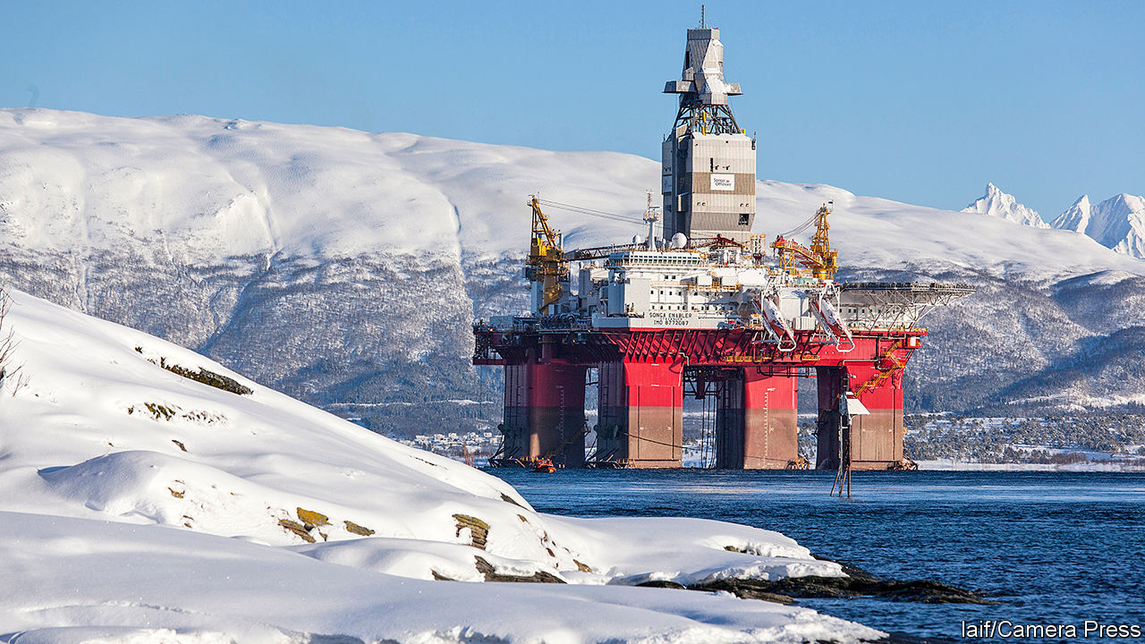

“WE EVEN HAD to pay for our cup of coffee in meetings,” says Espen Henriksen, recalling the strict code of conduct at the world’s largest sovereign- wealth fund. Mr Henriksen, who now works at the Norwegian Business School, reckons that anyone else who accepted a flight on a private jet and hospitality from a hedge-fund billionaire, as Yngve Slyngstad did, would have been fired instantly. But Mr Slyngstad, the outgoing boss of Norges Bank Investment Management (NBIM), merely told its employees that he was very sorry for having “screwed up”. He still intends to stay on as an adviser for another two years, once his successor takes over in September.

The big question now is whether, amid all the furore created by Mr Slyngstad’s misstep (the first in his 22 years at the fund), Nicolai Tangen still wants to take over as the next boss of NBIM. For the 54-year-old Norwegian is the very billionaire who treated Mr Slyngstad and a group of his friends to concerts by Sting and Gregory Porter, meals cooked by Jamie Oliver and a ride on a private jet with his friends from a Wharton Business School seminar in Philadelphia back to Oslo. The founder of AKO Capital, a $17bn hedge fund based in London, could just stay there and continue to make money. Yet Mr Tangen insists he wants to come home to take the helm at NBIM more than ever in these uncertain times. The state-owned fund where Norway stashes its petrodollars is worth around 10trn Norwegian kroner ($1trn), some $185,000 per Norwegian.

Mr Tangen’s appointment divided Norwegians even before the scandal. He was not on the official list of applicants published by the central bank, which oversees NBIM. It appeals to investment professionals, as Mr Tangen has shown great talent as a money manager. But others worry that he will want to manage the fund more actively than Norwegians are used to, and thus take on more risk in times that are now exceptionally risky. The cares of great (sovereign) wealth are heavy indeed.

This article was downloaded by calibre from <https://www.economist.com/europe/2020/05/02/a-scandal-in-squeaky-clean-norway>

|  |  |  |  |
| --- | --- | --- | --- |
| Previous | Articles | Sections | Next |

|  |  |  |  |
| --- | --- | --- | --- |
| Previous | Articles | Sections | Next |

#### Charlemagne

# Emmanuel Macron ditches Jupiter for other gods

First Mars, then Minerva

Apr 30th 2020 |

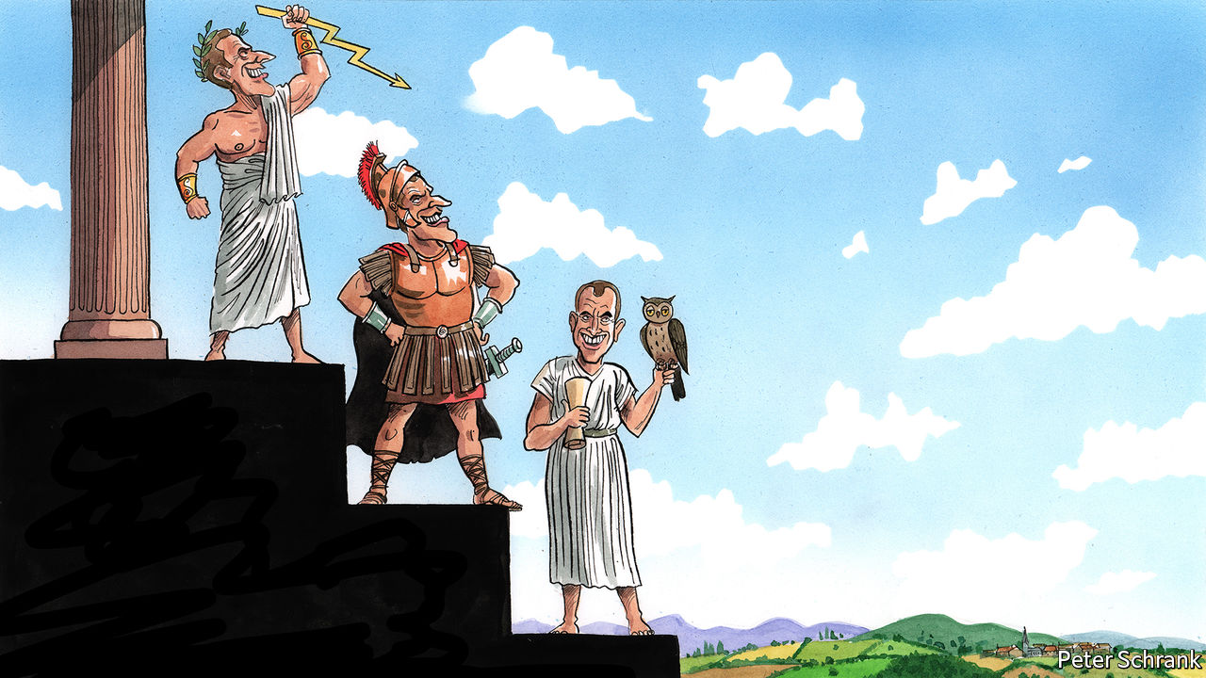

Editor’s note: The Economist is making some of its most important coverage of the covid-19 pandemic freely available to readers of The Economist Today, our daily newsletter. To receive it, register [here](https://my.economist.com/user#newsletter). For our coronavirus tracker and more coverage, see our [hub](https://www.economist.com/news/2020/03/11/the-economists-coverage-of-the-coronavirus)

THE OFFICIAL presidential plane, with its crisp-white fuselage and tricolore livery, is cruising at high altitude towards Paris from Beijing. Inside his airborne meeting room, Emmanuel Macron has just finished a debrief at the end of a China trip, leaving his staff to snatch a few hours’ sleep. To the visitor’s untrained eye, the most astonishing feature in the presidential aircraft office is not the framed print fixed defiantly to the wall, nor the leather chairs bolted rigidly to the floor. It is that Mr Macron is wearing a hoodie.

Most world leaders have their signature look. Unicolour jackets for Germany’s Angela Merkel. Artfully unkempt hair for Britain’s Boris Johnson. In Mr Macron’s case, his uniform is a suit. Not the pinstriped sort he once favoured as a young investment banker. But a well cut, navy costume, with matching sober tie. He wears it to visit hospitals, to talk virtually to European leaders, even last week to drop in on a tomato farm and a supermarket. For his detractors, the sharp suit is an offensive marker of his membership of the highly educated, metropolitan elite. For Mr Macron, a long-standing theatre enthusiast, the suit is literally a costume: a way of projecting in public an aura of formality, authority and power to fit the commanding Fifth Republic presidential office.

As the covid-19 health crisis unfolds in Europe, such aspects of leadership style are being tested. Mrs Merkel’s cautious, rational manner answers the moment’s yearning for quiet competence, at least for now. Mr Johnson’s customary bluster is more jarring. Mr Macron, who slipped into a Jupiterian costume on election night in 2017, stepping out from the shadows of the Louvre palace, has opted for a metaphorical change of attire. Since the pandemic struck, the know-it-all president who used to lecture his people from on high has switched outfits twice: to that of a warrior leading the French into battle, and then to one of a self-questioning leader who uses the word “humility” 11 times in a single interview. To borrow the president’s classical allusions, he has gone from wearing the costume of Jupiter (king of the Roman gods), to that of Mars (god of war), and now Minerva (goddess of wisdom).

Mr Macron’s earlier Jupiterian costume is worth revisiting. The “Jupiterian” presidency was his response to the excessively “normal” presidency of his Socialist predecessor, François Hollande, whom he served both as an adviser and minister. The French, with their romantic national myths of glorious conquest and civilisation, sought not just competent government, argued Mr Macron before his election, but leadership that symbolised exceptional, almost mystical, power. Once in office, however, if Mr Macron imagined he was projecting authority, the French increasingly saw aloofness and disdain. He once breezily told an unemployed gardener: “I can cross the road and find you a job.” The gilets jaunes (yellow jackets) protests followed. Jupiter tumbled from Olympus with a thud.

When the pandemic first took hold, Mr Macron pulled on his combat fatigues. “We are at war,” he declared no fewer than six times in an address on March 16th, putting France into lockdown. The “enemy” was invisible; the government was in “combat”. A week later, there he was at a military field hospital in eastern France, flanked by soldiers, camouflage and khaki. “It’s Clemenceau in the trenches,” claimed an Elysée aide, referring to the former prime minister who in 1917 made regular trips to the mud and gore of the front line, dressed in a square-tailed cloth coat and gaiters, to fight defeatism and despair.

The shortcomings of Mr Macron’s martial posture, however, soon became clear. France, like everywhere else, cannot “defeat” covid-19. The exit from lockdown, déconfinement, which will start in France on May 11th, is not a battle. It is a complex process of balancing trade-offs, managing fears and securing trust—all in the face of shifting evidence and imperfect information.

Hence the president’s more recent adoption of a Minervan cloak of sagesse. In his third televised address from the Elysée palace, on April 13th, there was plenty about solidarité and fraternité to stir the spirit. But Mr Macron was also a model of humility. “We should be honest,” he said, citing “mistakes” and “failures” over shortages of masks, gowns and hand gel. It was time, he concluded mysteriously, for “reinvention, of myself first of all”. Faced with so many unknowns, the philosopher-president seems to have ditched public lectures for self-analysis and a hyper-detailed fact-finding mission: quizzing supermarket cashiers one day; flying, bizarrely, to Marseille to question a microbiologist on the use of hydroxychloroquine the other. “This moment”, he told Le Point, a magazine, “has shaken a lot of things in me.” Like the owl of Minerva, a favourite reference of his, Mr Macron seems to be waiting for the pandemic’s dusk before seeking fully to understand.

## Class action suit

The president’s new look is more suited to the uncertain times. Covid-19 has offered a form of revenge to the rational-minded technocratic leader after the populist years. Mrs Merkel’s approval rating has soared; Mr Macron’s has jumped, though less high. Yet it would be rash to draw too many conclusions. For one thing, the political aftermath of the pandemic will be brutal, with claim and counterclaim about who took the right or wrong decision when. Many in France feel that they have been deeply misled over the use of masks and tests. Only 39% say that they trust the government to deal with covid-19. Marine Le Pen and her populist friends may be quiet for now. But nobody doubts that she will be back.

The other point is that, as a political quality, humility has its limits. Pragmatism can often be made to look like hesitation; adaptation mere improvisation. Ultimately, even the most fact-guided politician can defer only so much to scientists and experts. Decisions in the end are for them to take. After three years in office, Mr Macron knows this well. Which is why the wisest guise of all may also be the hardest: to sound humble, and act smart. ■

Dig deeper:  
For our latest coverage of the covid-19 pandemic, register for The Economist Today, our daily [newsletter](https://my.economist.com/user#newsletter), or visit our [coronavirus tracker and story hub](https://www.economist.com/news/2020/03/11/the-economists-coverage-of-the-coronavirus)

This article was downloaded by calibre from <https://www.economist.com/europe/2020/04/30/emmanuel-macron-ditches-jupiter-for-other-gods>

|  |  |  |  |
| --- | --- | --- | --- |
| Previous | Articles | Sections | Next |

|  |  |  |
| --- | --- | --- |
| Europe | Sections | International |

Britain

Universities: Time to think small

.

Horticulture: A nation of gardeners

.

Local government: Sinking

.

Scottish independence: Scarier alone?

.

Tracking and tracing: And then there were 18,000

.

Death toll: Rivalling the Blitz

.

British Airways: Grounded

.

Northern Ireland and Brexit: Just how is this going to work?

.

Bagehot: Blair’s back

.

|  |  |  |
| --- | --- | --- |
| Europe | Sections | International |

|  |  |  |  |
| --- | --- | --- | --- |
|  | Articles | Sections | Next |

#### Time to think small

# The government ponders bailing out universities

Before the crisis, the government was keen to shrink the university sector. Covid-19 makes it likelier that that will actually happen

May 2nd 2020 |

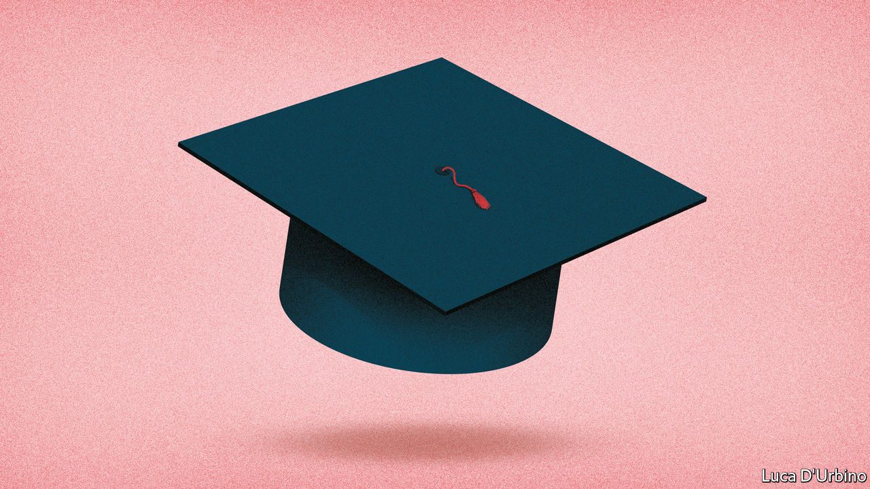

Editor’s note: The Economist is making some of its most important coverage of the covid-19 pandemic freely available to readers of The Economist Today, our daily newsletter. To receive it, register [here](https://www.economist.com/newslettersignup). For our coronavirus tracker and more coverage, see our [hub](https://www.economist.com/coronavirus)

A QUICK FLICK through a student brochure is all it takes to see why universities are so concerned by the pandemic, and the collapse in international travel it has wrought. A British undergraduate studying classics at Oxford, as the prime minister did, pays £9,250 ($11,500) a year for tuition. A Chinese undergraduate on the same course pays £27,285, almost three times as much. Altogether, foreign students last year provided at least a fifth of the income of 48 higher-education institutions, ranging from the London School of Economics to the University of Sunderland. That is why, as a vice-chancellor puts it, “everyone is nervous as hell.”

International students are not all that Britain’s vice-chancellors have to worry about these days. Any business that brings together crowds of people faces trouble. Universities are likely to have to move either some or all of their teaching online. That may mean fewer domestic students, depending on whether the urge to dodge terrible lectures on Zoom is greater than the desire to avoid a terrible labour market. Even before the crisis, some universities were looking shaky. Large deficits were common among smaller, less prestigious institutions. And the debt taken on by some of the country’s grandest universities now looks more concerning.

Universities UK, a lobby group, has opened the bidding for government help, petitioning for a £2bn bailout. The decision about whether to provide the cash, and if so how to distribute it, will shape higher education for years to come.

Before the crisis, ministers had big ambitions. In his budget on March 11th, Rishi Sunak, the chancellor, promised almost to double research and development spending to £22bn by 2024-25. But the ambition to invest in excellent research coexists with a belief in Downing Street that the sector has grown too big. Dominic Cummings, the prime minister’s chief adviser, has previously questioned the value of “third rate HE [higher-education] institutions”. Alison Wolf, another adviser who is the country’s most influential thinker on tertiary education, has called the expansion of universities “a bad bargain for the taxpayer and for the student”.

Michelle Donelan, the universities minister, has announced that she will tackle the problem of “low-quality” university courses. The government has its sights on universities producing the fifth of graduates, as identified by the Institute for Fiscal Studies (IFS), a think-tank, who would have been financially better off had they not attended university. The earnings of those who left university a decade ago suggest that’s true, on average, of female graduates of Bolton University and UC Falmouth (now Falmouth University), and of male graduates of 39 universities, including Goldsmiths and Manchester Met.

Ministers are not rushing to pony up the cash that Universities UK wants. For the moment, the Office for Students, the higher-education regulator, has demanded a pause in all changes to existing offers until May 4th to prevent a free-for-all in which universities poach each others’ students. Though the eventual impact may be big, higher education is at less immediate risk than other sectors seeking bail-outs, for most universities are relatively insulated at least until the start of the new academic year. The government will wait for the impact on student behaviour to become clearer, allowing it to decide whether to cough up, and if so what it wants in return.

Previous Conservative universities ministers have emphasised that they are not afraid to let universities go bust. The Treasury is said to be inclined not to offer universities a bail-out, allowing them to get access to standard business support and intervening only on a case-by-case basis. The expectation is that, if the government removes restrictions on recruitment on May 4th, higher-ranking universities will suck up students from lower-ranked peers to make up for the fall in those arriving from abroad. Many of the resulting strugglers would be universities producing graduates who earn less than they would have had they not gone to university. Treasury officials would not be sad to see those shrink or disappear altogether.

Yet there are problems with such an approach. Jack Britton of the IFS notes that graduate-earnings data looks at those who left universities in the late 2000s. The post-pandemic labour market may require different skills to the one which preceded it. And letting universities in poorer parts of the country go bust would be difficult to square with Boris Johnson’s desire to “level up” struggling areas. “The preponderance of institutions [which might need saving] that are in the north and Midlands is quite embarrassing,” notes a vice-chancellor.

Universities UK’s bail-out bid carefully balances universities’ competing interests. It asks for a doubling of the main source of research funding, which would mainly benefit high-ranked ones, helping to make up for the expected shortage of foreign students. In return, these institutions would agree to restrictions on recruitment, so that they do not suck up students from lower-ranked ones. It would also include a “transformation fund”, which could be used by the government to help universities merge with other universities or even further-education colleges, thus helping it to rebalance resources from universities to vocational education. In March the government said it would lay out its plans for further education later this year.

Universities hope the bail-out plan would allow them to get through the next few years, before a demographic boom in the number of 18-year-olds comes to their rescue. But recruitment restrictions would mean the government was, in effect, banning students from attending the best institution that would have them, and thus preventing top-rated universities from taking up the slack in the system. And the bailout would give higher education some protection against the government’s desire for radical reform.

On April 29th Gavin Williamson, the education secretary, told MPs that his priorities were protecting research, students and the role universities have in local economies—which sounds like a reference to the need to look after poorer places. Those aims will have to be squared with the Treasury’s pressing need to save money and the government’s ambition to squeeze waste out of the sector. It sounds like universities with poor graduate prospects in richer parts of the country should be worried.■

Dig deeper:  
For our latest coverage of the covid-19 pandemic, register for The Economist Today, our daily [newsletter](https://www.economist.com/newslettersignup), or visit our [coronavirus tracker and story hub](https://www.economist.com/coronavirus)

This article was downloaded by calibre from <https://www.economist.com/britain/2020/05/02/the-government-ponders-bailing-out-universities>

|  |  |  |  |
| --- | --- | --- | --- |
|  | Articles | Sections | Next |

|  |  |  |  |
| --- | --- | --- | --- |
| Previous | Articles | Sections | Next |

#### Life under lockdown

# A nation of gardeners

Britons dig in for the lockdown

May 2nd 2020 |

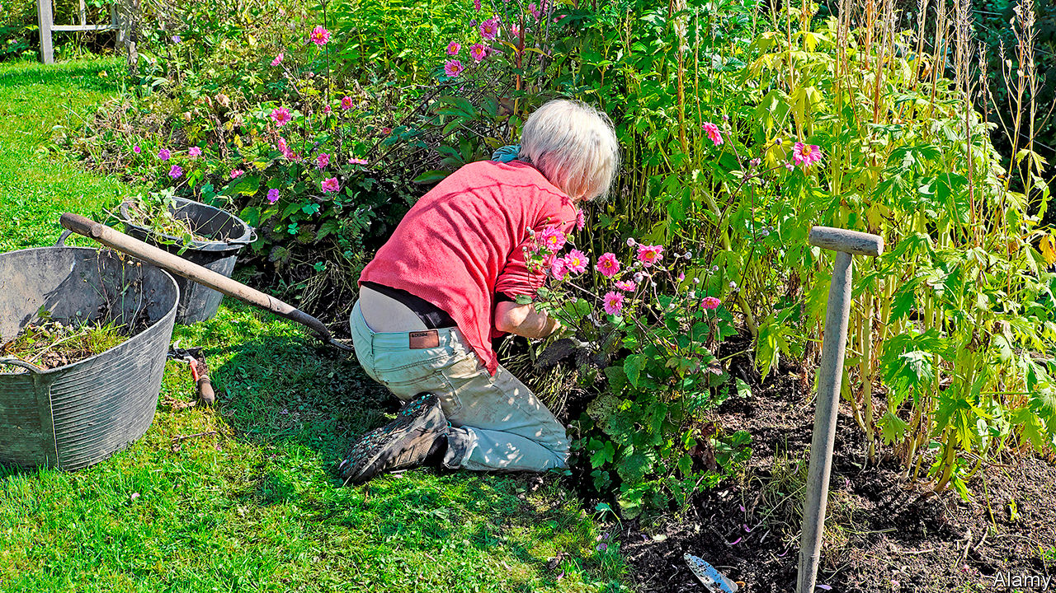

SUE BIGGS, director-general of the Royal Horticultural Society (RHS), a gardening charity, was “quite fearful” when the government ordered Britons into lockdown six weeks ago. She is single and has only her dog for company. But, like many of the society’s 500,000 or so members, she has found solace in her garden. “I have attacked the creeping buttercups with a vengeance,” she says. She ordered so many new plants that she had to dig up part of her lawn to squeeze them in.

Britain’s gardens have never been in better nick. Confined to their homes, folk are manicuring their hedges and lavishing attention on their vegetable patches. Official statistics show that 45% of Britons are coping with the lockdown by gardening, slightly more than are cooking or reading. Surveys suggest that between eight and nine in ten Britons have a private garden, pipping the share in France and Poland and dwarfing that in Spain, where a survey in 2014 found 27% had gardens. Millions watch flower shows that are screened on prime time television.

This national obsession is a mixture of temperature and temperament. Britain’s climate, with mild winters and plenty of rain, is particularly suited to gardening. And from the 18th century, aristocrats competed to hire the most renowned landscapers, such as Lancelot “Capability” Brown, to transform the grounds of their country estates. Victorian villas and suburban terraces, with gardens front and back, echoed these in miniature.

In a time of isolation and anxiety, the habit should stand Britons in good stead. Two new books—“The Natural Health Service” by Isabel Hardman, a journalist, and “A Well-Gardened Mind” by Sue Stuart-Smith, a psychiatrist—highlight the mental-health benefits of gardening. Studies suggest it is associated with significant reductions in depression and anxiety. Mrs Stuart-Smith sees it as a fundamentally optimistic activity. Even as plans for holidays and parties are being cancelled, imagining that a bunch of dull-looking seeds will transform into bright blooming flowers requires faith in the future.

Kew Gardens, a popular spot in a posh suburb of London, is closed, but Kew’s gardens are busier than ever. A few streets away, Lila Fenton, a management trainer, spends at least two hours a day in her garden. “I come down in the morning, make my coffee, then I check on my seedlings,” she says. She has clubbed together with neighbours to organise mass deliveries of plants and compost.

Gardens are so central to the lockdown experience that they have become a political issue. They are regularly cited to explain how the effects of the pandemic are unevenly felt. When councils began to close parks, politicians protested that tower-block dwellers would be deprived of their only green space. Boris Johnson, who spent much of his campaign for the Tory leadership in garden centres, is likely to heed pleas from plant-sellers to be allowed to reopen. More than two-thirds of growers’ sales are in the spring.

For now, the Kew Gardener, a nearby plant shop, is only taking orders online. But that has not stopped hopeful gardeners dropping by. Its owner, Daniel Slack, says one local asked him to pass a plant through the railings. He is not the only one looking for green shoots. ■

This article was downloaded by calibre from <https://www.economist.com/britain/2020/05/02/a-nation-of-gardeners>

|  |  |  |  |
| --- | --- | --- | --- |
| Previous | Articles | Sections | Next |

|  |  |  |  |
| --- | --- | --- | --- |
| Previous | Articles | Sections | Next |

#### Local government

# Councils’ outgoings are rocketing and revenues collapsing

The crisis is hitting councils every which way

May 2nd 2020 |

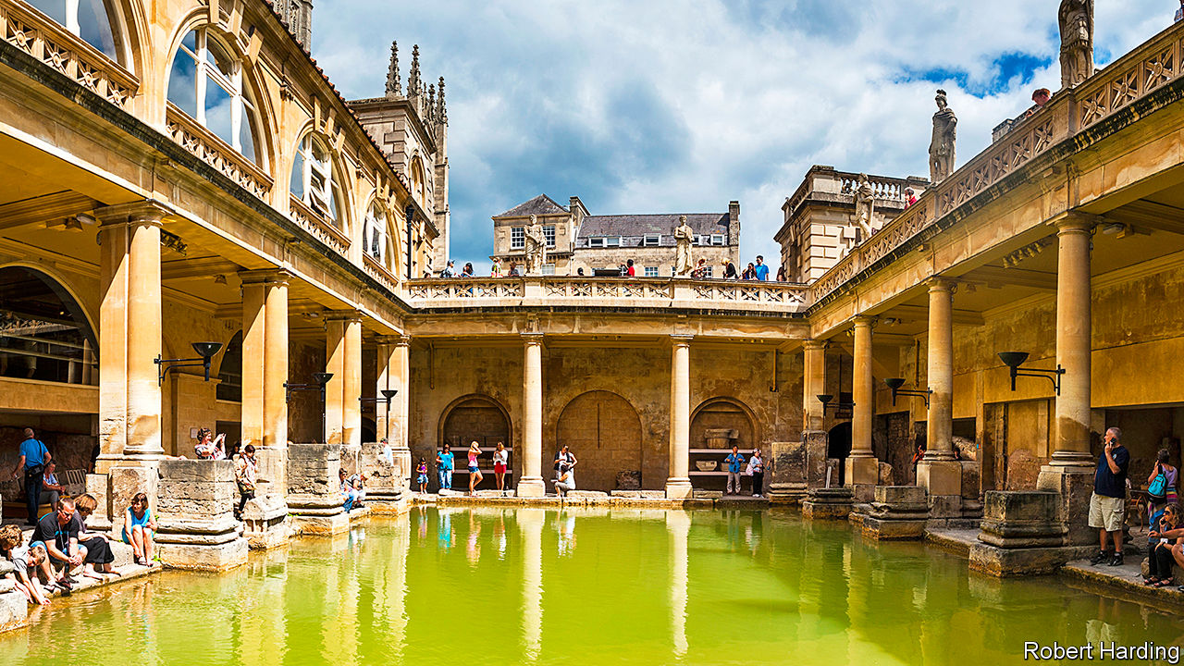

Editor’s note: The Economist is making some of its most important coverage of the covid-19 pandemic freely available to readers of The Economist Today, our daily newsletter. To receive it, register [here](https://www.economist.com/newslettersignup). For our coronavirus tracker and more coverage, see our [hub](https://www.economist.com/coronavirus)

IN MAY THE Roman plunge pools and saunas in Bath (or Aquae Sulis, as the builders called it) usually throng with tourists and history buffs. But for six weeks they have stood empty, thanks to covid-19. The tour guides have been redeployed by their employer, Bath and North East Somerset Council, to administer emergency grants for local traders. The baths, along with the city’s art gallery and museum, ought to have pulled in £9.6m ($11.9m) this year, mostly over the summer season. Now the council predicts a shortfall of £40m in its annual budget of £120m. The gloom may last two or three years if the tourists stay away, says Will Godfrey, its chief executive.

Britain’s town halls are doing the heavy lifting of fighting the pandemic. They fund care homes, deliver food parcels and bury the dead. They are finding hotels for rough sleepers and refuges for victims of domestic violence. Spending is up, because social distancing and sickness means employing more care staff. Mr Godfrey expects to spend £500,000 a week on protective kit.

At the same time, revenues are down sharply. There is little demand for car parks, swimming pools or school dinners. Bath forecasts a 10% fall in council-tax receipts if hard-up families fail to pay bills. Bradford Council, which runs four theatres, had expected £4.5m in ticket sales on a production of “The Lion King”, a musical, which had been due to open on April 30th.

Robert Jenrick, the communities secretary, has announced a £3.2bn bailout for English councils as well as measures to relieve cashflow. But the Local Government Association, a representative body, says three to four times that sum may be needed. Bath’s share is £10m.

The impact is exacerbated by big changes to council financing over the last decade. Since 2010 successive national governments have cut grants sharply, forcing councils to look elsewhere for income. Some turned to property. Local authorities invested £6.6bn in commercial property in the three years to 2019, a 14-fold increase on the previous period. That poses risks if asset values and rents fall, the National Audit Office warned in February. The Treasury plans to curtail cheap lending for investment in shopping centres and cinemas.

Warrington Borough Council is one of a number of big spenders, with a £700m portfolio of offices, supermarkets and distribution centres. Covid-19 is forecast to leave the council with a deficit of £35m to its £143m budget. Steven Broomhead, its chief executive, worries that rental income may fall behind borrowing costs.

Since 2013 councils have been allowed to keep at least half the business-property taxes raised locally, and since 2011, to earn bonuses for building new houses. That will leave them exposed if businesses fail to pay and housebuilding dries up. Rural district councils are particularly vulnerable because of their reliance on income from parking, leisure and waste, according to research by the Institute for Fiscal Studies, a think-tank.

By law, councils must run balanced budgets. Those that do not must declare de facto bankruptcy and freeze non-essential spending. That is rare in normal times but risks becoming more common without more support from Mr Jenrick. It may be the fate of Bradford Council, which forecasts a £60m deficit this year, of which only half will be covered by the bailout. “We are really, really stuck,” says Chris Chapman, the finance director. “What services can we feasibly cut?” ■

Dig deeper:  
For our latest coverage of the covid-19 pandemic, register for The Economist Today, our daily [newsletter](https://www.economist.com/newslettersignup), or visit our [coronavirus tracker and story hub](https://www.economist.com/coronavirus)

This article was downloaded by calibre from <https://www.economist.com/britain/2020/05/02/councils-outgoings-are-rocketing-and-revenues-collapsing>

|  |  |  |  |
| --- | --- | --- | --- |
| Previous | Articles | Sections | Next |

|  |  |  |  |
| --- | --- | --- | --- |
| Previous | Articles | Sections | Next |

#### Scotland

# Coronavirus has made Scottish independence even less likely

The economic risks of independence look ever higher

May 2nd 2020 | EDINBURGH

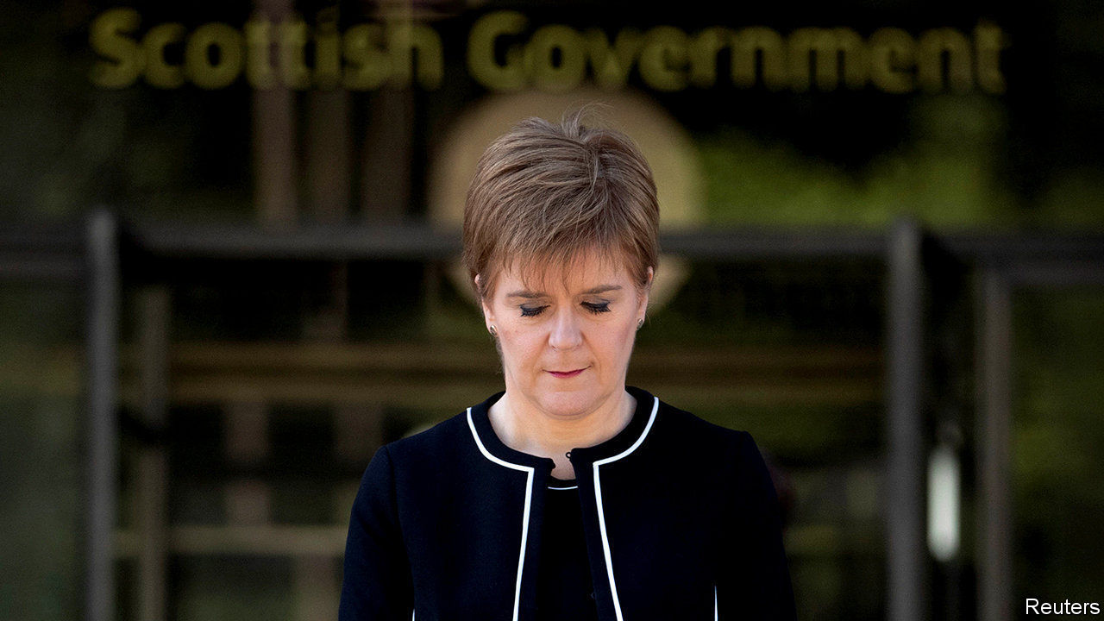

Editor’s note: The Economist is making some of its most important coverage of the covid-19 pandemic freely available to readers of The Economist Today, our daily newsletter. To receive it, register [here](https://www.economist.com/newslettersignup). For our coronavirus tracker and more coverage, see our [hub](https://www.economist.com/coronavirus)

NICOLA STURGEON, Scotland’s first minister, makes it her business to find ways of highlighting differences—sometimes real, sometimes contrived—between the way that the Scottish and United Kingdom governments do things. She normally treats the UK government’s difficulties as opportunities for point-scoring.

Things have changed. During the pandemic, in her daily briefings and in interviews, she has emphasised how closely politicians and officials from the central and devolved administrations have been working together. Rather than picking fights, she makes it clear that partisan politics are inappropriate.

This softening may outlast covid-19. Some Scottish Nationalists are using the crisis to boost the cause of independence: Angus Brendan MacNeil, a Scottish National Party MP, said that Scotland would be faring better through the pandemic if the country was not “involved in the web around Cobra [the cabinet committee calling the shots] and the United Kingdom”. But the messaging coming out of the first minister’s office is very different. Those close to her say the virus has made the prospect of a second independence referendum in the medium term unrealistic.

The central problem is economics. The idea that Scotland would be richer alone, which the SNP pushed in the 2014 referendum, was undermined by the subsequent collapse in the oil price. When it emerged that in 2018-19, Scotland’s notional deficit represented 7% of GDP compared the UK’s 1.1%, the nationalists could no longer argue that independence wouldn’t come with some pain, initially at least.

The SNP takes the view that it lost the last independence referendum because people were not prepared to take an economic gamble. That was in the good times. Now oil is cheap and Scotland is running a big deficit. If it went for independence, on the basis of the deal agreed in 2014, it would have to pay 10% of the covid-19 bill. “I don’t fancy making the case for taking on the costs of independence while the country’s struggling,” says an SNP MP.

Writing in Scotland’s Herald on Sunday newspaper on April 26th, Ms Sturgeon outlined her belief that the pandemic creates an opportunity for Scots to discuss the kind of country they want in future. But nationalists should note: not once did she mention independence.■

Dig deeper:  
For our latest coverage of the covid-19 pandemic, register for The Economist Today, our daily [newsletter](https://www.economist.com/newslettersignup), or visit our [coronavirus tracker and story hub](https://www.economist.com/coronavirus)

This article was downloaded by calibre from <https://www.economist.com/britain/2020/05/02/coronavirus-has-made-scottish-independence-even-less-likely>

|  |  |  |  |
| --- | --- | --- | --- |
| Previous | Articles | Sections | Next |

|  |  |  |  |
| --- | --- | --- | --- |
| Previous | Articles | Sections | Next |

#### And then there were 18,000

# An army of sleuths could help Britain emerge from lockdown

Human beings, rather than an app, may be the key

May 2nd 2020 |

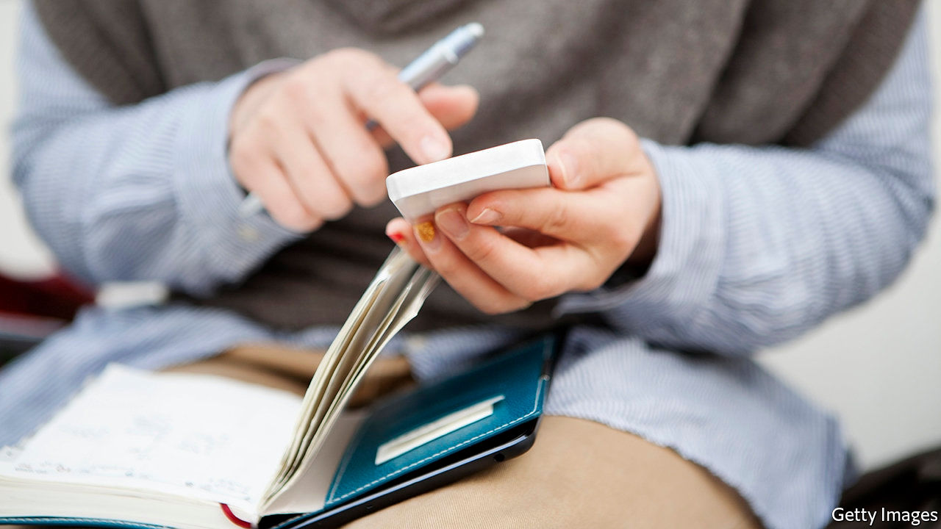

Editor’s note: The Economist is making some of its most important coverage of the covid-19 pandemic freely available to readers of The Economist Today, our daily newsletter. To receive it, register [here](https://www.economist.com/newslettersignup). For our coronavirus tracker and more coverage, see our [hub](https://www.economist.com/coronavirus)

“WHERE WERE you on the evening of Friday May 1st?” It is the sort of question one might expect to hear from a hard-boiled detective or a prosecutor in a courtroom drama. It is also the kind of question that Britons will have to get used to answering if daily life is to return to anything resembling normal.

Much of the focus of the government’s “test, track and trace” strategy to reopen Britain and prevent a second lockdown has been on testing and on an app being developed by NHSX, the digital-innovation arm of the health service. The app uses Bluetooth to register nearby devices that also have it installed. If an app-user shows symptoms of covid-19, she can report it through the app and grant permission for other users who have been in “close contact” with her to be informed. They would receive a message telling them that they may have been exposed, that they should self-isolate and what they should do next. If such people can also be quickly tested to establish whether they have the disease, that will allow the majority of the population to go about their lives while a small number of people stay home and recover or go to hospital for treatment.

That is the theory, anyway. In reality, take-up of the app may be considerably lower than 60% of the population, the number at which it would be truly effective. In Singapore, which was early to roll out a similar app, less than a fifth of the population has downloaded it. In Australia, less than a tenth has.

Even with widespread adoption, an app-based system is still a relatively blunt tool. “An app can tell us you and I were within two metres of each other, but there is a different process if we had a conversation in a sealed room for two hours or in the open air with the wind blowing. Human judgment needs to be applied,” says Chris Yiu of the Tony Blair institute, which has published detailed analyses of strategies to come out of lockdown. It’s not a choice between technology and people. “International best practice is very clear on this: you need both,” says Jeremy Hunt, who chairs the House of Commons health and social care select committee.

That is why the third pillar of the government’s alliterative slogan is “trace”. At the start of the crisis Public Health England (PHE), a government agency, had 290 “contact tracers”, or people who call patients and ask them about their movements and whom they have been around in recent days. Think of them as the public-health equivalent of the nosy detective, except that they are soft-boiled and rely on the co-operation of their interviewees. Now the plan is to increase that number fast to 18,000, of whom 3,000 will be medical professionals and the rest call-handlers.

Firms such as Serco, a big contractor, are in talks with the government to provide the workforce. It should be possible to train new recruits fairly quickly—the requirements of the job are similar to those of 111 operators, for whom the training time is just four hours. They will work from a script that guides them through the various stages of an interview.

Most people have no idea what they were doing on the evening of a particular day two weeks ago. “So what you try to do is you break the day up into segments,” says Dr Azeem Majeed, a public-health expert at Imperial College London. As Britons wait for the army of new tracers to be hired, and indeed for a tracking app to download, one way to fill the days may be to get in the habit of keeping a diary. ■

Dig deeper:  
For our latest coverage of the covid-19 pandemic, register for The Economist Today, our daily [newsletter](https://www.economist.com/newslettersignup), or visit our [coronavirus tracker and story hub](https://www.economist.com/coronavirus)

This article was downloaded by calibre from <https://www.economist.com/britain/2020/05/02/an-army-of-sleuths-could-help-britain-emerge-from-lockdown>

|  |  |  |  |
| --- | --- | --- | --- |
| Previous | Articles | Sections | Next |

|  |  |  |  |
| --- | --- | --- | --- |
| Previous | Articles | Sections | Next |

#### Rivalling the Blitz

# Covid-19 is killing Londoners at a faster rate than German bombs did

The myth and memory of the war

May 2nd 2020 |

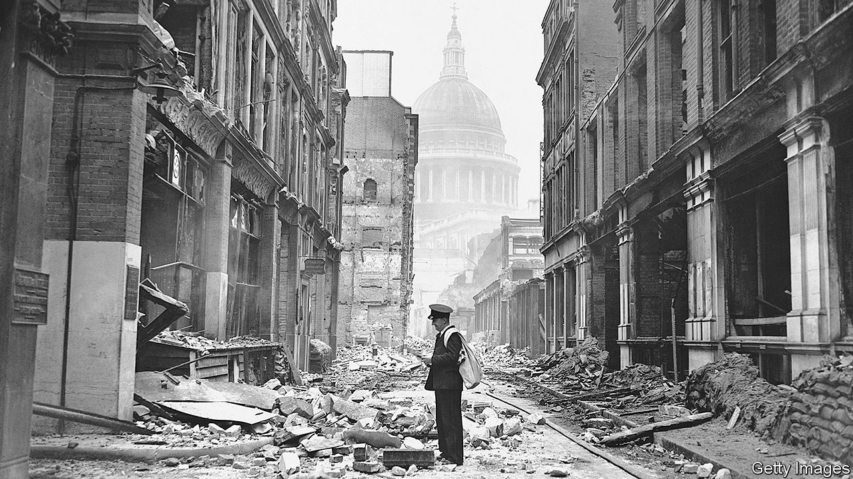

Editor’s note: The Economist is making some of its most important coverage of the covid-19 pandemic freely available to readers of The Economist Today, our daily newsletter. To receive it, register [here](https://www.economist.com/newslettersignup). For our coronavirus tracker and more coverage, see our [hub](https://www.economist.com/coronavirus)

IN SEPTEMBER 1940, with German bombers overhead, George Orwell sat down for a haircut. His barber told him that no Nazi air-raid could stop him shaving a client’s face. “One day a bomb will drop near enough to make him jump,” Orwell forecast, “and he will slice half somebody’s face off.” Later that day Orwell met a commercial traveller fleeing the city who was a nervous wreck.

Which of the two men best represented reality is unknowable, but “Blitz spirit”, that patriotic device embedded in collective memory, favours the coiffeur. Early on in the pandemic, Matt Hancock, the health secretary, asked Britons to emulate their grandparents’ behaviour during the bombardment.

In its effect on London, covid-19 is now rivalling the Blitz. According to figures from the Office of National Statistics, it killed 4,731 people in the city in the four weeks to April 17th; by comparison, 4,677 people died in the worst four-week stretch of the Blitz in the capital. The virus has some way to go before it kills off more Londoners than the 30,000 who perished in the eight months of the Blitz, but those monthly figures may be understating its toll. They were for deaths in which covid-19 was cited on the certificate. But in those four weeks, there were around 6,000 more deaths than the average for the time of year.

Because the Blitz looms so large in the national psyche, it is startling that covid-19’s toll is already in its league. Yet the Blitz is a myth as well as a memory, and the reality was not quite as upstanding as the rhetoric suggests. Under the cover of blackout, crimes rose by 57%; there were 4,584 recorded lootings during the bombardment. Not all of the nation’s grandparents were model citizens.

Dig deeper:  
For our latest coverage of the covid-19 pandemic, register for The Economist Today, our daily [newsletter](https://www.economist.com/newslettersignup), or visit our [coronavirus tracker and story hub](https://www.economist.com/coronavirus)

This article was downloaded by calibre from <https://www.economist.com/britain/2020/05/02/covid-19-is-killing-londoners-at-a-faster-rate-than-german-bombs-did>

|  |  |  |  |
| --- | --- | --- | --- |
| Previous | Articles | Sections | Next |

|  |  |  |  |
| --- | --- | --- | --- |
| Previous | Articles | Sections | Next |

#### Redundancies

# British Airways’ huge job cuts

Measures to freeze the economy in place have limited impact

May 2nd 2020 |

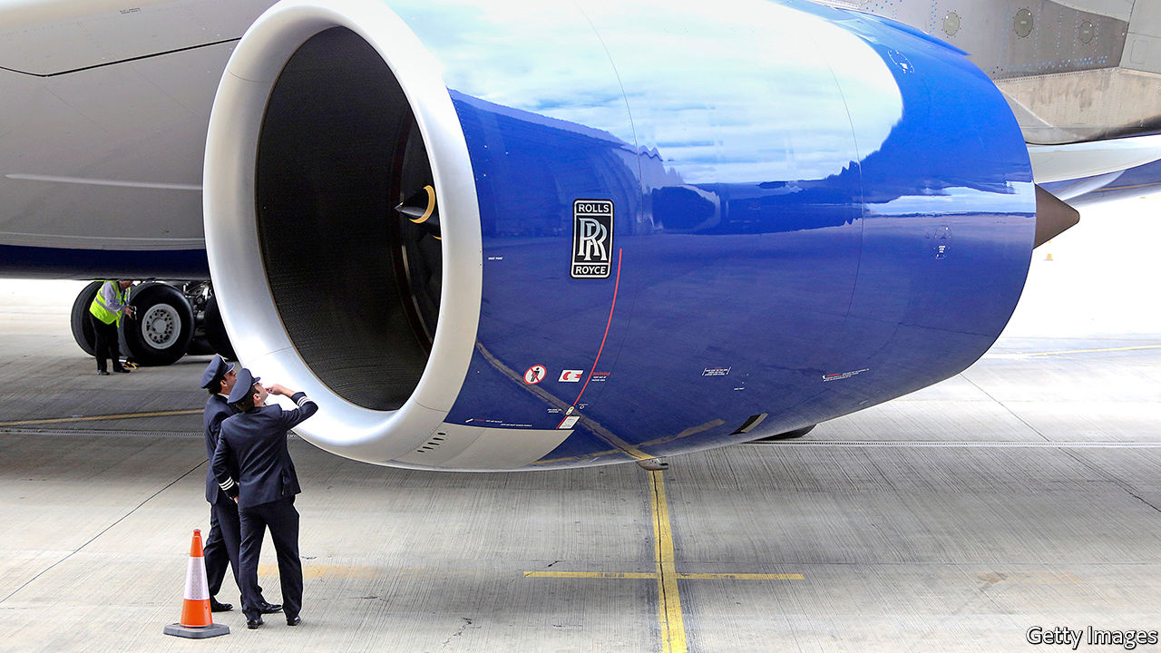

Editor’s note: The Economist is making some of its most important coverage of the covid-19 pandemic freely available to readers of The Economist Today, our daily newsletter. To receive it, register [here](https://www.economist.com/newslettersignup). For our coronavirus tracker and more coverage, see our [hub](https://www.economist.com/coronavirus)

RARELY, IF EVER, has the economic outlook shifted so rapidly, leaving firms struggling to respond. On April 2nd, as demand for air travel collapsed, British Airways placed 30,000 of its 42,000 employees on the government-backed furlough scheme. Less than a month later Alex Cruz, the chief executive, wrote to staff to say that “in the last few weeks, the outlook for the aviation sector has worsened further” and that around 12,000 staff would now be facing redundancy.

Travel restrictions, lockdowns and social distancing measures have hit airlines especially hard. The International Air Travel Association, a trade body, reckons that global revenues will be down by 55% in 2020. In an update to investors IAG, British Airways’ parent company, said that passenger capacity in April and May this year would be 94% lower than in 2019, and it was unable to give firm guidance on the outlook for revenues and profits this year. British Airways believes it will be “several years” before demand fully recovers to pre-pandemic levels.

The government has sought to use wage subsidies and soft loans to support companies while public-health needs mean economic activity is suppressed. The intention was to freeze the economy in place for weeks or months and prevent the kind of job losses and business failures that would be a lasting drag on the economy. But that approach relies on the idea that things will eventually return to normal and as Mr Cruz put it in his message to staff “what we are facing as an airline, like so many other businesses up and down the country, is that there is no ‘normal’ any longer.”

Demand for transport services, especially international ones, is unlikely to bounce back rapidly. Hospitality firms, such as restaurants and pubs, are likely to be forced to operate well below capacity to maintain distancing. Non-essential shops will probably experience lower footfalls. As firms in these sectors reassess the outlook, they are being forced into making tough choices now.

The government’s retention scheme, under which it pays 80% of a worker’s salary up to £2,500 a month ($3,100), bought firms some breathing space. It was initially due to run until the end of May but has since been extended to June. Businesses accept that the Treasury cannot pay their wage bills indefinitely but are asking for more clarity on how support will be phased out. The worry for many is that the scheme will end abruptly, leaving them saddled with costs that they can no longer cover. For firms like British Airways, the end of the scheme is already looming and, given the statutory 45-day consultation period for redundancies, they must make decisions quickly. A survey from the Chartered Institute of Personnel and Development, an employer body, found that just 7% of firms have made covid-19 related redundancies so far but a further 12% are planning to lay people off. ■

Dig deeper:  
For our latest coverage of the covid-19 pandemic, register for The Economist Today, our daily [newsletter](https://www.economist.com/newslettersignup), or visit our [coronavirus tracker and story hub](https://www.economist.com/coronavirus)

This article was downloaded by calibre from <https://www.economist.com/britain/2020/05/02/british-airways-huge-job-cuts>

|  |  |  |  |
| --- | --- | --- | --- |
| Previous | Articles | Sections | Next |

|  |  |  |  |
| --- | --- | --- | --- |
| Previous | Articles | Sections | Next |

#### Brexit

# The problematic Northern Ireland protocol

Nobody knows how the province will trade with the mainland after Brexit

May 2nd 2020 |

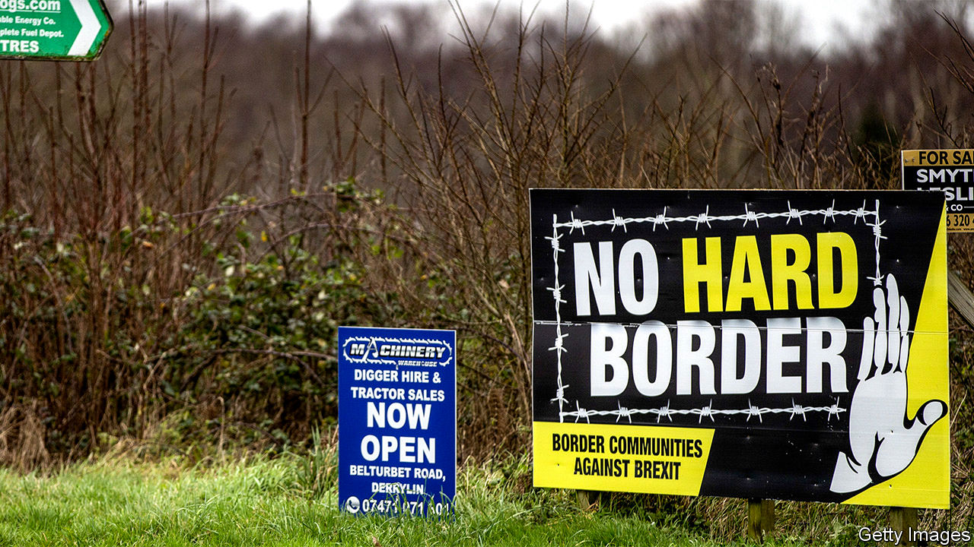

TO THE SURPRISE of many, Northern Ireland proved the most intractable issue in the first round of Britain’s EU withdrawal negotiations. But Boris Johnson then triumphantly replaced the hated Irish backstop, which could have locked the entire United Kingdom into a customs union with the EU, with a protocol that kept Northern Ireland alone in the single market and customs union.

The inevitable consequence is border and customs checks in the Irish Sea between Great Britain and the province—although several ministers, including the prime minister, have often denied this, or at least promised that such checks will be minimal. Yet practical details on what will happen to goods moving in both directions are lacking. The first virtual meeting of the key UK-EU sub-committee concerned took place only this week.

Trade from west to east is relatively simple, as the British government wants Northern Ireland to retain unfettered access to the British market. Even here, though, single-market rules require export declarations that will impose extra costs on businesses. East-west is much trickier. When Britain diverges from EU rules, goods may be subject to both customs and rules-of-origin checks, and (for agricultural products) to food-safety inspections.

Local businesses are fretful. Great Britain is the province’s biggest trade partner, with traffic running at almost £25bn a year. Much of this is retail or small manufacturing, but a big chunk is agricultural produce. Around 98% of exporters into Britain are small enterprises unused to red tape. The logistics industry says it cannot prepare when such big questions as whether tariffs will be charged are undecided. Graham Keddie, the boss of Belfast airport, is demanding greater clarity from Whitehall. Seamus Leheny of the local freight transport association wants what he calls a soft landing for the haulage industry.

Yet the government is sending mixed messages. Colin Murray of Newcastle University says ministers often promise domestic audiences that they will tear up tiresome EU regulations. But by suggesting that only limited controls are needed in the Irish sea, they also imply that divergence from single-market rules will be small. Trust is lacking on both sides. This was shown once again when the government peremptorily rejected an EU request to open an office in Belfast to let it monitor compliance with the terms of the protocol.

Time is very short. Since the government insists that it will not extend the transition period beyond December, only eight months are left before new trade rules come into effect. Yet Katy Hayward of Queen’s University Belfast says there is little sign of such preparations as hiring new customs inspectors or creating space to accommodate lorry queues.

The biggest worry is that the trade negotiations, which both sides admit are making little progress, may end with no trade deal at all being done. If that happens, customs duties will be charged on many goods, notably food, and the protocol would still come into force. This would require, for example, applying the EU’s single-market rules against state subsidies to any companies that do significant business in Northern Ireland, even if they are based in Great Britain.

Some Tory Brexiteers reckon that after no deal the protocol could be ignored. But that would mean not just a breach of treaty obligations, but also the return of the very conundrum that the protocol is designed to solve: how to avert a hard border with Ireland. Northern Ireland may yet come to dominate the second round of Brexit negotiations just as it did the first. ■

This article was downloaded by calibre from <https://www.economist.com/britain/2020/05/02/the-problematic-northern-ireland-protocol>

|  |  |  |  |
| --- | --- | --- | --- |
| Previous | Articles | Sections | Next |

|  |  |  |  |
| --- | --- | --- | --- |
| Previous | Articles | Sections | Next |

#### Reforming government

# Tony Blair is having a covid moment

Could Blairism have a new lease of life?

May 2nd 2020 |

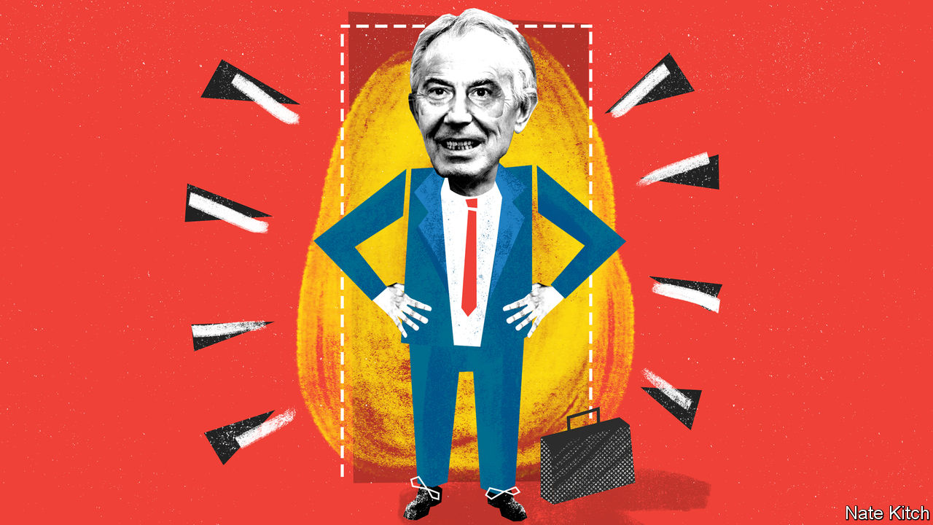

Editor’s note: The Economist is making some of its most important coverage of the covid-19 pandemic freely available to readers of The Economist Today, our daily newsletter. To receive it, register [here](https://www.economist.com/newslettersignup). For our coronavirus tracker and more coverage, see our [hub](https://www.economist.com/coronavirus)

SINCE HE RETIRED as prime minister in 2007, Tony Blair has seemed a forlorn figure. The Iraq war rendered him so toxic that security worries prevented him from attending the launch of his own memoirs. And the greatest election winner in Labour Party history lost every big battle he was involved in, with Jeremy Corbyn and his ilk hijacking the party and the Brexiteers taking Britain out of the European Union. But now covid-19 is giving Mr Blair a new lease of political life.

The former prime minister has a well-earned reputation for messianic enthusiasm. This was evident in his approaches to the divisive issues of the Iraq war and Brexit, and it is manifesting itself just as clearly in his approach to a problem that has a potential to unite the public. He is dedicating his personal energy and the collective resources of the Tony Blair Institute for Global Change to the covid-19 pandemic.

He has received plenty of flak for using his pulling power to build an institution bearing his name dedicated to furthering his political vision. Britons regard it as rather vulgar, or American, or both, and wonder how many devils he supped with to raise the cash. But the institute is now coming into its own. By British standards, it has a lot of resources—250-300 people working all around the world, including some who were on the front line of the Ebola outbreak in 2014. It is focused on the important question of making government more effective and combines specialists in fields that are central to the fight against the virus: public policy, technology and medicine.

Mr Blair argues that Boris Johnson should be willing to reconfigure his government in the light of this all-consuming crisis. One idea might be to identify a series of core sub-portfolios—for example technological innovation or community volunteering or learning from other countries—and hand them to the best ministers available. He believes that creating a “minister for testing” would help Britain to regain some of the ground it has lost on this front. Another idea is to recruit as much talent from outside government as possible. Mr Blair is keen on distinguishing between political and operational functions, and giving operational functions to business people who have experience in things like mass production and procurement.

In some ways the government is already moving in a Blairite direction. It talks about “targets” with the same enthusiasm that New Labour once did. It is deferring to experts and justifying its behaviour in the light of something that it calls “the science”. It is also tapping business people: Lord Deighton, chairman of Heathrow (and also chairman of The Economist) has been given responsibility for improving the supply of personal protective equipment. Dominic Cummings, Mr Johnson’s chief adviser, shares much of Mr Blair’s enthusiasm for reorganising government and focusing on crisis-management. Some of the ideologues who occupied centre stage in the post-Blair years have been replaced by “heirs to Blair” who would have thrived in the Blair-Cameron years—people such as Matt Hancock, the health secretary, a Remain-supporting protégé of George Osborne, the former chancellor of the exchequer, and Robert Jenrick, the housing and communities minister, whose nickname is “Generic”.

But the government is not in a good state to deal with covid-19. The cabinet is still packed with inexperienced ministers who were selected on the basis of their enthusiasm for Brexit rather than their competence. Several ministers are so ineffectual or unreliable that they have to be kept on a short leash: Gavin Williamson, the education secretary, Alok Sharma, the business secretary, and Priti Patel, the home secretary, spring to mind. Meanwhile some of the party’s most experienced performers are confined to the backbenches. Both Greg Clark, a former business secretary, and Jeremy Hunt, a former health secretary and Mr Johnson’s main rival for the Conservative Party leadership, keep demonstrating, as chairs of the science and health select committees respectively, what a loss they are to the government.

The cabinet, cumbersome at the best of times, is ill-designed for crisis. When digital communications are crucial, the department for digital, culture, media and sports, looks even more like a bureaucratic jumble than it did before. Meanwhile, Mr Hancock is overwhelmed with responsibilities: he combines two jobs that are a stretch at the best of times—running the health-care system and the social care system—and is also one of the government’s most hyperactive spokespeople.

## But for how long?

The interesting question is what sort of a turn politics takes after the pandemic—whether the difficulties ahead underline the need for competent centrist managers, or whether bad times widen ideological divisions. Mr Blair worries that the big winners of this crisis may be populists of both sorts, with right-wingers railing against globalisation and left-wingers against inequality, all at a time when insecurity is rife. These worries are plausible enough to be compelling. The crisis has demonstrated the fragility of global supply chains, particularly when it comes to medical supplies. Inequality is widening as brain-workers work from home while manual workers either lose their jobs or risk infection. Tory MPs are already ramping up the rhetoric against China.

But there is also a case that the crisis will drag politics back to the centre. If the government is to deliver vital public services at a time of soaring public debt, it will have to embrace reform and innovation. If globalisation is to survive, then the winners will have to do much more for the losers. The world will be shaped not just by the fight against the coronavirus but also by the fight over the best way to recover from its effects. Mr Blair is making it abundantly clear that, whatever his past sins, he wants to be at the centre of that fight. ■

Dig deeper:  
For our latest coverage of the covid-19 pandemic, register for The Economist Today, our daily [newsletter](https://www.economist.com/newslettersignup), or visit our [coronavirus tracker and story hub](https://www.economist.com/coronavirus)

This article was downloaded by calibre from <https://www.economist.com/britain/2020/05/02/tony-blair-is-having-a-covid-moment>

|  |  |  |  |
| --- | --- | --- | --- |
| Previous | Articles | Sections | Next |

|  |  |  |
| --- | --- | --- |
| Britain | Sections | Business |

International

Closing schools: No more pencils, no more books

.

The experience of Ebola: Lessons learned

.

Covid-19 infections: Think of the children

.

|  |  |  |
| --- | --- | --- |
| Britain | Sections | Business |

|  |  |  |  |
| --- | --- | --- | --- |
|  | Articles | Sections | Next |

#### No more pencils, no more books

# Closing schools for covid-19 does lifelong harm and widens inequality

Primary schools in particular are vital to social mobility

Apr 30th 2020 | AMSTERDAM

Editor’s note: The Economist is making some of its most important coverage of the covid-19 pandemic freely available to readers of The Economist Today, our daily newsletter. To receive it, register [here](https://www.economist.com/newslettersignup). For our coronavirus tracker and more coverage, see our [hub](https://www.economist.com/coronavirus)

IN THE STREETS of Amsterdam children spend the “corona holiday” whizzing around on scooters; their peers in Madrid are mostly stuck at home with video games; those in Dakar look after younger siblings. The one place they are not is at school. Over three-quarters of the world’s roughly 1.5bn schoolchildren are barred from the classroom, according to UNESCO, a UN agency. In most of China and in South Korea they have not darkened school doors since January. In Portugal and California they will not return before September.

Schools have striven to remain open during wars, famines and even storms. The extent and length of school closures now happening in the rich world are unprecedented. The costs are horrifying. Most immediately, having to take care of children limits the productivity of parents. But in the long run that will be dwarfed by the amount of lost learning. Those costs will fall most heavily on those children who are most in need of education. Without interventions the effects could last a lifetime.

For these reasons Singapore in 2003 cut its month-long June holiday by two weeks to make up for a fortnight of school closures during the SARS epidemic. Closing schools even briefly hurts children’s prospects. In America third-graders (seven-year-olds) affected by weather-related closures do less well in state exams. French-speaking Belgian students hit by a two-month teachers’ strike in 1990 were more likely to repeat a grade, and less likely to complete higher education, than similar Flemish-speaking students not affected by the strike. According to some studies, over the long summer break young children in America lose between 20% and 50% of the skills they gained over the school year.

Closures will hurt the youngest schoolchildren most. “You can make up for lost maths with summer school. But you can’t easily do that with the stuff kids learn very young,” says Matthias Doepke of Northwestern University. Social and emotional skills such as critical thinking, perseverance and self-control are predictors of many things, from academic success and employment to good health and the likelihood of going to jail. Whereas older children can be plonked in front of a computer, younger ones learn far more when digital study is supervised by an adult.

Then there are those who are missing crucial exams. Germany is reopening schools for final-year high-school students who face exams soon. But most countries are not willing to do that. China has postponed its Leaving Certificate exam (gaokao) until July. Britain and France have cancelled this year’s exams. Grades will in part be decided by teachers’ predictions of how a student might have performed. This fuels fears about inequality, as some experts worry teachers unconsciously discriminate against disadvantaged children and give them unfairly low marks.

Statistics Norway estimates “conservatively” that the country’s educational shutdowns—from crèches to high schools—are costing NKr1,809 ($173) per child each day. Most of that is an estimate of how much less today’s schoolchildren will earn in the future because their education has been disrupted. (It is assumed they are learning roughly half of what they normally would.) The rest is lost parental productivity today.

Of course schooling has not stopped completely, as it does during holidays. Nearly nine in ten affected rich countries are providing some form of distance-learning (compared with fewer than one in four poor countries). But video-conferencing has its limits. For poorer children, internet connections may be ropey. Devices may have to be shared and homes may be overcrowded or noisy. Of the poorest quarter of American children, one in four does not have access to a computer at home.

Less well-off children everywhere are less likely to have well-educated parents who coax them to attend remote lessons and help them with their work. In Britain more than half of pupils in private schools are taking part in daily online classes, compared with just one in five of their peers in state schools, according to the Sutton Trust, a charity (private schools are more likely to offer such lessons). In the first weeks of the lockdown some American schools reported that over a third of their students had not even logged in to the school system, let alone attended classes. Meanwhile, elite schools report nearly full attendance and the rich have hired teachers as full-time tutors.

Ashley Farris, an English teacher at KIPP high school in Denver, Colorado, says several of “her” kids are virtual truants. Her school worked hard to get students computers and Wi-Fi access, but the digital gap is only part of the story. Some must work to make up for parents’ lost wages. Others must look after younger siblings.

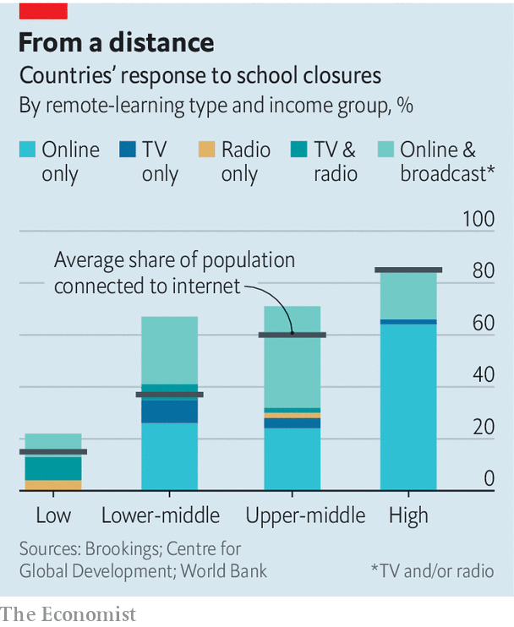

Closures in Britain could increase the gap in school performance between children on school meals (a proxy for economic disadvantage) and those not on school meals, fears Becky Francis of the Education Endowment Foundation, another charity. Over the past decade the gap, measured by grades in tests, has narrowed by roughly 10%, but she thinks school closures could, at the very least, reverse this progress. At least over summer, teachers are not on tap for anyone. In the current lockdown some students can still quench their thirst for education not just with highly educated parents but also with teachers; others will have access to neither.

Primary school is normally a crucial opportunity for gaps that emerged in early-years development to start narrowing, or at least to stop widening. That opportunity is now being missed. For a glimpse of the cost to the unluckiest young children, consider the Perry pre-school project of the 1960s, a study conducted in Ypsilanti, Michigan, which found that a control group of young children from disadvantaged backgrounds who did not attend pre-school suffered lifelong consequences.

Mr Doepke estimates that by the autumn the sizeable group of American children whose learning loss started when schools closed might have lost as much as a year’s learning. Since every year of education is associated with an increase in annual earnings of roughly 10%, the consequences for those children become clear. “I fear we will see further inequality and less social mobility if nothing is done,” he adds.

What can be done to limit the costs? Finland started distance learning only when it was satisfied that almost every child would be able to take part. South Korea extended its school holiday to prepare teachers and distribute devices where needed. “For my school of 1,000 students, just 13 borrowed tablets because they had several siblings in their house,” says Hyunsu Hwang, an English teacher at Inmyung Girls High School, in Incheon. Teachers now use a mixture of real-time interactive classes, pre-recorded material and homework-based digital classes. When schools began to reopen on April 9th, official attendance was 98%.

School systems where children are used to having to teach themselves will do better, reckons Andreas Schleicher of the OECD, a club of rich countries. “The real issue is if you’ve been spoon-fed by a teacher every day and are now told to go it alone, what will motivate you?” In Estonia and Japan students are used to “self-regulated activities”; across the OECD the share is nearly 40%. But in countries such as France and Spain, such autonomy is rare.

In the end, the only way to ensure all children get an education is to reopen the doors. At the Alan Turing primary school in Amsterdam, it quickly became clear that 28 of its 190 pupils could not take part in online classes. The school now opens its doors for 15 from this group three mornings a week and has found other ways to help the remaining 13, such as arranging for them to get assistance from their neighbours. “At first it felt like we were doing something illegal,” says Eva Naaijkens, the headmistress, “but how can you accept a situation where a number of children just drop out?” She estimates that, working remotely, her teachers can impart perhaps 40% of the education they would normally.

As well as letting final-year secondary-school students facing exams resume classes, Denmark has also begun to reopen crèches and primary schools. It has made a priority of the very young for several reasons. The early stage of learning is crucial. The burden toddlers place on parents is heavy. And the risk of young kids getting or spreading the virus appears low.

Around the world many parents will be hoping their children’s schools can also safely reopen soon. Some children may have mixed feelings about swapping extra Xbox time for geography lessons. Tough luck: holidays have to end sometime. For the future well-being of whippersnappers scooting around the streets of Amsterdam, it is good news that Dutch primary schools will partially reopen on May 11th.■

Dig deeper:  
For our latest coverage of the covid-19 pandemic, register for The Economist Today, our daily [newsletter](https://www.economist.com/newslettersignup), or visit our [coronavirus tracker and story hub](https://www.economist.com/coronavirus)

This article was downloaded by calibre from <https://www.economist.com/international/2020/04/30/closing-schools-for-covid-19-does-lifelong-harm-and-widens-inequality>

|  |  |  |  |
| --- | --- | --- | --- |
|  | Articles | Sections | Next |

|  |  |  |  |
| --- | --- | --- | --- |
| Previous | Articles | Sections | Next |

#### The classless society

# School closures: lessons from the Ebola pandemic

Children in west Africa were badly hurt when classes were cancelled in 2014

May 2nd 2020 |

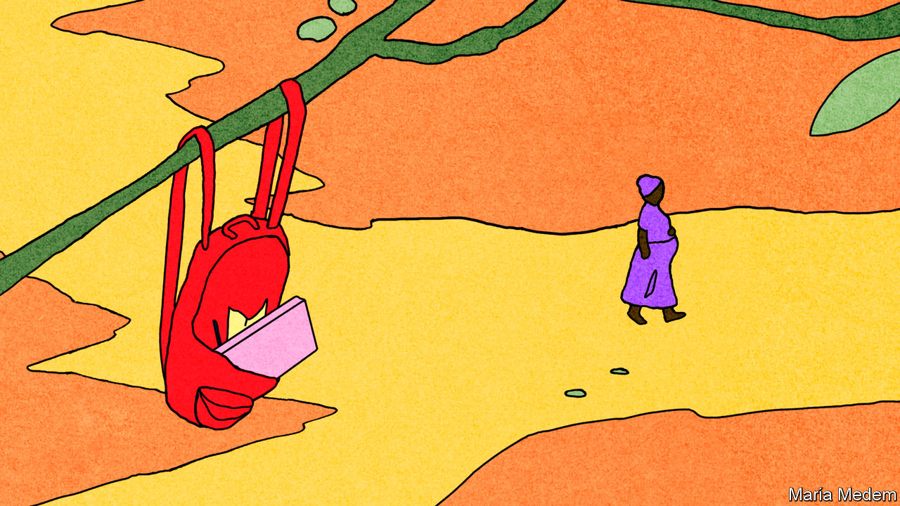

SIX YEARS ago Rosaline Margai’s secondary-school education came to a halt just as it was about to begin. In 2014-15 schools in Sierra Leone were closed for nine months because of the Ebola outbreak in west Africa. Six years later her schooling has again been interrupted. Covid-19 has caused Sierra Leone to close its schools and to cancel or postpone exams. Ms Margai was determined to start college by the age of 17. “I will turn 17 soon,” she explains. “But I fear I will not be able to take exams in time.”

Across west Africa memories of the devastation caused by Ebola and the school shutdowns are still fresh. Education for 5m children was severely disrupted. The luckiest met sporadically in small groups in homes. Others listened to government-provided education programmes by radio. But for many, learning stopped altogether.

Children were more likely to go to work. Sexual exploitation increased. Unplanned teen pregnancies rose sharply. “When you live in a country that already struggles to keep kids in school, and then schools are closed and poverty goes through the roof, you quickly become a candidate for child labour,” says Hani Mansourian of UNICEF, the UN’s children’s agency. He worries about a similar dynamic now; with the government overstretched, it is easier for employers to hire cheap young labour.

In 2014 school closures crimped many essential services, such as nutrition and health programmes, information on disease prevention, and access to clean water and sanitation. According to UNICEF, nearly 1m children in Liberia were not immunised that year.

When schools did reopen, many pupils did not return. Sierra Leone’s government banned “visibly pregnant girls” from school. In a survey in 2015 of adolescent girls asked why they were not in secondary school, “my parents cannot afford it” soared as a reason, recalls Tom Dannatt of Street Child, a British charity. Ms Margai remembers many kids dropping out: “Their parents would say ‘there is no need to be in school any more.’”

The current crisis is in some ways worse. During the Ebola outbreak, clubs for girls in some places provided education and support: those attending were less likely to get pregnant than those in similarly affected areas without such groups. Social distancing means that such efforts will be hard to replicate now. Mr Mansourian fears that the long-term consequences of covid-19 in low- and middle-income countries will be “much more dire” than Ebola was in west Africa.

Though it was terrible for children overall, Ebola did have the good effect of highlighting the flaws in west African education systems. It galvanised efforts to improve schooling, increase education budgets and reduce classroom crowding. “Whilst it seems early—and almost grim—to be thinking of it now,” says Mr Dannatt, “we should also absolutely be looking at how we can reopen education on a new level after the crisis.”

This article was downloaded by calibre from <https://www.economist.com/international/2020/05/02/school-closures-lessons-from-the-ebola-pandemic>

|  |  |  |  |
| --- | --- | --- | --- |
| Previous | Articles | Sections | Next |

|  |  |  |  |
| --- | --- | --- | --- |
| Previous | Articles | Sections | Next |

#### Think of the children

# The young seem to be less likely to catch or pass on covid-19

That boosts arguments for reopening schools

May 2nd 2020 |

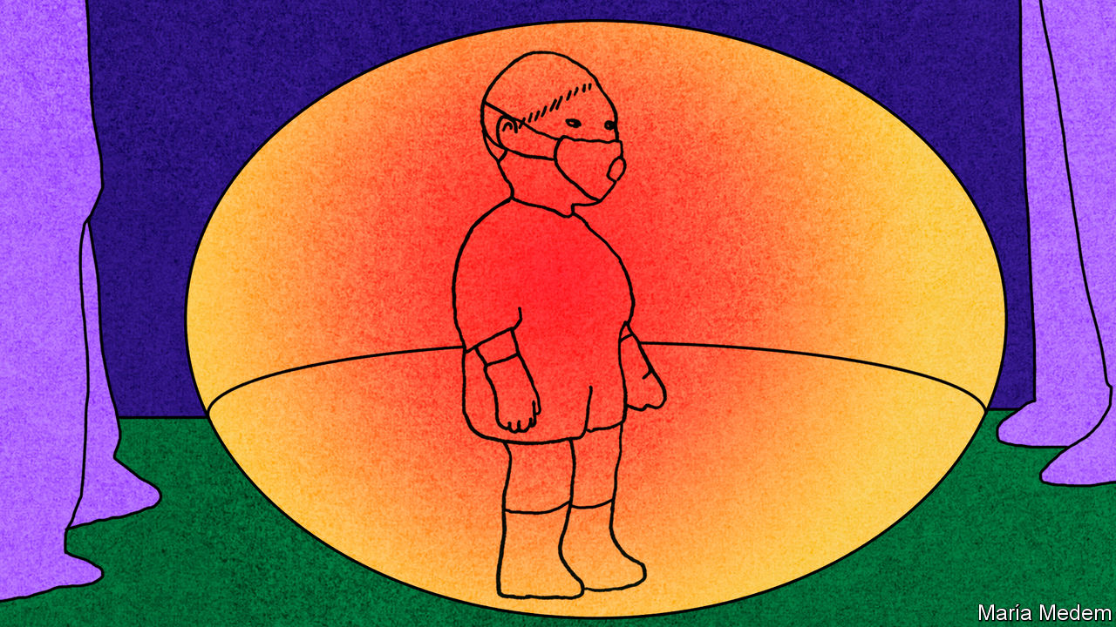

Editor’s note: The Economist is making some of its most important coverage of the covid-19 pandemic freely available to readers of The Economist Today, our daily newsletter. To receive it, register [here](https://www.economist.com/newslettersignup). For our coronavirus tracker and more coverage, see our [hub](https://www.economist.com/coronavirus)

WHENCOVID-19 began spreading in January, parents everywhere were terrified. Respiratory bugs thrive in children; this one kills. But children infected with the new coronavirus have had mild symptoms or none at all and deaths have been rare, says a review of nearly 80 studies published on April 22nd by an international network of child-health experts.

Whether children spread covid-19 has been less clear. Experts feared they could be easily infected but show no symptoms and so spread the disease to adults. Children pass on flu more than adults. They are more likely to catch it than adults who have some immunity from previous bouts. They are in close contact with their peers. So closing schools can slow flu epidemics.

But several studies now suggest that children are no more easily infected by covid-19 than adults, maybe less so. The most reliable ones have traced the contacts of infected people, tallying the infections in children and adults stemming from each “patient zero”. Two studies from China have just appeared in Science and the Lancet. One found similar infection rates; the other, in a different province, found that children were less susceptible.

Less conclusive studies also suggest children may be less vulnerable. In Vo, an Italian town where almost the entire population of 3,000 was tested for infection twice during its outbreak, none of the 234 children under ten was infected, compared with 1-3% of the population as a whole. In Stockholm, however, where over 700 people were tested once, 2.8% of those aged between two and 15 were infected, compared with 2.5% of the whole group.

These studies may miss infections in children who recover quickly. To catch all infections—and track when they ripple through each age group—requires frequent testing for both active infections and antibodies (the footprints of past infection), says Andrew Lover of the University of Massachusetts. Antibody-tracking studies have begun in Germany, the Netherlands and elsewhere. The first round of the Dutch study, of more than 2,000 people, found that about 2% of those under 20 had been infected, against 4.2% of those over 20. Rates among younger children were lower than among older ones.

According to the European Centre for Disease Prevention and Control, child-to-adult transmission “appears to be uncommon”. Researchers tracing chains of infections in Iceland and the Netherlands have found no cases of children infecting their families. Their samples are small but their observations chime with data from China.

But almost all these studies were done when schools were closed; most countries shut them early in the pandemic. A few recent studies have tried to disentangle the contribution of schools—with mixed results. In one French town with a covid outbreak linked to a secondary school, a study with antibody tests found that 41% of staff and students at the school had been infected, compared with 11% of their family members. A report from New South Wales in Australia that tracked close contacts of 18 infected students and teachers in 15 primary and secondary schools, however, found that of the 735 students and 128 staff, only two children contracted the disease from the initial cases. No staff member was infected. But attendance at the time was low because parents had been encouraged to keep their kids at home. More evidence will emerge as schools reopen. But so far children do not seem to be the stealthy super-spreaders once feared. ■

Dig deeper:  
For our latest coverage of the covid-19 pandemic, register for The Economist Today, our daily [newsletter](https://www.economist.com/newslettersignup), or visit our [coronavirus tracker and story hub](https://www.economist.com/coronavirus)

This article was downloaded by calibre from <https://www.economist.com/international/2020/05/02/the-young-seem-to-be-less-likely-to-catch-or-pass-on-covid-19>

|  |  |  |  |
| --- | --- | --- | --- |
| Previous | Articles | Sections | Next |

|  |  |  |
| --- | --- | --- |
| International | Sections | Finance and ... |

Business

Chinese entrepreneurs: Flowerbeds of enterprise

.

Bartleby: The road to hell

.

Virtual AGMs: Low resolution

.

German blue chips: Despondent DAX

.

Schumpeter: The riddle of Samsung

.

|  |  |  |
| --- | --- | --- |
| International | Sections | Finance and ... |

|  |  |  |  |
| --- | --- | --- | --- |
|  | Articles | Sections | Next |

#### Flowerbeds of enterprise

# Private companies have put down strong roots in China

The pandemic and a more assertive Communist Party are testing their resilience

May 2nd 2020 | HANGZHOU, SHANGHAI AND XIAMEN

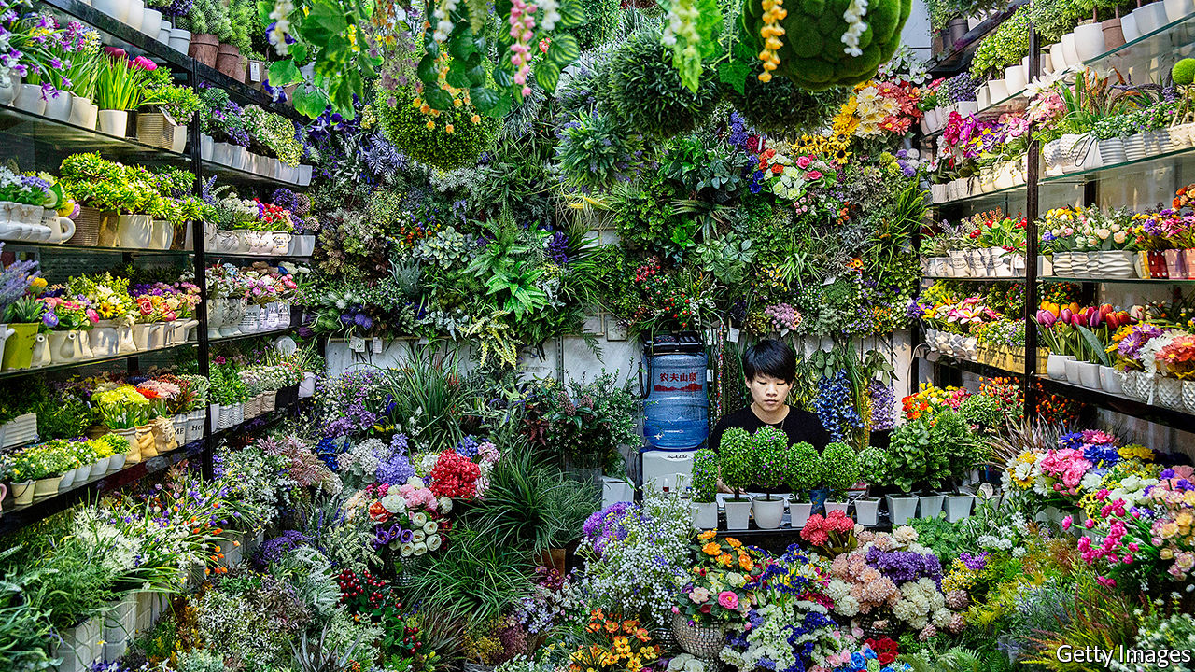

TO SAY THAT China’s economy has been hurt by covid-19 is putting it mildly. The 6.8% year-on-year fall in GDP in the first quarter ended a 28-year stretch of continuous, mostly rapid growth. The Communist Party, which derives legitimacy from rising living standards, is keen to put the slump behind it. President Xi Jinping is reversing a harsh lockdown and propping up state firms. But the world’s second-biggest economy will not heal by Mr Xi’s fiat alone.

For a collectivist state, China is remarkably reliant on private enterprise. As it ages, and its economy shifts from manufacturing for export to domestic services, the entrepreneurial class should grow in stature. Right now, though, the corona-crisis and, under Mr Xi, a more hands-on, inward-looking regime are testing private-sector resilience like never before.

The People’s Republic recognised its first private business in 1980, when a 19-year-old street hawker named Zhang Huamei registered her stall selling buttons and toys in the port city of Wenzhou. Since then the party has developed its own form of “economic gardening”—the notion, popularised in America in the 1980s, that grassroots entrepreneurs drive growth. It told business folk what not to do—certain industries, such as tobacco, were out of bounds—but otherwise let them grow unimpeded. As Jonathan Woetzel of McKinsey, a consultancy, puts it, China’s garden has had more in common with the deliberate wilderness of an English one than with manicured French lawns.

## Horticultural miracle

This approach has let entrepreneurship put down deep roots in China over the past 40 years. By 2017 budding business owners were registering close to 6m firms a year—or more than 15,000 a day—nearly three times the figure in 2010. Private firms contribute three-fifths of GDP and four-fifths of urban employment. Private wealth funds 70% of investment. Wenzhou’s party bosses today proudly proclaim that 99% of its businesses are privately owned and one in five locals has founded a company.

Chinese internet startups are a case in point. IT Juzi, a research firm, reckons that between 2015 and 2018 some $1.3trn in venture capital flowed into such firms. More than 130,000 have been created since 2001. Many ventures fail. The Asian Development Bank reckons that the average life expectancy of all small firms in China is less than four years, half that in America. Research by Renmin University in Beijing in 2016 found that only 2% of graduates who began a first business succeeded. Yet the same survey found that four in five still wanted to try their hand at starting one.

This zeal may stem from a belief that anyone can make it big. Chen Long, provost of the Hupan School of Entrepreneurship in Hangzhou, a startup-rich city in Zhejiang province, puts his compatriots’ entrepreneurial vim down to “countless examples of success”, which give “a sense that you can change your own fate”. In Fujian, a hive of business activity in pre-Mao days, people asked about the secret of business success recite a folk song: “Three parts of your life the heavens determine, the other seven you can if you’re hard-working.”

Tales like that of Jack Ma, who twice failed to get into university and started Alibaba, an e-commerce titan, in a cramped Hangzhou apartment, enrapture millions. Biographies of rock star founders like him or his namesake Pony Ma of Tencent, an online games-to-payments giant, fly off the shelves. Their pronouncements become aphorisms. And, as Roger King of the Hong Kong University of Science and Technology points out, their riches—the two Messrs Ma are worth a combined $88bn—provoke admiration rather than envy.

This sentiment may be reinforced by the high share of startups that turn into “unicorns”. China has 206 privately held companies valued at $1bn or more, more than any other country. Beijing alone hosts 82, more than San Francisco’s tally of 55, according to Hurun Report, a research firm. They include ByteDance, the world’s mightiest unicorn (which owns TikTok, a hit short-video app, and is valued at $90bn or thereabouts).

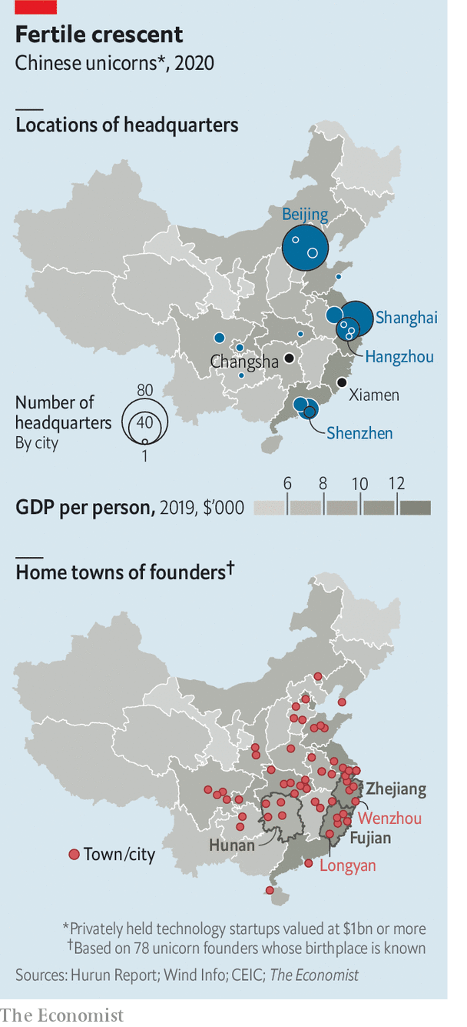

Unicorns are not, of course, a representative sample of private enterprise. But they nonetheless illustrate that Chinese entrepreneurship is broad as well as deep. According to Vision Plus Capital, a venture-capital firm, a big share of the herd grazes around cities with a high startup density per million residents, such as Hangzhou (31), Shenzhen (27) and Beijing (24). But their founders are a more geographically diverse bunch. Hurun lists 112 founders of Chinese startups worth $1.5bn or more. The 78 whose birthplace The Economist has been able to identify in China hail from 20 provincial-level regions (see map).

The founders of Kuaishou, a video-sharing app, Musical.ly, which became TikTok, and WeChat, a ubiquitous messaging app owned by Tencent, all came from inland Hunan province. Its capital, Changsha, houses more than 12,000 companies in the creative and cultural industries, luring more go-getters in these fields. Longyan, an otherwise unremarkable city in Fujian province, has spawned Zhang Yiming of ByteDance and Wang Xing of Meituan-Dianping, a now-listed super-app with a market capitalisation of $75bn.

Successful founders often nurture entrepreneurship in their home regions. A dozen Longyan-bred ones, including Mr Wang and Mr Zhang, have participated in a “Summit of New Rising Internet Stars from Longyan”. Cai Wensheng, a Fujianese high-school dropout who made billions trading internet domain names, has invested in dozens of local startups. In 2015 Alibaba’s Mr Ma opened the Hupan School, dreamed up in the midst of the global financial crisis a few years earlier as China’s answer to Harvard Business School (itself founded during the banking panic of 1907).

If businesspeople have been tending to the entrepreneurial garden, local authorities have been heaping fertiliser on it. Zhejiang, where Wenzhou is also located, embraced small businesses as soon as Deng Xiaoping lifted the Mao-era ban on them in 1979. Lending from Zhejiang’s state banks allowed some early stars to rise. They included Zong Qinghou, a juice-and-soda tycoon who founded Wahaha in 1987; Guo Guangchang, an industrialist who began Fosun Group in 1992; and later Ding Lei of NetEase, a gaming giant set up in 1997.

More recently Dream Town, a state-run startup village near Alibaba’s campus in Hangzhou, has been handing out cash and free office space to promising founders. Xiamen, a city in Fujian, offers the 3,000 startups in its Software Park generous subsidies for rent and research and development. Firms got preferential loans and a two-year waiver on corporate tax, plus a discount for another three.

China’s vibrant ecosystem of private enterprise faces three challenges. First, Chinese startups and small businesses, like everywhere else in the world, have been hit hard by the lockdowns. Their revenues fell by almost 60% in March, year on year, according to a survey by Tsinghua University in Beijing. CBInsights, a data provider, says the number of deals involving Chinese startups dropped by nearly 40% in the first quarter, compared with the previous one, to the lowest level since 2016. Early-stage funding declined by 70%.

To help out, Beijing has told banks that smaller companies may delay loan repayments up to the end of June. On April 23rd officials in Zhongguancun, the capital’s tech hub, teamed up with 30 venture-capital firms to launch a 30bn yuan ($4.2bn) investment campaign to support startups. Some large corporations are stepping up, too. Xiaomi, a smartphone-maker, participated in nine equity deals in the first quarter, one more than in the previous three months. Alibaba has launched the “2020 Spring Thunder Initiative” to help smaller export-oriented businesses expand into new markets. Ant Financial, its finance arm, has teamed up with hundreds of commercial banks to offer loans to tens of millions of smaller firms. Ant’s payment business, AliPay, is helping 50,000 merchants move online, in part by providing free online courses. Daniel Zhang, Alibaba’s boss, said the company must “stand arm in arm” with the little guy.

## Inconstant gardeners

Not everyone is as obliging. State-owned lenders refuse to extend new loans to many smaller firms, favouring lumbering state-owned champions. And Beijing’s ongoing crackdown on informal sources of lending, on which most private businesses rely, has starved many of resources.

This increasingly heavy hand is the private sector’s second problem. The party looks more hostile to it than at any time since before Deng set up “special economic zones”, capitalist sandboxes for firms, in the 1980s. Mr Xi favours state-led development over private-sector effervescence, maybe seeing the cult of entrepreneurs as a rival source of authority. The former party boss in Zhejiang and provincial head of equally enterprising Fujian has disappointed those who say breakthroughs require an environment where people are free, in the words of R. May Lee, “to indulge, to daydream and to do things differently”. Ms Lee stepped down as dean of the School of Entrepreneurship and Management at ShanghaiTech University in 2018 partly out of frustration over increasing state control of the curriculum.

The third worry for many Chinese firms is the prospect of being shut off from the world. This is not wholly China’s fault; America has limited exports of certain technologies to Chinese buyers as part of a trade war between the two superpowers. But Mr Xi’s pursuit of greater autonomy from the West will make it harder for Chinese firms to procure kit and components unavailable at home, including advanced microprocessors, and, increasingly, to attract business partners abroad. Officials’ early response to the virus, when they tried to suppress reports of the original outbreak in Hubei province, has only added to foreign queasiness of all things Chinese.

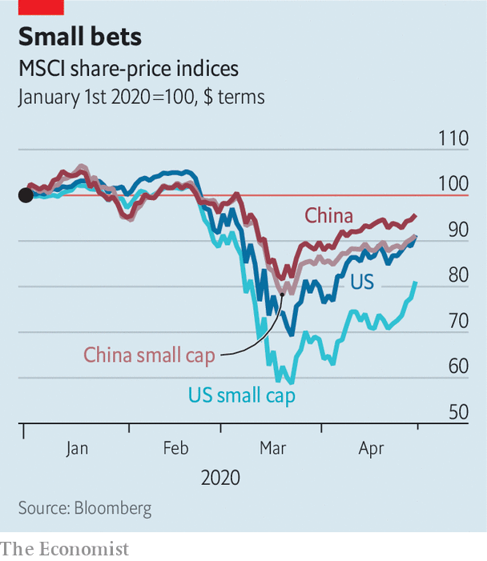

It is a testament to the private sector’s strength in China that it has held up. The share prices of smaller listed firms have done only half as badly in the pandemic as those of their counterparts in America and Europe. Whereas America’s small businesses have underperformed its biggest corporations by a factor of two, in China the small fry have done nearly as well as the whales (see chart). Once the crisis passes, venture capitalists, including home-grown ones, will no doubt loosen their purse strings.

And although Mr Xi has been less green-fingered than his predecessors, he is unlikely to pave over China’s flowerbeds of enterprise. The party realises that its promise of future growth requires a robust private sector. As one veteran foreign observer adds, it is also a useful “vaccine”—one that inoculates the regime against those too wilful to serve its interests as bureaucrats. Better for them to channel energy into entrepreneurship. Luckily for Mr Xi, many are still happy to do just that.■

This article was downloaded by calibre from <https://www.economist.com/business/2020/05/02/private-companies-have-put-down-strong-roots-in-china>

|  |  |  |  |
| --- | --- | --- | --- |
|  | Articles | Sections | Next |

|  |  |  |  |
| --- | --- | --- | --- |
| Previous | Articles | Sections | Next |

#### Bartleby

# Imagine the post-pandemic misery of business travel

The public announcements could be worrying, at the least

May 2nd 2020 |

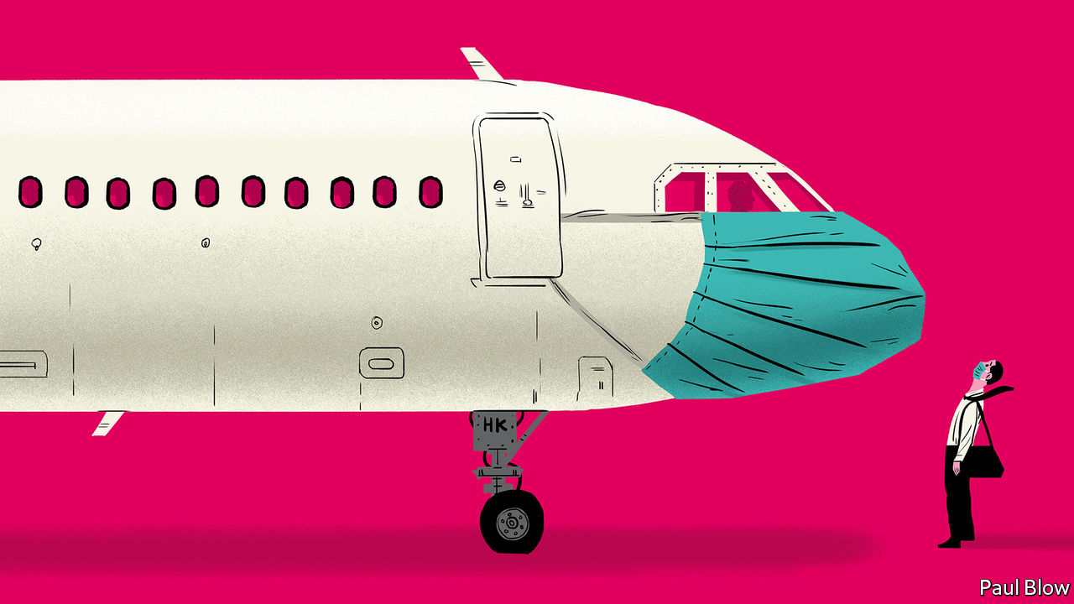

GOVERNMENTS ARE keen to get employees back to work in order to limit the economic damage of covid-19. And some companies will also be eager to send employees out in search of clients. But a vaccine is unlikely to be ready for at least another 12 months. So the next business trip you make might be an endurance test. Imagine the public announcements that travellers will hear.

Ding dong. Welcome to the renamed Heathrow Waystation 5. We decided the word “terminal” might be a little off-putting to passengers in the current circumstances. Please check in your baggage so it can be disinfected: apologies to those whose suitcases are made out of genuine leather as there will probably be stains. But never mind, it will be a good excuse to go shopping when you get to your destination. After check-in, head straight to security for your nasal swab and temperature check. As everyone needs to stand six feet (two metres) apart, the queue currently snakes around the building.

When you make it through security, head to duty-free where you can choose from our extensive selection of hand sanitisers. Hope you ate before you arrived because none of the restaurants is open. Travel safely. Ding dong.

Welcome aboard Acme Airlines flight 107 to New York. I am your pilot, Captain Richards. Social-distancing rules mean no co-pilot as there is not enough room in the cockpit for more than one person. But don’t worry; I brought a flask of coffee with me and I haven’t fallen asleep on a flight yet. If I don’t give you an update every 30 minutes, the cabin crew will hammer on the cockpit door.

We won’t be able to give you our normal in-flight food and beverage service but please enjoy the complimentary bottle of water, packets of salted nuts and crisps, and the empty seat next to you. Just a warning, though, to those of you who have chosen to sit by the window. Passengers must observe distancing rules so you won’t be allowed to squeeze past the person in the aisle seat if they fall asleep. In any case, only three people are allowed in the line for the restroom at any time. You may want to go easy on that water. If you need anything extra, the cabin crew will come and help you. Give them a few minutes as they need to don a hazmat suit first.

Ladies and gentlemen, you have arrived at JFK airport. We have good news and bad news. The good news is that passenger traffic is lower than normal. The bad news is that, given the need to disinfect the electronic passport reader after each use, the line for immigration is still two hours long. And no, you can’t use your cell phone to catch up on calls while you are in the waiting area. Welcome to the land of the free. Be brave.

Good afternoon and thanks for choosing Hotel Purgatory for your stay. Our motto: you can check in any time you like but, if we hear you coughing, you can never leave. Your disinfected room pass is already available in a disinfected envelope. Unfortunately, as only one person is allowed in the elevator at a time, the wait time to get to your room is 60 minutes. By the way, the same delay applies in the morning, so if you are heading for meetings, you had better book an early alarm call. There are no baggage porters, so we hope you packed light.

To reduce the risk to staff, the room will be cleaned only after you leave, so make your own bed. Feel free to take home the shampoo in the shower: no one else wants to touch it. The spa, pool and bar are closed for obvious reasons, and there is no room service. Enjoy your stay.

Morning all and welcome to the 2020 Risk Managers’ Conference. Or should that be the Risk Takers’ Conference? Ha ha. Rest assured this is a fully sanitised room. This year’s slogan: We Care About Your Health Because Your Employer Doesn’t. When it comes to questions, we won’t be passing round microphones, so please speak as loudly as possible. Panel sessions are difficult at the moment, so will be limited to two speakers at opposite ends of the stage.

We are afraid that a buffet lunch is unavailable so take a chance on one of the street-food carts outside the conference centre. Your choice will sort out the real risk managers from the also-rans. This wouldn’t be a conference without exhibition stands in the foyer. Our sponsors will be delighted to see you, but only from a safe distance, and wearing a mask. Finally, please familiarise yourself with the exits behind me, on the left and right. Obviously they are there in case of a fire but they could come in handy if someone has a coughing fit.

This article was downloaded by calibre from <https://www.economist.com/business/2020/05/02/imagine-the-post-pandemic-misery-of-business-travel>

|  |  |  |  |
| --- | --- | --- | --- |
| Previous | Articles | Sections | Next |

|  |  |  |  |
| --- | --- | --- | --- |
| Previous | Articles | Sections | Next |

#### Low resolution

# Online annual meetings may favour managers over shareholders

Small wonder some executive may wish to preserve them after the pandemic passes

May 2nd 2020 | NEW YORK

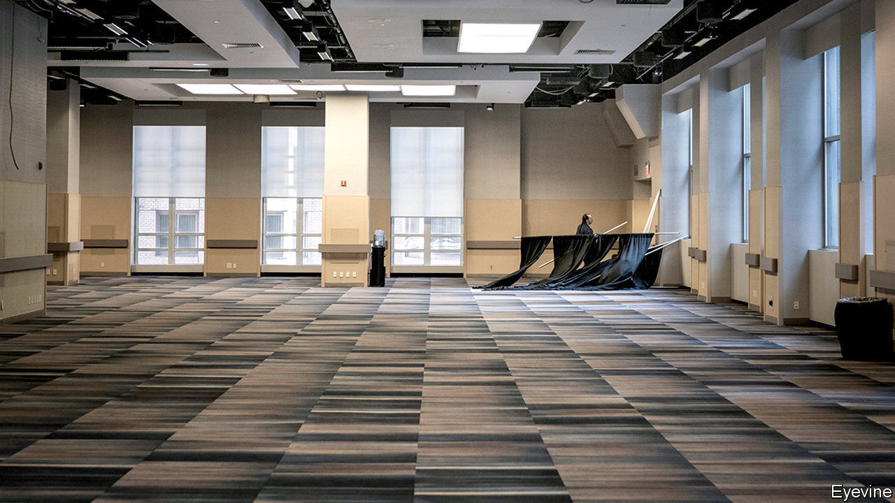

“WE WILL GREATLY miss seeing our shareholders,” lamented Warren Buffett ahead of Berkshire Hathaway’s annual general meeting (AGM) on May 2nd. Thousands of his devoted shareholders would normally have flocked to Nebraska for the jamboree. Not this year. Because of covid-19 the conglomerate has moved the gathering online. The 2020 edition of “Woodstock for capitalists”, as Mr Buffett calls it, may turn out to be a “wooden experience”, says Charles Elson of the University of Delaware.

An oddity in pre-coronavirus times, virtual AGMs are spreading fast in the age of social distancing. By the reckoning of Institutional Shareholder Services (ISS), a shareholder-advisory firm, the total number of planned annual meetings worldwide confirmed to be online-only as of April 22nd was 2,240, up from 286 for all of 2019. American firms accounted for over half that figure. On April 27th Boeing, a troubled aeroplane-maker, and Honeywell, an industrial conglomerate, both held their AGMs in cyberspace (including voting on shareholder resolutions, most of which were defeated). On May 4th America’s Securities and Exchange Commission, a regulator, will hold a public hearing (online, naturally) to discuss what it all means for corporate governance.

Online meetings have their virtues. Many AGMs are sparsely attended because far-flung shareholders, who could easily join a virtual one, cannot make it to a physical venue. They are also cheaper, greener and less time-consuming than traditional meetings once travel is accounted for.

Firms may cite such things as reasons to stick with virtual AGMs after the crisis. That would be unfortunate, for the apparent high-mindedness may conceal a more self-serving reason why bosses prefer virtual AGMs: they can tilt proceedings in favour of management.

It is easy to see how online meetings could dampen shareholder dissent. In a room full of people you can take the pulse of the crowd. Those on the fence about a resolution may be swayed to join a rebellion if they sense seething frustration in others. Francesca Odell and Helena Grannis of Cleary Gottleib, a law firm, point out that in online meetings “people can’t see someone shaking their fists angrily or waving their hands.”

Most observers support online meetings during the pandemic as a stopgap, so long as they meet high standards of transparency. ISS urges firms to ensure that shareholders can still “ask questions of directors and senior management and to engage in dialogue”.

But the consensus among corporate-governance types is that AGMs should be held in person as soon as it is safe to do so. Otherwise, warns Mike Mayo, an analyst at Wells Fargo, post-crisis annual meetings risk becoming “emotionless, toneless, check-the-box exercises”. He finds attending them to be an invaluable way to hold executives to account. In contrast with the “one and done” question-and-answer session typical of online forum, in-person encounters allow for a proper grilling of bosses and board members. “For directors, it is a meet-your-makers moment,” echoes Mr Elson. The makers would no doubt rather meet in a room than on Zoom.■

This article was downloaded by calibre from <https://www.economist.com/business/2020/05/02/online-annual-meetings-may-favour-managers-over-shareholders>

|  |  |  |  |
| --- | --- | --- | --- |
| Previous | Articles | Sections | Next |

|  |  |  |  |
| --- | --- | --- | --- |
| Previous | Articles | Sections | Next |

#### Despondent DAX

# The covid-19 crisis exposes the frailties of Germany’s biggest firms

The main German stockmarket index holds up a mirror to the world’s fourth-biggest economy

May 2nd 2020 | BERLIN

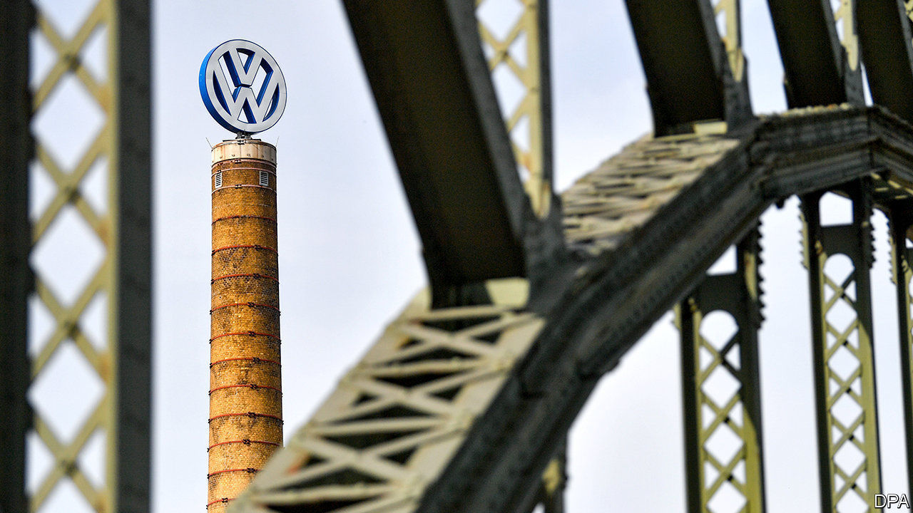

Editor’s note: The Economist is making some of its most important coverage of the covid-19 pandemic freely available to readers of The Economist Today, our daily newsletter. To receive it, register [here](https://www.economist.com/newslettersignup). For our coronavirus tracker and more coverage, see our [hub](https://www.economist.com/coronavirus)

THE DAX INDEX of Germany’s 30 most valuable listed companies holds up a mirror to the world’s fourth-biggest economy. The reflection isn’t pretty. In mid-March the average “price-to-book” ratio of DAX firms’ market capitalisation to the book value of their assets fell below one, which has previously only happened in 2009 and 2011, amid the global financial crisis and the euro crisis, respectively. It is now hovering barely above one.

The pandemic has hit all of the world’s big stockmarkets. But it is shining a particularly brutal light on the weaknesses of Germany’s flagship index, which has underperformed those in other advanced markets (see chart).

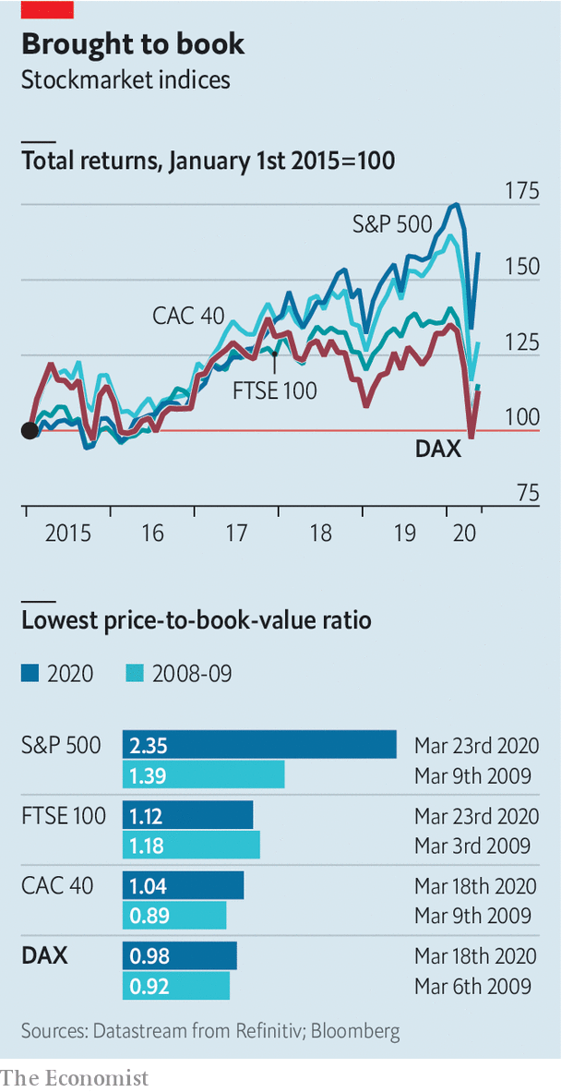

On April 29th Volkswagen, Europe’s biggest carmaker (price-to-book ratio: 0.6) reported that its operating profit sank by 81% in the first quarter, year on year. The day before Lufthansa, which is trading at two-fifths of book value, said it may seek bankruptcy protection, as talks with the government over aid for the airline stalled. Days earlier Deutsche Bank reported a 67% fall in quarterly profits. That this beat analysts’ estimates is damning with faint praise. Its ratio of 0.2 suggests investors don’t think much of its prospects.

Germany’s business-software champion, SAP, is doing well enough. The DAX’s only other tech firm, Wirecard, is not. On April 28th the payments processor’s share price fell by 26% when it published incomplete findings of a special audit, commissioned after reports of allegations of accounting fraud. Wirecard also delayed the publication of results for last year, which were due on April 30th.

The MDAX, which consists of the next 60 biggest listed companies, looks perkier, thanks to digital darlings such as Delivery Hero and HelloFresh (online food), TeamViewer and Nemetschek (software), Zalando (online fashion), Scout24 (digital classifieds) and Freenet (telecoms), as well as biotech firms like Evotec, Morphosys and Qiagen. Delivery Hero or Qiagen may soon ascend to the DAX, possibly pushing out Lufthansa.

“We think obituaries for the DAX are premature,” insists Ulrich Stephan, chief investment officer at Deutsche Bank. He is right. But it would look considerably less morbid with fewer corporate oldies stuck in the pre-digital economy.■

Dig deeper:  
For our latest coverage of the covid-19 pandemic, register for The Economist Today, our daily [newsletter](https://www.economist.com/newslettersignup), or visit our [coronavirus tracker and story hub](https://www.economist.com/coronavirus)

This article was downloaded by calibre from <https://www.economist.com/business/2020/05/02/the-covid-19-crisis-exposes-the-frailties-of-germanys-biggest-firms>

|  |  |  |  |
| --- | --- | --- | --- |
| Previous | Articles | Sections | Next |

|  |  |  |  |
| --- | --- | --- | --- |
| Previous | Articles | Sections | Next |

#### Schumpeter

# What is weighing on Samsung?

The business model is shockproof. But the mood is grim

May 2nd 2020 |

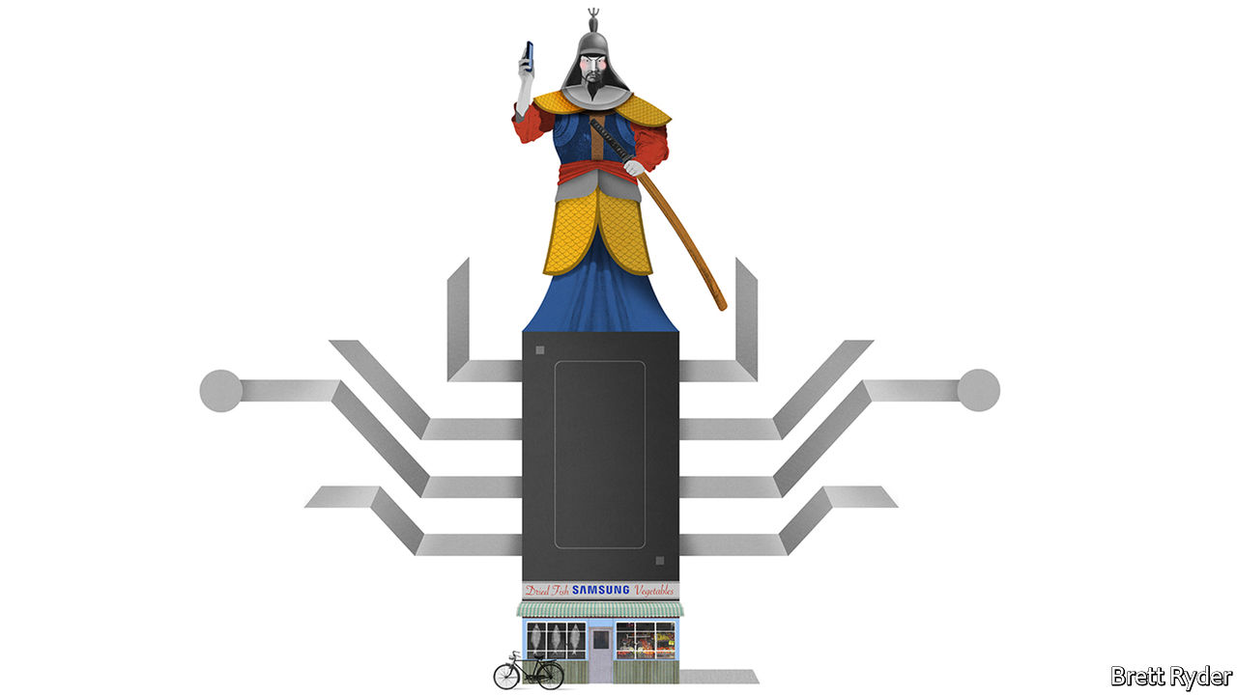

EVEN IN A corporate world rife with despotic founders, complex cross-shareholdings and cultlike initiation rituals, Samsung stands out as the most mysterious of firms. Founded in 1938 as a provincial vegetable and dried-fish shop, it has grown into a conglomerate accounting for a fifth of South Korea’s exports. Its crown jewel, Samsung Electronics, has for years been one of the world’s biggest seller of smartphones, televisions and chips, with a market capitalisation of more than $270bn and 310,000 workers in 74 countries. The group’s riveting story, chronicled in a new book, “Samsung Rising”, by Geoffrey Cain, is one of entrepreneurial derring-do and excruciating work habits mixed with scandals, vendettas and political intrigue. What the author (a former contributor to this newspaper) skips over is how a company with so many well-documented flaws can be such a resounding success.

To get a sense of the Samsung enigma consider first its ruling dynasty. Long before Kim Jong Un, North Korea’s dictator, disappeared from view in April, Samsung’s chairman, Lee Kun-hee, vanished into hospital. The 78-year-old has not been heard from since 2014. No one outside the family knows how ill he is. His only son and heir-apparent, Lee Jae-yong, aged 50, faces a retrial on charges of influence-peddling, for which he spent almost a year behind bars in 2017-18. Jay, as he calls himself, has exerted huge influence over Samsung Electronics despite directly owning a tiny fraction of its shares and no longer sitting on its board, thanks to an ownership structure set up around other group holdings and family foundations. It is not clear who would represent the clan’s interests if Jay were found guilty.

The chaebol’s corporate culture is no less eyebrow-raising. Mr Cain describes a leadership style at Samsung Electronics that is military-like, macho and intolerant of mistakes. When the conglomerate turned from fertilisers and transistors to semiconductors in the early 1980s, the ruling family toughened up its chip engineers with an overnight march in midwinter, followed by the usual 16-hour work shift. In 1995, to embarrass its technicians for shoddy workmanship, the elder Mr Lee ordered a bonfire of 140,000 gadgets; $50m went up in smoke. Mr Cain recounts numerous expletive-filled tirades by the firm’s top brass. And yet Samsung Electronics continues to be South Korea’s most prestigious employer and a magnet for bright graduates.

Most enigmatic of all is the success bred by this inclement environment. Within a few years of that frosty march, Samsung Electronics’ semiconductor business had caught up with its big Japanese competitors. In 2011, just two years after it had introduced its first smartphone, its Galaxy devices edged past Apple’s iPhone in sales volume. Its speed is matched by its chutzpah; competitors, like Apple and Sony, are also the biggest customers for its components, from chips to OLED screens. Samsung makes diversification seem like a virtue, not a distraction. When sales of phones and other gadgets suffer, as they did in the first quarter owing to the covid-19 crisis, the memory-chip business provides ballast; it got a boost from lockdown-related use of cloud-based servers, Samsung said on April 29th. Ten years after the Lees decided to further diversify the conglomerate by 2020, the pandemic has helped turn Samsung Biologics, a manufacturer of vaccines and other pharmaceuticals, into South Korea’s third-most-valuable company.

So what puts the fire into Samsung’s kimchi? Mark Newman, a former Samsung Electronics employee now at Bernstein, an investment firm, says the secret ingredient has always been faith in the founding family, who, for all their flaws, retain a godlike status within the firm. As in Western companies, executives bicker over where to spend money. But when a decision is taken at the top, they quickly fall into line. That helps some of Samsung’s bold, strategic bets to pay off. Others, such as Samsung cars and solar panels, have not.

Samsung executives believe it is time for another big flutter on the future—nowhere more so than at Samsung Electronics. For all its strengths, it has two big problems to grapple with. The first is how to become more than just the world’s most exemplary slicer-and-dicer of chips, screens and gadgets. It wants to triumph in higher-margin (and chicer) software and services. As smartphone sales peak, Apple is enveloping its customers in wearables, watchables and listenables. The American giant’s returns dwarf Samsung’s. Rather than develop its own operating system to rival Apple’s, the Korean firm outsourced the job to Google’s Android. Instead of software, it has recently doubled down on manufacturing non-memory chips and biopharmaceuticals. To make a success of services, especially in the era of the all-connected “Internet of Things”, it needs creative skills that it has struggled to nurture.

The second challenge is China. The country is changing both as a market and as a source of competition. Last year Samsung pulled the plug on smartphone production in China after its market share, once in double digits, fell below 1%. Big Chinese firms have the cash and long-term focus to give it a run for its money in semiconductors. Phone companies like Xiaomi are better at software and apps. As one of the biggest beneficiaries of globalisation, Samsung will draw little consolation from the prospect of supplying the West if the tech cold war gets worse.

## Less leeway

Despite $81bn of net cash (more than the market value of Sony) to invest, a sense of gloom pervades Samsung Electronics. With the Lee family in an agonising limbo, it is unable to place big strategic wagers, jeopardising its ability to move beyond manufacturing or compete with Chinese rivals. There is a way forward. Like most dynastic firms, Samsung will eventually have to put all its faith in professional managers, rather than in its founding family. Now is as good a time as any to start. To be sure, it will take the mystery out of the firm. It doesn’t have to kill its mojo. ■

This article was downloaded by calibre from <https://www.economist.com/business/2020/05/02/what-is-weighing-on-samsung>

|  |  |  |  |
| --- | --- | --- | --- |
| Previous | Articles | Sections | Next |

|  |  |  |
| --- | --- | --- |
| Business | Sections | Schools brief |

Finance and economics

Bailing out small businesses: Averting nightmare on Main Street

.

Bailing out large firms: Big bucks

.

Melissa Dell: To good effect

.

Local finances in America: Less than zero

.

Buttonwood: Pulp fiction

.

Free exchange: Mountain to climb

.

|  |  |  |
| --- | --- | --- |
| Business | Sections | Schools brief |

|  |  |  |  |
| --- | --- | --- | --- |
|  | Articles | Sections | Next |

#### Averting nightmare on Main Street

# Politicians in America and Europe scramble to help small firms

But their schemes are meeting with mixed success

May 2nd 2020 | WASHINGTON, DC

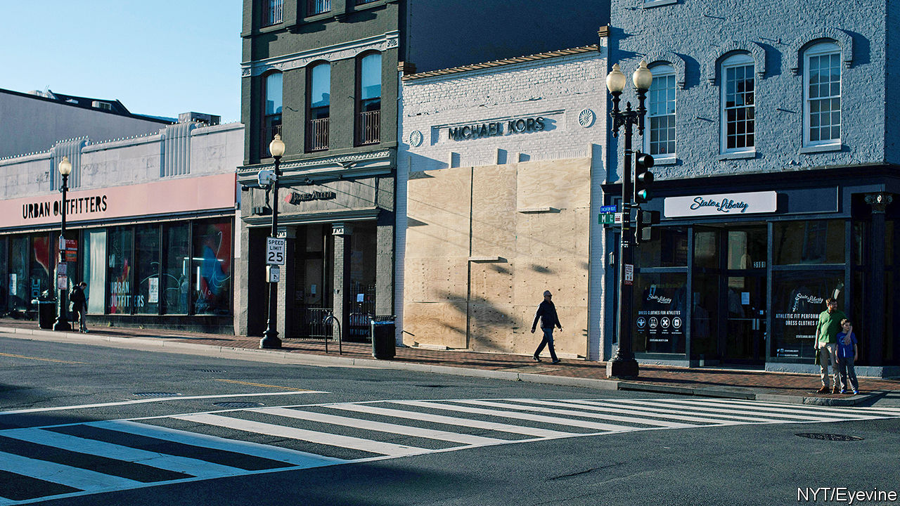

Editor’s note: The Economist is making some of its most important coverage of the covid-19 pandemic freely available to readers of The Economist Today, our daily newsletter. To receive it, register [here](https://www.economist.com/newslettersignup). For our coronavirus tracker and more coverage, see our [hub](https://www.economist.com/coronavirus)

RANDY HATHCOCK appeared to be out of options. The time had come for the owner of H&T Truss Mill, a construction company in Arkadelphia, Arkansas, to decide how many of his 16 employees to sack. The pandemic had led to orders drying up. Then a lifeline appeared. The Paycheck Protection Programme (PPP), a scheme administered by America’s Small Business Administration, promised enough to cover two-and-a-half months of wages. It was “an answer to our prayers”, says Mr Hathcock. If he retains his staff for two years, the $161,200 loan turns into a grant.

Voters abhor bail-outs when they involve airlines and Wall Street, but seem altogether happier to provide succour to the likes of Mr Hathcock and Main Street. Politicians in America and Europe have all the more reason to help: small and medium-sized businesses (SMEs) have been clobbered by the pandemic, even more so than their larger peers. Fully 60% of people who worked for businesses with fewer than ten employees in America at the start of the year have since been fired, according to one study. In Britain, seven in ten firms managed by their owners say they have lost over half their revenue.

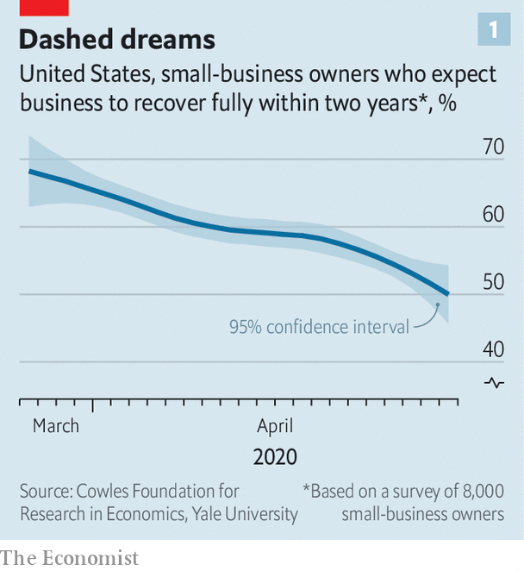

Even as the share prices of listed titans have perked up—the S&P 500 index of large American stocks is up by 31% since its nadir on March 23rd—small firms are becoming ever more uncertain about their prospects. Most have cash buffers that stretch to weeks, not years. Roughly half of American entrepreneurs do not expect business to recover within two years, according to a survey by academics at Oxford, Princeton and Yale universities (see chart 1).

Schemes like the PPP should help. But rich-country bail-out schemes that were put together in a rush are experiencing sharp teething pains. As a result, lifelines that are generous on paper have been less so in practice. Aid has not reached the most distressed firms, and has been hogged by larger SMEs savvy enough to navigate the bail-out bureaucracy, if not by even bigger businesses (see article).

America and Europe have adopted similar strategies to preserve the fabric of their economies. First help SMEs cut cash outgoings quickly, for example by delaying tax deadlines or even reversing past payments. Then find ways to lend or grant cash so that companies make it through the lockdown.

In Europe, the fastest way for businesses to cut costs has been to lay off workers temporarily. Britain and all members of the European Union now have temporary-unemployment schemes that allow firms to cut staff hours, sometimes to zero. Workers receive benefits in lieu of most of their salary. When lockdowns are lifted, they will go back to their old jobs. That limits the disruption to both their livelihoods and their employers’ prospects.

Such short-time working schemes, which originated in Germany and spread continent-wide after the global financial crisis, were once the purview of big firms, says Stefano Scarpetta of the OECD, a policy adviser to rich countries. Now they have been opened to SMEs. The take-up has been rapid. Nearly 11m French workers, or roughly half the salaried workforce, are temporarily unemployed. In Germany, more than 700,000 firms have applied.

America has no such federal scheme (though some states have smaller programmes in place). Hence the PPP. But the $349bn originally allocated to the programme ran out just 13 days after it was launched on April 3rd. On April 27th a further $310bn approved by Congress became available; the demand crashed the Small Business Administration’s systems. “It’s been all hands on deck trying to get the loans approved,” says Darrin Williams, the boss of Southern Bancorp, a Mississippi-delta lender, which helped unlock the PPP riches for Mr Hathcock. Even once firms’ applications have been approved, delays in receiving the cash are common.

European countries have also looked to direct cash to small firms—and faced similar delays. In Britain, Germany and Italy, among others, the smallest firms (or self-employed workers) have received handouts reasonably promptly. Bigger SMEs are entitled to low-interest loans, typically covering three months of payroll. Doling these out has proved tricky.

To ensure the money did not end up going to businesses with no hope of paying it back, bankers were roped in to assess potential recipients. Governments agreed to shoulder 70-90% of potential loan losses, limiting the downside for banks. Still, lending figures have underwhelmed. In Spain after five weeks only €13.4bn ($14.6bn) out of €100bn in state guarantees earmarked for SMEs have been tapped. Britain managed to allocate a meagre £4.1bn ($5.1bn) by April 28th. From early May it will join Germany in offering some loans that are completely underwritten by the state. Bankers can distribute cash without having to worry about the creditworthiness of the borrower.

There will still be suspicions that the money is flowing into the wrong pockets. A study by researchers at the University of Chicago finds that SMEs in the bits of America where activity had fallen most were only half as likely to receive PPP funds as those in the least-disrupted places.

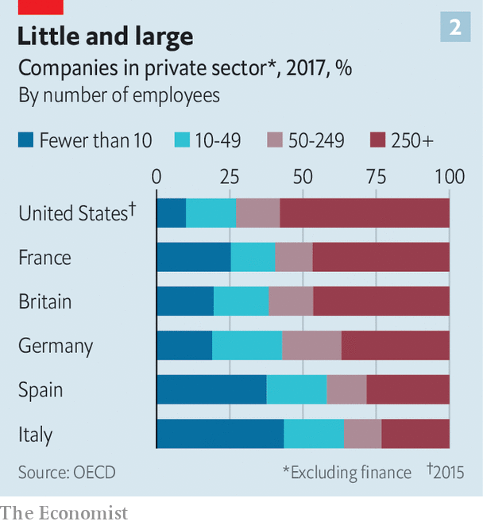

In Europe, finding ways to help SMEs is economically essential. Nearly half of workers toil in firms with fewer than 50 employees (see chart 2). But many of the most troubled companies are in Spain or Italy, which have been hit especially hard by covid-19, and where governments have little fiscal space to fund large-scale bail-outs. That imbalance has raised complaints that firms in the European Union do not really compete in a single market.

Given the rush, it is perhaps not much of a surprise that neither America’s nor Europe’s schemes have achieved all that policymakers hoped. Europe’s short-timework schemes will preserve employment—but at huge cost, and at the risk of keeping employees in jobs that ought to disappear. America is now dishing out money more decisively, but unemployment there has soared (see Free Exchange), in no small part owing to Main Street’s woes. Back in January, roughly half of all small firms had at least three employees on their books. By April, a similar share had none. ■

Dig deeper:  
For our latest coverage of the covid-19 pandemic, register for The Economist Today, our daily [newsletter](https://www.economist.com/newslettersignup), or visit our [coronavirus tracker and story hub](https://www.economist.com/coronavirus)

This article was downloaded by calibre from <https://www.economist.com/finance-and-economics/2020/05/02/politicians-in-america-and-europe-scramble-to-help-small-firms>

|  |  |  |  |
| --- | --- | --- | --- |
|  | Articles | Sections | Next |

|  |  |  |  |
| --- | --- | --- | --- |
| Previous | Articles | Sections | Next |

#### Big bucks

# America’s large firms can count on generous government support

But there are strings attached

May 2nd 2020 |

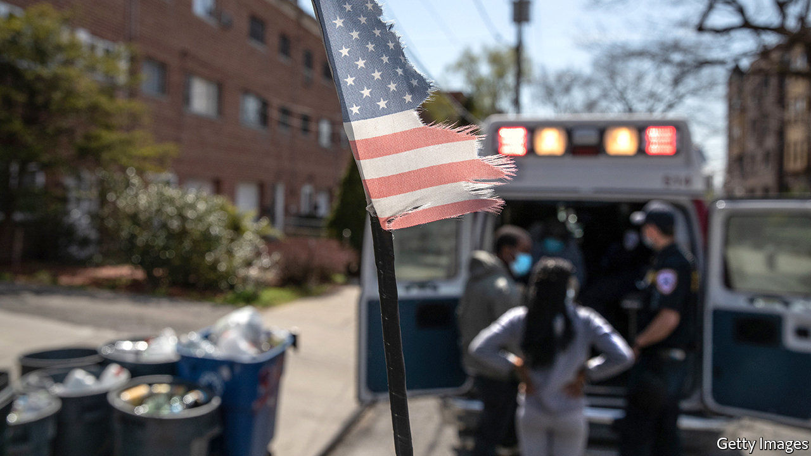

Editor’s note: The Economist is making some of its most important coverage of the covid-19 pandemic freely available to readers of The Economist Today, our daily newsletter. To receive it, register [here](https://www.economist.com/newslettersignup). For our coronavirus tracker and more coverage, see our [hub](https://www.economist.com/coronavirus)

BAIL-OUTS ARE often a source of public ire. Americans still seethe over the rescue of banks during the crisis of 2007-09 even as homeowners went bust. The latest group in the spotlight are big firms masquerading as small ones. Companies including Shake Shack, a listed burger franchise, and Potbelly, a meaty sandwich chain, have returned funds granted to them under the $659bn Paycheck Protection Programme (PPP), a scheme primarily designed to help small firms keep employees on their payroll during the pandemic.

Big businesses have facilities of their own to tap. A “Main Street Lending Fund” will soon dispense a total of $600bn to firms with up to 10,000 employees. The Federal Reserve has set aside $750bn to buy corporate bonds.

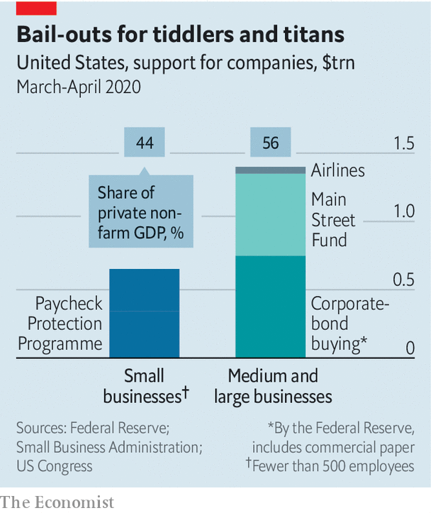

At first glance the support might appear more generous than the cash set aside for small firms, even when you adjust for their contributions to economic activity (see chart). But the big-company schemes differ from PPP in a crucial aspect: they are loans, and must eventually be repaid. By contrast, the minnows can keep PPP funds, as long as they retain workers.

The big firms receiving the most aid are those requiring specific bail-outs. The government will spend $50bn to keep America’s airlines aloft. But that too comes with conditions. Carriers have agreed to keep staff until October, cut executive pay and halt shareholder payouts until late 2021. The more generous the aid, the more strings attached.■

Dig deeper:  
For our latest coverage of the covid-19 pandemic, register for The Economist Today, our daily [newsletter](https://www.economist.com/newslettersignup), or visit our [coronavirus tracker and story hub](https://www.economist.com/coronavirus)

This article was downloaded by calibre from <https://www.economist.com/finance-and-economics/2020/05/02/americas-large-firms-can-count-on-generous-government-support>

|  |  |  |  |
| --- | --- | --- | --- |
| Previous | Articles | Sections | Next |

|  |  |  |  |
| --- | --- | --- | --- |
| Previous | Articles | Sections | Next |

#### To good effect

# Melissa Dell wins the John Bates Clark medal

Her work on conflict and coercion has changed how economists think about development

May 2nd 2020 | WASHINGTON, DC

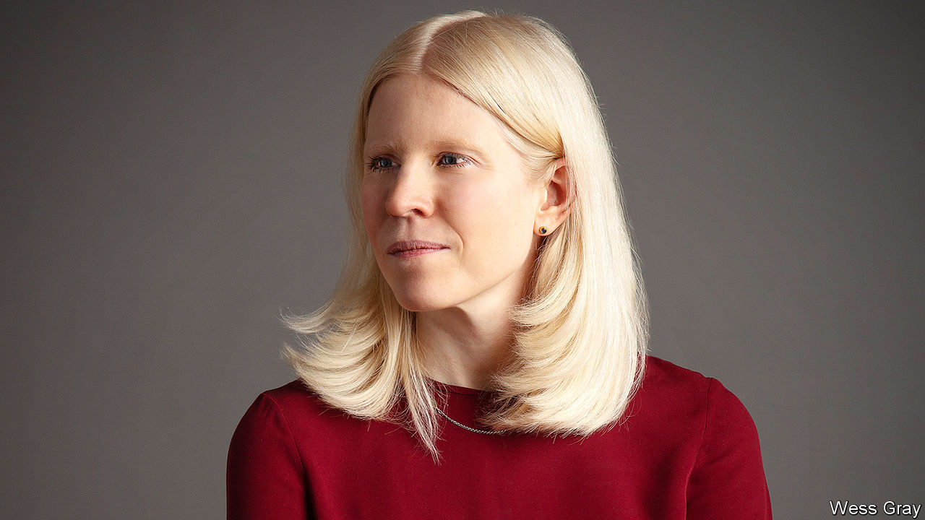

WHEN MELISSA DELL was an undergraduate she heard about some economics research that reminded her of a recent trip to Peru. It was no idle daydream. The study, by Daron Acemoglu and Simon Johnson of the Massachusetts Institute of Technology (MIT) and James Robinson of the University of Chicago, argued that colonial institutions could determine economic performance today. Ms Dell wondered whether Peru’s history might explain its extreme poverty. Her answer to the question has helped her win the John Bates Clark Medal, an award given annually by the American Economic Association to an economist under 40.

The colonial institution was the Spanish-imposed “mita” system in Peru and Bolivia, which between 1573 and 1812 forced a seventh of adult men from indigenous communities to work in silver and mercury mines. This was in place in some regions but not others, allowing Ms Dell to measure its effects. Her results supported the findings of Messrs Acemoglu, Johnson and Robinson, that extractive institutions have pernicious and persistent effects. Centuries on, families living just inside mita areas consume 25% less than those just outside them, are less educated and rely more on subsistence farming.

Ms Dell then asked why the mita had such damaging effects. She showed that haciendas, or big agricultural estates, thrived outside mita areas, not inside them. (That, she hypothesised, was because a greedy state did not want competition for scarce mine workers.) Unequal land ownership was thought to have held back Latin American development. But Ms Dell argued that the alternative was worse.

Hacienda owners may not have been benevolent, but they did have the power to lobby for public goods. That meant that places outside mita areas had decent roads. But those inside them did not, and had fewer means and incentives to invest. (Even after the system was phased out, inhabitants had to contend with the confiscation of their land, as well as bandits.)

The research formed Ms Dell’s master’s thesis and was published in a top journal in 2010. Though her broader body of research won her the medal, this paper, gushed the prize-giving committee, “beautifully” illustrates her work, which draws on history, and “very convincingly” pinpoints cause and effect. Now a professor at Harvard University, Ms Dell still explores the role of the state as an engine of development. Together with Benjamin Olken of MIT, for instance, she shows that colonial institutions can have mixed effects: Indonesian villages closer to Dutch sugar factories are today richer than those further away. By combining history and economics, Ms Dell uses the past to shine light on today.■

This article was downloaded by calibre from <https://www.economist.com/finance-and-economics/2020/05/02/melissa-dell-wins-the-john-bates-clark-medal>

|  |  |  |  |
| --- | --- | --- | --- |
| Previous | Articles | Sections | Next |

|  |  |  |  |
| --- | --- | --- | --- |
| Previous | Articles | Sections | Next |

#### Less than zero

# America’s cities and states face a cash crunch

Help from the federal government and the Federal Reserve may be on the way

May 2nd 2020 | WESTCHESTER COUNTY

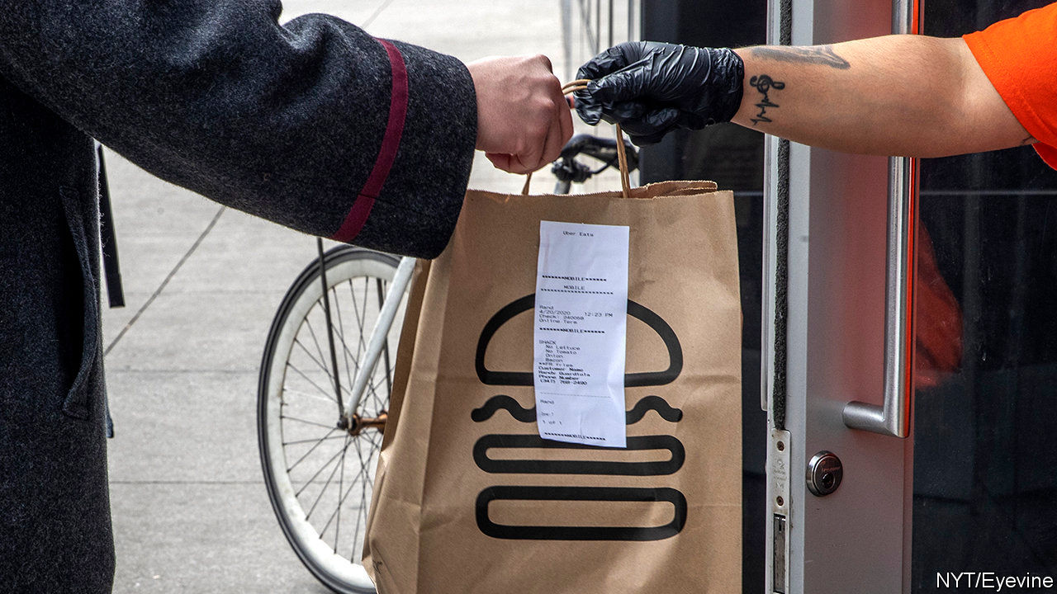

Editor’s note: The Economist is making some of its most important coverage of the covid-19 pandemic freely available to readers of The Economist Today, our daily newsletter. To receive it, register [here](https://www.economist.com/newslettersignup). For our coronavirus tracker and more coverage, see our [hub](https://www.economist.com/coronavirus)

NO COUNTY IN New York, outside the city and Long Island, has seen more cases of covid-19 than Westchester, just north of the Bronx. For weeks tens of thousands of would-be commuters have been staying home. Bars, restaurants and other businesses have been closed.

Sales-tax revenue, usually around $500m, may be down by as much as $100m this year. With fewer people travelling, hotel-tax receipts will be lower. Meanwhile, spending on emergency and health services has soared. The county may face a shortfall of up to $160m on a $2.1bn annual budget. It can hope for at best limited help from the state of New York, which itself expects a 14% decline in revenue, due to lower corporate- and personal-income-tax receipts, requiring $7.3bn in spending cuts in the next budget. “We’ve done a variety of projections,” explains George Latimer, the county executive: “Bad, worse, even worse and totally horrible.”

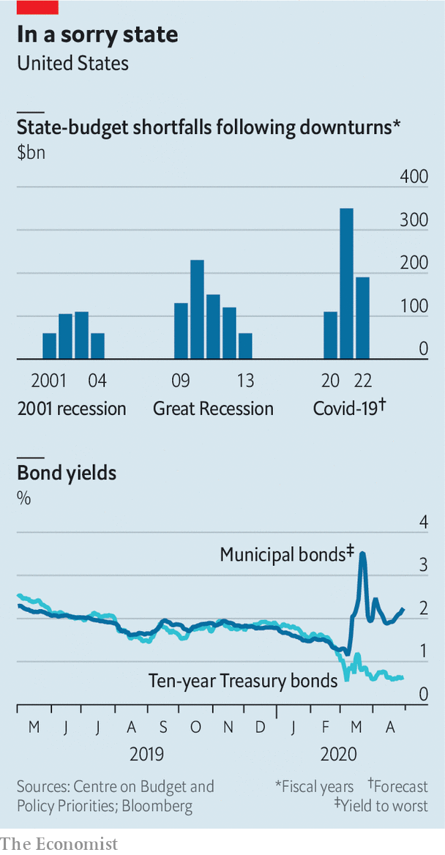

Mr Latimer is not alone. Shortfalls have hit local governments across America—and not just in covid-battered places. Wyoming, for instance, claims to have around 400 confirmed cases, but may face a collapse in revenue of 30% over the next two years, driven by low oil prices and electricity demand (it is America’s leading coal-producing state). The National Association of Counties estimates that revenue declines and covid-related spending increases could take $144bn out of county budgets through the upcoming fiscal year. The Centre on Budget and Policy Priorities (CBPP), a left-leaning think-tank, reckons that states will face an even bigger shortfall, of $350bn, next year (see chart). The prospect of such shortfalls led investors to sell off municipal bonds in March, causing yields to rise sharply. Terrifying though these numbers are, there may also be grounds for hope.

Start with the horror. Most states begin their next fiscal year on July 1st. States and cities issue debt to fund long-term infrastructure projects, such as building hospitals or schools. But for the most part—because of a combination of constitutional requirement, statute and tradition—they must balance their budgets, and cannot use debt to fund operating costs. When revenues fall, therefore, states must cut spending or raise taxes. With so many people out of work, and uncertainty over whether and when consumer spending will return, states will want to keep tax increases minimal. That leaves only one alternative: deep spending cuts.

Anything remotely discretionary is probably imperilled, as is education, which was cut heavily after the 2007-09 crisis. Local governments may also have to start furloughing and firing people. High unemployment will make that especially painful. Chris Coons, a Democratic senator from Delaware who during the financial crisis ran his state’s most populous county, warns that municipal lay-offs could hit “employees processing unemployment cheques…or those who will be critical to retraining and placement of people unemployed now, or folks who provide critical community services.”

Fortunately, most states are in a better position than they were before the last recession. In mid-2019 tax revenues in every state but five had exceeded their pre-recession levels (commodity-dependent Wyoming and Alaska were among the exceptions). All states but four reported that they had collected more revenue in the year to July 2019 than expected.

Rainy-day funds also hit an all-time high, with the median covering 8% of general-fund expenditures. The healthy average, though, masks wide gaps. On the whole, western states appear in better shape than hard-hit north-eastern ones. New York’s kitty, for instance, is just 3.2% of general-fund expenditures; New Jersey’s and Pennsylvania’s are at 1% each. Drawing down around half of these funds would allow states to plug around $36bn of the shortfall. Federal aid passed to date has provided another $281bn.

More is probably coming. A Senate bill sponsored by Bob Menendez, a Democrat from New Jersey, and Bill Cassidy, a Republican from Louisiana, would disburse $500bn to state and local governments in proportion to their populations, revenue losses and number of covid-19 cases. Its chances of passing the Republican-controlled Senate are slim. But even Mitch McConnell, the majority leader—who at first suggested that states be allowed to go bankrupt—concedes that cities and states will probably receive more federal funds.

In order to calm the bond market, the Federal Reserve has said it will buy up to $500bn of state and local debt. On April 27th it amended its programme to include more states and cities. It now plans to buy investment-grade bonds issued by states and counties with a population of at least 500,000, and cities with a population of at least 250,000. That excludes smaller places, but lets states and counties use the proceeds of their sales to the Fed to help smaller entities.

Investors hope the combination of federal loans and aid can keep bond markets stable. Geoffrey Schechter of MFS Investment Management believes that a wave of defaults is unlikely: “states and local governments recognise they need access to capital markets.” An uncertain couple of months, followed by a lean few years: cautious optimism in a pandemic.■

Dig deeper:  
For our latest coverage of the covid-19 pandemic, register for The Economist Today, our daily [newsletter](https://www.economist.com/newslettersignup), or visit our [coronavirus tracker and story hub](https://www.economist.com/coronavirus)

This article was downloaded by calibre from <https://www.economist.com/finance-and-economics/2020/05/02/americas-cities-and-states-face-a-cash-crunch>

|  |  |  |  |
| --- | --- | --- | --- |
| Previous | Articles | Sections | Next |

|  |  |  |  |
| --- | --- | --- | --- |
| Previous | Articles | Sections | Next |

#### Buttonwood

# How to detect business fraud

Carson Block, a short-seller, on uncovering false accounting

May 2nd 2020 |

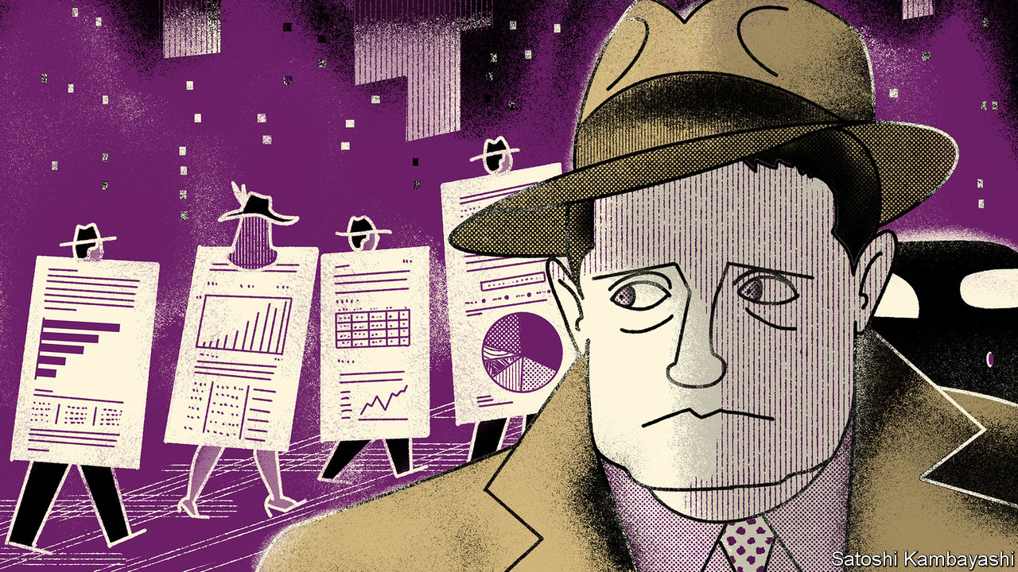

LIKE A LOT of people, Carson Block found his vocation by accident. In 2010 he was living in China and trying to set up a business. His father asked him to look at Orient Paper, a Chinese firm listed in New York. He scoured the company’s filings and became doubtful of its claims. That scepticism grew when he visited a factory. He decided to publish a damning report. But first he would bet against the stock to cover his costs. The report went viral. The share price collapsed. Lawsuits were soon flying.

It has been like that ever since. Mr Block is an activist short-seller. His firm, Muddy Waters, borrows shares in a shifty-looking company and then sells them. That allows it to profit from a fall in their value. There is something of the gumshoe about him—imagine Philip Marlowe, the private eye created by Raymond Chandler, but with coarser language. (Example: XYZ Corporation is a “predatory shit-bag”). Instead of pounding the mean streets, Mr Block ploughs through reams of company documents. He makes his findings freely available. He then shows up on CNBC’s “Squawk Box” to denounce the bad guys.

More appearances seem assured. The stock of covert embezzlement—what John Kenneth Galbraith, a quotable economist, called “the bezzle”—varies with the business cycle. It grows during booms. Tell people that XYZ Corporation is a fraud, and they won’t listen. Short-sellers get short shrift. But the cycle always turns. The bezzle peaks just as boom turns to bust. For short-sellers, these are the good times.

Mr Block made his name angling for Chinese scams. His company’s name derives from a Chinese proverb: muddy waters make it easy to catch fish. China is to stock fraud what Silicon Valley is to technology, he says. But there is plenty of dodgy accounting, albeit of a less blatant kind, outside it. Muddy Waters has evolved into a short-seller with a global purview.

The art of the bezzle is to inflate profits, pump up the stock price and quietly sell your shareholdings to credulous outsiders. But money is not the only incentive. Vanity is also a factor. Jeff Skilling, the boss of Enron, a book-cooking firm that went bust spectacularly in 2001, had an unshakable belief in his own acumen. Executives of his kind tend to serve up the financial results that bolster their own delusions. “Once you’ve been put on a pedestal, once you’re on the cover of Business Genius Monthly, it becomes hard to believe you are fallible,” says Mr Block.

Each stock fraud is fraudulent in its own way. But there are common elements. One is a breach between earnings as defined by Generally Accepted Accounting Principles (GAAP) and non-GAAP measures. Another is an increase in “days payable outstanding”, a yardstick of how long it takes a company to settle bills with suppliers. Delay boosts cashflow, at least for a while. So does gathering more quickly payments you are owed. Firms with dressed-up earnings also tend to pile on debt because they lack strong underlying cashflow. And there are grounds to suspect the worst of companies that engage in a lot of acquisitions. Aligning the accounts of acquirer and acquired gives ample scope for fiddling.

But looking only at numbers is not enough. They need to be cross-checked with other information. Finding it is gumshoe work. There may be clues in the firm’s risk disclosures. Lawyers are skilled at writing these in ways that put readers to sleep, says Mr Block. Stay awake, though, because they occasionally slip something important in between all the guff. Transcripts of conference calls with stock analysts can also be revealing. If the company keeps moving the goalposts, then be on alert.

Muddy Waters has built a reputation for diligent research. A pronouncement by Mr Block has the power to move prices. That worries regulators. Like Chandler’s detective, Mr Block seems to take as many beatings from cops as from bad guys. Even admirers worry about possible errors and lapses. But he is refreshingly candid about his flaws. A sense of alienation from his “postcard-perfect” surroundings as a youth bred an urge to expose the shallow, the vapid and the fake. “When I discovered there were all these frauds in China, it was a form of therapy,” he says.

There are easier ways to earn a living. A few years after shorting Orient Paper, Mr Block totted up the numbers and found that he had lost $600. No matter. He sees no shortage of firms with accounting that distorts reality. “There are real excesses out there.” The bezzle has only grown fatter.

This article was downloaded by calibre from <https://www.economist.com/finance-and-economics/2020/05/02/how-to-detect-business-fraud>

|  |  |  |  |
| --- | --- | --- | --- |
| Previous | Articles | Sections | Next |

|  |  |  |  |
| --- | --- | --- | --- |
| Previous | Articles | Sections | Next |

#### Free exchange

# Why the unemployed in America could face a lost decade

Even under the rosiest of assumptions, a labour-market crisis is looming

May 2nd 2020 |

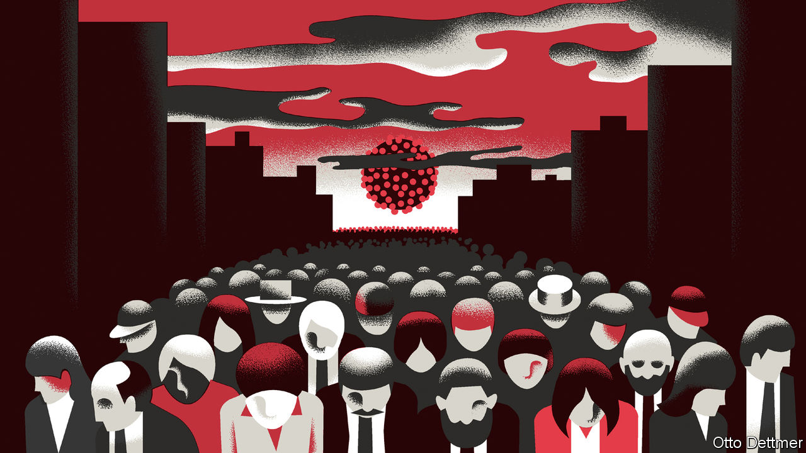

Editor’s note: The Economist is making some of its most important coverage of the covid-19 pandemic freely available to readers of The Economist Today, our daily newsletter. To receive it, register [here](https://www.economist.com/newslettersignup). For our coronavirus tracker and more coverage, see our [hub](https://www.economist.com/coronavirus)

THE FIGURES are staggering, even to those hardened by the experience of the global financial crisis. Disney will furlough 100,000 of its hotel and theme-park workers. Uber may slash its staff by a fifth. Fully 26m new claims for unemployment insurance have been filed in America since late March. By April 18th more than a tenth of participants in the labour force were receiving unemployment benefits, the highest rate on record. In March alone American firms shed more than 700,000 jobs, on net. Another 2m may have gone in April, a drop rivalling the record decline in employment that occurred in 1945, as America’s armed forces demobilised. Covid-19 has spread large-scale economic disruption around the world. It is increasingly clear that the pandemic confronts America with a labour-market crisis not seen since the Great Depression of the 1930s.

How severe will the crisis be? America’s unemployment rate rose to around 10% after the global financial crisis and to 25% during the Depression. Recent forecasts, though beset by uncertainty, put the probable peak rate in 2020 somewhere between those figures. Modelling based on recent filings for benefits suggests that the unemployment rate in mid-April may have been around 16%, according to Ernie Tedeschi of Evercore ISI, a consultancy. An analysis of the macroeconomic effects of the coronavirus published on April 24th by America’s Congressional Budget Office (CBO) paints a similar, sobering picture. The CBO reckons that unemployment will rise to 14% in the second quarter of this year, and peak in the third quarter at around 16%. The rate would be even higher, but for the 8m workers it assumes will become discouraged and leave the workforce (in order to count as unemployed, people must participate in the labour market by actively seeking work). Some places and groups will fare worse than others. During the financial crisis, peak unemployment rates across states ranged from just over 4% to nearly 15%. The peak rate for black Americans, at 16.8%, was nearly twice that for whites.

The heights that unemployment reaches will depend on the depths that economic activity plumbs. There is no question that the drop in output through the first half of 2020 will be staggering. Figures published on April 29th showed that GDP fell by 1.2% in the first quarter, compared with the final quarter of 2019 (an annualised rate of -4.8%). The CBO projects that output will fall by about 12% between the first quarter and the second, or an annualised pace of roughly -40% (see chart, middle panel). But the economic and social pain of unemployment rests largely on how persistent the weakness in the labour market proves to be, which in turn depends on the pace of the economic recovery. The CBO, like many forecasters, expects America’s economy to begin growing again in the second half of the year, as restrictive measures are relaxed. They forecast, perhaps optimistically, a robust rate of growth in the third quarter of 5.4% (an annualised rate of 23.5%). A fast initial rebound might well materialise as sectors shut down by pandemic-fighting measures begin to re-open. But growth is expected to moderate thereafter to an annual rate of 2.8% in 2021, in line with America’s recent pre-pandemic performance. If the past relationship between output and job growth is a guide, such a rate will be sufficient only to reduce unemployment to 9.5% by the year’s end. In other words, some 20 months from now, unemployment may still be close to the peak reached in the aftermath of the financial crisis. If GDP growth continued at 2.8% thereafter, America would regain its pre-pandemic unemployment rate only in 2026.

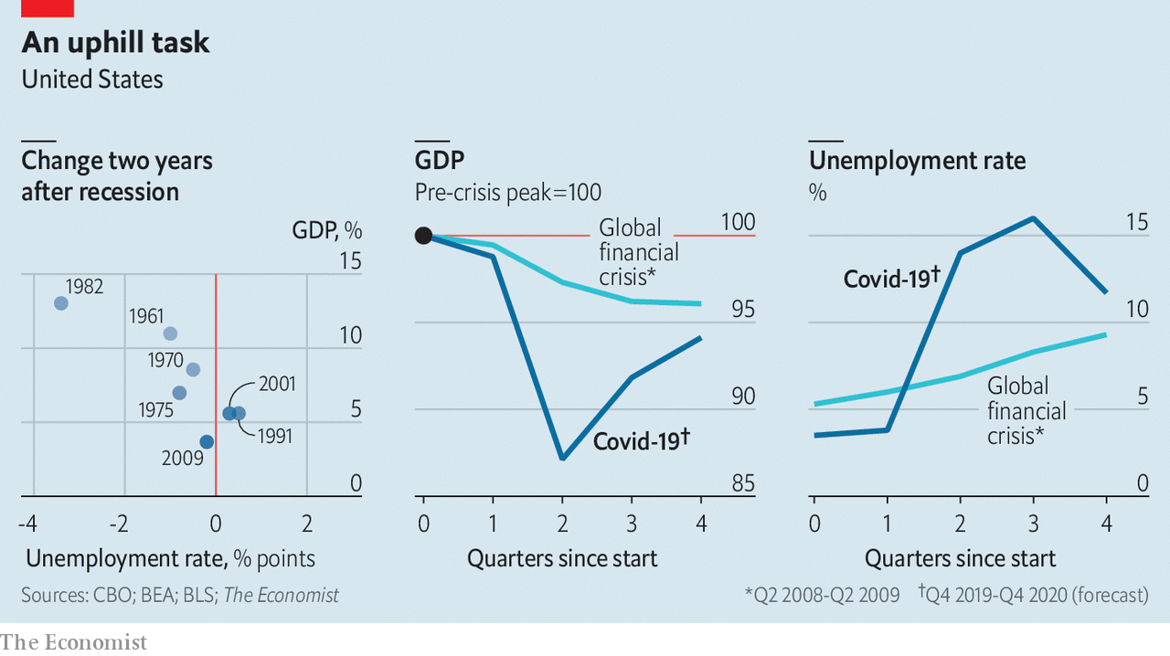

As dire as the CBO’s projections are, it is difficult to see how the economy could do better. The forecast drop in the unemployment rate from the third quarter to the fourth, of 4.3 percentage points, would, if realised, easily be the fastest ever three-month decline. It would achieve in three months what took a year during the early 1940s, when America mobilised for war. In the absence of a miracle treatment or early vaccine, it is the very best America can hope for. Far easier to imagine are ways in which the forecast disappoints. New outbreaks or restrictions on activity could push output lower and delay a turnaround in the jobs market. Though economic recoveries from the 1950s to the 1980s were often V-shaped, recent business cycles have proven more lopsided. Dramatic declines in output and employment have not been followed by correspondingly steep rebounds.

## Deep trouble

Many of the factors implicated in this change in recovery patterns are likely to apply as the pandemic recedes. Easing could prove insufficient. Though America’s spending on stimulus has been impressive so far, there are some signs of fiscal fatigue. The Federal Reserve has largely succeeded in averting financial-market havoc, but its ability to revive economic growth may be hampered by near-zero interest rates. Household and company debt, already high before the pandemic compared with the early post-war era, will grow more burdensome as the economy shrinks, reducing the scope for new spending once the recovery gets under way. Firms may come to view the pandemic as an opportunity to streamline production—through the use of remote-work and automating technologies, for example—potentially reducing labour demand down the road. Research by Nir Jaimovich of the University of Zurich and Henry Siu of the University of British Columbia finds that such structural shifts during downturns have contributed to the joblessness of recent recoveries.

Even in the rosiest of scenarios, the outlook for those without a job seems grim. Were unemployment to fall as quickly as it did from 1933 to 1937, a return to pre-pandemic jobless rates would still take half a decade. At the rate of improvement experienced after the financial crisis, by contrast, full recovery could take two decades. All that after the hardship of the 2010s seems nearly unthinkable. Yet without a hefty dose of good luck and an aggressive government effort, America’s unemployed face a real risk of another lost decade—or two. ■

Dig deeper:  
For our latest coverage of the covid-19 pandemic, register for The Economist Today, our daily [newsletter](https://www.economist.com/newslettersignup), or visit our [coronavirus tracker and story hub](https://www.economist.com/coronavirus)

This article was downloaded by calibre from <https://www.economist.com/finance-and-economics/2020/05/02/why-the-unemployed-in-america-could-face-a-lost-decade>

|  |  |  |  |
| --- | --- | --- | --- |
| Previous | Articles | Sections | Next |

|  |  |  |
| --- | --- | --- |
| Finance and ... | Sections | Science and ... |

Schools brief

Computing climate change: Model behaviour

.

|  |  |  |
| --- | --- | --- |
| Finance and ... | Sections | Science and ... |

|  |  |  |  |
| --- | --- | --- | --- |
|  | Articles | Sections | Next |

#### Projections of the future

# How modelling articulates the science of climate change

From paper and pencil to the world’s fastest computers

May 2nd 2020 |

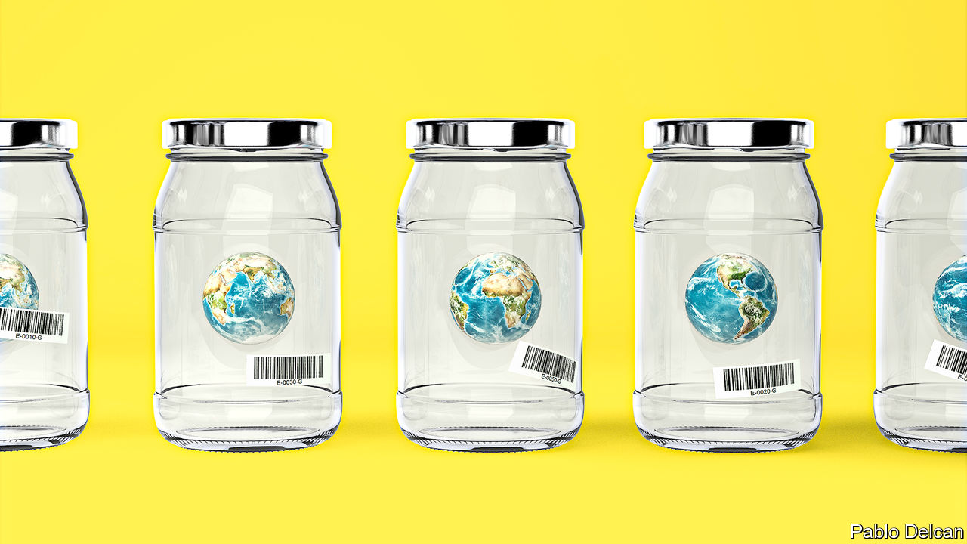

TO IMAGINE EARTH without greenhouse gases in its atmosphere is to turn the familiar blue marble into a barren lump of rock and ice on which the average surface temperature hovers around -18ºC. Such a planet would not receive less of the sunlight which is the ultimate source of all Earth’s warmth. But when the energy it absorbed from the sunlight was re-emitted as infrared radiation, as the laws of physics require, it would head unimpeded back out into space.

Greenhouse gases block that swift exit. Transparent to incoming sunlight, they absorb outgoing infrared radiation, thus warming the atmosphere and, in so doing, the surface below. The result is an average surface temperature of some 15ºC—warm enough for open seas and oceans and a vibrant biosphere.

In the late 19th century the discovery of the ice ages led scientists to the conclusion that climate could change on a global scale. Svante Arrhenius, a Swedish chemist, wondered if a weakened greenhouse effect might be to blame. Carbon dioxide was known to be a greenhouse gas: Eunice Foote, an American scientist, had found in the 1850s that the rate at which a sealed jar of air warmed up in sunlight depended on the level of carbon dioxide in that air. So Arrhenius—recently divorced, somewhat melancholy and in need of a project—began laboriously to calculate the effects on the climate of halving the atmosphere’s level of carbon dioxide.

Doing so required him to tackle a problem of the sort that most frustrates and most delights scientists who study the Earth system: a feedback loop through which a change in one factor affects another factor which, in turn, affects the first factor more.

Because water evaporates more slowly in cooler climes, the amount of water vapour in the atmosphere falls with the temperature. And water vapour, like carbon dioxide, is a greenhouse gas. Cooling the atmosphere dried the atmosphere which cooled the atmosphere further. Many pencils and thousands of sheets of paper into his exploration of this, Arrhenius concluded that halving the carbon-dioxide level would cool the planet by 5ºC (9ºF).

He also noted that the same relation would hold the other way round: double the carbon dioxide and you would get 5ºC of warming. Industry’s coal burning could thus warm the world—but only, he thought, very slowly indeed. He never imagined that the carbon-dioxide level would increase by a third in just a century.

Around the same time as Arrhenius was pondering the climate, a Norwegian scientist called Vilhelm Bjerknes was working on the physics of how heat drives fluid flow. His students applied these insights to large scale flows in the atmosphere and the oceans, laying the foundations of 20th-century weather forecasting. In 1950 one of those students’ students, Ragnar Fjørtoft, was part of the team which first programmed a computer to forecast the weather by solving such equations.

The computer models central to today’s climate research bring together Arrhenius’s curiosity and Bjerknes’s techniques. Programmes developed from weather-forecasting software calculate how the level of carbon-dioxide and other greenhouse gases is likely to affect the world’s flows of heat, energy and water, and through them the future climate. To do so they use computers that can be some 25trn times faster than the one used in 1950.

These climate models do not treat the atmosphere as a whole. They divide it into millions of “cells”. The conditions in each of these cells depend on the conditions in its neighbours above, below and to the sides as well as on its own history. The idea is to calculate how conditions in each cell change over time. Unlike a weather forecast, which tries to predict how a specific state of the atmosphere will evolve over a few days, these climate models simulate years, even centuries, of weather in order to discover the averages and probability distributions that define the climate—the envelope which constrains the norms and extremes of future weather.

Dozens of teams at meteorological and research organisations around the world run such models, each using different code to capture the climate’s underlying mechanisms and study everything from future peak rainfall to the tracks of storms to shifts in seasonality. Since 1995 the Coupled Model Intercomparison Project, or CMIP, has brought these teams together by providing standardised tasks for their models and then looking at the range of results. Thus, for example, the 56 different models considered in the fifth of the CMIP projects, which concluded in 2013, found that doubling the carbon-dioxide level would, in time, bring about a warming of between 1.5ºC and 4.5ºC. The uncertainty in what the models suggest at smaller scales is greater still. Different models can provide very different pictures of the future of regional climates.

## Rows and floes of angel hair

The wide range of outcomes is, for the most part, down to the fact that no two models represent the mechanisms of the climate—and particularly its feedbacks—in precisely the same way. Some ways of doing things can be ruled out because the models they produce fail to capture the behaviour of the climate as it is, or as it was in the past (studies of the low-carbon-dioxide ice ages provide useful calibration, which would have pleased Arrhenius). But among models which reproduce past and current climates reasonably well, there is no clear way to say which one’s representations are most reliable. The differences between the models represent a basic level of uncertainty, given the current state of knowledge.

This endemic uncertainty, though, does not mean the models have nothing useful to say. Given how long modelling has been going on, it is now possible to compare predictions made decades ago with the way things have turned out. A study published last year systematically assessed what models published between the 1970s and 2007 had said about the way the climate would respond to steady rises in carbon dioxide. It found that for 14 out of 17 models what had happened had been within the model’s error bars; of the other three, two had overshot, one had undershot. Taking the models seriously would have been a good bet.

The most important source of uncertainty in the models lies in the clouds. As greenhouse gases warm the atmosphere its humidity changes, as does the extent to which it cools with altitude. These changes affect how clouds develop; the clouds, in turn, change surface temperature. Most clouds warm the world; some cool it.

The problem is that the processes which control a cloud’s thickness, lifetime and other qualities work on pretty small scales. The models do not. Even if every layer of the atmosphere is represented by hundreds of thousands of grid cells, they still end up being hundreds of kilometres on a side—much too large to capture the processes responsible for individual clouds.

Not all the feedbacks sit squarely within the atmosphere; some extend beneath it. Various feedbacks link the atmosphere to the oceans, which store, move and release heat in ways that do a great deal to shape the climate. In the 1960s modellers began trying to capture these effects by “coupling” models of the ocean to models of the atmosphere, so that what they saw in the atmosphere reflected changes in the oceans and vice versa.

Feedbacks involving the land matter, too. Cold weather brings snow; snowy ground, especially under clear skies, reflects away more sunlight, cooling things further. Biology adds yet more complexity. A tropical forest pumps water vapour into the atmosphere with far greater efficiency than a savannah does. In warmer oceans it is harder for nutrients to rise to the surface, which reduces the ability of plankton to suck carbon dioxide from the atmosphere. Melting permafrost produces copious microbial methane—a gas which absorbs infrared much more strongly than carbon dioxide does. Over the decades modellers have attempted to build more and more of these interrelationships into their models, adding greatly to their complexity.

Unfortunately increasing complexity does not always reduce uncertainty. A model which ignores, say, the instability of ice sheets—as most did until recently—is clearly missing something important. However, because there are always different ways to incorporate something new, two models updated to capture ice-sheet dynamics may diverge more after this “improvement” than they did when, unrealistically, they simply ignored the issue. In the CMIP6 process, which is currently winding up, preliminary results show a wider range of uncertainties than was seen in CMIP5.

The biggest source of uncertainty, though, lies not inside the models but outside them. Climate change is a problem because human activity is adding carbon dioxide, methane and other greenhouse gases to the atmosphere at a rate that is both prodigious and impossible for the physics, chemistry and biology encoded in the models to predict.

To estimate how changes in policy might affect emissions a different family of models is used—“integrated assessment models” (IAMs) which import simplified results from climate models into models of the economy.

One of the things that CMIP5 asked climate modellers to look at is the way that the climate might evolve if emissions followed four standardised “pathways” developed from four particular IAMs in the 2000s. Three were generated from IAMs trying to simulate various types of climate policy. The fourth, RCP8.5, though often referred to as “business as usual”, was generated from an IAM run featuring high population growth, low technological progress and very large scale use of coal. As a result it shows emissions increasing at a spectacular rate, which makes it scary, but not a helpful baseline.

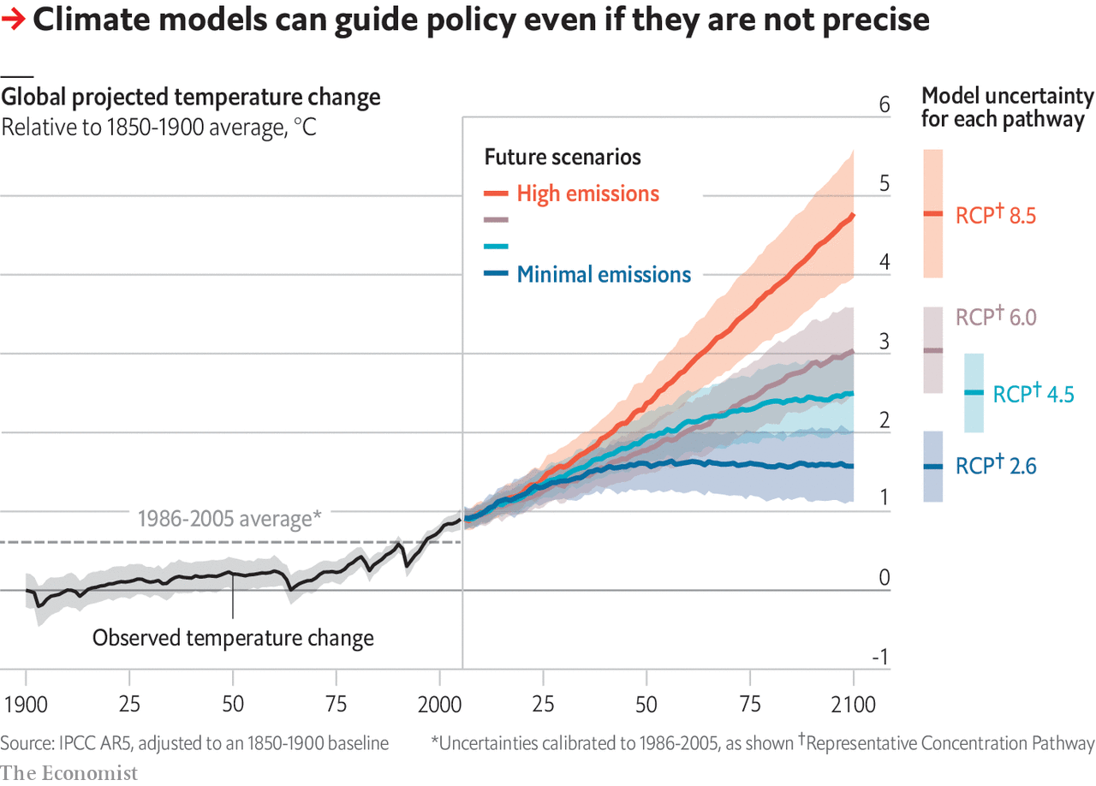

The uncertainties in what the models predicted was as striking as ever (see chart). But they all agreed that only the pathway embodying the strongest climate action—much stronger than what is seen and promised today—might allow the world to keep the temperature rise since the 18th century well below 2ºC in the 21st, the target enshrined in the Paris agreement of 2015. ■

This article was downloaded by calibre from <https://www.economist.com/schools-brief/2020/05/02/how-modelling-articulates-the-science-of-climate-change>

|  |  |  |  |
| --- | --- | --- | --- |
|  | Articles | Sections | Next |

|  |  |  |
| --- | --- | --- |
| Schools brief | Sections | Books and arts |

Science and technology

The origin of covid-19: Only connect

.

Covid-19 and the immune system: Uncertainty’s principals

.

Covid-19 and smoking: An unexpected ally

.

|  |  |  |
| --- | --- | --- |
| Schools brief | Sections | Books and arts |

|  |  |  |  |
| --- | --- | --- | --- |
|  | Articles | Sections | Next |

#### The origin of covid-19

# The pieces of the puzzle of covid-19’s origin are coming to light

How they fit together, though, remains mysterious

May 2nd 2020 |

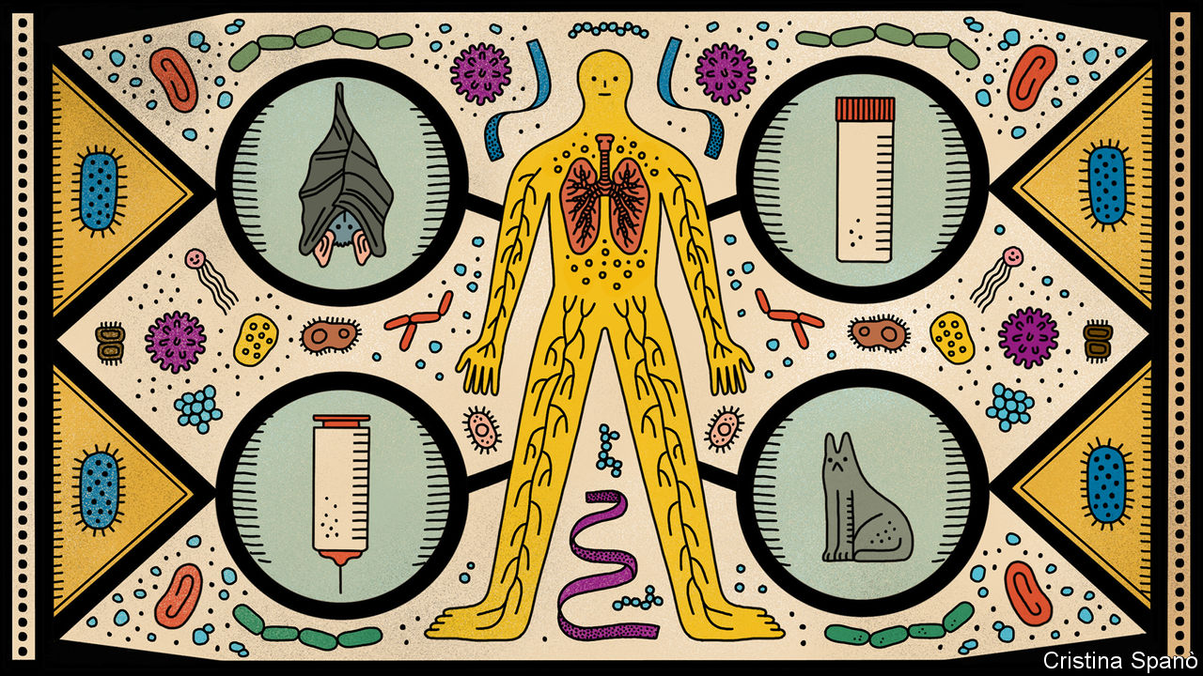

Editor’s note: The Economist is making some of its most important coverage of the covid-19 pandemic freely available to readers of The Economist Today, our daily newsletter. To receive it, register [here](https://www.economist.com/newslettersignup). For our coronavirus tracker and more coverage, see our [hub](https://www.economist.com/coronavirus)

AURIC GOLDFINGER, villain of the novel which bears his name, quotes a vivid Chicago aphorism to James Bond: “Once is happenstance, twice is coincidence, the third time it’s enemy action.”

Until 2002 medical science knew of a handful of coronaviruses that infected human beings, none of which caused serious illness. Then, in 2002, a virus now called SARS-CoV surfaced in the Chinese province of Guangdong. The subsequent outbreak of severe acute respiratory syndrome (SARS) killed 774 people around the world before it was brought under control. In 2012 another new illness, Middle Eastern respiratory syndrome (MERS), heralded the arrival of MERS-CoV, which while not spreading as far and as wide as SARS (bar an excursion to South Korea) has not yet been eliminated. It has killed 858 people to date, the most recent of them on February 4th.

The third time, it was SARS-CoV-2, now responsible for 225,000 covid-19 deaths. Both SARS-CoV and MERS-CoV are closely related to coronaviruses found in wild bats. In the case of SARS-CoV, the accepted story is that the virus spread from bats in a cave in Yunnan province into civets, which were sold at markets in Guangdong. In the case of MERS-CoV, the virus spread from bats into camels. It now passes regularly from camels to humans, which makes it hard to eliminate, but only spreads between people in conditions of close proximity, which makes it manageable.

## Third time unlucky

An origin among bats seems overwhelmingly likely for SARS-CoV-2, too. The route it took from bat to human, though, has yet to be identified. If, like MERS-CoV, the virus is still circulating in an animal reservoir, it could break out again in the future. If not, some other virus will surely try something similar. Peter Ben Embarek, an expert on zoonoses (diseases passed from animals to people) at the World Health Organisation says that such spillovers are becoming more common as humans and their farmed animals push into new areas where they have closer contact with wildlife. Understanding the detail of how such spillovers occur should provide insights into stopping them.

In some minds, though, the possibility looms of enemy action on the part of something larger than a virus. Since the advent of genetic engineering in the 1970s, conspiracy theorists have pointed to pretty much every new infectious disease, from AIDs to Ebola to MERS to Lyme disease to SARS to Zika, as being a result of human tinkering or malevolence.

The politics of the covid-19 pandemic mean that this time such theories have an even greater appeal than normal. The pandemic started in China, where the government’s ingrained urge to cover problems up led it to delay measures that might have curtailed its spread. It has claimed its greatest toll in America, where the recorded number of covid-19 deaths already outstrips the number of names on the Vietnam War Memorial in Washington, DC.

These facts would have led to accusations ringing out across the Pacific come what may. What makes things worse is a suspicion in some quarters that SARS-CoV-2 might in some way be connected to Chinese virological research, and that saying so may reapportion any blame.

There is no evidence for the claim. Western experts say categorically that the sequence of the new virus’s genome—which Chinese scientists published early on, openly and accurately—reveals none of the telltales genetic engineering would leave in its wake. But it remains a fact that in Wuhan, where the outbreak was first spotted, there is a laboratory where scientists have in the past deliberately made coronaviruses more pathogenic.

Such research is carried out in laboratories around the world. Its proponents see it as a vital way of studying the question that covid-19 has brought so cruelly into the spotlight: how does a virus become the sort of thing that starts a pandemic? That some of this research has been done at the Wuhan Institute of Virology (WIV) seems all but certainly a coincidence. Without a compelling alternative account of the disease’s origin, however, there is room for doubt to remain.

## The 4% difference

The origin of the virus behind the 2003 SARS outbreak—“classic SARS”, as some virologists now wryly call it—was established in large part by Shi Zhengli, a researcher at WIV sometimes referred to in Chinese media as “the bat lady”. Over a period of years she and her team visited remote locations all across the country in search of a close relative of SARS-CoV in bats or their guano. They found one in a cave full of horseshoe bats in Yunnan.

It is in the collection of viral genomes assembled during those studies that scientists have now found the bat virus closest to SARS-CoV-2. A strain called RaTG13 gathered in the same cave in Yunnan shares 96% of its genetic sequence with the new virus. RaTG13 is not that virus’s ancestor. It is something more like its cousin. Edward Holmes, a virologist at the University of Sydney, estimates that the 4% difference between the two represents at least 20 years of evolutionary divergence from some common antecedent, and probably something more like 50.

Although bats could, in theory, have passed a virus descended from that antecedent directly to humans, experts find the idea unlikely. The bat viruses look different from SARS-CoV-2 in a specific way. In SARS-CoV-2 the spike protein on the viral particle’s surface has a receptor-binding domain (RBD) that is adept at sticking to a particular molecule on the surface of the human cells the virus infects. The RBD in bat coronaviruses is not the same.

One recent study suggests that SARS-CoV-2 is the product of natural genomic recombination. Different coronaviruses infecting the same host are more than happy to swap bits of genome. If a bat virus similar to RaTG13 got into an animal already infected with a coronavirus which boasted an RBD better suited to infecting humans, a basically batty virus with a more human-attuned RBD might well arise. That is what SARS-CoV-2 looks like.

Early on, it was widely imagined that the intermediate host was likely to be a species sold in Wuhan’s Huanan Seafood and Wildlife Market, a place where all sorts of creatures, from raccoon dogs to ferret badgers, and from near and far, are crammed together in unsanitary conditions. Many early human cases of covid-19 were associated with this market. Jonathan Epstein, vice-president of science with EcoHealth Alliance, an NGO, says of 585 swabs of different surfaces around the market, about 33 were positive for SARS-CoV-2. They all came from the area known to sell wild animals. That is pretty much as strong as circumstantial evidence gets.

The first animal to come under serious suspicion was the pangolin. A coronavirus found in pangolins has an RBD essentially identical to that of SARS-CoV-2, suggesting that it might have been the virus with which the bat virus recombined on its way to becoming SARS-CoV-2. Pangolins are used in traditional medicine, and though they are endangered, they can nonetheless be found on menus. There are apparently no records of them being traded at the Huanan market. But given that such trading is illegal, and that such records would now look rather incriminating, this is hardly proof that they were not.

The fact that pangolins are known to harbour viruses from which SARS-CoV-2 could have picked up its human-compatible RBD is certainly suggestive. But a range of other animals might harbour such viruses, too; it’s just that scientists have not yet looked all that thoroughly. The RBD in SARS-CoV-2 is useful not only for attacking the cells of human beings and, presumably, pangolins. It provides access to similar cells in other species, too. In recent weeks SARS-CoV-2 has been shown to have found its way from humans into domestic cats, farmed mink and a tiger. There is some evidence that it can actually pass between cats, which makes it conceivable that they were the intermediate—though there is as yet no evidence of a cat infecting a human.

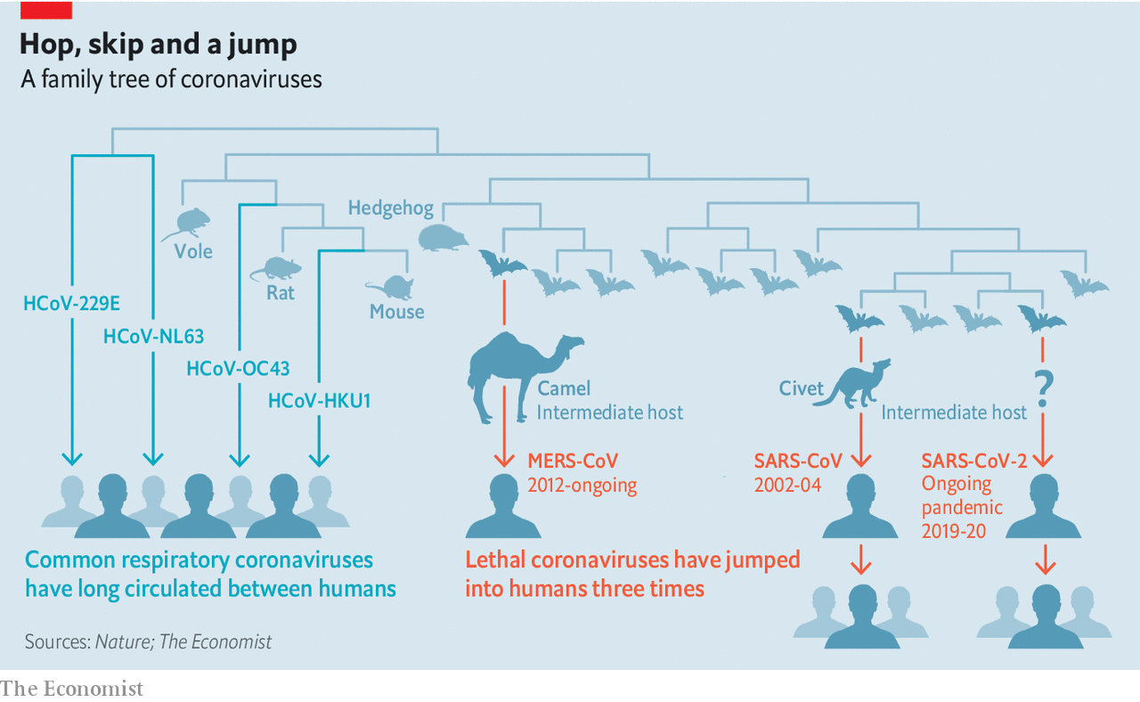

The market’s appeal as a site for the human infections behind the Wuhan outbreak remains strong; a market in Guangdong is blamed for the spread of SARS. Without a known intermediate, though, the evidence against it remains circumstantial. Though many early human cases were associated with the market, plenty were not. They may have been linked to people with ties to the market in ways not yet known. But one cannot be sure.

## Where to begin?

The viral genomes found in early patients are so similar as to suggest strongly that the virus jumped from its intermediate host to people only once. Estimates based on the rate at which genomes diverge give the earliest time for this transfer as early October 2019. If that is right there were almost certainly infections which were not serious, or which did not reach hospitals, or which were not recognised as odd, before the first official cases were seen in Wuhan at the beginning of December. Those early cases may have taken place elsewhere.

Ian Lipkin, the boss of the Centre for Infection and Immunity at Columbia University, in New York, is working with Chinese researchers to test blood samples taken late last year from patients with pneumonia all around China, to see if there is any evidence for the virus having spread to Wuhan from somewhere else. If there is, then it may have entered Huanan market not in a cage, but on two legs. The market is popular with visitors as well as locals, and is close to Hankou railway station, a hub in China’s high-speed rail network.

Further research may make when, where and how the virus got into people clearer. There is scope for a lot more virus hunting in a wider range of possible intermediate species. If it were possible to conduct detailed interviews with those who came down with the earliest cases of covid-19, that genetic sampling could be better aimed, says Dr Embarek, and with a bit of luck one might get to the source. But the time needed to do this, he adds, “might be quick, or it might be extremely long”.

If it turns out to have originated elsewhere, the new virus’s identification during the early stages of the Wuhan epidemic may turn out to be thanks to the city’s concentration of virological know-how—know-how that is now surely being thrown into sequencing more viruses from more sources. But until a satisfactory account of a natural spillover is achieved, that same concentration of know-how, at WIV and another local research centre, the Wuhan Centre for Disease Control and Prevention, will continue to attract suspicion.

In 2017 WIV opened the first biosecurity-level 4 (BSL-4) laboratory in China—the sort of high-containment facility in which work is done on the most dangerous pathogens. A large part of Dr Shi’s post-SARS research there has been aimed at understanding the potential which viruses still circulating among bats have to spill over into the human population. In one experiment she and Ge Xingyi, also of the WIV, in collaboration with American and Italian scientists, explored the disease-like potential of a bat coronavirus, SHC014-CoV, by recombining its genome with that of a mouse-infecting coronavirus. The WIV newsletter of November 2015 reported that the resulting virus could “replicate efficiently in primary human airway cells and achieve in vitro titres equivalent to epidemic strains of SARS-CoV”. In early April this newsletter and all others were removed from the institute’s website.

This work, results from which were also published in Nature Medicine, demonstrated that SARS-CoV’s jump from bats to humans had not been a fluke; other bat coronaviruses were capable of something similar. Useful to know. But giving pathogens and potential pathogens extra powers in order to understand what they may be capable of is a controversial undertaking. These “gain of function” experiments, their proponents insist, have important uses such as understanding drug resistance and the tricks viruses employ to evade the immune system. They also carry obvious risks: the techniques on which they depend could be abused; their products could leak. The creation of an enhanced strain of bird flu in 2011 in an attempt to understand the peculiar virulence of the flu strain responsible for the pandemic of 1918-19 caused widespread alarm. America stopped funding gain-of-function work for several years.

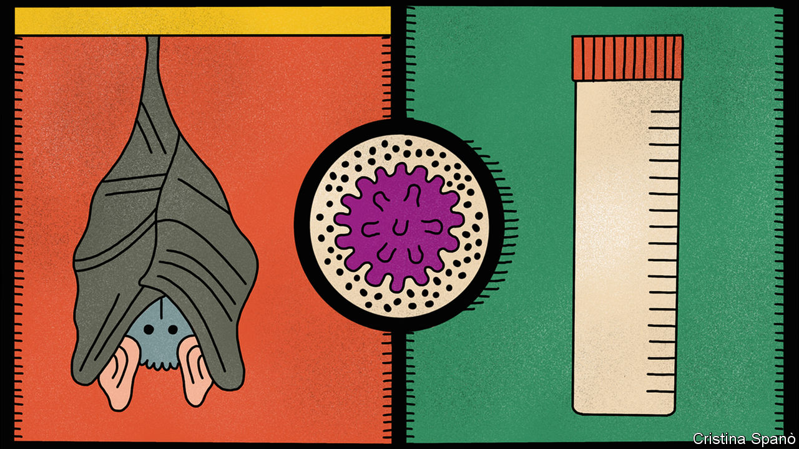

Filippa Lentzos, who studies biomedicine and security at King’s College, London, says the possibility of SARS-CoV-2 having an origin connected with legitimate research is being discussed widely in the world of biosecurity. The possibilities speculated about include a leak of material from a laboratory and also the accidental infection of a human being in the course of work either in a lab or in the field.

Leaks from laboratories, including BSL-4 labs, are not unheard of. The world’s last known case of smallpox was caused by a leak from a British laboratory in 1978. An outbreak of foot and mouth disease in 2007 had a similar origin. In America there have been accidental releases and mishandlings involving Ebola, and, from a lower-containment-level laboratory, a deadly strain of bird flu. In China laboratory workers seem to have been infected with SARS and transmitted it to contacts outside on at least two occasions.

## Here’s one I made earlier

Things doubtless leak out of labs working at lower biosafety levels, too. But how much they do so is unknown, in part because people worry about them less. And as in other parts of this story the unknown is a Petri dish in which speculation can grow. This may be part of the reason for interest in a lab at the Wuhan Centre for Disease Control and Prevention. A preprint published on ResearchGate, a website, by two Chinese scientists and subsequently removed suggested that work done there may have been cause for concern. This lab is reported to have housed animals—including, for one study, hundreds of bats from Hubei and Zhejiang provinces—and to have specialised in pathogen collection.

Richard Pilch, who works on chemical and biological weapons non-proliferation at the Middlebury Institute of International Studies, in California, says that there is one feature of the new virus which might conceivably have arisen during “passaging experiments” in which pathogens are passed between hosts so as to study the evolution of their ability to spread. This is the “polybasic cleavage site”, which might enhance infectivity. SARS-CoV-2 has such a site on its spike protein. Its closest relatives among bat coronaviruses do not. But though such a cleavage site could have arisen through passaging there is no evidence that, in this case, it did. It could also have evolved in the normal way as the virus passed from host to host. Dr Holmes, meanwhile, has said that there is “no evidence that SARS-CoV-2...originated in a laboratory in Wuhan, China.” Though others have speculated about coincidences and possibilities, no one has been able, as yet, to undermine that statement.

Many scientists think that with so many biologists actively hunting for bat viruses, and gain-of-function work becoming more common, the world is at increasing risk of a laboratory-derived pandemic at some point. “One of my biggest hopes out of this pandemic is that we address this issue—it really worries me,” says Dr Pilch. Today there are around 70 BSL-4 sites in 30 countries. More such facilities are planned.

Again, though, it is necessary to consider the unknown. Every year there are tens of thousands of fatal cases of respiratory disease around the world of which the cause is mysterious. Some of them may be the result of unrecognised zoonoses. The question of whether they really are, and how those threats may stack up, needs attention. That attention needs laboratories. It also needs a degree of open co-operation that America is now degrading with accusations and reductions in funding, and that China has taken steps to suppress at source. That suppression has done nothing to help the country; indeed, by supporting speculation, it may yet harm it. ■

Dig deeper:  
For our latest coverage of the covid-19 pandemic, register for The Economist Today, our daily [newsletter](https://www.economist.com/newslettersignup), or visit our [coronavirus tracker and story hub](https://www.economist.com/coronavirus)

This article was downloaded by calibre from <https://www.economist.com/science-and-technology/2020/05/02/the-pieces-of-the-puzzle-of-covid-19s-origin-are-coming-to-light>

|  |  |  |  |
| --- | --- | --- | --- |
|  | Articles | Sections | Next |

|  |  |  |  |
| --- | --- | --- | --- |
| Previous | Articles | Sections | Next |

#### Covid-19

# Leaving lockdown means understanding immune responses to the virus

Unfortunately, a lot is still unknown

May 2nd 2020 |

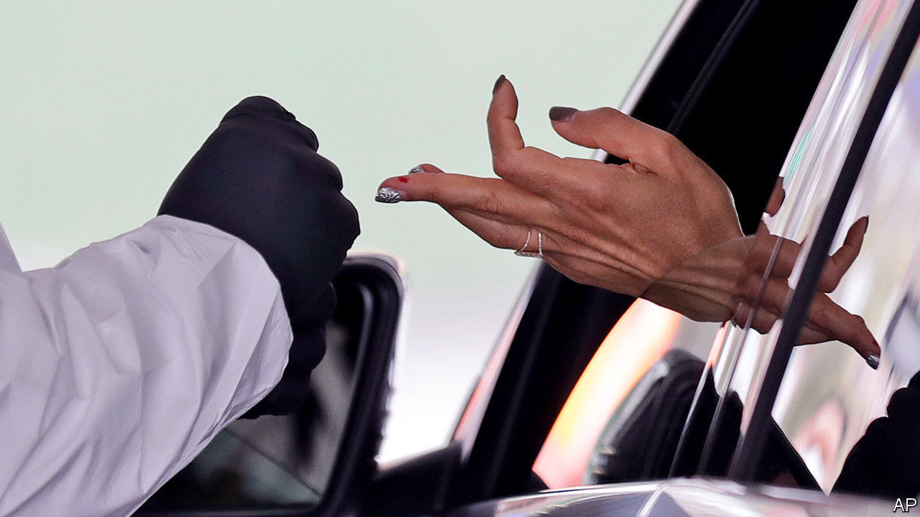

Editor’s note: The Economist is making some of its most important coverage of the covid-19 pandemic freely available to readers of The Economist Today, our daily newsletter. To receive it, register [here](https://www.economist.com/newslettersignup). For our coronavirus tracker and more coverage, see our [hub](https://www.economist.com/coronavirus)

OF THE VARIOUS ideas being touted to ease the world out of viral lockdown, one of the most striking is that of giving “immunity passports” to those who test positive for antibodies to SARS-CoV-2, the virus that causes covid-19. These passes would let people move around and return to work—based on the assumption that possession of such antibodies prevents reinfection. This might sound like a reasonable assumption. It is, after all, true of many other infections. Assumptions, however, are not data. So on April 24th the World Health Organisation issued a briefing note on why immunity passports are not a good idea: “There is currently no evidence”, it said, “that people who have recovered from covid-19 and have antibodies are protected from a second infection.”

Medical researchers have learned a lot about SARS-CoV-2 in the months since it was first isolated. But their knowledge of its interactions with the human immune system remains gappy. What are the specifics of the immune system’s response? How does this response affect the severity of someone’s illness? How long does immunity last? Lack of such knowledge makes it hard to decide when to relax restrictions on movement and association. Do it too soon and you risk a viral resurgence. Do it too late and you risk having no economy for people to return to.

When someone’s immune system is exposed to a pathogen, its first response is to recruit white blood cells called macrophages to slow the invaders’ progress by engulfing them. This is followed, five to ten days after infection, by a more tailored, two-pronged reaction. One prong involves the production of antibodies, by cells known as “B” lymphocytes (so named because they mature in the bone marrow). Antibodies are specially tailored proteins that latch onto a pathogen. Some, called neutralising antibodies, gum up the pathogen’s works and render it inoperative. All, whether neutralising or not, mark it for destruction by macrophages.

## Mind your Bs and Ts

The other prong comes in the form of “T” lymphocytes (which mature in the thymus). These recognise and kill infected body cells. And if the combined efforts of macrophages, B cells and T cells are sufficient, the pathogen will be beaten back and eventually cleared from the body. Once this has happened, specialised “memory” B and T cells will help the immune system remember the pathogen, ready to respond if it returns.

The length of that memory depends on the pathogen. For measles, protection lasts a lifetime. For influenza, it can last just six months. How long the memory of SARS-CoV-2 lasts is, at present, unknown—for the simple reason that it has not yet been around long enough to find out.

There are, however, clues. One set come from SARS and MERS, two potentially lethal diseases caused by coronaviruses closely related to SARS-CoV-2. Those who have recovered from these illnesses have detectable antibodies in their blood for two years after infection in the case of SARS and three years for MERS. Similarly, around half of those who survived SARS still had strong T-cell responses a year later, while T-cell responses to MERS have been detected up to four years after infection.

Another set of clues comes from human coronavirus 229E. Unlike SARS-CoV-2, SARS or MERS, 229E is not deadly. Its symptoms present as what is known colloquially as a cold (though it is not the only cause of colds). But it, too, provides information about immune responses to coronaviruses. An experiment conducted in the late 1970s showed that those infected by 229E maintain their protective antibodies for less than a year. However, further work done in 1990 indicated that, despite this, people reinfected after a year developed much less severe symptoms.

## Blind man’s buff

As this work shows, a lack of antibodies does not mean that someone has no immune protection, for T cells also come into play. And that may apply to SARS-CoV-2 as well, as is suggested by a study from Shanghai that was posted recently to MedRxiv, a preprint server (and is thus not yet peer reviewed). The researchers involved examined blood samples taken from 175 people with mild cases of covid-19. They found that most patients developed neutralising antibodies 10-15 days after the onset of illness, though the amounts of these varied greatly. Intriguingly, however, ten people never had detectable antibodies in their blood, yet nonetheless managed to clear their infections. This suggests that other components of immunity, most likely the T-cell response, are indeed crucial.

That immunity to reinfection might be granted in the absence of antibodies is not, of course, an argument against antibody-based immunity passports. It would just be tough luck on those with T-cell-based immunity, who would still not be able to escape lockdown. A more pertinent objection, even if antibody protection is real, is that antibody tests are not yet truly reliable and cannot, in particular, distinguish between antibodies that are neutralising and those that are not.

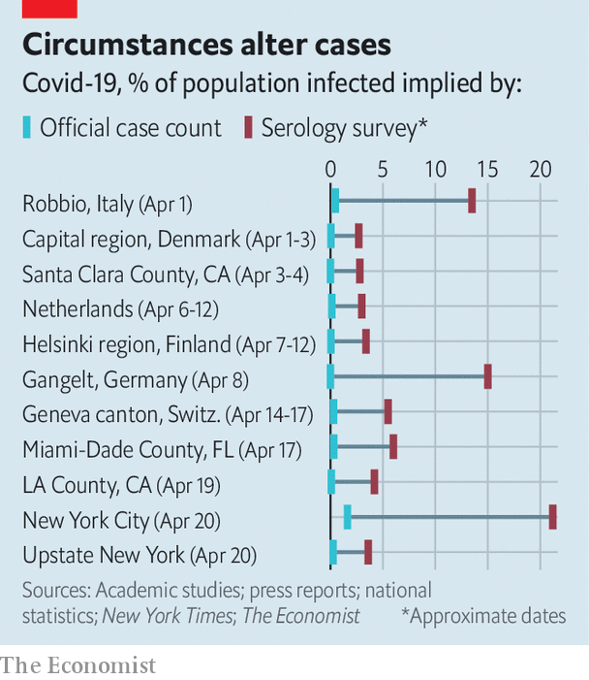

These tests can, though, still give insights into the pandemic’s progress, by flagging up most of those who have been infected, including people who have had no symptoms. Antibody-based studies in America, Denmark, the Netherlands and other places have suggested that around 5% of the population sampled had been infected at some point prior to testing (see chart). In New York City, the centre of America’s covid-19 epidemic, that figure is around 20%. So far, no large-scale antibody surveys have been conducted in European hotspots such as Spain and Belgium.

Antibody data, when combined with mortality figures, suggest covid-19 is both faster-spreading and less deadly than was generally believed two months ago. But the reliability of those data depends on several things. One is the accuracy of the tests. Even a false-positive rate of just 1% could lead researchers to erroneous conclusions if the real rate is as small as 5%. Another is the representativeness of the participants. One much-criticised study, conducted in Santa Clara County, California, recruited its volunteers through Facebook, to which not everyone—particularly not the elderly—has access. The survey in New York was similarly skewed. It was conducted in a series of shops, and thus netted only those who felt healthy enough to go out shopping. Many of the data from Denmark and the Netherlands, meanwhile, relied on blood donors—a category that excludes the old and the sick.

More governments, including those in Britain and Germany, plan to run antibody-based surveys involving tens of thousands of people over the coming months. With luck, these will be more representative. A true understanding of the immune response to SARS-CoV-2 and of how that virus has spread through the world will, though, take years to emerge. Meanwhile, enduring uncertainties increase the risks associated with strategies for ending lockdowns that rely on people having long-term immunity from reinfection. Politicians in most countries are emphasising their willingness to follow science’s lead in matters concerning the pandemic. Their worry now must be that science has no lead to offer.■

Dig deeper:  
For our latest coverage of the covid-19 pandemic, register for The Economist Today, our daily [newsletter](https://www.economist.com/newslettersignup), or visit our [coronavirus tracker and story hub](https://www.economist.com/coronavirus)

This article was downloaded by calibre from <https://www.economist.com/science-and-technology/2020/05/02/leaving-lockdown-means-understanding-immune-responses-to-the-virus>

|  |  |  |  |
| --- | --- | --- | --- |
| Previous | Articles | Sections | Next |

|  |  |  |  |
| --- | --- | --- | --- |
| Previous | Articles | Sections | Next |

#### Covid-19

# Smokers seem less likely than non-smokers to fall ill with covid-19

That may point towards a way of treating it

May 2nd 2020 |

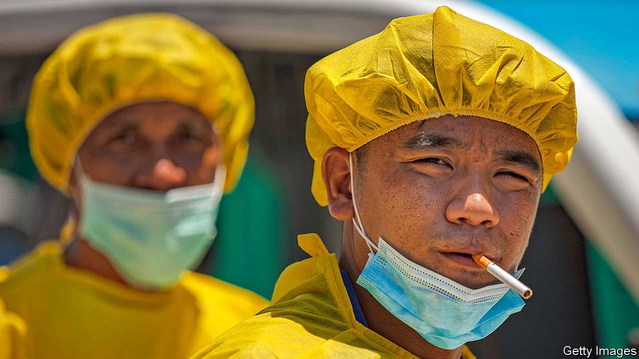

Editor’s note: The Economist is making some of its most important coverage of the covid-19 pandemic freely available to readers of The Economist Today, our daily newsletter. To receive it, register [here](https://www.economist.com/newslettersignup). For our coronavirus tracker and more coverage, see our [hub](https://www.economist.com/coronavirus)

A QUARTER OF French adults smoke. Many people were surprised, therefore, when researchers reported late in April that only 5% of 482 covid-19 patients who came to the Pitié-Salpêtrière hospital in Paris between February 28th and April 9th were daily smokers. The ratios of smokers to non-smokers in earlier tallies at hospitals in America, China and elsewhere in France varied. But all revealed habitual smokers to be significantly underrepresented among those requiring hospital treatment for the illness. Smokers, the authors of the report wrote, “are much less likely” to suffer severely from SARS-CoV-2, the virus that causes covid-19. Rarely, they added, is such a result seen in medicine.

Smokers are almost certainly not protected from initial infection by SARS-CoV-2. In fact, because they first handle and then puff on cigarettes, they may be especially susceptible—for transmission often takes place through the mouth’s mucous membranes. What seems to be happening is that infected smokers are less likely to develop symptoms, or, if they do develop them, are more likely than non-smokers to have symptoms which are mild. That means they are more likely to stay home and not to show up in hospital statistics.

All this suggests that something in tobacco smoke is having a protective effect. The best guess is that the something in question is nicotine. News of this hypothesis has spread like wildfire. To stop a run on nicotine chemically extracted from tobacco, which is taken in one form or another by many smokers who are trying to quit the habit, France’s health ministry suspended online sales of the substance on April 24th. Purchases from pharmacies were limited to a month’s supply per person. With encouragement from the health minister, the organisations behind the Pitié-Salpêtrière study, which include the Pasteur Institute and the Sorbonne, are preparing trials. The plan is to offer nicotine patches to covid-19 patients, front-line workers and ordinary citizens. How they fare will be compared with control groups given a placebo.

Nicotine is not thought to attack SARS-CoV-2 directly. It may, however, play an indirect role that involves a cell-membrane protein called ACE2, to which the virus attaches itself in order to gain access to a cell. Some researchers suspect that nicotine binds to ACE2 as well, and that this makes it harder for the virus to do so alongside it. Nicotine may also soothe inflammation caused by the infection, a hypothesis supported by its use to treat inflamed bowels.

The new French study, which is expected to begin in three weeks’ time, may cast light, too, on another possible therapeutic effect of nicotine. Those severely ill with covid-19 are often the victims of a hyperactive immune response called a cytokine storm. Cytokines are a group of signalling molecules. Some have the job of recruiting pathogen-fighting white blood cells to a site of infection. If too many of these cells arrive at once they can end up attacking the body’s own tissues. Jason Sheltzer, a molecular biologist at Cold Spring Harbor Laboratory, in New York state, who is investigating the matter, reckons it possible that nicotine, which interferes with this process, may lessen the damage.

Anti-smoking campaigners have been eager to point out that none of this is a recommendation to take up smoking. If a few lucky smokers have thus evaded the worst effects of covid-19, it can hardly be said that their actions were part of some well-thought-out plan. That is not, however, an excuse for pretending observations like those from the Pitié-Salpêtrière are irrelevant, and thus failing to follow them up. If either nicotine or some other chemical found in tobacco smoke leads to a treatment, the rest of humanity may be thankful for the world’s smokers having made themselves accidental guinea pigs in a giant epidemiological experiment.■

Dig deeper:  
For our latest coverage of the covid-19 pandemic, register for The Economist Today, our daily [newsletter](https://www.economist.com/newslettersignup), or visit our [coronavirus tracker and story hub](https://www.economist.com/coronavirus)

This article was downloaded by calibre from <https://www.economist.com/science-and-technology/2020/05/02/smokers-seem-less-likely-than-non-smokers-to-fall-ill-with-covid-19>

|  |  |  |  |
| --- | --- | --- | --- |
| Previous | Articles | Sections | Next |

|  |  |  |
| --- | --- | --- |
| Science and ... | Sections | Economic and ... |

Books and arts

Me time: All the lonely people

.

Romek Marber: Order and peril

.

Johnson: The purpose of classics

.

Home Entertainment: Ghosts of baseball’s past

.

Home Entertainment: Rereading “The Leopard”

.

|  |  |  |
| --- | --- | --- |
| Science and ... | Sections | Economic and ... |

|  |  |  |  |
| --- | --- | --- | --- |
|  | Articles | Sections | Next |

#### All the lonely people

# Solitude has always been both a blessing and a curse

Two timely books spell out its dangers and perennial allure

May 2nd 2020 |



A Biography of Loneliness. By Fay Bound Alberti. Oxford University Press; 320 pages; $25.95 and £20.

A History of Solitude. By David Vincent. Polity; 304 pages; $35 and £25.

IN HIS “POLITICS” Aristotle argued that, thanks to the gift of language, man is destined to be a social and therefore a political animal. Yet the human instinct to socialise has always been balanced by an urge to withdraw into solitude. A few hermits make their lives in isolation, but many ordinary folk believe society is only tolerable if punctuated by frequent spells on their own. “There are many modern thinkers who emphasise the individual’s dependency upon society,” John Cowper Powys, a British writer and advocate of solitude, observed. “It is, on the contrary, only the cultivation of interior solitude, among crowded lives, that makes society endurable.”

Historians are for the most part solitary creatures themselves—the sort of people who, at school, preferred reading to team sports and, as adults, desperately try to avoid committees in order to spend more time in the library. All the same, they generally focus on gregarious activities, whether politicians on manoeuvres or the masses on the march. Bucking that trend, a couple of fascinating books on social isolation have appeared in time for the lockdown. Fay Bound Alberti has tried her hand at a history of loneliness. David Vincent focuses on loneliness’s rather more interesting sibling, solitude. Both concentrate on late modern Britain, Ms Alberti because she argues, somewhat unpersuasively, that loneliness is a recent phenomenon, the product of industrialisation and secularisation; Mr Vincent because he has spent a lifetime studying the country’s modern social history. What Aristotle called the “bird which flies alone” is finally getting his due.

Medieval Christendom saw some extraordinary feats of solitude. In the late third century St Anthony spent years in the desert with only scorpions and beasts for company. St Jerome tried a similar feat but took a large library with him. St Simeon Stylites upped the ante by sitting on top of a pillar in order to be closer to heaven. (“The progress of an ulcer in his thigh might shorten, but it could not disturb, this celestial life,” Edward Gibbon wrote in a wonderful description of the saint, “and the patient Hermit expired, without descending from his column.”) Monasteries were refuges from the world that combined communal living with hours of solo prayer. Thomas Merton, a modern advocate of monasticism, claimed that “man’s loneliness is in fact the loneliness of God.”

The 18th and 19th centuries saw this cult of solitude reinvented in secular forms. Enlightenment philosophers argued that the key to a civilised life lay in mixing sociability and solitude in just the right doses: immerse yourself too deeply in urban life and you might become neurotic, but retreat for too long to the country and you might degenerate into a bearded barbarian. The Romantics thought the best way to create great art was to surround yourself with nature. John Clare began one poem: “O thou soothing Solitude/From the vain and from the rude”. William Wordsworth wandered “lonely as a cloud”. By taking long walks in remote places, such as the Lake District or the Alps, you could become what Robert Louis Stevenson later called “a pipe for any wind to play upon”.

The Romantics set off a lasting fashion for grappling with nature in the raw. In Britain intellectuals showed that scaling mountains and hiking long distances could connote brains as well as brawn (Leslie Stephen and G.M. Trevelyan thought nothing of walking from Cambridge to London for dinner). In America the march of civilisation generated a compensatory fascination with the wilderness. Henry David Thoreau retreated to Walden Pond. As a young man Teddy Roosevelt reinvented himself as a western cowboy by travelling around the Dakotas. As president he created National Parks to let ordinary Americans escape from the pressure of civilisation to a natural world of soaring peaks and wild animals. Many of the iconic images of 19th-century America capture a sense of solitude—the “lonesome cowboy” on cattle drives or the haunting sound of the train whistle in the middle of nowhere.

## Lost in the crowd

As Mr Vincent says, industrial society brought a spate of solitary hobbies within reach by boosting living standards and enlarging personal space. Women with a little time on their hands took up pastimes that had once been necessities, such as cooking, dressmaking and embroidery. Men tried pigeon-breeding and stamp-collecting. People of both sexes took on jigsaw puzzles and, from the 1920s, crosswords. The cult of solitude also encouraged less healthy habits. Charles Kingsley, a subscriber to “muscular Christianity”, regarded tobacco as the ideal accompaniment to the solitary life—“a lone man’s companion, a bachelor’s friend, a hungry man’s food, a sad man’s cordial, a wakeful man’s sleep, and a chilly man’s fire”. Arthur Conan Doyle’s Sherlock Holmes preferred an opium pipe to ignite his solitary reveries.

Healthy or otherwise, these hobbies united a nation that was divided by class. Britain’s allotment movement meant that, by 1910, half a million working-class men could enjoy the pleasures of gardening. Such activities also married sociability with solitude. Smokers shared their solitary vice in dedicated rooms in clubs and pubs. Angling encouraged people to collaborate on being alone. “We may club together as against others, but by the water we divide,” Morley Roberts wrote in 1932. “When I fish I am the universe.”

Yet the more civilisation has advanced, the further people have had to go to achieve that sensation. Starting with Joshua Slocum in 1895, solo yachtsmen sailed around the world, sometimes cutting themselves off from all outside help. Robin Knox-Johnston, for example, didn’t talk to anyone for five months. Mountaineers competed with each other to slip the knot of civilisation. In 2017 Alex Honnold climbed El Capitan in Yosemite with neither companions nor crampons. These extraordinary battles against nature were inspired by the belief that the best way to explore body and soul is to strip the self to its essence. “It is here, in the immense desert of the Southern Ocean,” Bernard Moitessier wrote, “that I feel most strongly how much man is both atom and god.”

And the more sophisticated civilisation has become, the more people have been willing to use its fruits to escape the enforced sociability that has mostly been humanity’s lot. In 1900 just 5% of households comprised one person. Today a quarter do in America, along with a third in Britain and perhaps half in Sweden. Sometimes the solo life is a choice: people use their money to dump an unsatisfactory partner. Sometimes it is a tragedy: in Britain a million older people say they routinely suffer from loneliness. Most feel unable to admit their plight to friends and relatives.

This points to the paradox at the heart of solitude, which, as Mr Vincent says, can be both a blessing and a curse. Loneliness and solitude are not the same: you can feel lonely in a crowd—indeed loneliness is at its darkest when you are surrounded by people having fun—but they overlap. Unwanted solitude can lead to the most miserable sort of loneliness. “I’d like to meet,” C.S. Lewis wrote to a friend after his wife died, “for I am—Oh God that I were not—very free now. One doesn’t realise in early life that the price of freedom is loneliness. To be happy is to be tied.”

Even voluntary solitude can foster mental illness. In the early modern period John Evelyn warned that solitude “creates witches”. Samuel-Auguste Tissot feared it led to masturbation and all that masturbation entails, “melancholy, sighing, tears, palpitations, suffocations and faintings”. The first great book devoted to solitude, by George III’s personal doctor, Johann Georg Zimmerman, was titled “Solitude Considered with Respect to its Dangerous Influence Upon the Mind and Heart” (1791). Joseph Conrad condemns his character Nostromo to die of solitude, “the enemy known but to few on this Earth, and whom only the simplest of us are fit to withstand”.

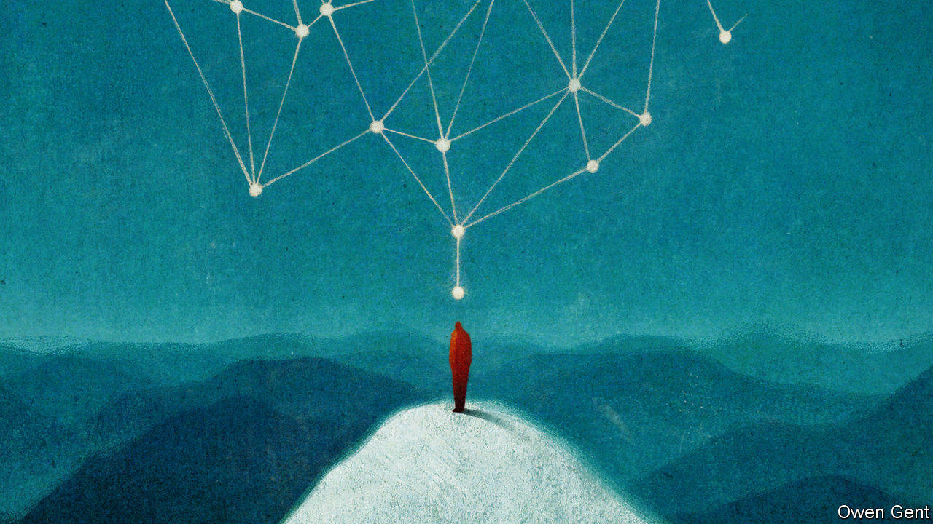

Given its power to break the spirit, loneliness has inevitably been used as a punishment. Pentonville, Britain’s first model prison built on Utilitarian principles, confined all prisoners in solitary cells, though it dropped the face masks that, in Jeremy Bentham’s original design, they were supposed to wear to stop them communicating during meals. The most extreme use of solitary confinement was in a wing of a state prison in Auburn, New York, where inmates were confined in total solitude, with no exercise and no human contact of any kind. Gustave de Beaumont and Alexis de Tocqueville were appalled when they visited the place in 1833: “In order to reform them they have been submitted to complete isolation; but this absolute solitude, if nothing interrupt it, is beyond the strength of man; it destroys the criminal without intermission and without pity; it does not reform, it kills.”

Ms Alberti notes that anxiety over involuntary loneliness has become a big political issue, particularly in northern European and Anglo-Saxon countries, where the breakdown of the family has gone furthest. In 2016 the BBC released a television documentary on “the age of loneliness”. In 2017 Vivek Murthy, America’s former surgeon general, declared an “epidemic of loneliness”. In 2018 Theresa May appointed Britain’s first “minister for loneliness”, declaring that “up to a fifth of UK adults feel lonely most or all of the time.”

## Life in the quiet carriage

The history of solitude is thus partly a history of extremes—of people who have willingly sat on top of pillars for decades and of prison reformers who aim to use loneliness to break men’s souls. But it is also a history of the quest for balance.

The healthiest form of solitude is a flexible kind that combines it with sociability as necessary. Modern technology has made it both easier and harder to get the balance right. On the one hand, it has introduced what Mr Vincent calls “networked solitude”. Just as St Jerome squatted in his cave surrounded by his library, so modern hermits can sit in their flats gorging on downloaded books and films or chatting with friends across the world. On the other hand, it has made it more difficult to enjoy the benefits of solitude. Distraction is always one click away. And the same technology that allows the solitary individual to engage remotely with society also allows society to engage remotely—and sometimes secretly—with the individual. Giant companies watch over you whether you are alone or in a crowd.

There is also something disturbing about the way the boundaries between solitude and sociability are blurring. Visit a gym and you see sweaty solipsists performing private workouts in public. On a train many of your fellow passengers will be insulated by headphones. Those ubiquitous devices are double-edged: they can fill your head with babble or, thanks to noise-cancelling, leave you in Trappist silence. As the two categories mingle, so the quest for balance becomes more intense. Popular modern fads offer a reacquaintance with the virtues of solitude: mindfulness provides access to peace and silence; some of the most popular pastimes in Silicon Valley, the source of so much noise and distraction, are hiking, yoga and meditation.

The lockdown has put the question of solitude at the heart of politics. Social distancing has been a tragedy for those living and, in some cases, dying alone. But for others it has proved a strange blessing. Overworked people have been able to take a break from the treadmill of commuting. Many have picked up long-abandoned hobbies, such as tending the garden or playing bridge. Solitude is both one of mankind’s greatest blessings and greatest curses—and thanks to a virus that has been carried across the world by human sociability, more people than ever are getting the chance to experience both. ■

This article was downloaded by calibre from <https://www.economist.com/books-and-arts/2020/05/02/solitude-has-always-been-both-a-blessing-and-a-curse>

|  |  |  |  |
| --- | --- | --- | --- |
|  | Articles | Sections | Next |

|  |  |  |  |
| --- | --- | --- | --- |
| Previous | Articles | Sections | Next |

#### Order and peril

# Remembering Romek Marber, a master visual craftsman

Born in Poland, he survived the Holocaust and helped transform graphic design in Britain

May 2nd 2020 |

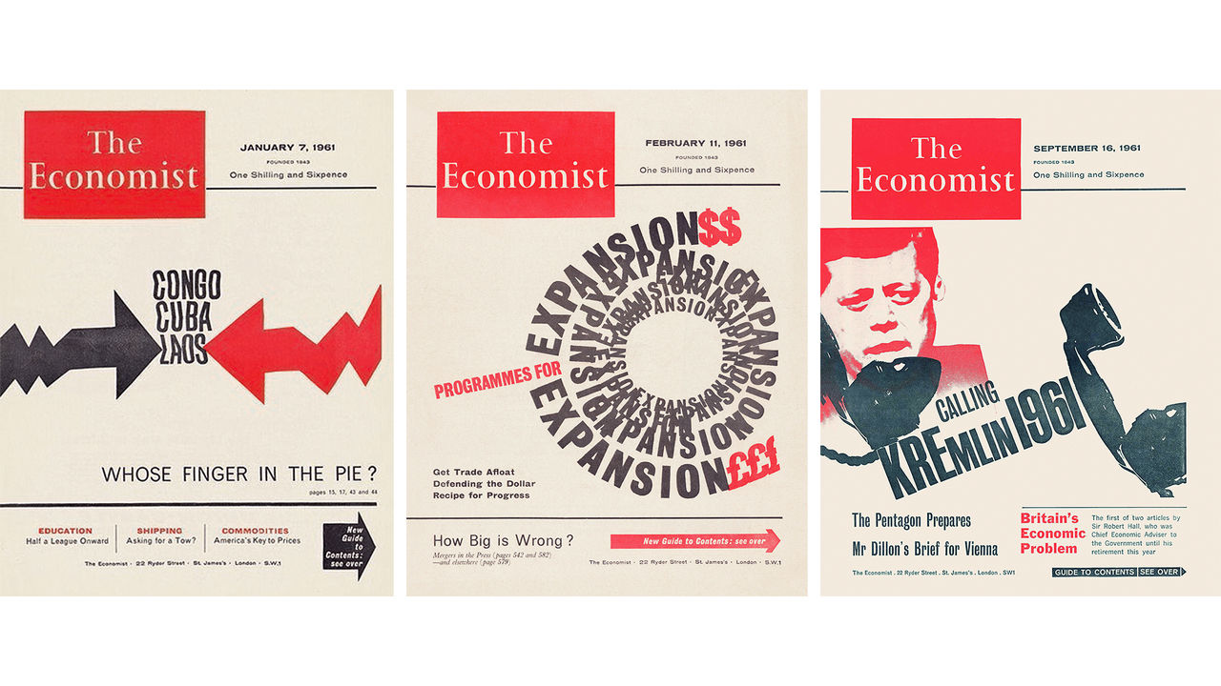

WHEN THE Gestapo burst into the safe house in Krakow where Romek Marber was hiding in 1943, they ordered him to face the wall. He had broken out of the Jewish ghetto in Bochnia, but his guide had betrayed him, and he expected to be killed on the spot. His mother, twin sister and grandparents had already been murdered. Marber leant his forehead against the dusky wallpaper, and for the rest of his life would remember the paper’s pattern—an ornate motif picked out in two shades of green.

He was 17. After the war he became one of Britain’s most distinguished graphic designers, whose haunting style will be familiar even if his name is not. When Poland was invaded in 1939 he fled Turek, his hometown, in a column of refugees that the Luftwaffe strafed. He led his family’s horses through blazing streets, watching adults make snap, life-and-death decisions about whether and where to run. Instead of being shot against the green wallpaper he was dispatched to Plaszow concentration camp; he survived that hell, and a death march, and a freezing, famished ride to Germany in an open railway wagon. Liberated just in time, he set off for Palestine and had reached the heel of Italy when his father and brother, alive and in London, wangled him a visa to join them.

An encounter with a dress-designer while he was sweeping the floors in a clothing factory led him to evening classes in drawing, then to St Martin’s College of Art (where he met his wife, Sheila Perry) and finally to the Royal College of Art. The grant he had received, for displaced Poles, stipulated that his course be vocational, and he picked commercial design. Graduating in 1956, he turned down a job in advertising and soon set up his own practice. By the early 1960s he was producing covers for magazines, including The Economist; he fondly recalled long waits in Soho pubs while the editors agreed on his theme. That piqued the interest of Penguin Books, which asked him to submit a new template for its crime covers, then to design 20 of them in a hurry, with many more to follow.

Marber’s dramatic imagery, with its sharp contrasts and suggestive spaces, bore traces of European modernism, and of Swiss typography in particular. He was one of a clutch of émigrés, many Jewish like him, who transformed the practice of design in Britain. The English, he later said, “still had a pre-war approach”, by which he meant “from the end of the 19th century”. Yet he had never studied on the continent, and, says Richard Hollis, an eminent designer and old friend, it was hard to make out his influences or know exactly where his techniques came from. His craftsmanship—which took in collage and cut-outs as well as drawing and photography—might now seem low-tech, but it imbued his work with depth and dynamism.

Orna Frommer-Dawson, his long-term partner after his wife died and another fellow designer, says a key part of his process was swift decision-making. Marber would pace up and down his studio, pondering a commission and smoking his pipe (a relative in Paris, believing that all Englishmen had one, gave him his first in 1946). Then, quickly, he would decide. Often the results shimmer with an unsettling tension that is his hallmark: between a pursuit of order and an undertow of peril.

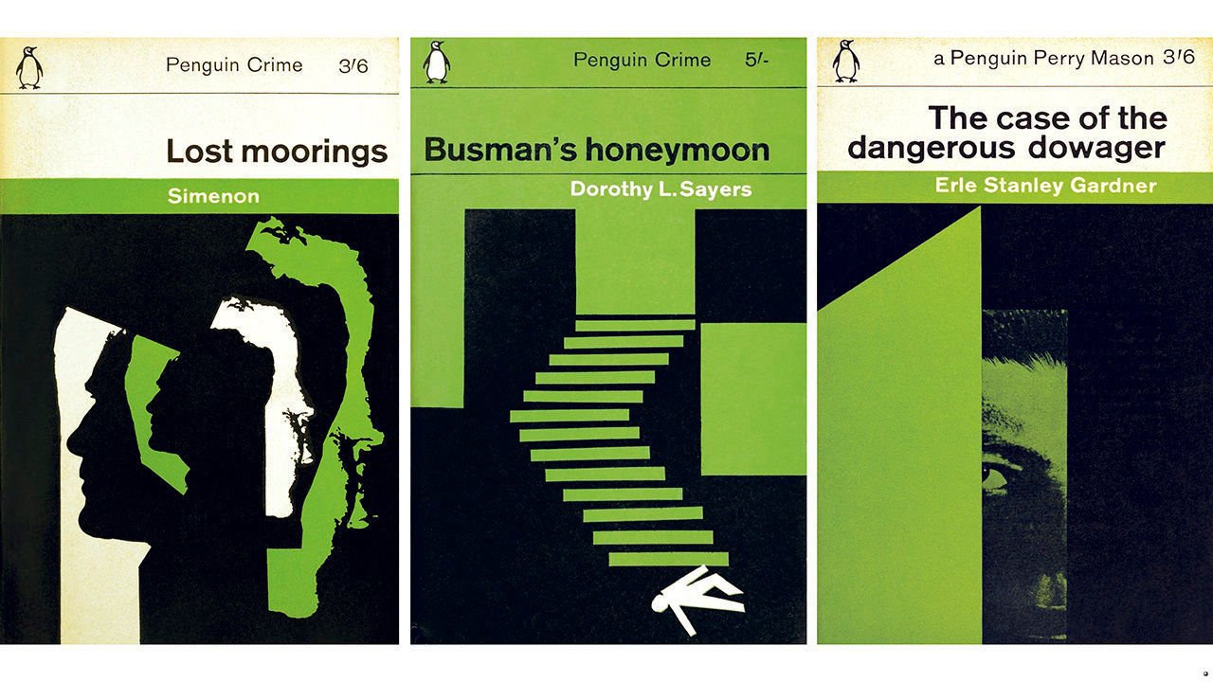

The “Marber grid”, which he created for Penguin’s crime imprint and was later adopted for others, epitomised this blend of geometry and jeopardy. It arranged the title and author’s name in a precise format at the top of the jacket, leaving the space below open for uncanny, Hitchcockian silhouettes and eerily cropped figures. But the same blend of method and menace characterises his magazine covers. John F. Kennedy tries to call the Kremlin, but the receiver dangles unattended, the text skewed at a disorienting angle. Other Economist headlines swirl in concentric circles or twist across the page. On a cover of New Society, Harold Wilson, then Britain’s prime minister, looms behind an outsized fist. As art director of the Observer’s magazine Marber adorned a feature on the mafia with daggers and shadows. “Romek himself was not fearful,” says Ms Frommer-Dawson, “but when a subject needed to illustrate fear maybe he drew on his knowledge of what fear can be.”

He kept his Polish accent. Penny Garrett, a student at Hornsey College of Art where he served as head of graphic design (herself later art director of The Economist), remembers his smiling demeanour and tell-tale pronunciation: “As a matter of fuct…” Later the college was integrated into Middlesex University, where Marber became professor emeritus. But he rarely talked about his past, until, nudged by Mr Hollis, he published a wartime memoir in 2010. “In my memory I see all the faces as I left them, faces that have not grown older,” he wrote of his lost relatives. “However much I long to see Poland, I couldn’t go back.” He called the book “No Return”.

Marber died near his home in Essex on March 30th at the age of 94. But five years earlier, he did go back. The Galicia Jewish Museum in Krakow put on an exhibition of his work, and at the opening he addressed the guests in his elegant 1930s Polish, the first time he had visited the country in 70 years. He still could not return to Turek, where as a boy he rode in a haycart to his grandfather’s farm, eating cherries that the driver whipped from overhanging trees. But in Bochnia—where, on the night before he fled the ghetto, he “lost God”—he “remembered every street, every house”, says Tomasz Strug, the show’s curator.

In Krakow, where the Gestapo caught him, Ms Frommer-Dawson took a photo of Marber gazing at a poster for the exhibition, which adapted his cover for the novel, “Lost Moorings”. As he sometimes did, Marber had used himself as a model; the image shows several versions of his profile, jaggedly layered on top of one another in white, black and green. ■

This article was downloaded by calibre from <https://www.economist.com/books-and-arts/2020/05/02/remembering-romek-marber-a-master-visual-craftsman>

|  |  |  |  |
| --- | --- | --- | --- |
| Previous | Articles | Sections | Next |

|  |  |  |  |
| --- | --- | --- | --- |
| Previous | Articles | Sections | Next |

#### Johnson

# The real reason to study the classics

Discovering ancient civilisations is humbling rather than self-aggrandising

May 2nd 2020 |

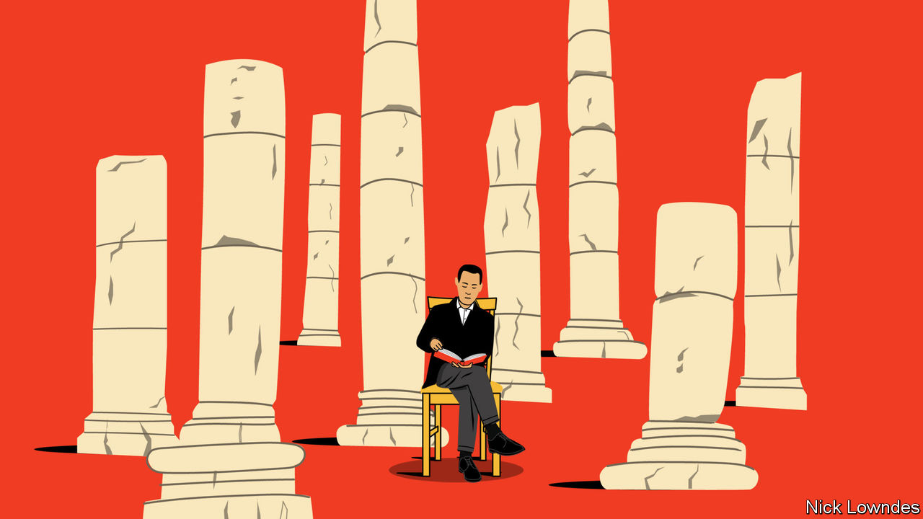

WHY STUDY classical languages? For a long time the reason was clear: there wasn’t much else to read. Medieval Europe read and wrote in Latin, even as its spoken form had changed so much it had become early French and Spanish. During the Renaissance the rediscovery of Greek made it essential for the cultured to know it too. From there, “classics” had momentum: even as people started writing in their vernaculars, they still learned Latin and Greek, until those languages became a mark of education itself. And since education was limited to the upper classes and clergy, they became synonymous with power. In Britain, the classics carry the cachet of the posh schools where they have predominantly been taught. Boris Johnson, the latest Old Etonian prime minister, enjoys showing off with snatches of Greek.

Since overt snobbery has fallen from fashion, though, proponents of the classics have updated their case. Classical languages are good training for the mind, many now argue. Latin and Greek, with their panoply of case-endings, force readers and students to pay attention to the grammatical function of every word in a sentence, incidentally improving their English grammar as well. But is learning Latin or Greek really the best way to achieve that goal? To learn cases you could choose a living language such as Russian or German. The best way to learn English grammar is by studying English grammar.

Nicola Gardini, a professor of literature at Oxford, has no time for the “trains your mind” argument for Latin; the subtitle of his book “Long Live Latin”, published last year, is “The Pleasures of a Useless Language”. The subject, he insists, is not a “cognitive boot camp”. A glorious civilisation was built on the back of Latin. True, Rome’s great works can be read in translation, and discovering them in the original takes effort. But, says Mr Gardini, that lets you “enter the world of the ancients, the very opposite of the desire to haul them into the present age”.

Mary Norris’s father was a fireman, and not taken by the practical arguments for Latin, either; he refused to let his daughter learn it. Instead, Ms Norris, today the chief copy editor for the New Yorker, fell in love with Greek, and last year published her own love-letter to it, “Greek to Me”. If Mr Gardini’s book is about a passion for a language and its authors, hers celebrates Greek culture more broadly, with lashings of ouzo and island-hopping. She has studied both the ancient and the modern tongue, experiencing an unexpected attraction to her female teacher. Greek, she concludes, is “sexy”, especially for someone with her logophilic cast of mind. Since ancient Greek has given so many rarefied words to English, Ms Norris gets a small thrill from being asked “dipsas?” (“Are you thirsty?”) The root that shows up in the English “dipsomaniac” is everyday Greek.

Coulter George’s new book, “How Dead Languages Work”, is a reminder that Greek and Latin are hardly the only classical languages. A linguist at the University of Virginia, he devotes chapters to Greek, Latin, Old English, Sanskrit, Old Irish and Hebrew. All but Hebrew belong to the Indo-European family, as does English, and Mr George delights in drawing links between them. But he also revels in the quirks that make each unique: Latin’s ablative absolutes (like mutatis mutandis), Old English’s poetic compounds (like banhus, “bonehouse”, meaning the body), or the rules of “sandhi”, by which Sanskrit words change their sounds based on those adjacent to them. If you are up for a mighty challenge, Old Irish makes Latin look like a lazy stroll.

That Greek, Latin, Sanskrit and such are highly complicated, dripping with grammatical endings in particular, may suggest such languages forced people to develop a greater rigour of thought. It shouldn’t. All languages are easy for their speakers. Nor were all ancient languages heavily inflected like Greek or Sanskrit. Classical Chinese is virtually the opposite of a language such as Latin—it is almost entirely monosyllabic and lacks rigid distinctions between parts of speech. Instead of making it easy, this merely presents different challenges.

Mr Gardini gives another reason for studying classical languages: “The story of our lives is just a fraction of all history…life began long before we were born.” This is the very opposite of a practical argument—it is a meditative, even self-effacing one. To learn a language because it was spoken by some brilliant people 2,000 years ago is to celebrate the world; not a way to optimise yourself, but to get over yourself.

This article was downloaded by calibre from <https://www.economist.com/books-and-arts/2020/05/02/the-real-reason-to-study-the-classics>

|  |  |  |  |
| --- | --- | --- | --- |
| Previous | Articles | Sections | Next |

|  |  |  |  |
| --- | --- | --- | --- |
| Previous | Articles | Sections | Next |

#### Home Entertainment

# The comfort of old-time baseball broadcasts

Forlorn fans can revisit past glories, and America’s history, on the internet

May 2nd 2020 |

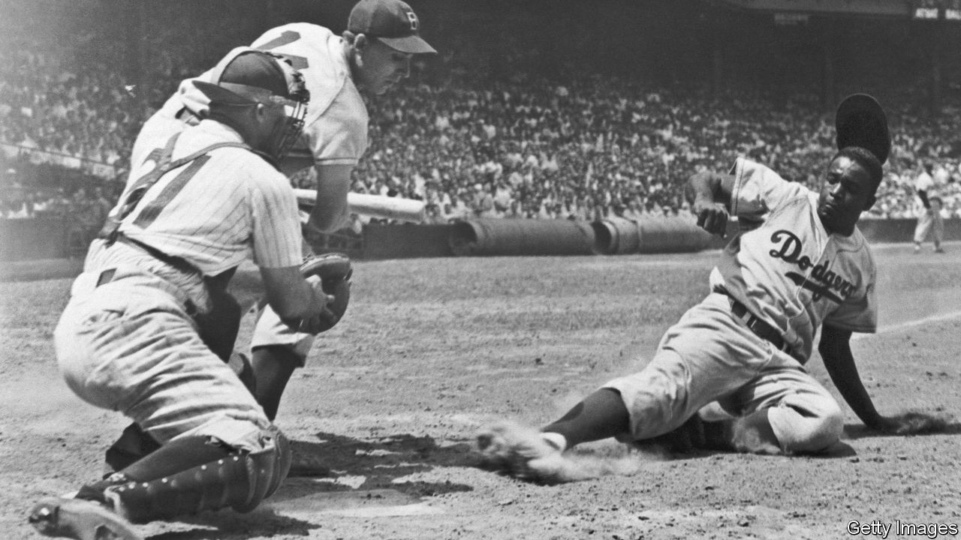

IN ADDITION TO being one of America’s best-known poets, Walt Whitman was among the earliest fans of baseball. “In our sun-down perambulations of late”, he wrote in 1846, “through the outer parts of Brooklyn, we have observed several parties of youngsters playing ‘base’, a certain game of ball.” In lines that bite in a world under quarantine, Whitman urged: “Let us go forth a while, and get better air in our lungs. Let us leave our close rooms…The game of ball is glorious.”

There is no substitute for a summer afternoon in the bleacher seats or extra innings in the shortening evenings of October. But listening to radio commentaries of memorable baseball games can help ease the ache in self-isolating fans’ hearts. By searching for “classic baseball radio broadcasts” on the internet, enthusiasts can tune in to more than 500 games played between 1934 and 1973.

Radio and baseball evolved together as both expanded and were commercialised in the first half of the 20th century. In part because of those early ties, baseball radio always feels nostalgic. The great announcers—Vin Scully, Harry Caray, Ernie Harwell—are old friends whispering in fans’ ears, filling them in on so-and-so’s nasty curveball or batting average. The relationships between listeners and their local emcees, and the intimate feel of audio description, make baseball radio seem personal in the same way that podcasts can be—and as televised sports never will.

Sports-lovers who favour action over finesse often bemoan the longueurs of baseball. But its cadence is well-suited to the lockdown. You can cook dinner or disinfect the house in the company of the Cubs (your correspondent is a native North Sider). The unhurried pace shaped the broadcasts themselves: to fill the airwaves between innings, announcers opine on players’ personal lives or how they themselves would write the ending of the game—only to be interrupted when the ball is at last hit.

Returning to classic games also provides fans with an oral history of Major League Baseball, and, obliquely, of the cities it is played in, even of America itself. Listening to Jackie Robinson (pictured), a pathbreaking African-American star, hit a single to left field for the Brooklyn Dodgers in 1951 is a reminder of earthly transience (the Dodgers moved from New York to Los Angeles in 1958), as well as of the racism that has been endemic to the country and its pastimes.

While audio from such early games is gravelly compared with today’s, some things haven’t changed at all. Announcers from 1940 and 2020 alike fall into the same rhythms: short, staccato sentences when the ball is in play; crescendos when it is hit; drawn-out vowels when home runs look certain and guttural screams from the crowd when victory or defeat looms. Unlike Whitman, fans today may not yet be able to leave their close rooms. But thanks to radio and the internet, baseball—in all its meandering, heart-fluttering glory—is still within their reach. ■

This article was downloaded by calibre from <https://www.economist.com/books-and-arts/2020/05/02/the-comfort-of-old-time-baseball-broadcasts>

|  |  |  |  |
| --- | --- | --- | --- |
| Previous | Articles | Sections | Next |

|  |  |  |  |
| --- | --- | --- | --- |
| Previous | Articles | Sections | Next |

#### Home Entertainment

# Travel to a land of “sun and dust” with “The Leopard”

Giuseppe Tomasi di Lampedusa’s novel is both an escapist joy and a political education

May 2nd 2020 |

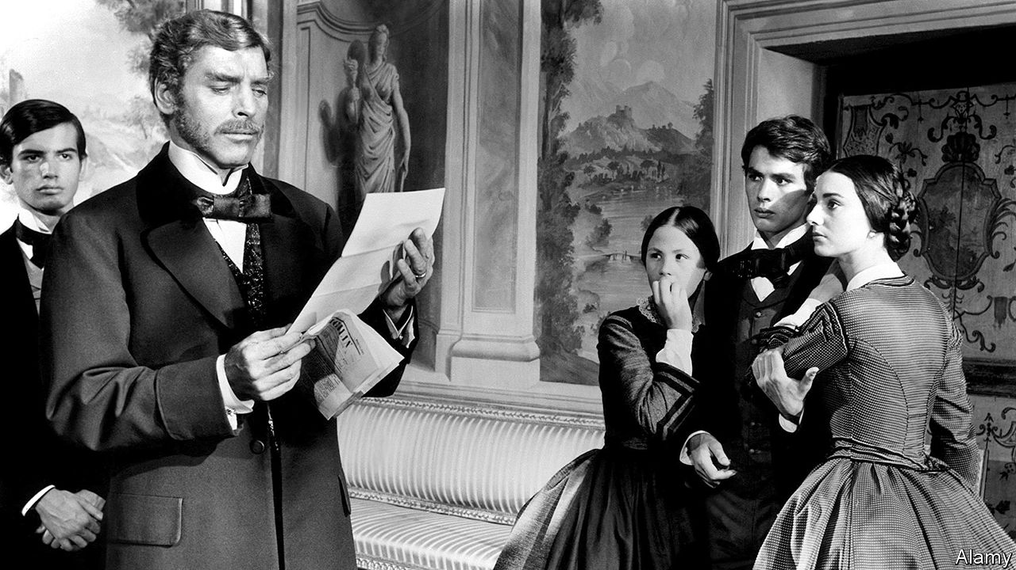

YOU MIGHT think that a nostalgic novel about a declining 19th-century Sicilian aristocrat by an unknown writer would have sunk without trace. Yet Giuseppe Tomasi di Lampedusa’s “The Leopard”, first published in 1958 shortly after his death, became a classic. One reason is that it is an extraordinarily evocative piece of writing. Another is that it distils timeless truths about revolutions and the rise and fall of elites.

Wherever you might be locked down, “The Leopard” will transport you to western Sicily, a “lovely, faithless land” of “sun and dust”, of “carnal delights and golden crops”, of lush gardens and barren mountains, of crumbling palaces and Ozymandian monuments to an ancient past of multiple invasions. Its people are sunk in a “voluptuous torpor”, their vanity stronger than their misery, full of secrets nobody keeps.

The protagonist, Fabrizio, Prince of Salina, is based on Lampedusa’s great-grandfather. He is a conservative, attached to feudal order, but self-aware. His world is challenged in 1860 by Garibaldi’s invasion of the island. At night, on the hills around Palermo, glimmer the flickering lights of dozens of bonfires lit by the rebel band, “silent threats to the city of palaces and convents” (in Archibald Colquhoun’s translation). Garibaldi’s overthrow of the moth-eaten Bourbon kingdom of Naples and Sicily was the prelude to the unification of Italy.

Although he has several children, Fabrizio sees his true heir in Tancredi, his zestful nephew who prepares to join Garibaldi. “If we want things to stay as they are, things will have to change,” Tancredi explains. That sentiment has entered the political vocabulary of the Latin world as gattopardismo (a play on the novel’s Italian title, “Il Gattopardo”), a philosophy of embracing change to neuter or at least control it.

Change is personified by Don Calogero, the shrewd mayor of Donnafugata, an inland town and location of Fabrizio’s favourite palace. Crushing the amorous hopes of his own daughter, Concetta, Fabrizio spies the advantage to Tancredi’s career of marrying him to the mayor’s only child, the beautiful Angelica. This involves Fabrizio welcoming into his family the “little conglomeration of ill-cut clothes, money and cunning brashness” that is Calogero.

The victors of revolutions often ape the rulers they dislodge. That is especially so in the Latin world, where many have been rearrangements of the furniture rather than genuine upheavals. Lampedusa was not alone in believing that unification had taken Sicily backwards (one form of resistance would be the Mafia). At first, the Italian left decried “The Leopard”; it took Luchino Visconti, a communist but an aristocratic one, to recognise the book’s genius, turning it into a baroque film starring Burt Lancaster, Alain Delon and a young Claudia Cardinale. That multinational cast was a fitting tribute to a story rooted in time and place that also transcends them. ■

This article was downloaded by calibre from <https://www.economist.com/books-and-arts/2020/05/02/travel-to-a-land-of-sun-and-dust-with-the-leopard>

|  |  |  |  |
| --- | --- | --- | --- |
| Previous | Articles | Sections | Next |

|  |  |  |
| --- | --- | --- |
| Books and arts | Sections | Graphic detail |

Economic and financial indicators

Economic data, commodities and markets

.

|  |  |  |
| --- | --- | --- |
| Books and arts | Sections | Graphic detail |

|  |  |  |  |
| --- | --- | --- | --- |
|  | Articles | Sections | Next |

# Economic data, commodities and markets

May 2nd 2020 |

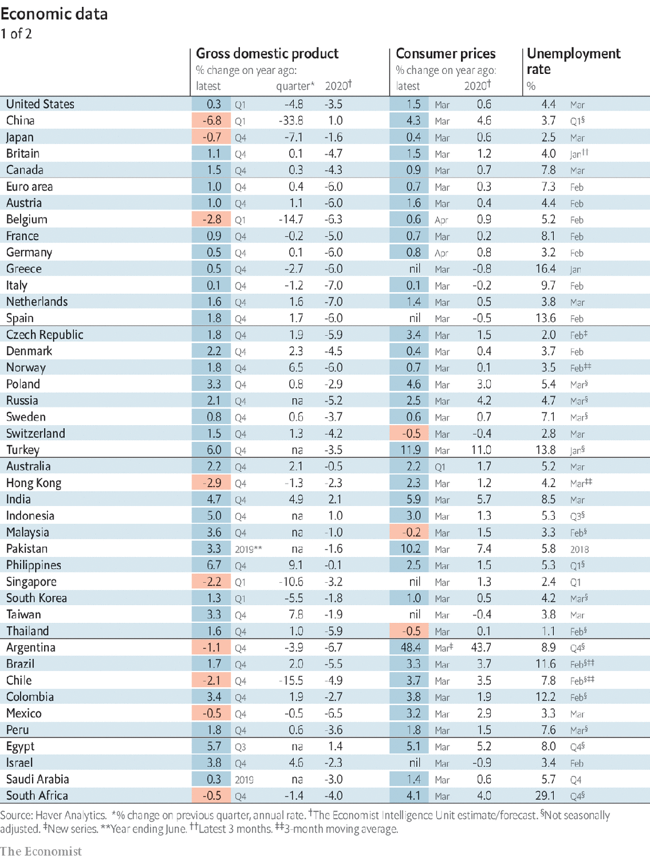

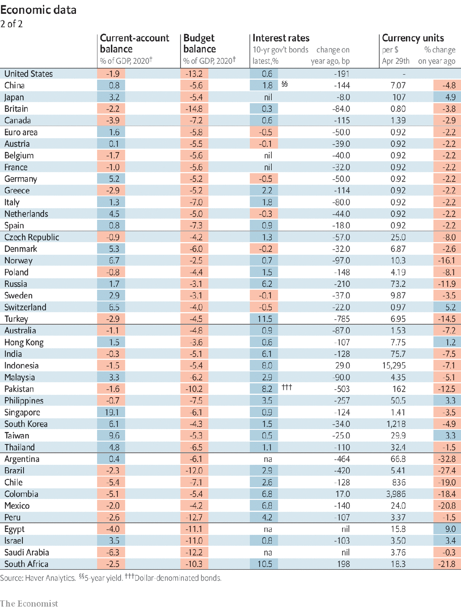

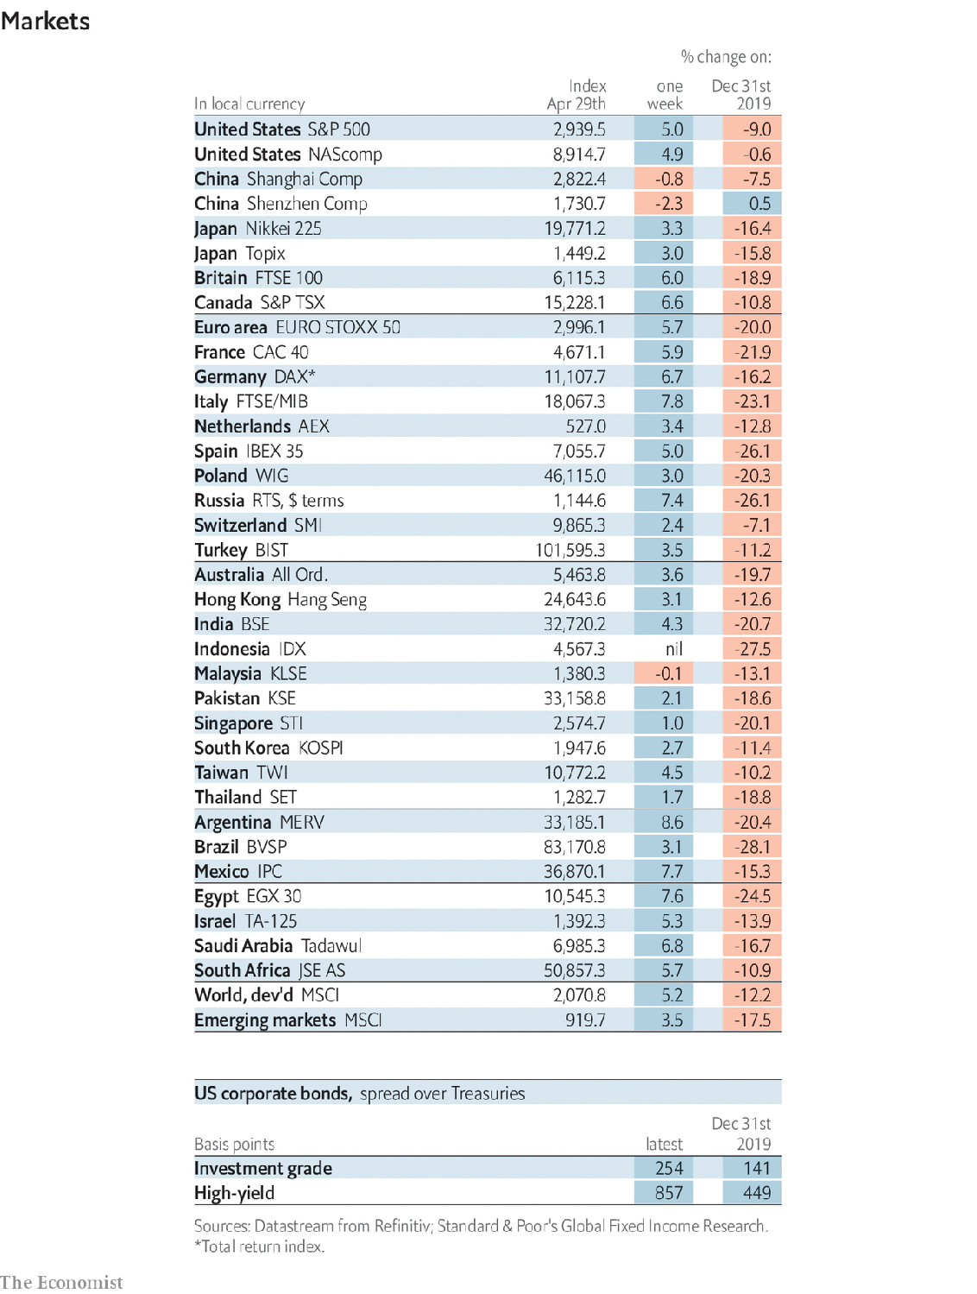

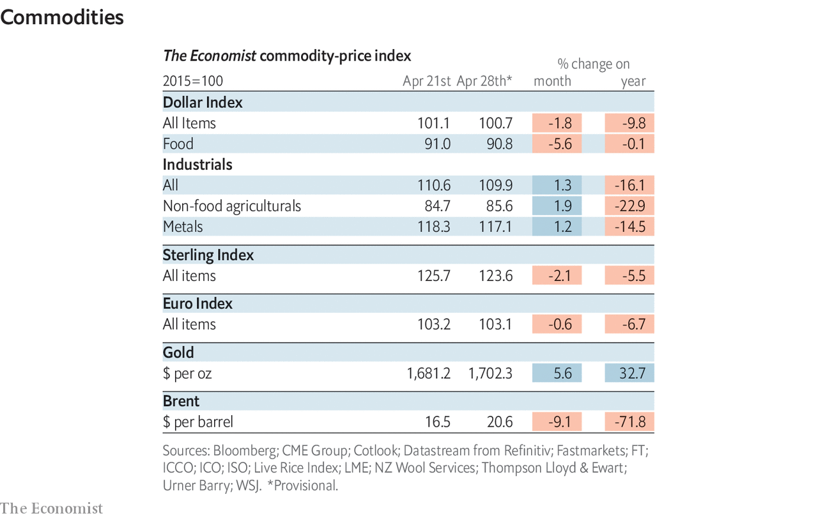

This article was downloaded by calibre from <https://www.economist.com/economic-and-financial-indicators/2020/05/02/economic-data-commodities-and-markets>

|  |  |  |  |
| --- | --- | --- | --- |
|  | Articles | Sections | Next |

|  |  |  |
| --- | --- | --- |
| Economic and ... | Sections | Obituary |

Graphic detail

Covid-19 and life expectancy: Before their time

.

|  |  |  |
| --- | --- | --- |
| Economic and ... | Sections | Obituary |

|  |  |  |  |
| --- | --- | --- | --- |
|  | Articles | Sections | Next |

#### Before their time

# Would most covid-19 victims have died soon, without the virus?

A new study suggests not

May 2nd 2020 |

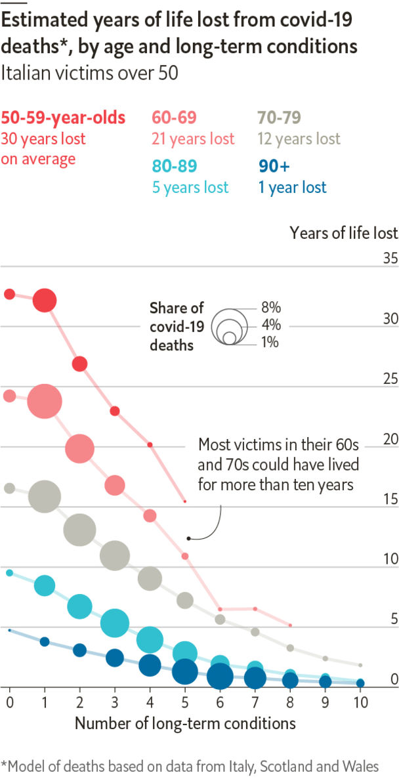

“SACRIFICE THE WEAK”, urged a sign at a protest against Tennessee’s lockdown on April 20th—though whether the person holding it was trolling the other protesters is unknown. Some claim social distancing is pointless, since covid-19’s elderly victims would soon have died of other causes. In Britain many pundits have said that two-thirds of the country’s dead were already within a year of passing away. They cite an estimate made in March by Neil Ferguson, an epidemiologist at Imperial College London who advises the government.

Mr Ferguson notes that two-thirds was the upper bound of his estimate, and that the real fraction could be much lower. He says it is “very hard” to measure how ill covid-19’s victims were before catching it, and how long they might have lived otherwise. However, a study by researchers from a group of Scottish universities has attempted to do so. They found that the years of life lost (YLLs) for the average Briton or Italian who passed away was probably around 11, meaning that few of covid-19’s victims would have died soon otherwise.

First the authors analysed data for 6,801 Italian victims, grouped by age and sex for confidentiality. About 40% of men were older than 80, as were 60% of women. (The virus has killed fewer women than men, perhaps because they have different immune responses.) The authors excluded the 1% of victims under 50. Then they calculated how much longer these cohorts would normally survive. Life expectancies for old people are surprisingly high, even when they have underlying conditions, because many of the unhealthiest have already passed away. For example, an average Italian 80-year-old will reach 90. The YLLs from this method were 11.5 for Italian men and 10.9 for women.

Then the authors accounted for other illnesses the victims had, in case they were unusually frail for their age. For 710 Italians, they could see how many had a specific long-term condition, such as hypertension or cancer. The authors used a smaller Scottish sample to estimate how often each combination of diseases occurs among covid-19 victims. Finally, they analysed data for 850,000 Welsh people, to predict how long somebody with a given age and set of conditions would normally live.

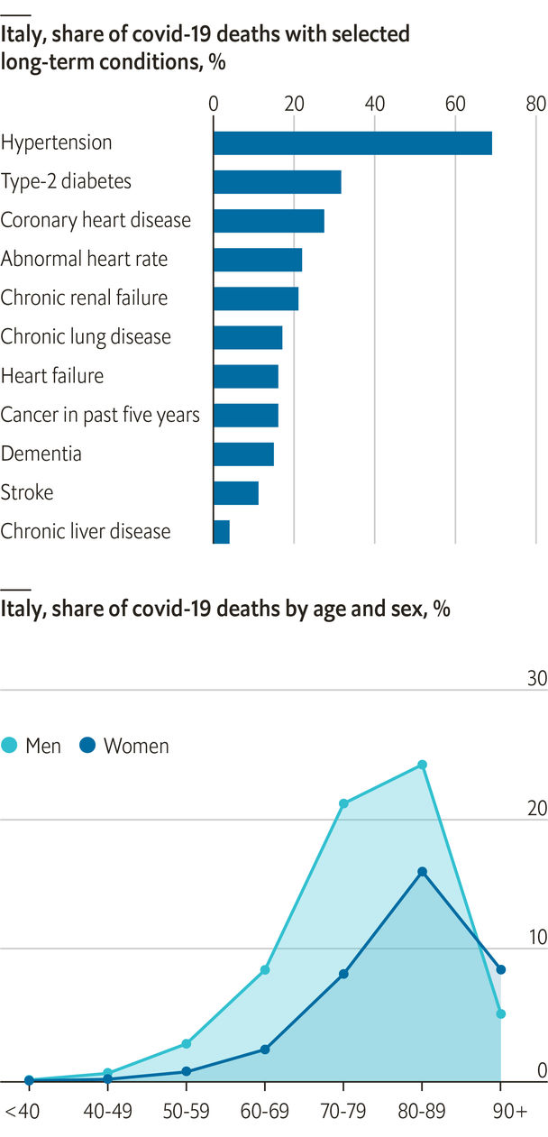

Strikingly, the study shows that in this hybrid European model, people killed by covid-19 had only slightly higher rates of underlying illness than everyone else their age. When the authors adjusted for pre-existing conditions and then simulated deaths using normal Italian life expectancies, the YLLs dropped just a little, to 11.1 for men and 10.2 for women. (They were slightly lower for Britons.) Fully 20% of the dead were reasonably healthy people in their 50s and 60s, who were expected to live for another 25 years on average.

The researchers warn that their data exclude people who died in care homes, who might have been especially sickly. Nor can they account for the severity of underlying illnesses. For example, covid-19 victims might have had particularly acute lung or heart conditions. More complete data could produce a lower estimate of YLLs. Mr Ferguson also points out that tallies of all-cause mortality will contain clues. If the pandemic has merely hastened imminent deaths, there should be fewer than usual once covid-19 is under control.

Still, the available evidence suggests that many covid-19 victims were far from death’s door previously, and cut down at least a decade before their time. Allowing the virus to spread freely would sacrifice the strong as well as the weak. ■

Sources: "Covid-19 – exploring the implications of long-term condition type and extent of multimorbidity on years of life lost: a modelling study", by P Hanlon, F Chadwick, A Shah et al., 2020; Istituto Superiore di Sanità (Italy); SAIL Databank (Wales); Public Health Scotland

This article was downloaded by calibre from <https://www.economist.com/graphic-detail/2020/05/02/would-most-covid-19-victims-have-died-soon-without-the-virus>

|  |  |  |  |
| --- | --- | --- | --- |
|  | Articles | Sections | Next |

|  |  |  |
| --- | --- | --- |
| Graphic detail | Sections |  |

Obituary

Joe Brown: Through crack and crag

.

|  |  |  |
| --- | --- | --- |
| Graphic detail | Sections |  |

|  |  |  |  |
| --- | --- | --- | --- |
|  | Articles | Sections | Next |

#### Through crack and crag

# Joe Brown died on April 15th

The colossus of British rock-climbing was 89

May 2nd 2020 |



THAT FIRST time was not to be forgotten. He was 16, the youngest of seven, a small skinny boy from the grimmest part of Manchester. His father was dead; his mother did cleaning. He was apprenticed to a builder to learn a trade. But he also liked to be out on the moors, messing about with his mates in quarries and what-not. That was where one day they saw a plume of white water in the sky and ran to investigate. It was Kinder Downfall in spate blowing up in the wind, and at once he scaled the rocks beside it. Only 60 feet or so, but icy—and at the top, throwing the rope down to his companions, Joe Brown felt his whole life had suddenly got better.

That elation never went away. He felt it when he climbed the west face of the Petit Dru at Chamonix in 1954, which was reckoned the hardest ascent in the Alps; when he led his little team up Kanchenjunga in the Himalayas, the world’s third-highest mountain, in 1955, when no one had conquered it yet; when in 1967 he was first to scale the south face of the Old Man of Hoy, 450 feet of sheer sea-stack in the Orkneys; and when he did the first ascent of the Mustagh Tower in Pakistan, 24,000 feet of rock spire known as “the last citadel”. Triumphs like these made his reputation as the best British climber of the century. Yet he felt just as grand on home turf—or rather gritstone, or granite, or slate. To be the first up Cenotaph Corner in Snowdonia in 1952, when no one had previously got beyond the first 20 feet, or to find a new line up a Derbyshire peak, was sheer joy, and earned a smoke at the end of it.

It wasn’t a matter of getting to the top. That was by the by. The king of Nepal didn’t want them to tread on the holy peak of Kanchenjunga, so they stopped four feet short, and that was fine. He wasn’t one for sticking flags on mountains. The point was working out an untrodden route, the trickier the better. Existing routes, even VS, Very Severe, in the guidebook, often seemed to him a fuss about nothing. He thrived on foot- and hand-jamming up perpendicular cracks for hundreds of feet, scrabbling for handholds on flakes of rock a fraction of an inch thick, inching out round overhangs and even, on the Spiders Web at Craig Gogarth, on the inside of an immense arch over the sea. There were plenty of slips. A gritstone edge almost sawed through his rope once. He had several near-topples off ledges. In the Himalayas he got excruciating snow-blindness. He realised on one occasion that he was standing not on rock or ice but hanging snow, and had to tiptoe back trying to be weightless. But he was a light climber in any case, limiting himself to two pegs per pitch to give other people an equally challenging time. He named his routes to encourage them: Mousetrap, Masochism, Right Unconquerable, Cemetery Gates.

He did like to go fast. He was nimble, and his eye for a line made him the natural leader of the little teams he assembled. Competitive, too. His new route up the west face of the Aiguille de la Blaitière in the Mont Blanc massif, named “Fissure Brown” after him, involved overtaking three of the fastest climbers in France. Following a new line on the Carn Dearg buttress of Ben Nevis, he joyfully overtook a team of Scots, naming the route “Sassenach” in their honour. If he failed, though, he would just ruminate about the next time. He would hold the rock in his mind like a photo as he did his building day-job, working out all the options he could try. On his favourite climbing cliff, Clogwyn Du’r Arddu on Snowdon—“Cloggy” to him—he laid around two dozen new routes in the 1950s and 1960s, and perhaps 400-500 in the rest of Wales over his career. As with plastering, he kept trying to increase the daily yardage.

Building was a natural occupation for someone of his background. Rock-climbing was not. Before the war, it was a pursuit for the middle and upper classes. Afterwards he led the way to making it a pastime for anyone. His chief mentor, “Slim” Sorrell, was a pipefitter; his chief companion, Don Willans, was a plumber from Salford. They would leave Manchester by the Friday-night train to get to the climbing places, or go by bus. Rain or clag didn’t deter them; the weekend was all they had. No one trained them, and they got what kit they could. His first ropes were pinched from roadworks, his chockstones metal nuts picked up on railway tracks. His first boots, proper nailed ones, were out of his reach until his boss gave him three pounds ten shillings. The trip to the Alps in 1954 cost him his job as well as all his money; after that he became a jobbing builder, taking breaks when he wanted. Cash still didn’t exactly flow. When he was invited on the Himalayan expedition, on a team with Everest-conquerors and Oxbridge men, he was told to bring £20 pocket money. He didn’t have £20 in the world.

In truth, making a living by jamming up cracks and hanging on ledges was never going to be easy. He could have made money from his fame, especially after 15m BBC viewers saw his climb on the Old Man of Hoy. But he hated all that. He wished his CBE could have been slipped into his pocket in a plain brown envelope, rather than all the fuss. And he refused outright to speak at any dinners; he liked to eat at home, with family. His solution to the money problem later was to open mountain-equipment shops in Snowdonia and make his own helmets for them, good rock-proof ones, just right for the job.

He made a few TV shorts, though. In one series, after each spectacularly difficult climb, he would emerge to find a near-inaccessible pool and go fishing. Angling was his second great love, as if he was back in Manchester trying his luck in the industrial canals. On most of his expeditions he took a collapsible rod with him, and in the Andes in 1979 he reached a black pool where explorers later found Mayan gold. He didn’t find any himself, and in his TV programmes he appeared to catch no fish either. As usual, it didn’t matter. Simply getting up there had been perfection enough. ■

This article was downloaded by calibre from <https://www.economist.com/obituary/2020/05/02/joe-brown-died-on-april-15th>

|  |  |  |  |
| --- | --- | --- | --- |
|  | Articles | Sections | Next |